**Name - Tisha Garg**

**Class - CSE CSTI**

**Roll no - 2K20CSUN05020**

**LAB - 6**

**Ques-1** To find the area/ surface area of

(a). Circle

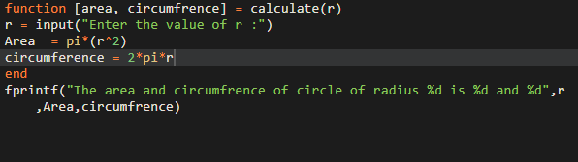

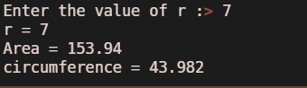

(b). Cylinder

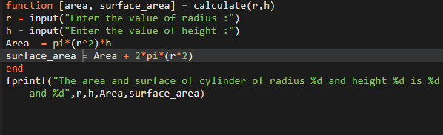

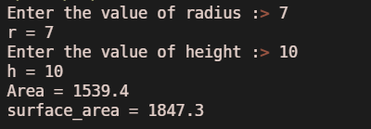

(C). right circular cone

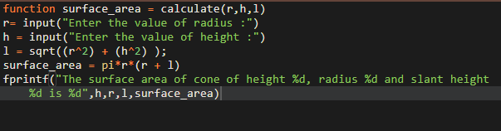

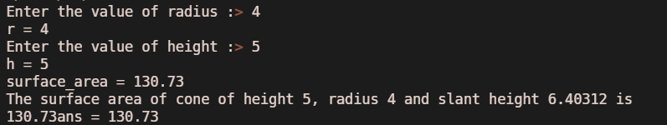

(d) triangle (using perimeter formula) using functions.

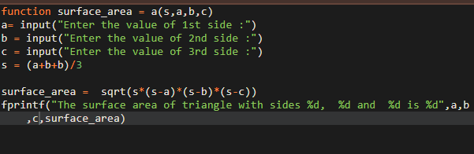

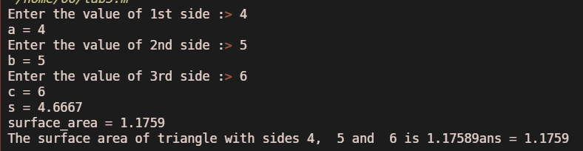

**Ques-2** To calculate the root of a quadratic polynomial function.

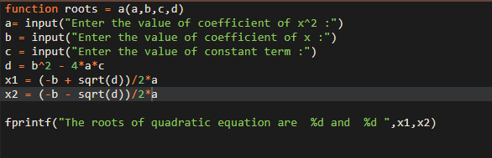

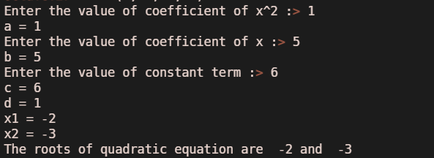

**Ques-3** To calculate the simple interest and compound interest

Simultaneously using functions.

