**Name - Tisha Garg**

**Class - CSE CSTI**

**Roll no - 2K20CSUN05020**

**LAB - 7**

**Ques- 1 Compute the inverse of the matrices**

**1.**

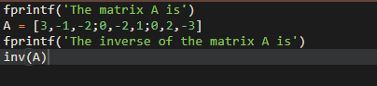

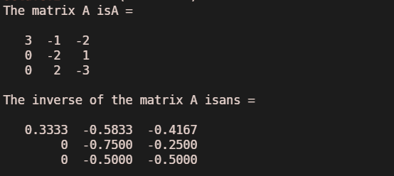

**2.**

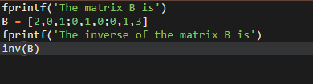

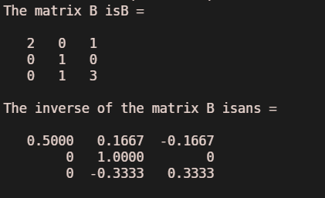

**3.**

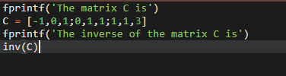

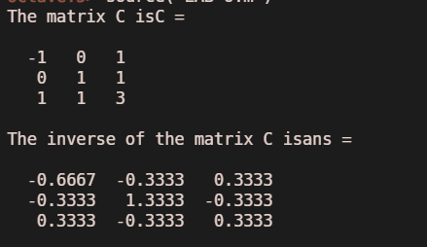

**Ques- 2 Find the rank of the matrices**

**1.**

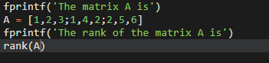

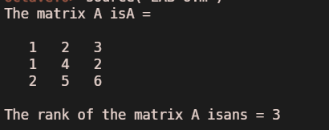

**2.**

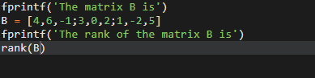

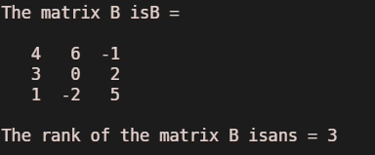

**3.**

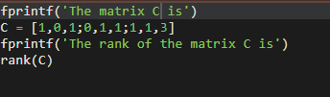

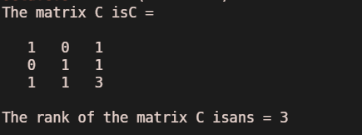

**Ques-3 Reduce each of the following matrices into their normal form/row echelon form and be find their Ranks:**

**1.**

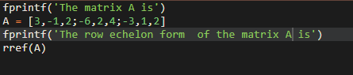

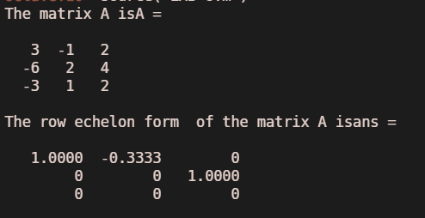

**2.**

