## **PicVerse : Data Flow Diagrams**

##### ____________________________________________________________________________

## 

## **Project Title: PicVerse – A Social Media Photo Sharing Platform**

**Group ID: 14**

#### **Prepared By:~**

#### **202412026 Jain Tisha Navinkumar**

#### **202412032 Kaival Shah**

#### **202412066 Patel Dhruv Alkeshbhai**

## 

### **Version: v1.0**

### **Date: March 14, 2025**

## 

## 

# 

# **Level 0**

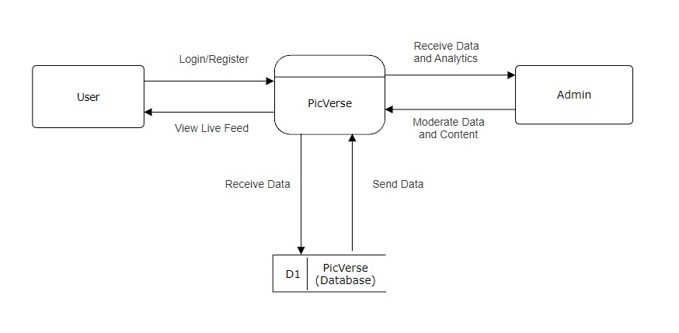

The Level 0 DFD accurately represents the highest level of data flow:

* **User ↔ PicVerse:** The "User" sends data (requests, content) to "PicVerse" and receives data (posts, responses) from "PicVerse."
* **Admin ↔ PicVerse:** The "Admin" sends data (moderation commands) to "PicVerse" and receives data (analytics, reports) from "PicVerse."
* **PicVerse ↔ PicVerse Database:** "PicVerse" constantly exchanges data with the "PicVerse Database" for storage and retrieval of information.

# **Level 1**

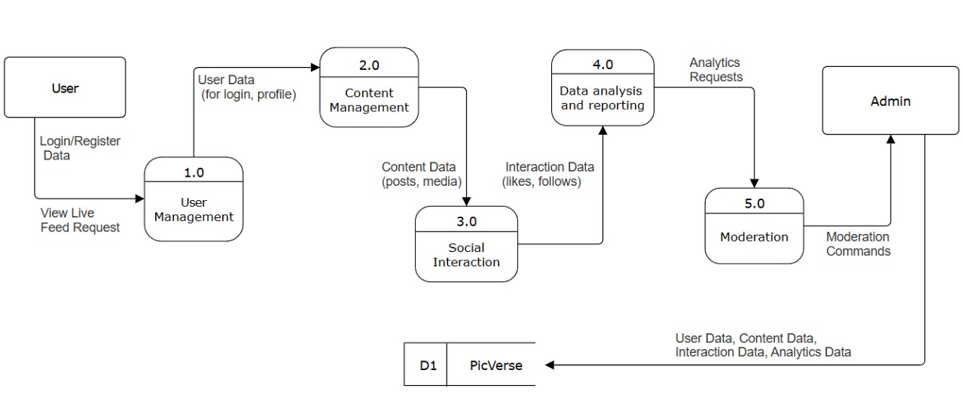

**1.0 User Management:** Handles user accounts (registration, login, profiles).

**2.0 Content Management:** Handles user-generated content (posts).

**3.0 Social Interaction:** Manages how users interact (likes, comments, follows).

**4.0 Data Analysis and Reporting:** Generates analytics and reports (primarily for the admin).

**5.0 Moderation:** Admin functions for managing users and content.

**Data Flows:-**

* **Login/Register Data and View Live Feed Request:** Data from the User to the User Management process.
* **User Data (for login, profile):** Data flowing between User Management and the PicVerse database.
* **Content Data (posts, media):** Data flowing between Content Management and the PicVerse database.
* **Interaction Data (likes, follows):** Data flowing between Social Interaction and the PicVerse database.
* **Analytics Requests:** Data from the Admin to the Data Analysis and Reporting process.
* **Moderation Commands:** Data from the Admin to the Moderation process.
* **User Data, Content Data, Interaction Data, Analytics Data:** Data flowing between the PicVerse database and the various processes.

# **Level 2**

## **1.0 User Management**

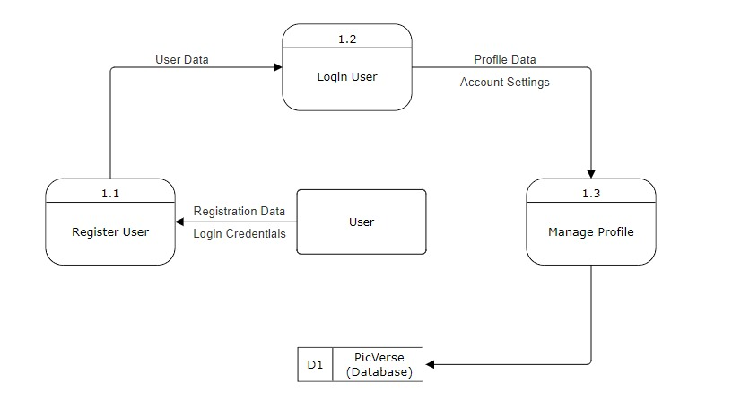

* **User Management:**
  + "Registration Data": Data provided by the user during signup.
  + "Login Credentials": Username/email and password for authentication.
  + "User Data": Information about the user (profile details, settings).

## **2.0 Content Management**

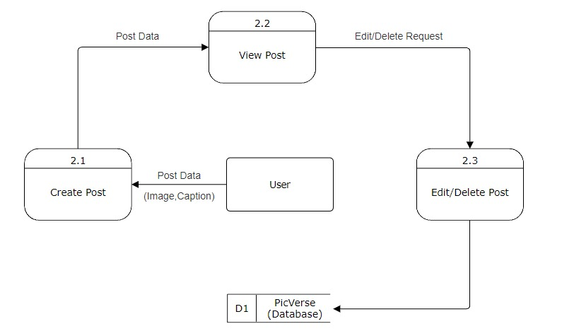

* **Content Management:**
  + "Post Data (Image, Caption)": The image and text content of a user's post.
  + "Post Data": Data representing a post.
  + "Edit/Delete Request": User request to modify or remove a post.
  + "Content Data": All stored post information.

## **3.0 Social Interaction**

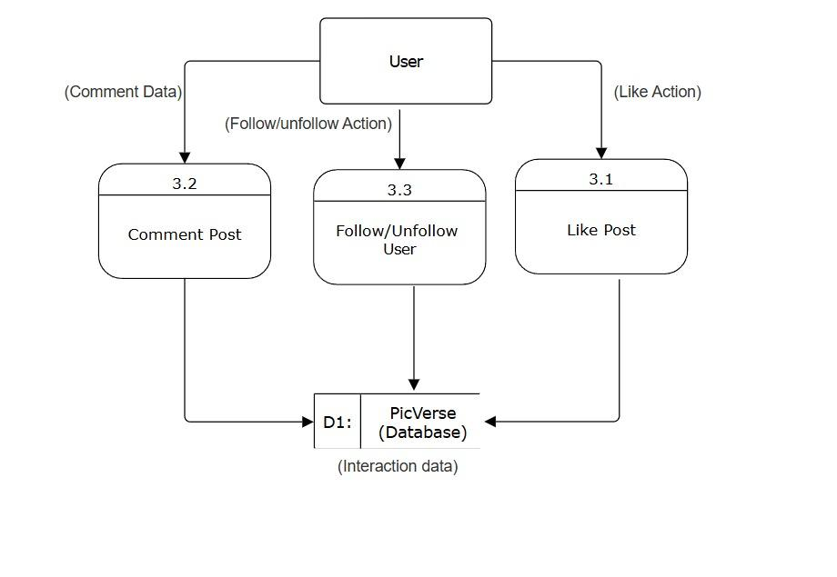

* **Social Interaction:**
  + "Like Action": User action to like a post.
  + "Comment Data": Text content of a user's comment.
  + "Follow/Unfollow Action": User action to follow or unfollow another user.
  + "Interaction Data": Data about likes, comments, follows, etc.

## **4.0 Data Analysis and Reporting**

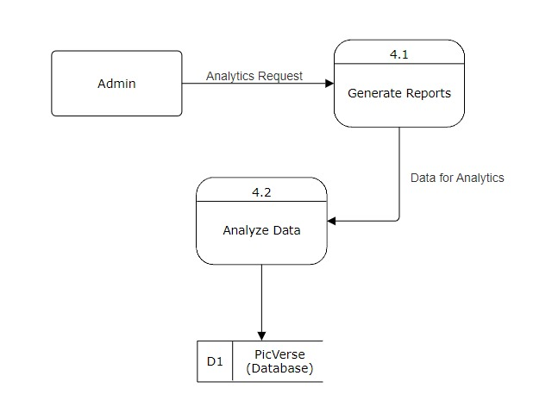

* **Data Analysis and Reporting:**
  + "Analytics Request": Admin request to generate analytics reports.
  + "Data for Analysis": Data retrieved for analysis.
  + "Analytics Data": Processed data and generated reports.

## **5.0 Moderation**

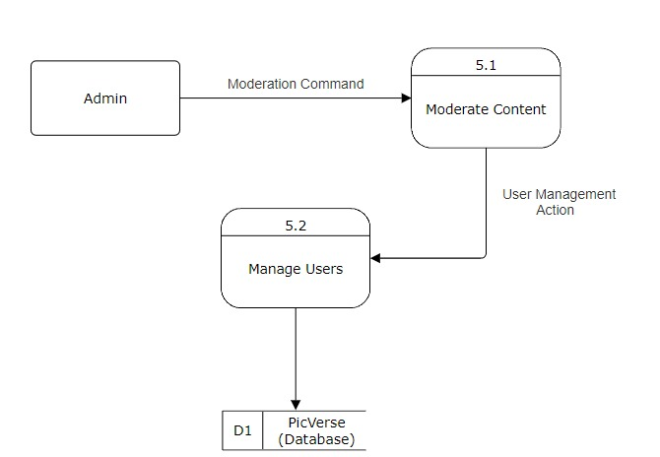

* **Moderation:**
  + "Moderation Command": Admin action to moderate content (e.g., delete, ban).
  + "User Management Action": Admin action to manage users (e.g., ban, suspend).
  + "Moderation Data": Data related to moderation actions and rules.