**Title:** Diana Trujillo: A Lesson in Perseverance

LID: 19978  
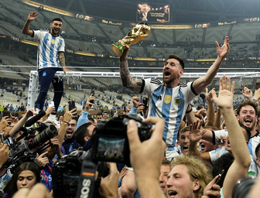

When Trujillo was born in Cali, Colombia in 1980, her madre and abuela (her mother and grandmother) bestowed on her the only gift they could afford to give—an auspicious name—Lady Diana Trujillo. This noble name carried with it all her family’s hopes and dreams for a better future, although Trujillo will be the first to admit that she identifies with intergalactic warrior princesses more than the British royal she’s named after!