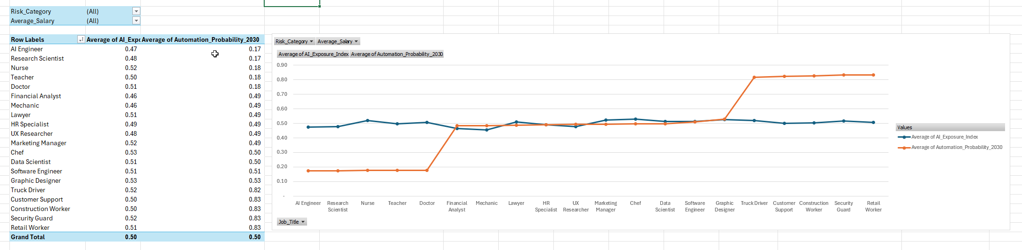
On average
Least at-risk jobs:
- AI Engineer
- Research Scientist
- Nurses
- Teachers
- Doctors
Most at-risk from AI (way above the average risk prediction overall):
- Truck Drivers
- Customer Support
- Construction Worker
- Security Guard
- Retail worker
All other jobs on the dataset – 50/50 chance (approximately)
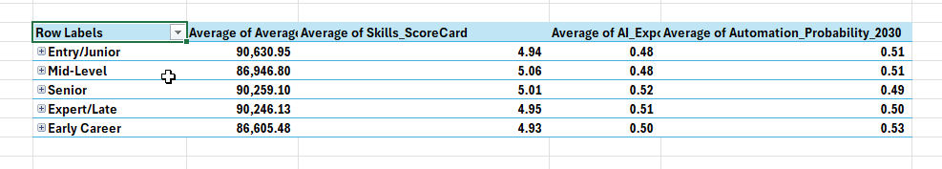
Synthetic Dataset so ‘balanced’ that:
- Overall number of years’ experience doesn’t count – on average (above) the distribution is equal for:
  - Similar average pay – around about 86,000 to 90,000
  - Skill scorecard around 4.9 to 5.0
  - Average AI exposure around 4.9/5.0
  - Average automation probability ranges from .49 to 0.53
Similarly, if we use job titles by itself, we won’t be able to tell who would be at risk – all these average to around same values (below)
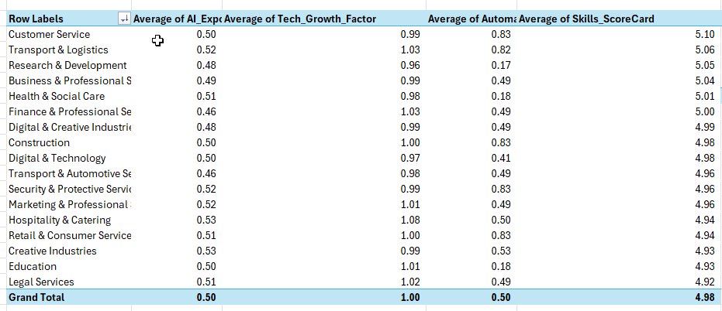
However, if you group the jobs by labour group – you get the following:
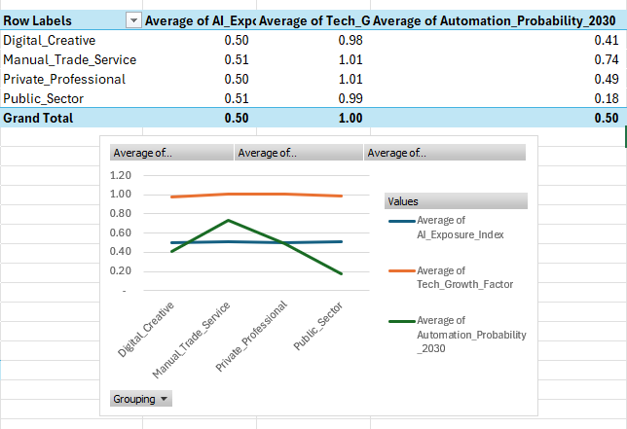
Main insight from above – manual trade service jobs are at higher risk than all other labour groups.
Skills 1-10 is misleading and not a factor for consideration here – data shows skills not an influencer for AI risk.
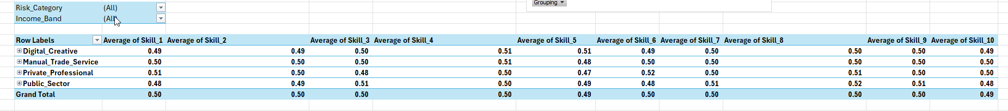

Split out of the Manual Trade Service 0.74 above into High of 0.83 and Medium risk 0.50 – only chef and mechanics are at 50/50 risk. 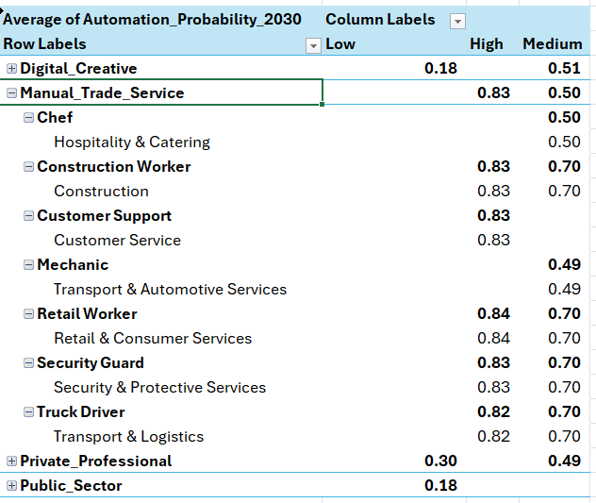
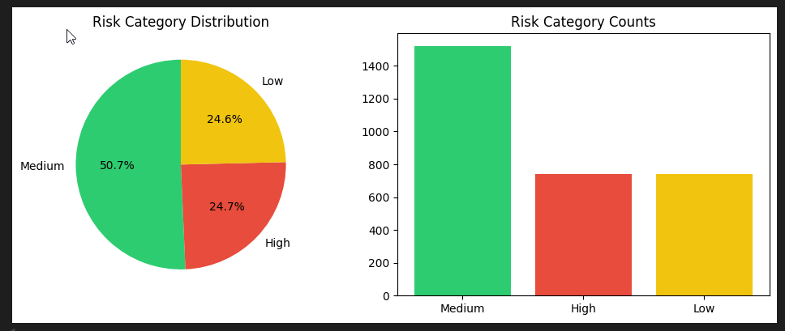
Highly imbalanced dataset shown above
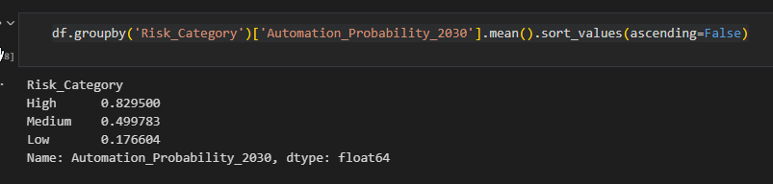
Cannot use Automation Prob 2030 is a predictor as it is one and the same as the Risk Cat target
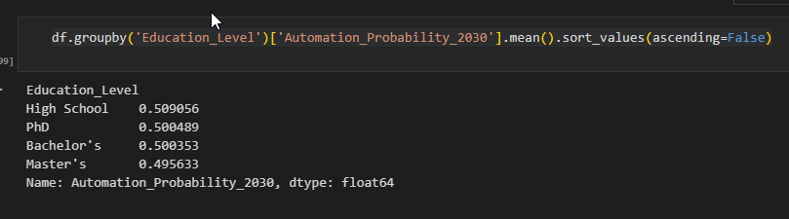
Higher Education is not an advantage for securing your job in the age of AI
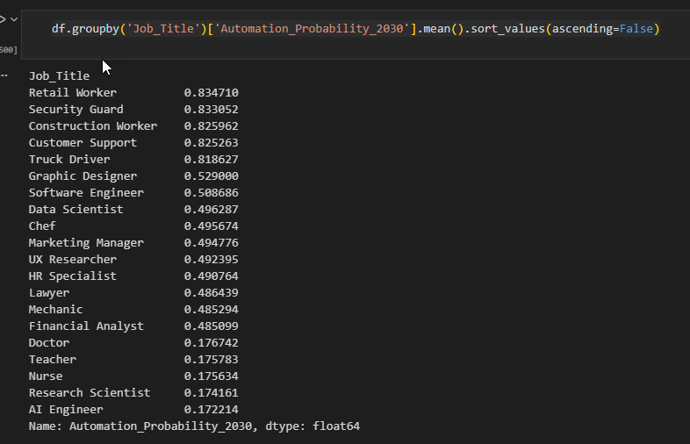
Top 5 high-risk – commonality is manual BUT doesn’t mean unskilled – at risk from AI automation (say from machines and/or robots) – e.g. driverless cars and trucks now an everyday reality in China (provide research).

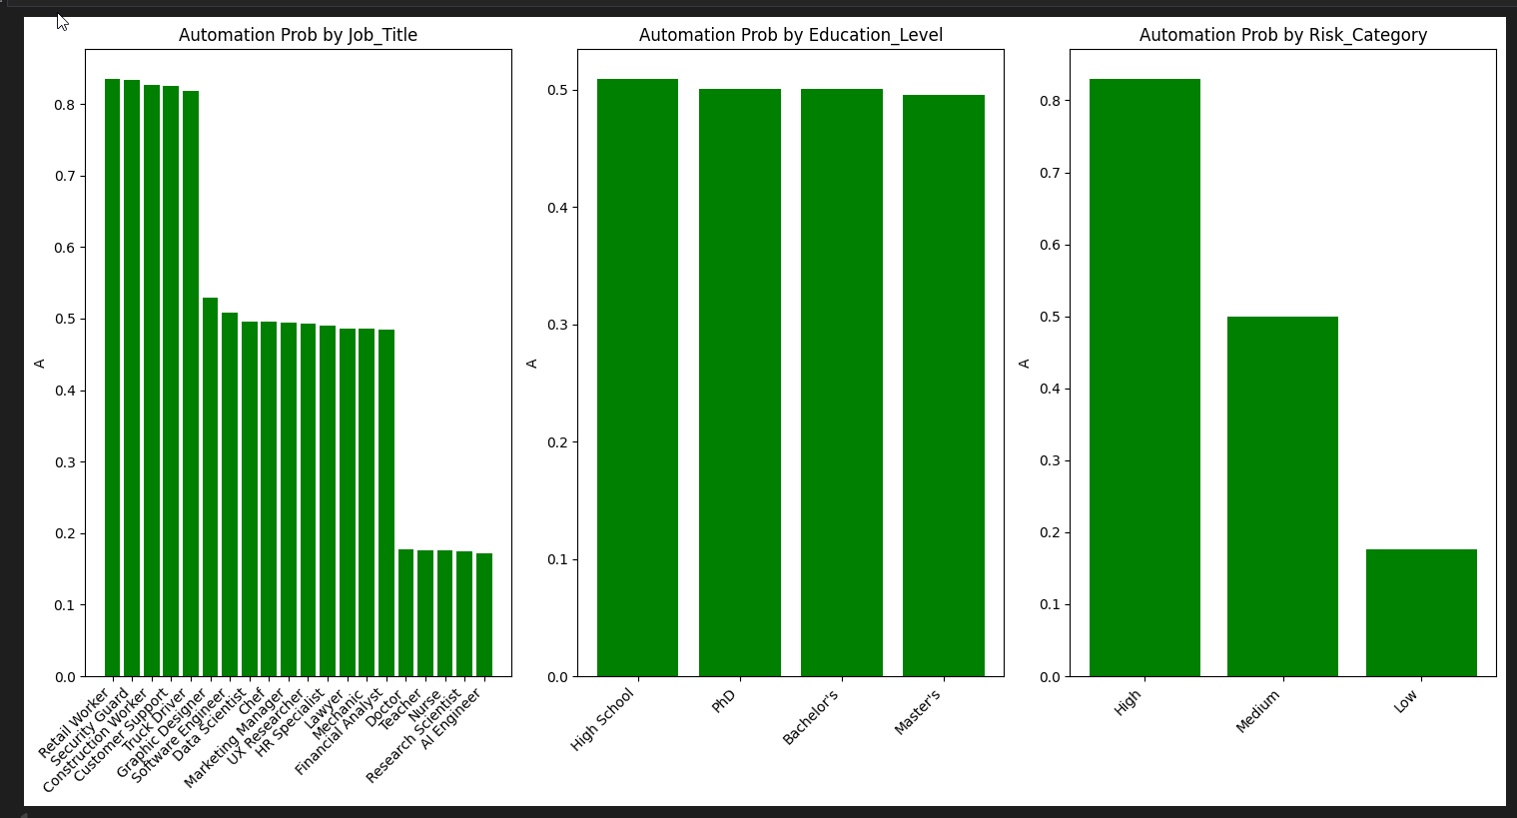
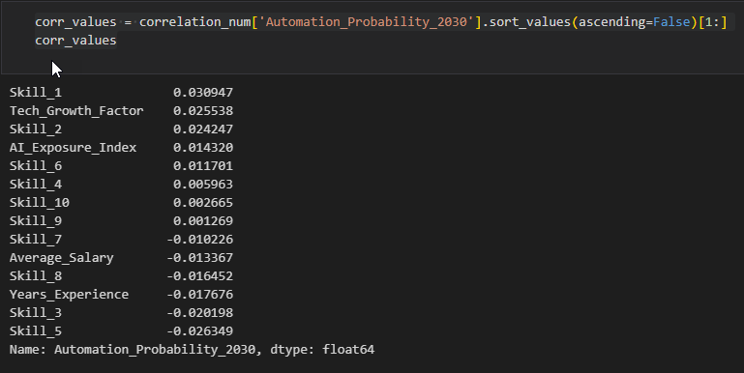
No (good) correlation exists for this dataset (by itself)

