Individual Formative Assignment:

Python ETL and Visualisation

“Can we use Global Finance Data to determine Global Index ETF pricing?”
by
Teerachai (“Tish”) Srisasi
14th November 2025

READ ME Documentation

Identifying the Problem/Opportunity for analysis - setting the scene using a fictional story:
- Let’s imagine you meet an old university friend over coffee, who is an entrepreneur.
- During the meeting you find out she’s looking to create a new company in the financial sector – primarily selling Global Index Exchange Traded Funds (or ETFs) to investor clients.
- Your friend says she is keen to start hiring ‘experts’ in this field right away to help her (e.g. Financial and Geo-Political Advisor, Economists, Credit Risk Analysts etc).
- You wish her the best of luck and tell her about your current course with the Code Institute and that she should at some point look into Data Analysis to help her with her start-up, as all the data she’ll need is more-than-likely already available on the Internet.
- At first, your friend is sceptical and says she doesn’t believe it would add any value to her new business venture, as she’s ‘dead set’ on building her new business the ‘old school’ way. You tell her you think these days it’s necessary to do the research, as data analysis could cut her initial hiring costs – she may achieve most of her customer service objectives through automation: using a dashboard to show her clients the information they need for insights into which Global Index ETF in the market would best suit their investment needs, with a view to move to Machine Learning/predictive route to future-proof her business later.
- Your friend is still not fully convinced, but as a favour to and old friend, she sends you a global finance dataset from 2024 and says your goal is to persuade her just by using:
  - Freely available analytic tools – she tells you he can’t provide you with any funding (you find out later the data she’s provided is feely available on Kaggle, and you also remember that she’s always been a bit too ‘careful’ with her money anyhow).
  - Just the financial dataset she has provided – your fiend admits a lot of the information is missing (i.e. not all country data is provided nor are the key fields required for a full analysis), and it isn’t a time series (it’s a snapshot of a particular day in 2024) but she’s willing to provide you with more info later on (Global Index ETF prices, more countries, economic info, key ratios etc) if you can show her data analysis adds value to her business venture. She also suggests for missing data - you can derive them from the other columns within the dataset and/or to use a temporary proxy (a substitute value) if needed.
  - A way to show her your outcome online – so she can see the workings as well as the resulting visuals (as you live and work far away from each other).
- She shows you her draft business start-up documentation (all very hush-hush still) – and confides in you that her extensive pre-launch customer surveys reveals she’ll needs a full analysis of the data below to enable her clients to choose a suitable Global Index ETF:
  - High Level Analysis on Country Credit Ratings
  - A view into the Global Stock Markets
  - Key Correlation Analysis & Economic Data Review, and
  - An Analysis of the Economic figures
- Initially, your friend’s target audience will be well-informed Investors (i.e. those who know what they are doing and is capable of choosing their ETF if she provides them using the above analysis) but she tells you she may want to expand her business into other markets and ‘less-informed’ investors – so she wants everything written up in simple/plain English (where possible) and/or shown in a visually ‘simplistic’ way – so everything is easy to comprehend and all the results and insights are easy to understand at first glance.
- She doesn’t want anything too fancy either (for now) just the proof of concept to show that the dataset will provide an accurate way for her client to choose which ETF to purchase.

Collecting the Data
Name of the Dataset | Global Finance Snapshot 2024
Dataset Description | “Global economic and financial indicators for markets, currencies, and growth”
Dataset Source Origins | Kaggle
Web URL | https://www.kaggle.com/datasets/minahilfatima12328/global-finance-snapshot-2024
Dataset Original Filename | Global finance data.csv (using its original CSV Format)
Dataset version & file size | 1.00 (6.14kB)
Useability Rating | 10.00 (as of 10/11/2025)
Dataset Dated | August 15th 2024

Data Review & First Impressions (pre-ETL)
- No data dictionary provided (will need to create one with appropriate field descriptions – see below).
- Missing rows noted (not all countries are represented in the dataset).
- Three columns with static values – “Date”, “Oil_Price_USD_Barrel” and “Gold_Price_USD_Barrel” to be automatically removed as part of data cleaning, as these add little or no value to the analysis (see Clean the Data Checklist).
- Data is a snapshot of values from 15th August 2024 – no time series provided but still fit for purpose (see above walk-through section).
- Missing Key field – Country’s Gross Domestic Product figure (USD Billion or Trillion) – may need to use an adequate substitute proxy value (will instead use “Market_Cap_Trillion_USD” and convert into USD Billion) (see ETL: Transformation Logic).
- No key economic ratios provided – will derive these as part of data cleaning and feature engineering (see ETL: Transformation Logic).
- No missing values found prima facie, so data is deemed high quality.
- Data integrity checks – spot checks using Microsoft Excel shows all values appear valid both in format and context.
- Under “Credit_Ratings” column it was noted that the Standard & Poor (S&P) rating system was used – this needs to be converted to a more user-friendly format (see ETL: Transformation Logic).
- New country-level grouping required to analyse data at higher levels (see ETL: Transformation Logic)
- “Banking_Sector_Health” to be reclassified into numerical/ordinal categories to pre-empt machine learning path (see ETL: Transformation Logic) `
- “Political_Risk_Score” – data field uses a reverse scoring system – high score means a low political risk (i.e. politics more stable the higher the scoring).

‘As is’: Original Dataset Source*: Original Global Finance Snapshot 2024 Kaggle Dataset (*please note that for the sake of accuracy, the Detailed Description column is AI generated with edits where needed.)
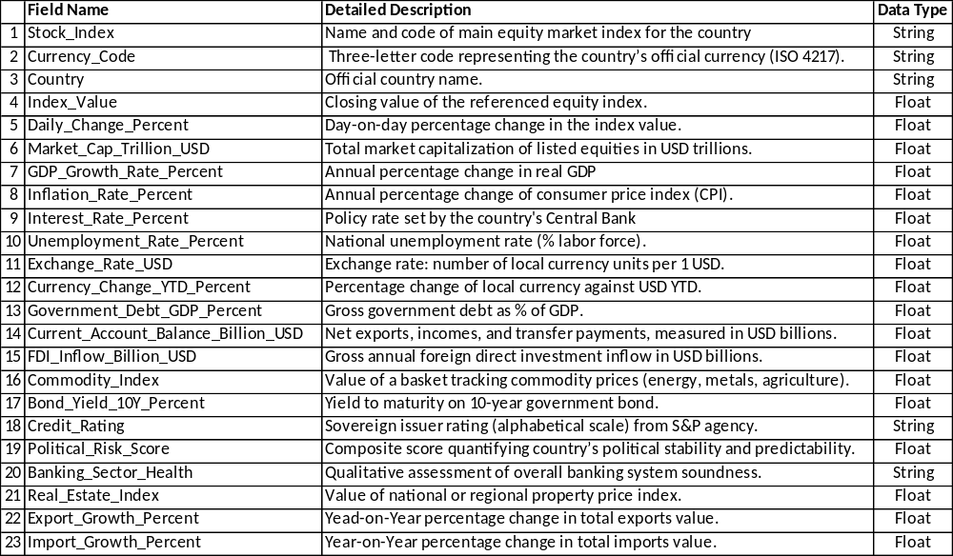
‘To be’: Additional Columns* through use of Transformation Logic (see below for details)
(*please note that for the sake of accuracy, the Detailed Description column is AI generated with edits where needed.)
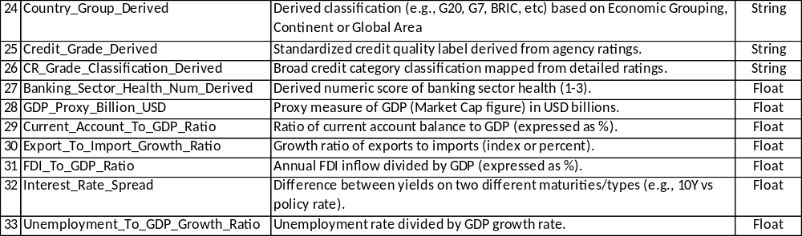

Dataset-split into Useful Subsets for Purposes of Initial Analysis and Work-in-Progress:
Country/Regional Credit Ratings Analysis | Global Stock Market Health | Key Percentages & 'Corr' Analysis | Key (Economic) Figures Feature Analysis
- Country Group Derived  - Credit Rating  - Political Risk Score  - Banking Sector Health  - Real Estate Index  - Credit Grade Derived  - CR Grade Classification Derived  - Banking Sector Health Num Derived | - Country Group Derived  - Index Value  - Daily Change Percent  - Currency Change YTD Percent  - Commodity Index | - Country Group Derived  - Daily Change Percent  - GDP Growth Rate Percent Inflation Rate Percent  - Interest Rate Percent  - Unemployment Rate Percent  - Currency Change YTD Percent  - Government Debt GDP Percent  - Bond Yield 10Y Percent  - Export Growth Percent  - Import Growth Percent Current Account To GDP Ratio  - Export To Import Growth Ratio  - FDI To GDP Ratio  - Interest Rate Spread Unemployment To GDP Growth Ratio | - Country Group Derived  - Market Cap Trillion USD  - Exchange Rate USD  - Currency Change YTD Percent  - Government Debt GDP Percent Current Account Balance Billion USD  - FDI Inflow Billion USD  - Commodity Index  - Export Growth Percent  - Import Growth Percent  - GDP Proxy Billion USD  - Current Account To GDP Ratio  - Export To Import Growth Ratio  - FDI To GDP Ratio  - Interest Rate Spread Unemployment To GDP Growth Ratio
ETL: Extract, Loading & Clean the Data

Data Extraction:

Successfully completed in its original CSV format using above-mentioned Kaggle Link – please refer to the Jupyter Notebook: “Extract, Loading & Cleaning the Data” for further details.

Data Loading:
Successfully completed. For easy accessibility, the raw data file was uploaded into GitHub using the following link: https://raw.githubusercontent.com/tishsrisasi/my-first-project/refs/heads/main/Global%20finance%20data.csv

Data Cleaning:
Successfully completed in its original CSV format using above-mentioned Kaggle Link – please refer to the Jupyter Notebook: “Extract, Loading & Cleaning the Data” (GitHub filename: CleanMyData_New) for further details.

Categorize Existing Features:
- Credit Rating
- Banking Sector Health/Banking Sector Health (Ordinal) Number

Indexing using the below features (with unique values):
- Stock Index
- Currency Code

Data Cleaning Checklist:
1. Check for null values – Completed.
2. Apply the Pandas dropna method to the whole data frame - Completed.
3. Dropping features with constant values: [“Date”, “Oil Price USD Barrel”, “Gold Price USD Ounce”] – Completed.
Saving the clean data frame as a new file: 'global_finance_data_cleaned.csv' (Completed)

ETL: Transformation Logic

Successfully completed – please refer to the Jupyter Notebook: “Data Transformation” (GitHub filename: FeatureEngine_New) for further details.

Feature Engineering Summary

Original Feature | Derivative Feature#1 | Derivative Feature#2 or Calculation
Country | Country Group Derived
Credit Rating | Credit Grade Derived | Credit Grade Classification Derived
Banking Sector Health | Banking Sector Health Number Derived
Market Cap Trillion USD (A) | *GDP Proxy Billion USD (B) | B = A x 1,000
Current Account Balance Billion USD (C)  *GDP Proxy Billion USD (B) | Current Account to GDP Ratio (D) (%age) | D = C / B x 100%
Export Growth Percent (E)  Import Growth Percent (F) | Export to Import Growth Ratio (G) | G = E / F
FDI Inflow Billion USD (H)  *GDP Proxy Billion USD (B) | FDI to GDP Ratio (I) (%age) | I = H/B x 100%
Bond Yield 10Y Percent (J)  Interest Rate Percent (K) | Interest Rate Spread (L) | L = K – J
Unemployment Rate Percent (M)  GDP Growth Rate Percent (N) | Unemployment to GDP Growth Ratio (O) (%age) | O = M / N x 100%

New Feature Input and Output: Country Groups/Country
Function Name: find_country_group(country)
Inputs: Country | Output: Country Group
United States, Japan, Germany, United Kingdom, France, Canada, Italy. | G7
China, India, Brazil, Russia, Hong Kong, Indonesia, South Africa, Egypt, UAE,  Saudi Arabia. | BRICS
Australia, South Korea, Mexico, Switzerland, Turkey, Argentina. | G20
Nigeria. | Africa
Singapore, Taiwan, Thailand, Malaysia, Philippines, Vietnam. | Asia
Spain, Netherlands, Sweden, Norway, Denmark. | Europe
Israel. | Middle East Region
Chile, Colombia, Peru. | South America

New Feature Input and Output: Credit Rating Scores and its Derivatives
Function Name: snpCRlookup(credit_rating,info=0)
Input: S & P Credit Rating | Output#1: Credit Grade Classification | Output#2: Credit Grade
AAA | Investment (1) | Prime (1)
AA+, AA, AA- |  | High Grade (2)
A+, A, A- |  | Upper Medium Grade (3)
BBB+, BBB, BBB- |  | Lower Medium Grade (4)
BB+, BB, BB- | Non-Investment/Speculative (2) | Speculative (5)
B+, B, B- |  | Highly Speculative (6)
CCC+, CCC, CCC- |  | Substantial Risk (7)
CC |  | Extremely Speculative (8)
C |  | Near Default (9)
D |  | Default (10)
R | Special Classification (3) | Regulatory Supervision (11)
SD |  | Speculative Default (12)
NR |  | Not Rated (13)

New Feature Input and Output: Banking Sector Health
Function Name: convert_bankingsechealth_tonum(banking_sector_health)
Input: Current Value | Output: Equivalent (Ordinal) Value
Strong | 1
Moderate | 2
Weak | 3

Saving the feature-enriched data frame as a new file: 'global_finance_data_FeatureEng.csv' (Completed)

Exploring the Data

High Level Data Analysis on Country Credit Ratings
What you need to do: First thing you should do once the data has been cleaned and enriched is to check things looks OK at the highest possible level: even before you delve into the sample dataset’s numbers, you want to make sure that the existing categories and those you’ve derived works well separately and more importantly works together to provides (logically) the correct information to the investor that makes absolute sense.
Why you need to do it: From your experience with country credit ratings, you know that its purpose is to tell a potential investor how much ‘trust’ they can put into the country’s financial institutions’ ability to pay them back the money they’ve invested. In basic terms it’s the likelihood of default on payment (be it loan-generated interest, bond coupons, share dividends or the actual loan amount) on a borrowing made by the country using financial instruments (e.g. a bond). However, from your background, you also know that countries with a weaker credit rating would normally give an incentive to the lender like better rates of return, which tends to attract investors with higher appetite for risk (think: higher risk usually means higher rewards).
How you plan to analyse the country’s credit rating: First thing is to create a category to enable to countries to be split into known economic, geo-political, or geographical groups. As the dataset is a ‘static’ snapshot, you will also find it much easier to look at the data using grouping of countries. This will enable you to find the relevant patterns, trends, etc for a specific country group to then drill-down to find out through further analysis at a more granular (read as country-specific) level if needed. From your conversation with your fiend over coffee, you will decide the country groups you have chosen make the most sense, as well as including all the countries within your sample data.
What information does this provide investors looking to buy the Global Index ETF: At the highest level – this provides the investor with the amount of country risk so they are able to gauge how much they should invest (e.g. what percent of their investment should be allocated to that index ETF). Again, this depends on the type of investor, with risk-adverse investors opting for lower returns on prime or investment graded countries rather than higher earnings from non-investment or more speculative grade countries). The information you’ve gleaned from the dataset matches credit risk to other influencing factors like the countries’ banking sector health, political risk and real estate index values so that you’re able to expand on the data analysis for the investor to make their decisions.
From researching the internet, you then find out the relationship between each of the Categories and adopt the following to prove:
- Assumption#1 (A1): Country’s Political Risk Score vs its Banking Sector Health: A higher political risk score means a safer banking environment, while a lower score means the banking sector is likely to struggle more due to political instability and related problems.

- Assumption#2 (A2): Country’s Credit Rating (S&P) vs its Banking Sector Health: A higher S&P credit rating for a country is linked to a healthier, more stable banking sector. A lower rating usually means the banking sector is more vulnerable due to economic and financial risks.

- Assumption#3 (A3): Country’s Credit Rating (S&P) vs its Real Estate Index: A higher S&P credit rating generally means a healthier real estate market, while a lower rating indicates more risk and instability in real estate values and investments. You may wish to use this as the ‘control group’ to make sure the above A2 assumption still stands.

A view into the Global Stock Markets
What you need to do: After you’re done with analysing the country's credit ratings (and the results are expected and they all make sense), you are now ready to start looking into the underlying numbers. The best place to begin is to have a look at the numbers connected with the country’s stock exchanges and commodity indexes.
Why you need to do it: First thing you need to do is find out what ETFs are and how they are linked with indexes – global or otherwise.
Your research into this shows that before ETFs were created, if an investor wanted to buy 1 share in all stocks listed on the Footsie 100 (or FTSE 100 or the 100 largest company by market capitalisation as listed on the London Stock Exchange) – they would have to purchase each share separately. You appreciate this took an enormous amount of time and effort to achieve to ‘track’ just one index.
What Exchange Traded Funds (ETFs) are essentially (for our intent and purpose) is a basket of stock (and/or other financial assets) for a given index, whereby someone else buys and keeps the 1 share of each of the 100 FTSE stock, then they issue a single ETF (based upon the underlying assets they hold on your behalf) that investors can by via an exchange (hence the exchange traded element). The benefit of an ETF lies in its risk-reduction through diversification (for example, not all 100 companies will all do well, nor will they all do badly at the same point in time giving the investor a way to mitigate their investment risk). Same goes for different types of financial assets, some may go up or down when influenced by different economic factors (e.g. rising inflation).
You find out how usage of and the variety of ETFs has expanded considerably (note: you can now get ETFs where the underlying assets are one or many types of crypto currencies) since its conception, to cover a diverse range indexes around the world, including global indexes (depending on the ETF in question covers a single country or multitude of countries in its basket on indexes) – enabling corporate investors (say Apple Computers) to be able to conveniently (through numerous electronic exchange) buy and sell stock indexed funds across the world. The composition of ETFs has also changed since its beginning, so instead of underlying shares, you can also get underlying bonds (i.e. government debt), or sometimes a mixture of both. For the sake of simplicity, and to limit the scope of your research*, you will only look at ETFs backed by stock and/or bond assets for your friend.
(*note to yourself – the scope of your research should not be too extensive, as your main task is to analyse the data aspects, but then again, a good background in the subject matter will greatly help you choose what and how to visualize the dataset)
How you plan to analyse the global stock market health:
Here, you may want to check the following:
- What’s the usual amount of daily market movement (change) in general.
- Contrast that against the year-to-date currency change and see if there’s a pattern/trend (i.e. can one predict the other).
- Find any abnormal market movement and/or changes in currency within the data provided and try to explain as to why before ruling out any outliers.
Like with the country credit ratings analysis, after carrying out the initial checks, it’s best that you start from a country group level and drill-down deeper to find the root of what’s happened. At the same time, you think that your friend’s investors would also want to know the essential information needed to decide where to invest or avoid depending on their investment goals/strategy (e.g. some of your friend’s potential investor clients may be interested in day trading so has an appetite for high market volatility wanting high returns within a single day whereas some others would want to keep their exposure to market risk at minimum levels).
What information does this provide investors looking to buy the Global Index ETF: Here stock market volatility is the key. You find out from your research that ETF pricing is highly sensitive to interest rate changes, country’s local currency changes (against the US dollar). Other economic factors also play a big part, but you’ll discuss those in a later. For now, you are just interested in looking at data related to the country’s stock exchange before we move on.

Key Correlation Analysis & Economic Data Review

What you need to do:
This is where you’ll do most of your data analysis work: reviewing which economic factors are correlated with each other and finding both strongly positive and negative correlations. You will also look at some of the economic percentages ranges to see how well their data fits overall with your ideas about the regular and irregularity of movement distribution pattern (perception of normal vs irregular changes in the percentage values).

Why you need to do it:
From your research into Global Index ETFs, you find out they are influenced by economic factors (like for example, the country’s interest and inflation rates). ETFs pricing and value are also determined by two or more economic factors either moving the same way (positively correlated) or moving in opposite directions (negatively correlated). Here, you will only look at cases where factors are strongly correlated to find out if your data corresponds to what you find from your research into ETFs.
Your main goal here is to find a way to determine HOW the country group’s Global ETFs may react when economic factors move towards or away from each other (for example if both inflation rate and interest rates rise, how should this impact the pricing of the Global Index ETF for say the BRIC collective of countries?).
Your secondary goal is the see the likeliness of the occurrence of high volatility (i.e. strong unexpected movements in value changes) for the key economic indicators, these movements may shift the Global ETFs prices up and down unexpectedly throughout the course of their exchange trading cycle.
In essence, you’re seeing if the data from your dataset follows to the rules prescribed by predetermined economic principles on ETFs.
How you plan to review the key correlation analysis and economic percentages:

To start with you should use just the percentage/ratio values within the dataset. From the whole dataset, you create a data frame pulling in just the feature/columns with percentage and the derived ratio values. You’d want to use the Pandas library to correlate these key features and see if there are any strong correlations (both positive and negative). Afterwards, if there’s too much ‘noise’ in the correlation visuals, you may need to reduce the number of correlations by using code to create a subset data frame which select just strong correlations (say correlation of 90% and over).

You would then throw this new data frame into a few graphs and plots to visualize the correlation (sampling a few strongly positive and strongly negative) note the results and apply it to what you’ve researched to see if both your results and the underlying de-facto economic principles are well aligned.

You will then use visualization, for each country group, the distribution of key economic factors, which will give your insight on how close (more likely to be volatile or prone to outliers) and dispersed (less likely to be volatile and less prone to outliers) the values are.

At this point, you also think it would be helpful if the sample dataset your friend provided to you had a range of Global Index ETF prices as you could use it to feed some Machine Learning models, which will also help with this and other parts of your analysis, however she did say use this sample set to prove the value of data analysis and you can also persuade her to go down the ML path at some later point.

Research Summary table: Correlation of Economic Indicator Pairing and its impact on Global Index ETF pricing.
Economic Pair | Correlation | Impact on Global Index ETFs
Inflation vs Interest Rates | Positive | Negative
Inflation Rate vs Bond Yield (10 Yrs) | Positive | Negative
FDI Inflow vs GDP Proxy | Positive | Positive
Inflation Rate vs Export-to-Import Growth rate | Negative | Negative
Interest Rate vs Export-to-Import Growth rate | Negative | Negative
Bond Yield (10 Yrs) vs Export-to-Import Growth rate | Negative | Negative

Your Research Key Points Summary:
- When interest and inflation rates rise – bond prices fall, so Global ETFs prices also fall
- Global Index ETF prices rise is linked to strong GDP growth, increase in foreign investments and healthy trade balances (i.e. export being bigger than your imports).
- The level of ETF price changes is also determined by what the ETF is created out of (e.g. bonds and stocks) as well as other considerations like geographic focus (e.g. country group that issued the bonds and/or stock) and sector exposure (e.g. stocks in technology or agricultural products).
- Strongly positive correlation tends to negatively impact the price of stock-based and bond-based Global Index ETFs but may positively impact commodity-based ETFs.
- Unlike you would anticipate, strongly negative correlation may not cancel each other out regarding how they impact Global Index ETF pricing but may increase the Global Index ETF pricing to other economic factors e.g. global market risk – so the investor should anticipate more price volatility (increase of price fluctuations) and asymmetry (i.e. less price distribution around the mean value but instead to either side of the graph)

An Analysis of the Economic figures

What you need to do:
This is the final bit of your work. Now that the category and ratio analysis is done and behind you, all that’s left to do is to showcase the features with actual USD-equivalent amounts for each country in your dataset.

Why you need to do it:
This shouldn’t take too long but for completeness you feel that it would be good to analyse, observe and record any findings.
How you plan to review the key economic amounts/figures:
- Given: Market Cap Trillion USD
- Given: FDI Inflow Billion USD
- Derived: GDP Proxy Billion USD
Initially, you won’t be able to do a like-for-like comparison UNLESS you use a proxy (or stand-in) for the Gross Domestic Product figure that’s missing from the sample global finance dataset as provided by your friend.
From your research online, you find that the Market Cap (Trillion USD) figure is a valid proxy so you’ve already a new feature based on that value called “GDP Proxy Billion USD” – this is basically the Market Cap Trillion USD value times by 1,000 to align it with the base unit of 1 Billion as used throughout the sample dataset.
You would then proceed (as you’ve done already) to use this substitute value where a country’s GDP figure/amount is needed.
You will then use pivot tables to align the amounts for each country group, use heatmaps to see how much each country getting in regards to foreign injection of capital (foreign direct investments) and how this impacts your country’s output via GDP (read this as the efficiency by which a country take capital investment from other countries and makes good (profitable) use out of it).

Sharing Insights & The Result
Missing Data & Current Dataset Limitations – this is by no means an exhaustive analysis
- Not Real-Time just a snapshot – Time Series would be crucial here
- No GDP figure – can’t really take the dataset seriously without proper figures
- Eradication of data bias – e.g. not all countries are represented give examples using graphs e.g. Africa only 1 country in list – would negatively impact the figures produced. Should be complete set to do a proper analysis. Give examples also using bar charts.
Expectations Going Forwards (if your friend agrees to use Data Analytics for her new venture)
- Further application of Machine Learning would provide additional and deeper insights (investment needed).
- Sourcing of real-time data with complete set of fields needed and for all countries & exchanges.
- Creation of a dashboard – for her clients – real-time viewing through data feed automation.
Findings Summary:
You tell your friend the following as an answer to “Can we use Global Finance Data to determine Global Index ETF pricing?” –
- The sample dataset, albeit limited, was shown as legitimate for every level of the analysis and she would be able recognise the data pattern from which her new business model could use it to eventually prediction of Global ETF prices.
- However, to do so will need further work done, beyond the limitations of this initial analysis.

