实验三 存储器实验
一、实验目的
1、了解随机存取存储器 RAM 的原理。
2、理解 RAM 读取、写入数据的过程。
3、理解计算机中存储器地址编址和数据索引方法。
4、熟悉并运用 verilog 语言进行电路设计。
5、 为后续设计 cpu 的实验打下基础。

二、实验设备
1、装有 Xilinx Vivado的计算机一台
2、 LS-CPU-EXB-002教学系统实验箱一套

三、实验内容
1、学习存储器的设计及原理和计算机中内存地址编址和数据索引方法。
2 、搭建一个异步的RAM，能够正确地将数据写入指定地址并读出。
3、将以上设计作为一个单独的模块，设计一个外围模块去调用它，外围模块中需要调用封装好的触摸屏模块。
4、向地址为50H-55H的六个单元送70H-75H六个数，验收时任意指定一个地址，屏幕上输出其存储的数据。
5、进行综合布局布线，下载到实验箱的FPGA板上进行演示。

四、实验步骤
1、启动Vivado，选择File->New Project，输入工程名称，选择工程文件的路径
2、选择RTL Project，勾选Do not specify sources at this time
3、在筛选器中进行如下选择：
family->Artix7 package->fbg676 最后选择型号xc7a200tfbg676-2
4、添加源文件Project Manager->Add sources->Add or create design sources
->Create File,开始输入程序代码
5、添加外围模块，该模块调用加法器和触摸屏模块以便在实验箱上输入原始数据和输
出结果。
6、将封装好的触摸屏模块添加进工程，用户只需要直接调用。继续选择Add sources，
添加lcd_module.dcp.
7、添加引脚绑定的约束文件，扩展名为.xdc。
8、也可以通过Vivado中的I/O Planning功能来产生约束文件。
点击Flow Navigator中Synthesis下的Run Synthesis，进行综合，综合完成后选择Open Synthesized Design，查看综合结果。参照实验板原理图和引脚对应关系表，在I/O Ports栏下输入正确的Package Pin，针对本实验板，I/O Std要统一设置为LVCM0S33。设置完成保存为约束文件。
9、综合、布局布线并产生可烧写文件，扩展名为.bit。可以依次双击运行，也可以只双击Generate Bitstream，会自动运行这三步。
10、打开实验箱电源，在比特流文件生成完成的窗口选择Open Hardware Manager，进入硬件管理界面。在Hardware Manager窗口的提示信息中，点击Open Target，选择Auto Connect自动连接器件。
11、对目标硬件编程，在Hardware窗口右键单击目标器件cx7a200t_0，选择Program Device…，选择下载的bit流文件，点击Program，完成下载后，窗口下的cx7a200t_0状态变成Programmed。
12、通过触摸屏完成数据输入和结果显示，验证实验的正确性。

五、记录实验结果。
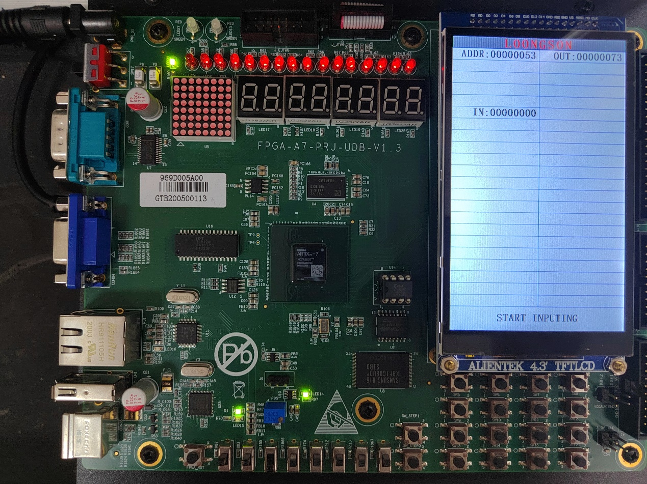
六、撰写实验报告
dream_v:
`timescale 1ns / 1ps

module dcram(
input clk,
input we,
input [7:0] addr,
input [31:0] datain,
output [31:0] dataout
);

reg [31:0] ram[0:127];
assign dataout = ram[addr];
always @(posedge clk) begin
if(we) ram[addr] <= datain;
end

integer i;
initial begin
for (i = 0; i < 128; i = i+1)
ram[i] = 0;
ram[8'h50] = 32'h70;
ram[8'h51] = 32'h71;
ram[8'h52] = 32'h72;
ram[8'h53] = 32'h73;
ram[8'h54] = 32'h74;
ram[8'h55] = 32'h75;
end
endmodule

display:
`timescale 1ns / 1ps

module dcram_display(
//时钟与复位信号
input clk,
input resetn, //后缀"n"代表低电平有效

//拨码开关，用于选择输入数和产生cin
input we_sel, //0:读;1:写
input input_sel, //0:addr;1:datain

//led灯，用于显示cout
output led_cout,

//触摸屏相关接口，不需要更改
output lcd_rst,
output lcd_cs,
output lcd_rs,
output lcd_wr,
output lcd_rd,
inout[15:0] lcd_data_io,
output lcd_bl_ctr,
inout ct_int,
inout ct_sda,
output ct_scl,
output ct_rstn
);

//-----{调用模块}begin
wire we;
reg [7:0] addr;
reg [31:0] datain;
wire [31:0] dataout;
dcram dcram_module (.clk(clk), .we(we), .addr(addr), .datain(datain), .dataout(dataout));
assign we = we_sel;

//-----{调用模块}end\

//---------------------{调用触摸屏模块}begin--------------------//
//-----{实例化触摸屏}begin
//此小节不需要更改
reg display_valid;
reg [39:0] display_name;
reg [31:0] display_value;
wire [5 :0] display_number;
wire input_valid;
wire [31:0] input_value;

lcd_module lcd_module(
.clk (clk ), //10Mhz
.resetn (resetn ),

//调用触摸屏的接口
.display_valid (display_valid ),
.display_name (display_name ),
.display_value (display_value ),
.display_number (display_number),
.input_valid (input_valid ),
.input_value (input_value ),

//lcd触摸屏相关接口，不需要更改
.lcd_rst (lcd_rst ),
.lcd_cs (lcd_cs ),
.lcd_rs (lcd_rs ),
.lcd_wr (lcd_wr ),
.lcd_rd (lcd_rd ),
.lcd_data_io (lcd_data_io ),
.lcd_bl_ctr (lcd_bl_ctr ),
.ct_int (ct_int ),
.ct_sda (ct_sda ),
.ct_scl (ct_scl ),
.ct_rstn (ct_rstn )
);
//-----{实例化触摸屏}end

//-----{从触摸屏获取输入}begin
//根据实际需要输入的数修改此小节，
//建议对每一个数的输入，编写单独一个always块

always @(posedge clk) begin
if (!resetn) begin
addr <= 8'd0;
end
else if (input_valid && !input_sel) begin
addr <= input_value;
end
end

always @(posedge clk) begin
if (!resetn) begin
datain <= 32'd0;
end
else if (input_valid && input_sel) begin
datain <= input_value;
end
end

//-----{从触摸屏获取输入}end

//-----{输出到触摸屏显示}begin
//根据需要显示的数修改此小节，
//触摸屏上共有44块显示区域，可显示44组32位数据
//44块显示区域从1开始编号，编号为1~44，
always @(posedge clk)
begin
case(display_number)
6'd1 :
begin
display_valid <= 1'b1;
display_name <= "ADDR";
display_value <= addr;
end
6'd11 :
begin
display_valid <= 1'b1;
display_name <= "IN";
display_value <= datain;
end
6'd2 :
begin
display_valid <= 1'b1;
display_name <= "OUT";
display_value <= dataout;
end
default :
begin
display_valid <= 1'b0;
display_name <= 40'd0;
display_value <= 32'd0;
end
endcase
end
//-----{输出到触摸屏显示}end
//----------------------{调用触摸屏模块}end---------------------//
Endmodule

register：
set_property IOSTANDARD LVCMOS33 [get_ports {lcd_data_io[13]}]
set_property IOSTANDARD LVCMOS33 [get_ports {lcd_data_io[12]}]
set_property IOSTANDARD LVCMOS33 [get_ports {lcd_data_io[11]}]
set_property IOSTANDARD LVCMOS33 [get_ports {lcd_data_io[10]}]
set_property IOSTANDARD LVCMOS33 [get_ports {lcd_data_io[9]}]
set_property IOSTANDARD LVCMOS33 [get_ports {lcd_data_io[8]}]
set_property IOSTANDARD LVCMOS33 [get_ports {lcd_data_io[7]}]
set_property IOSTANDARD LVCMOS33 [get_ports {lcd_data_io[6]}]
set_property IOSTANDARD LVCMOS33 [get_ports {lcd_data_io[5]}]
set_property IOSTANDARD LVCMOS33 [get_ports {lcd_data_io[4]}]
set_property IOSTANDARD LVCMOS33 [get_ports {lcd_data_io[3]}]
set_property IOSTANDARD LVCMOS33 [get_ports {lcd_data_io[2]}]
set_property IOSTANDARD LVCMOS33 [get_ports {lcd_data_io[1]}]
set_property IOSTANDARD LVCMOS33 [get_ports {lcd_data_io[0]}]
set_property IOSTANDARD LVCMOS33 [get_ports {lcd_data_io[15]}]
set_property IOSTANDARD LVCMOS33 [get_ports {lcd_data_io[14]}]
set_property IOSTANDARD LVCMOS33 [get_ports ct_int]
set_property IOSTANDARD LVCMOS33 [get_ports ct_rstn]
set_property IOSTANDARD LVCMOS33 [get_ports ct_scl]
set_property IOSTANDARD LVCMOS33 [get_ports ct_sda]
set_property IOSTANDARD LVCMOS33 [get_ports input_sel]
set_property IOSTANDARD LVCMOS33 [get_ports lcd_bl_ctr]
set_property IOSTANDARD LVCMOS33 [get_ports lcd_cs]
set_property IOSTANDARD LVCMOS33 [get_ports lcd_rd]
set_property IOSTANDARD LVCMOS33 [get_ports lcd_rst]
set_property IOSTANDARD LVCMOS33 [get_ports lcd_rs]
set_property IOSTANDARD LVCMOS33 [get_ports lcd_wr]
set_property IOSTANDARD LVCMOS33 [get_ports led_cout]
set_property IOSTANDARD LVCMOS33 [get_ports resetn]
set_property IOSTANDARD LVCMOS33 [get_ports we_sel]
set_property IOSTANDARD LVCMOS33 [get_ports clk]
set_property PACKAGE_PIN AD24 [get_ports input_sel]
set_property PACKAGE_PIN J25 [get_ports lcd_rst]
set_property PACKAGE_PIN H18 [get_ports lcd_cs]
set_property PACKAGE_PIN K16 [get_ports lcd_rs]
set_property PACKAGE_PIN L8 [get_ports lcd_wr]
set_property PACKAGE_PIN K8 [get_ports lcd_rd]
set_property PACKAGE_PIN J15 [get_ports lcd_bl_ctr]
set_property PACKAGE_PIN L19 [get_ports ct_int]
set_property PACKAGE_PIN G24 [get_ports ct_rstn]
set_property PACKAGE_PIN H21 [get_ports ct_scl]
set_property PACKAGE_PIN J24 [get_ports ct_sda]
set_property PACKAGE_PIN H9 [get_ports {lcd_data_io[0]}]
set_property PACKAGE_PIN K17 [get_ports {lcd_data_io[1]}]
set_property PACKAGE_PIN J20 [get_ports {lcd_data_io[2]}]
set_property PACKAGE_PIN M17 [get_ports {lcd_data_io[3]}]
set_property PACKAGE_PIN L17 [get_ports {lcd_data_io[4]}]
set_property PACKAGE_PIN L18 [get_ports {lcd_data_io[5]}]
set_property PACKAGE_PIN L15 [get_ports {lcd_data_io[6]}]
set_property PACKAGE_PIN M15 [get_ports {lcd_data_io[7]}]
set_property PACKAGE_PIN M16 [get_ports {lcd_data_io[8]}]
set_property PACKAGE_PIN L14 [get_ports {lcd_data_io[9]}]
set_property PACKAGE_PIN M14 [get_ports {lcd_data_io[10]}]
set_property PACKAGE_PIN F22 [get_ports {lcd_data_io[11]}]
set_property PACKAGE_PIN G22 [get_ports {lcd_data_io[12]}]
set_property PACKAGE_PIN G21 [get_ports {lcd_data_io[13]}]
set_property PACKAGE_PIN H24 [get_ports {lcd_data_io[14]}]
set_property PACKAGE_PIN J16 [get_ports {lcd_data_io[15]}]
set_property PACKAGE_PIN Y3 [get_ports resetn]
set_property PACKAGE_PIN AC19 [get_ports clk]
set_property PACKAGE_PIN H7 [get_ports led_cout]
set_property PACKAGE_PIN AC21 [get_ports we_sel]

