MD

Jay

2023-07-29

## R Markdown

This is an R Markdown document. Markdown is a simple formatting syntax for authoring HTML, PDF, and MS Word documents. For more details on using R Markdown see <http://rmarkdown.rstudio.com>.

When you click the **Knit** button a document will be generated that includes both content as well as the output of any embedded R code chunks within the document. You can embed an R code chunk like this:

summary(cars)

## speed dist   
## Min. : 4.0 Min. : 2.00   
## 1st Qu.:12.0 1st Qu.: 26.00   
## Median :15.0 Median : 36.00   
## Mean :15.4 Mean : 42.98   
## 3rd Qu.:19.0 3rd Qu.: 56.00   
## Max. :25.0 Max. :120.00

## Including Plots

You can also embed plots, for example:



Note that the echo = FALSE parameter was added to the code chunk to prevent printing of the R code that generated the plot.

library(ggplot2)

| Predicted/True | False | True |
| --- | --- | --- |
|  |  |  |
|  |  |  |
|  |  |  |

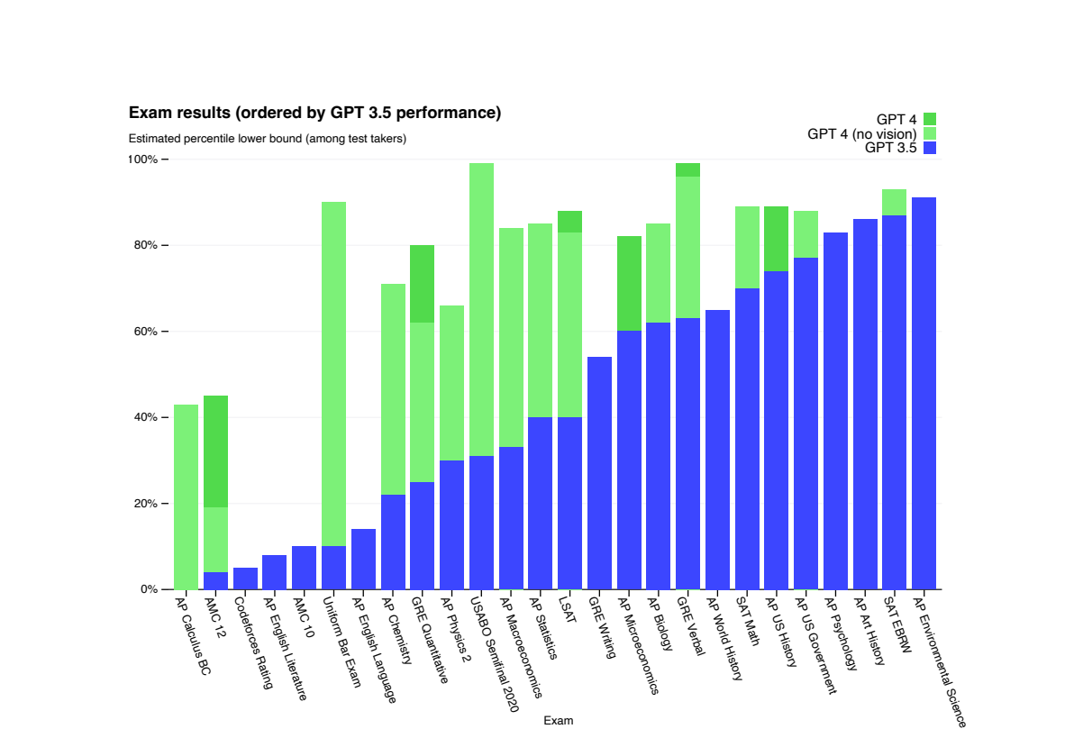

Gpt4

(Stenger 2022)

Matter

Matter is anything that has weight and can occupy space

[Github](https://github.com/dtech010/Test)

💏😍😍

<#Python is very great for ML>.

import math  
import random  
t=random.gauss(10)

Stenger, Pierre-Louis. 2022. “Anaconda: Targeted Differential and Global Enrichment Analysis of Taxonomic Rank by Shared Asvs.” <https://CRAN.R-project.org/package=Anaconda>.