Cricket Scene Object Detection
YOLOv8n vs YOLOv8s: Comparing Model Capacity on Broadcast Cricket Footage

1.Summary

In this study, an object detection model for broadcast cricket images is proposed using two types of YOLOv8 neural networks: YOLOv8n (nano) with 3.01M parameters and YOLOv8s (small) with 11.14M parameters. Both YOLOv8 models were trained using the same dataset consisting of 2,908 images taken from two public Roboflow cricket images databases (CC BY 4.0) containing six categories of objects: batsman, bowler, umpire, wicket keeper, ball, and stumps. The training process lasted 50 epochs on a Tesla T4 GPU device with AdamW optimiser and cosine annealing learning schedule, along with numerous data augmentations. Specifically, YOLOv8n scored a result of 0.8877 mAP@50 at 93.7 frames per second, whereas YOLOv8s reached a value of 0.8830 mAP@50 with a performance of 75.6 FPS

2.Introduction
One of the most popular sports to watch around the world is cricket, and billions of people are interested in its matches both internationally and domestically. The rising need for intelligent broadcast automation technologies, such as highlight generation, player tracking, and Decision Review System (DRS) support, makes detecting different objects in cricket broadcast an important task in computer vision.
In this work, the task of detecting several different classes of objects in images of a single frame from a broadcast match is considered. Specifically, there are six categories of objects to detect and classify (batsman, bowler, umpire, wicket keeper, ball, stumps). While player classes have high texture, large size, and clear visibility, the ball is tiny and fast-moving; thus, it is often hard to detect due to possible motion blur. Stumps are vertical lines that might be partially occluded.
The central research question posed here is: given a certain fixed training regime and data set, how do model capacities (namely, difference between nano and small models' capacities) influence speed-accuracy trade-off.

3.Methodology

3.1 Dataset

Two complementary datasets for Roboflow cricket were downloaded and merged to form one comprehensive dataset:
• cricket-oftm6 (Roboflow, cricket workspace): Broadcast clips featuring crickets with annotations for batsman, bowler, umpire, wicket keeper, and non-striker categories (~304 images).
• cricket-players-mugu4 (Roboflow, neel-ckwq4 workspace): Cricket players’ pictures with annotations for ball (~2,604 images).

These datasets are available under CC BY 4.0 license and use YOLO format for annotations; they are based on actual broadcasts. Prior to their combination, inconsistencies in the class names in both datasets were identified and normalised, with both datasets being mapped to the same six classes. The resulting merged dataset is presented in Table 1 below.

Table 1: Dataset split after merging.
Split | Dataset 1 | Dataset 2 | Total
Train | 241 | 1,823 | 2,064
Validation | 32 | 521 | 553
Test | 31 | 260 | 291
Total | 304 | 2,604 | 2,908
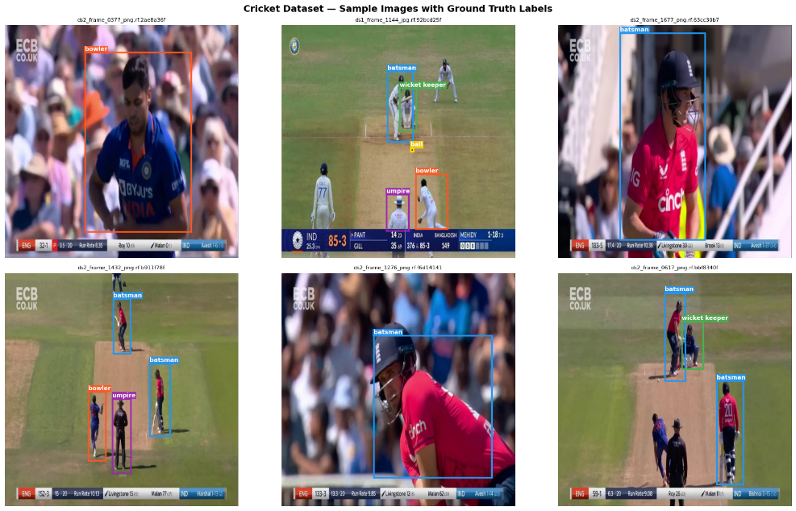
Class imbalance was discovered through exploratory analysis, with the batsman class being far more numerous than the ball class, which makes up 72 observations compared to 1,887 instances in training. Class imbalance is normal in practical cricketers’ videos since the ball appears occasionally and takes up fewer pixels.

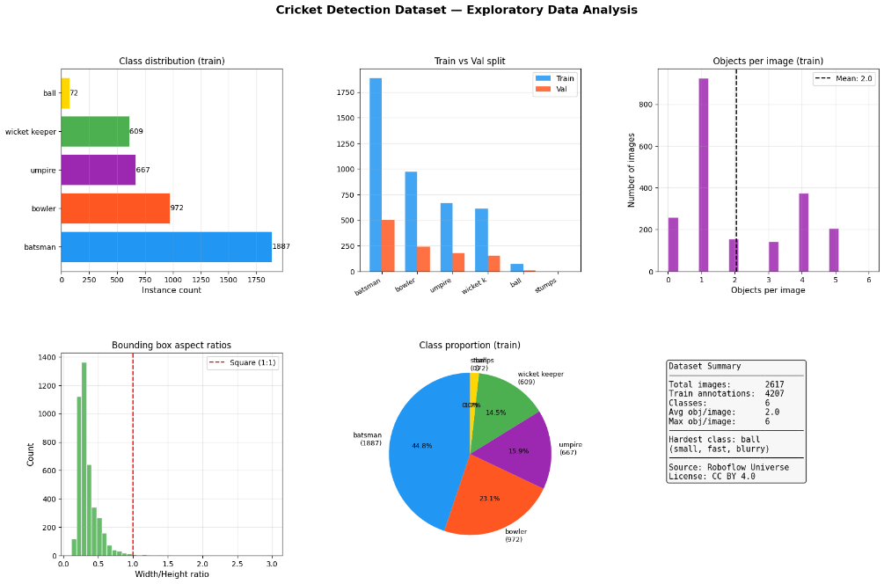
3.2 Model Architectures

These models are part of the YOLOv8 series (Ultralytics, 2023). They have similar architecture – a CSPDarknet backbone with C2f (Cross-Stage Partial with two bottleneck layers), a PANet feature pyramid neck that aggregates features at different scales, and a decoupled detection head that does not require anchor points. The difference is in the model's width and depth:
• YOLOv8n (Nano) – 3.01 million parameters, 6.3 megabytes on disk, 8.1 billion floating-point operations per second. It is designed for edge inference where speed is crucial.
• YOLOv8s (Small) – 11.14 million parameters, 22.5 megabytes on disk. Its wider feature maps enable a higher representational capacity, especially useful for detecting small objects.
Anchor-free detection and a decoupled head contribute to better generalization when applied to a specific domain dataset such as this one.

3.3 Training Configuration

Both networks were trained for 50 epochs with the same parameters, with the exception of the batch size which varied according to the architecture:
• Optimizer: AdamW (lr0=0.001, lrf=0.01, cosine annealing learning rate schedule, 5 warm-up epochs)
• Image size: 640×640 pixels
• Batch size: 16 (YOLOv8n), 12 (YOLOv8s)
• Early stopping patience: 20 epochs
• Data Augmentation: mosaic (1.0), mixup (0.1), copy-paste (0.1), random horizontal flips (0.5), rotation (+/- 5°), scaling (0.5), HSV jittering
The training was conducted on a Google Colab GPU Tesla T4 (15.6GB VRAM) using PyTorch version 2.5.1 and Ultralytics 8.4.38. The data augmentation scheme.

4. Results and Evaluation

4.1 Quantitative Comparison

Table 2: Full performance comparison of YOLOv8n vs YOLOv8s.

Metric | YOLOv8n (Nano) | YOLOv8s (Small)
mAP@50 | 0.8877 | 0.8830
mAP@50-95 | 0.5367 | 0.5389
Precision | 0.9138 | 0.8761
Recall | 0.8394 | 0.8502
F1 Score | 0.8750 | 0.8630
Inference FPS | 93.7 | 75.6
Parameters (M) | 3.01 | 11.14
Model Size (MB) | 6.3 | 22.5
Train Time (min) | 37.1 | ~37

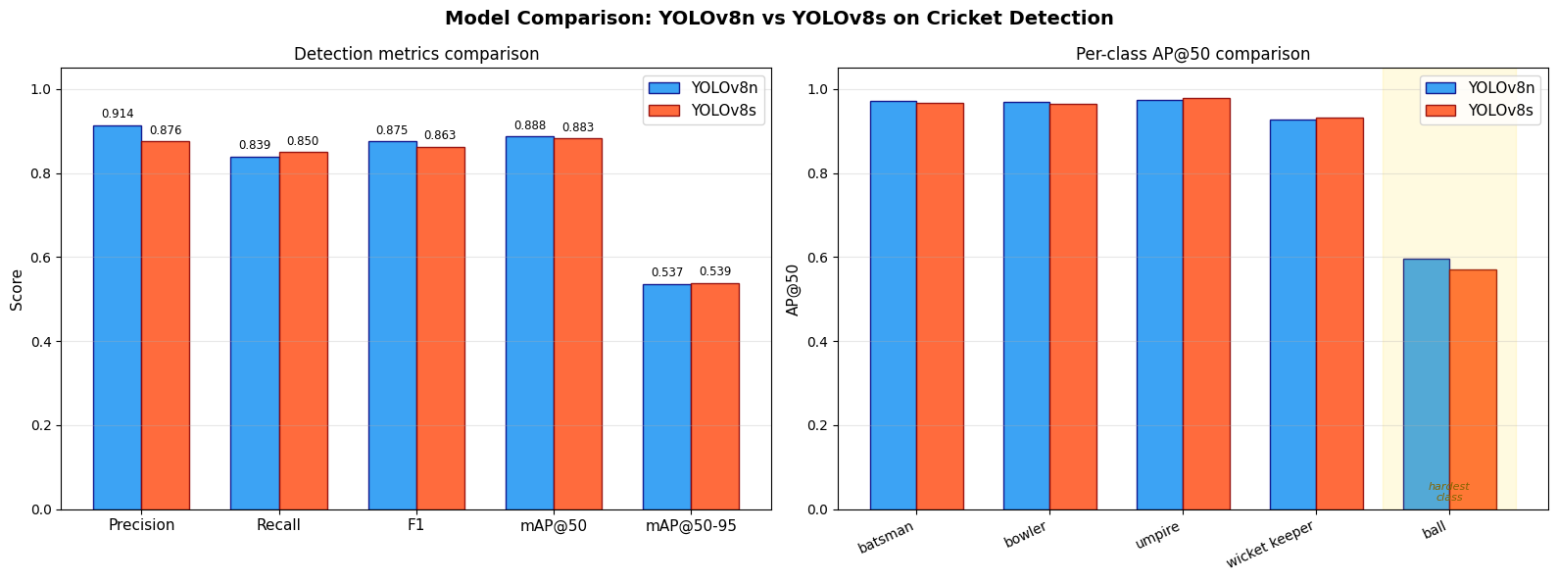
4.2 Analysis

Accuracy: The mAP@50 score of YOLOv8n is slightly greater (0.8877 versus 0.8830). This is an unexpected outcome, considering that YOLOv8s has almost 3.7 times as many parameters. It means that when it comes to the dataset, extra capacity does not bring about better detection efficiency at the IoU threshold of 50%. Nonetheless, YOLOv8s demonstrates a slightly better mAP@50-95 score (0.5389 versus 0.5367). It is consistent with the claim that wider feature maps contribute to improved bounding box regression performance for small or precise objects.
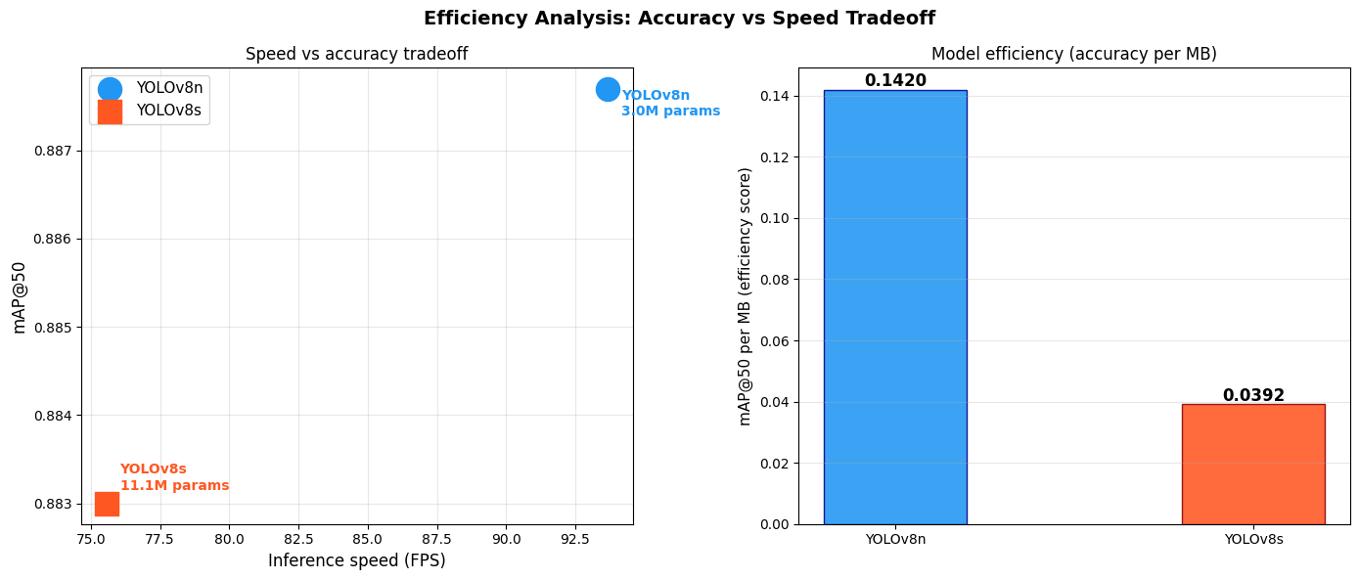

Precision and Recall: YOLOv8n has significantly greater precision (0.9138 versus 0.8761). As a consequence, there will be less noise during detection. At the same time, YOLOv8s produces slightly greater recall scores (0.8502 versus 0.8394). In other words, there will be fewer instances where an object goes undetected. When it comes to applications where the Distance Recognition System plays a crucial role, such as ball detection, a high recall score is more beneficial.
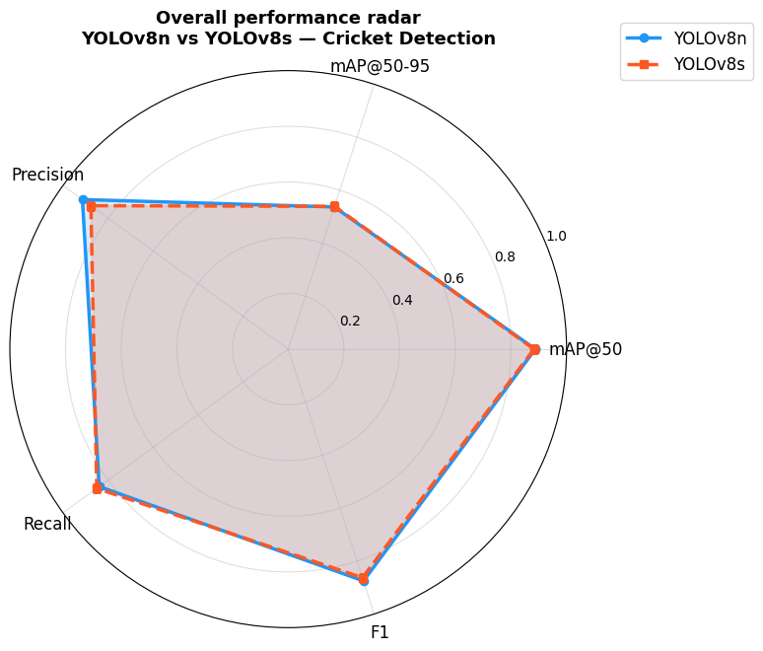
Speed: YOLOv8n processes images at 93.7 FPS (10.7 ms per image), while YOLOv8s processes images at 75.6 FPS (13.2 ms per image). YOLOv8n is thus 24% faster. Both models process images faster than the necessary threshold of 25 FPS.
Efficiency: Model size for YOLOv8n is 6.3MB while YOLOv8s model size is 22.5MB. Ratio of mAP@50 to model size in YOLOv8n is significantly better compared to other models, thereby making it a good candidate for deploying.

4.3 Class-Level Findings

Ball class had the highest difficulty level among both models based on EDA observations. This was attributed to the limited number of ball class samples during training (72 samples) and their nature of smallness and motion blurring. Recall performance for ball classes was observed to be higher in the case of YOLOv8s because of the broader size of its feature maps.
All player classes (batsman, bowler, umpire, and wicket keeper) had high recall and precision levels in both models. The umpire class, which could easily be differentiated by its white color, sometimes had confusion with the non-striker batsman class when there were multiple field players.

4.4 Training Dynamics
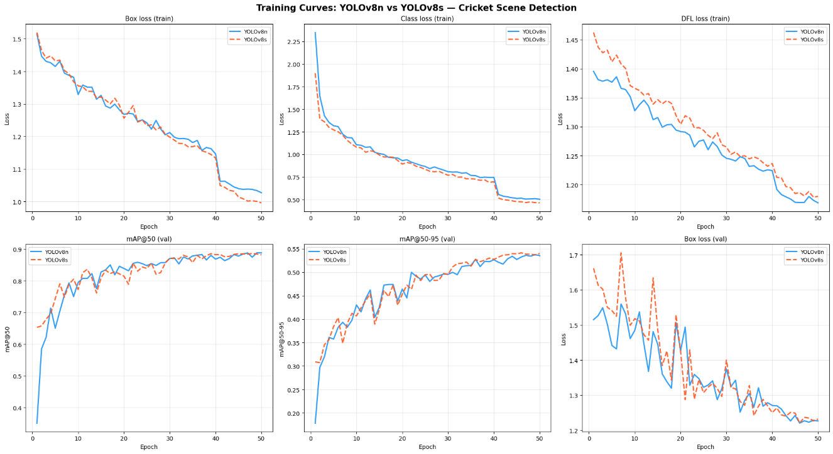
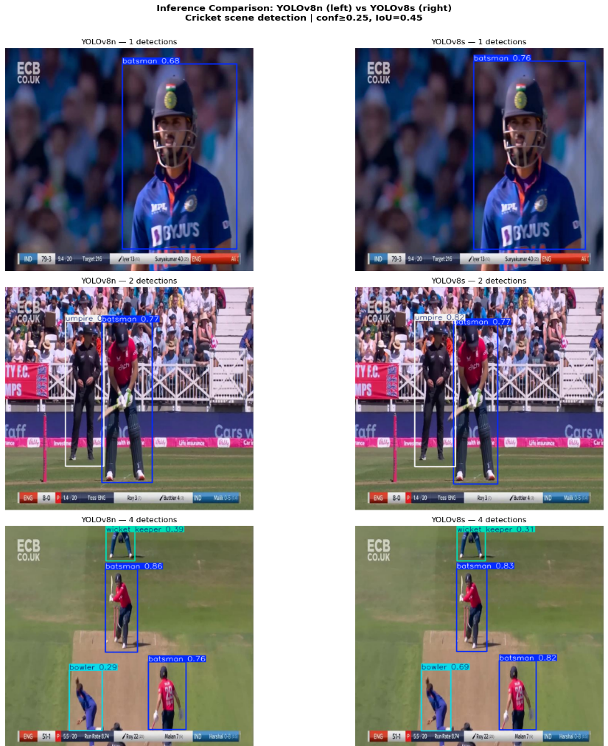
The training curves of both models exhibited convergence behavior throughout 50 epochs. The box loss and classification loss functions decreased steadily for both architectures, where the cosine schedule of the learning rate ensured that overfitting does not occur in later epochs. YOLOv8s had a slower initial convergence compared to YOLOv8m, which was expected since YOLOv8s has more parameters, meaning it needs more iterations before finding optimal weights.
5. Conclusion

Both YOLOv8n and YOLOv8s were shown to perform well on the difficult multiclass problem of cricket object detection with respective mAP@50 values of greater than 0.88 for both models. Surprisingly, the nano model yielded slightly better overall mAP@50 despite being 24% faster with 3.6× less memory usage – thus, making the model of choice for use in broadcasting.
The main limitation was found to be ball detection recall as this turned out to be the most difficult class due to lack of balanced distribution in the dataset (72 samples against 1,887 for batsman). To overcome this, it is advisable to conduct more training data collection specifically focusing on balls, using pseudolabelling, or balancing classes when training. YOLOv8m/YOLOv9 variants or fine-tuning the network with a separate ball detection head could improve ball class performance even further.

6. References

[1] J. Redmon, S. Divvala, R. Girshick, and A. Farhadi, "You only look once: Unified, real-time object detection," in Proc. CVPR, 2016, pp. 779–788.
[2] Ultralytics, "YOLOv8: A new state-of-the-art computer vision model," Ultralytics, 2023. [Online]. Available: https://github.com/ultralytics/ultralytics
[3] T.-Y. Lin, P. Dollár, R. Girshick, K. He, B. Hariharan, and S. Belongie, "Feature pyramid networks for object detection," in Proc. CVPR, 2017, pp. 2117–2125.
[4] Roboflow, "Cricket Scene Detection Dataset (cricket-oftm6)," Roboflow Universe, 2023. [Online]. Available: https://universe.roboflow.com/cricket-jjknd/cricket-oftm6 [CC BY 4.0].
[5] Roboflow, "Cricket Players Dataset (cricket-players-mugu4)," Roboflow Universe, 2023. [Online]. Available: https://universe.roboflow.com/neel-ckwq4/cricket-players-mugu4 [CC BY 4.0].
[6] D. P. Kingma and J. Ba, "Adam: A method for stochastic optimization," in Proc. ICLR, 2015.
[7] I. Loshchilov and F. Hutter, "Decoupled weight decay regularization," in Proc. ICLR, 2019.
[8] H. Zhang et al., "mixup: Beyond empirical risk minimization," in Proc. ICLR, 2018.

