CRMFLX Database Update to Incorporate Solar
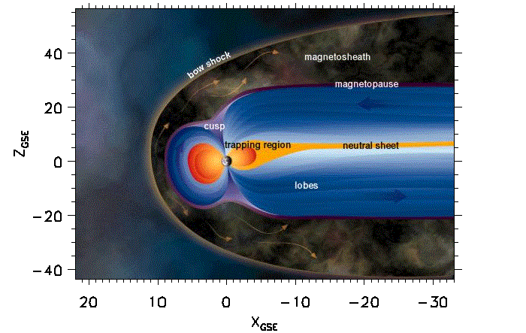
Proton Events – May 2003

Figure 1. Phenomenological Regions of Geospace

1.0 Introduction

The database co-released with CRMFLX v2.3 in November 2003 used only one correlate, the Kp magnetic activity index. A new database has recently been created which allows for a better representation of the solar proton flux penetration into the magnetosheath and magnetosphere phenomenological regions of geospace (Fig. 1). Special care must be taken to implement correctly the new database, because the proton flux environments calculated in the magnetosphere and magnetosheath must include the external solar-wind environment. This technical note describes how to implement correctly the recently created database for CRMFLX v2.3. Section 3.0 describes the model/database usage flag settings needed.

2.0 Brief History and Overview of the Chandra Radiation Model (CRMFLX)

CRMFLX is an empirical ion flux model of the magnetosphere using satellite observations of ion flux. Input to the model is location in space, date and time of year, and appropriate interplanetary environment conditions (e.g., interplanetary magnetic field, solar wind density and velocity) and geomagnetic index (Kp). The software returns values of the mean ion flux and percentile levels (e.g., the maximum flux value that would be predicted to occur 50% or 95% of the time).

The original version of CRMFLX used a technique of adopting only the physical location of 100 keV to 200 keV ions to fill an empirical model database [Blackwell et al., 2000] to estimate the low-energy radiation environment encountered by the Chandra X-Ray Observatory [O’Dell et al., 2000]. This first version of CRMFLX used a near-neighbor approach to estimate the flux at the spacecraft location for three different phenomenological regions: solar wind, magnetosheath, and magnetosphere. CRMFLX incorporates code from two separate space environment models to calculate magnetopause and bow-shock boundary locations. The magnetopause model is taken from the Tsyganenko geomagnetic-field model [Tsyganenko, 1995]. The bow-shock model used is one adapted from a model by Bennett et. al. [Bennett, 1997]. The original version of CRMFLX provided ion flux values as a function of Kp but was limited both in its range of spatial application (-8 Re < Z_{GSM} < +15 Re) and particle energy (100 keV to 200 keV protons) to meet specific requirements of the Chandra Program.

A more advanced version of the CRMFLX software (version 2.3) was released in November 2002, which implements a streamline/fieldline mapping algorithm that propagates flux from an observation location to other regions of the magnetosphere based on convective ExB and ∇B-curvature particle drift motions in electric and magnetic fields. This technique allows for the database to be more completely filled and to make maximum use of limited data obtained during high Kp periods or in areas of the magnetosphere with poor satellite coverage.

The CRMFLX versions 1 and 2 share a great deal of overall structure. However, significant changes were made to version 2 to optimize the run time in the magnetosphere region. This was necessary due to the large increase in the magnetosphere database created by the streamline/fieldline mapping of data. No streamline/fieldline mapping of data has been implemented in the magnetosheath, so that region retains the original near-neighbor approach.

The proton flux database distributed with CRMFLX v2.3 for the solar wind, magnetosheath, and magnetosphere phenomenological regions is correlated with the Kp magnetic activity index. The Kp index provides a way to correlate CRMFLX output with the proton flux measured in the magnetosphere during geomagnetic substorms, and is also a useful correlate for the ion flux leakage from the magnetosphere into the magnetosheath. However, there is another source of proton flux that is not well correlated with Kp in these regions, the flux due to the penetration of solar event protons.

Studies show that the proton flux measured by the Polar and Geotail spacecraft in the magnetosphere and magnetosheath regions is strongly correlated with the 0.14 MeV solar-proton flux measured by the ACE spacecraft at the Sun-Earth L1 point (1.5 million km sunward). As a result of these studies, new databases for the magnetosphere and magnetosheath regions were created which keep the Kp correlation used previously, but only use the Geotail and Polar measurements during periods when the solar proton flux measured by ACE is low. These new databases allow the user to include the effects of solar proton events. There were no code changes associated with this database change so CRMFLX v2.3 is still used. Figure 2 shows example output from CRMFLX.

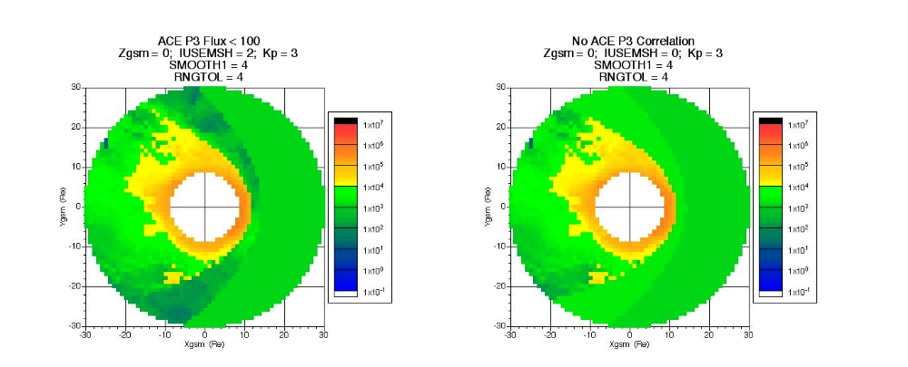

Figure 2. 2-D ion flux map of CRMFLX output using the ACE-solar proton-correlated-magnetosheath database (left) and the uniform flux analytic model, not correlated with ACE solar proton flux levels (right).

3.0 Model/Database Selections

The user must decide whether to use the Kp-correlated database distributed with CRMFLX v2.3 or to use the Kp + ACE-correlated database. See Appendix A for the complete list of available options.

3.1 Kp-Correlated (No ACE) Model/Database Selections

The database distributed with CRMFLX v2.3 used only the Kp magnetic activity index as a correlate for prediction of the proton flux. No correlation with solar event protons (SEPs) was included. Since there was no attempt to treat the SEPs separately, they were included in the Kp-correlations, producing additional scatter (noise) in the calculations.

3.1.1 Solar Wind Selections

If the Kp correlation only case is selected to calculate the proton flux in the solar wind region (without ACE correlation), the user can choose either to run the database driven model (IUSESW=2 or 3), or may choose to use the faster analytic model (IUSESW=0 or 4). The analytic model treats the solar wind as a region of uniform proton flux, while the database driven model uses a near-neighbor algorithm.

There is an option (IUSESW=1) which allows the proton flux calculations by CRMFLX to be replaced by a user supplied uniform solar flux value.

3.1.2 Magnetosheath Selections

If the Kp correlation only case is selected to calculate the proton flux in the magnetosheath region (without ACE correlation), the user can choose either to run the database driven model (IUSEMSH=2 or 3), or may choose to use the faster analytic model (IUSEMSH=0 or 4). The analytic model treats the magnetosheath as a region of uniform proton flux, while the database driven model uses a near-neighbor algorithm.

There is an option (IUSEMSH =1), which allows the proton flux calculations by CRMFLX in the magnetosheath to be replaced by scaling the user supplied uniform solar flux value by a factor of two.

3.1.3 Magnetosphere Selections

If the Kp correlation only case is selected to calculate the proton flux in the magnetosphere region (without ACE correlation), the user can choose to run only the database driven model (IUSEMSP=0). The user also has the option to add the scaled value of the user supplied solar wind flux value to the calculated magnetosphere value (IUSEMSP=1), or add the analytic solar wind model’s scaled flux (IUSEMSP=2).

3.2 Kp+ACE-Correlated Model/Database Selections

As described in Section 2.0, new databases for the magnetosphere and magnetosheath regions have been created that allow for the more accurate handling of solar proton events. CRMFLX v2.3 can still be used to exercise these databases, since no code changes were involved. However, because it is necessary for the solar event proton flux to be added to the CRMFLX model predictions, the options available to the user are limited.

3.2.1 Solar Wind Selections

There is no CRMFLX database for the solar wind region when the Kp+ACE correlation case is selected. The user must supply the appropriate solar proton flux value (IUSESW=1).

3.2.2 Magnetosheath Selections

If the Kp+ACE correlation case is selected to calculate the proton flux in the magnetosheath region, the user must choose to run the option where the sum of the magnetosheath database driven model is added to the appropriately scaled user supplied solar wind flux value (IUSEMSH=3).

3.2.3 Magnetosphere Selections

If the Kp+ACE correlation case is selected to calculate the proton flux in the magnetosphere region, the user must choose to run the option where the sum of the magnetosphere database driven model is added to one half the user supplied solar wind flux value (IUSEMSP=1).

4.0 References

Bennett, L., M. G. Kivelson, K.K. Khurana, L. A. Frank, and W. R. Patterson, A model of the Earth’s distant bow shock, J.Geophys.Res., 102, 26927, 1997.
Blackwell, W.C., J. I. Minow, S.L. O'Dell, R.M. Suggs, D.A. Swartz, A.F. Tennant, S.N. Virani, & K.M. Warren, “Modeling the Chandra space environment”, in X-Ray and Gamma-Ray Instrumentation for Astronomy XI, Proc. SPIE, 4140, pp. 111 – 122, 2000a.
O'Dell, S.L., M.W. Bautz, W.C. Blackwell, Y.M. Butt, R.A. Cameron, R.F. Elsner, M.S. Gussenhoven, J.J. Kolodziejczak, J.I. Minow, D.A. Swartz, A.F. Tennant, S.N. Virani, K. Warren, “Radiation environment of the Chandra X-ray Observatory”, in X-Ray and Gamma-Ray Instrumentation for Astronomy, Proc. SPIE, 4140, pp. 99-110, 2000.
Tsyganenko, N.A. Modeling the Earth's magnetospheric magnetic field confined within a realistic magnetopause, J. Geophys.Res., 100, 5599, 1995.

Appendix: Model/Database Usage Control Variables

C IUSESW - flag for control of solar wind flux calculation:
C IUSESW = 0 if (uniform flux) analytic solar wind model used.
C IUSESW = 1 if user supplied uniform solar wind flux value used.
C IUSESW = 2 if solar wind database used.
C IUSESW = 3 if sum of solar wind database value and user
C supplied uniform solar wind flux value used.
C IUSESW = 4 if sum of (uniform flux) analytic solar wind model
C and user supplied uniform solar wind flux value used.
C
C FSWIMN - user supplied mean uniform solar wind flux for the
C selected species (#/[cm^2-sec-sr-MeV]).
C
C FSWI95 - user supplied 95% level uniform solar wind flux for
C the selected species (#/[cm^2-sec-sr-MeV]).
C
C FSWI50 - user supplied 50% level uniform solar wind flux for
C the selected species (#/[cm^2-sec-sr-MeV]).
C
C FSWISD - user supplied std. dev. of uniform solar wind flux
C for the selected species (#/[cm^2-sec-sr-MeV]).
C
C IUSEMSH - flag for control of magnetosheath flux calculation:
C IUSEMSH = 0 if (uniform flux) analytic magnetosheath model used.
C IUSEMSH = 1 if user supplied uniform solar wind flux value used.
C IUSEMSH = 2 if magnetosheath database used.
C IUSEMSH = 3 if sum of magnetosheath database value and user
C supplied uniform solar wind flux value used.
C IUSEMSH = 4 if sum of (uniform flux) analytic magnetosheath model
C and user supplied uniform solar wind flux value used.
C
C IUSEMSP - flag for control of magnetosphere flux calculation:
C IUSEMSP = 0 if only the magnetosphere model flux is used.
C IUSEMSP = 1 if user supplied uniform solar wind flux value
C is added to the magnetosphere flux.
C IUSEMSP = 2 if analytic solar wind model (uniform flux) is
C added to the magnetosphere flux.

