

Internet of Things – Smart Home

Using ethernet

Phạm Minh Quang - Vũ Minh Tú Anh | Computer Networks | 2019

# DEVICES & OPERATIONS

1. Devices

* 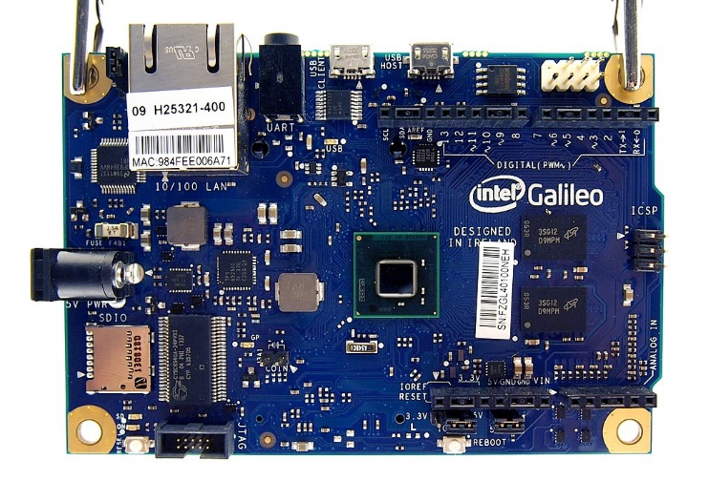Intel Galileo Gen 1
* Gas Sensor

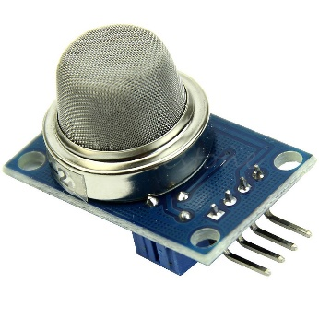

* Soil Moisture Sensor

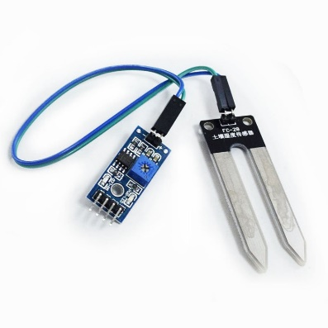

* Air Humidity and Temperature Sensor

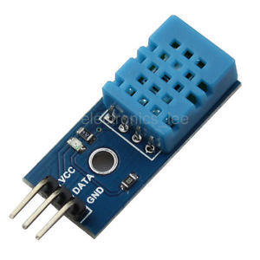

* 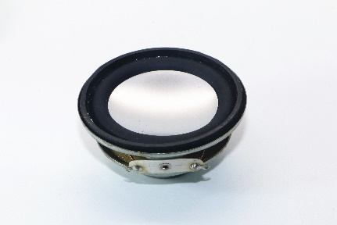Mini Speaker 3W
* 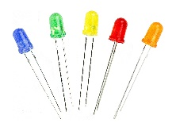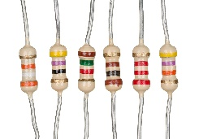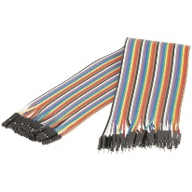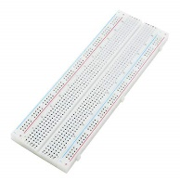Other devices: Breadboard, USB Cable, Wires, Resistors, Capacity, and LEDs

1. Operations

* 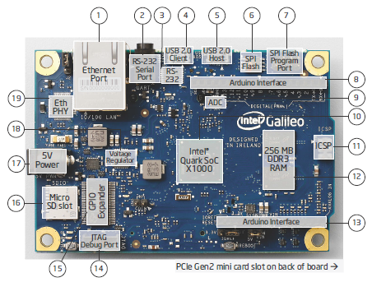**Intel Galileo**
* Electrical Summary:

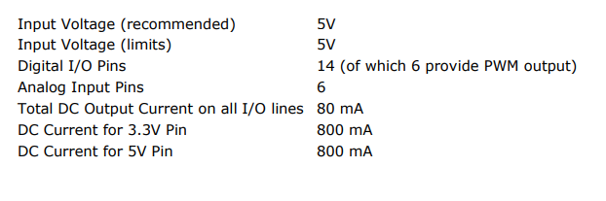

* For further information: <https://www.intel.com/content/dam/support/us/en/documents/galileo/sb/galileo_datasheet_329681_003.pdf>
* **MQ2 Gas Sensor**:
* 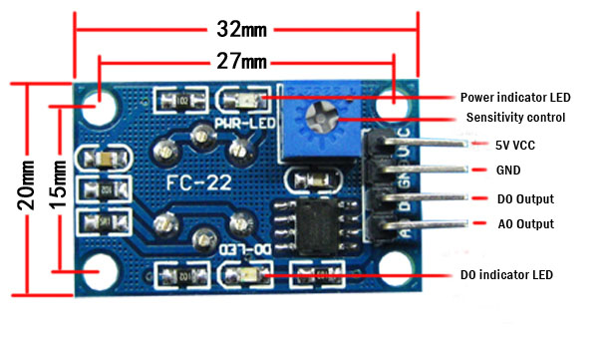 Configuration:

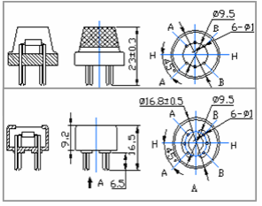

* Technical Data

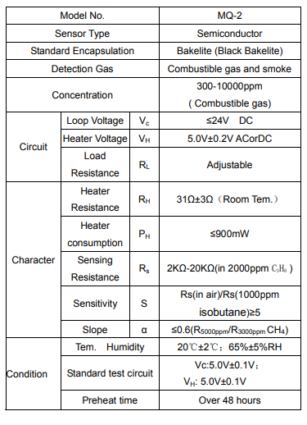

* For futher information: <https://www.pololu.com/file/0J309/MQ2.pdf>
* 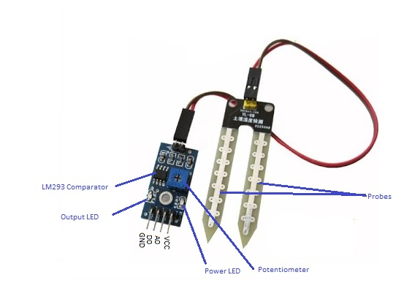**Soil Moisture Sensor (built around the LM393 comparator)**
* Specifications:

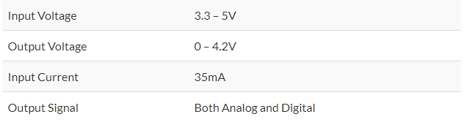

* For further information: [http://www.circuitstoday.com/arduino-soil-moisture-sensor](%20http:/www.circuitstoday.com/arduino-soil-moisture-sensor)
* 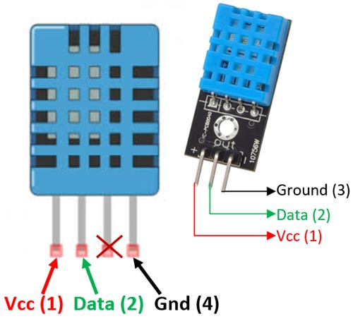**Temperature and Humidity Sensor DHT-11**
* 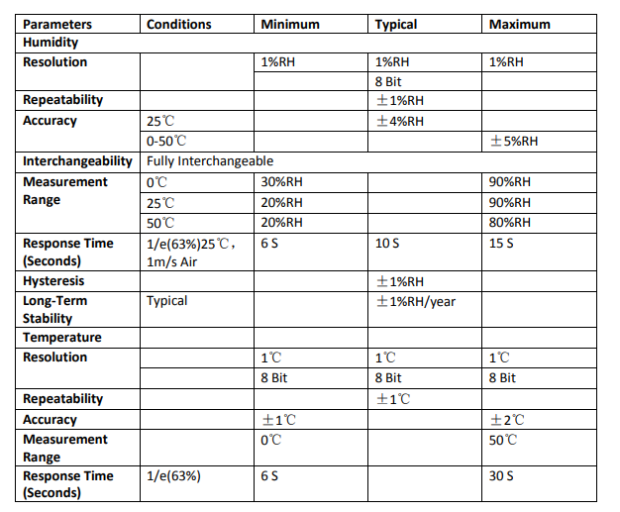Specifications:
* For further information: <https://www.mouser.com/ds/2/758/DHT11-Technical-Data-Sheet-Translated-Version-1143054.pdf>

## Schematic

You might like the photo on the cover page as much as we do, but if it’s not ideal for your report, it’s easy to replace it with your own.

Just delete the placeholder picture. Then, on the Insert tab, click Picture to select one from your files.