Individual Face Recognition of Mountain Gorillas
A Short Continuation of the Orangutan Report
Version 1, Virunga
Research internship report
CNRS IPHC Strasbourg
Author: Titouane
Supervisor: Cedric Sueur
July 2026

1. Introduction
This is a short companion to the orangutan report. Having built a working facial recognition pipeline for orangutans, the same method was carried over to a second and harder species, the mountain gorilla (Gorilla beringei beringei) of the Virunga massif. This document explains how the gorilla model was built, what changed for this species, and how good the first version is. It leans on the orangutan report for the shared background and stays deliberately short.

2. The Same Design, a New Species
The system keeps the two part design of the orangutan work. A detector finds gorilla faces in a photograph, and an identifier turns each face into a fingerprint that is compared to a gallery of known animals. The network stays frozen once deployed, and animals are added by editing the gallery, so a new individual takes a handful of photographs and no retraining.
What carried over directly was the identification recipe: the MegaDescriptor backbone, the angular margin objective, the invariance training against degraded images, and the exemplar gallery. What had to change was everything specific to gorillas, a new face detector trained for gorilla faces, a new field dataset, and augmentations tuned for the forest.

3. The Data
The gallery covers 66 individuals from the Virunga population, photographed in the field. A gorilla name carries an age and sex code as a prefix, such as SB for silverback, ADF for adult female, JUV for juvenile or BB for baby. This code is used during training to give the fastest changing animals, the juveniles and babies, more than one anchor direction, because their appearance shifts quickly.
From 71 individuals in the raw set, two with too few crops were excluded and three were held out as pretend strangers to calibrate the rejection threshold, leaving 66 for training. The detector produced 2,809 face crops, split into 2,023 for training and 358 for validation, plus 428 background crops that stand for any gorilla not in the gallery. The dataset is strongly unbalanced, from about nine crops for the rarest animal to well over a hundred for the best photographed one (Figure 1).
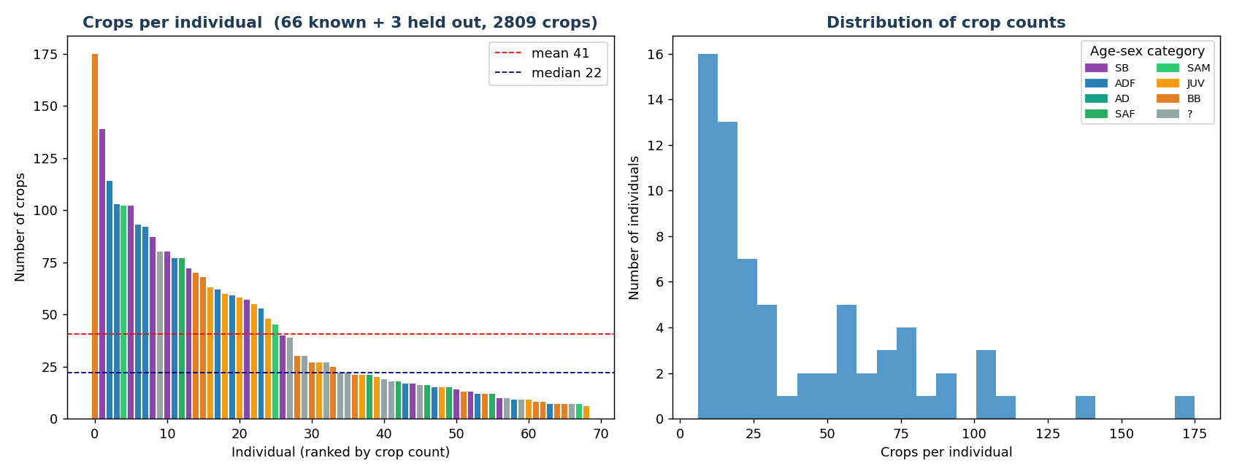
Figure 1. Crops per individual in the V1 dataset, coloured by age and sex category. The set is small and strongly unbalanced.

4. Training the Model
The identifier is the small MegaDescriptor-T-224 backbone, a Swin Transformer that outputs a 768 number fingerprint, pretrained by others on many animal species. Training combines three objectives. The angular margin objective, Sub-center ArcFace, forces wide separation between individuals. An invariance objective passes each image twice, once clean and once degraded, and requires the two fingerprints to match, so the model learns to ignore field damage. A supervised contrastive objective sharpens the separation inside each batch.
Training follows a four phase curriculum: a short warmup with the backbone frozen, then three phases that unfreeze the network and raise the amount of simulated degradation stage by stage, from none to full. The augmentations are tuned for the forest, low resolution to imitate a distant animal, JPEG compression for phone photos, dark horizontal or vertical bands for foliage filtered light, and colour temperature shifts. There is no upside down flip, since gorillas are always upright. The best model appeared at epoch 42, after about 66 minutes on a modest laptop graphics card. Figure 2 shows the losses falling, the clean and degraded accuracy rising together, and the separability between animals growing across the phases.
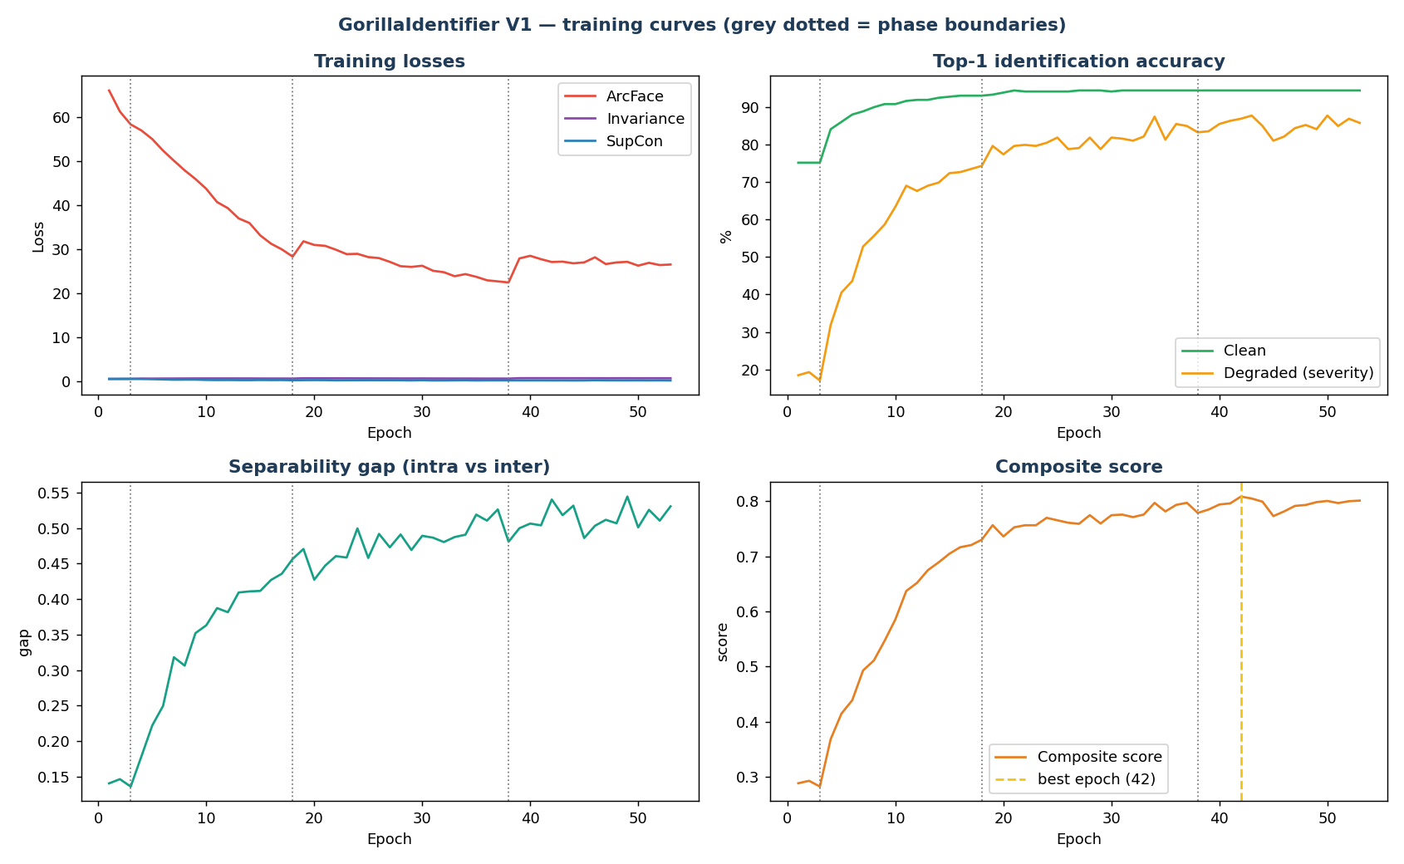
Figure 2. Training curves. Clean and degraded accuracy rise together while the separability gap grows, and the composite score peaks at epoch 42.

5. Results
On the held out validation set the first version identifies the correct gorilla at the top of the list 93.0 percent of the time, and within its top three guesses 96.1 percent of the time, with a mean F1 of 0.981. The average similarity of a face to its own individual is 0.74, against 0.33 for a different individual, a clean gap that lets the system reject a stranger below a threshold of 0.4689. Recognition is even across the age and sex categories, including the juveniles and babies that change the most (Figure 3). For a first version on 66 animals this is a strong result, and the top three number is the practical one in the field, where a ranger checks the first few suggestions.
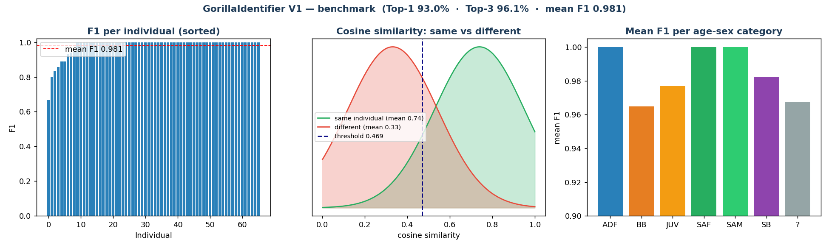
Figure 3. Benchmark on the validation set. F1 is high and even across individuals, the same and different similarity distributions are well separated, and every age-sex category scores above 0.96.

6. Limitations
Three limits should be stated plainly. First, these numbers are measured on the validation set, which also served to calibrate the threshold, so they are a little optimistic. A strictly separate test set would give the fully defensible figure. Second, if crops from the same photo session were split between training and validation, the accuracy is inflated, so the split should be checked to be by session rather than by individual crop. Third, the dataset is small and unbalanced, and the rejection of unknown animals was calibrated on only three held out individuals and the background crops, so the open set behaviour is not yet strongly tested. None of these blocks a first field deployment, but all three point to the next steps.

7. Deployment
The trained network, the gorilla detector and the 66 animal gallery are packaged into an Android application that runs fully offline, from the same family as the orangutan tool. A ranger photographs an animal, the detector finds the face, and the fingerprint is matched against the gallery, returning a name and a confidence, or the answer unknown. New animals are added on the phone from a few photographs, and the gallery can be exported and shared. The recognition backbone is converted to the mobile TFLite format through a small Linux step, as in the orangutan project.

8. Conclusion and Next Steps
The orangutan method transferred cleanly to a second and harder species, and the first gorilla model already identifies 66 individuals with 93 percent top one accuracy, fully offline. The next steps are the ones the limitations point to, a strictly separate test set for publishable figures, a check that the train and validation split is by session, more photographs for the least represented animals, and a wider test of unknown rejection. The same pipeline would extend to other populations or species by retraining only the detector and refilling the gallery.

Appendix A. Key Numbers
Metric | Value
Individuals | 66 recognised, plus 3 held out and 2 excluded (71 raw)
Face crops | 2,809 (2,023 train / 358 validation) + 428 background
Top-1 accuracy | 93.0%
Top-3 accuracy | 96.1%
Mean F1 | 0.981
Separability gap | 0.4351
Rejection threshold | 0.4689 (calibrated on validation)
Backbone | MegaDescriptor-T-224 (Swin Transformer Tiny, 768-dim)
Best epoch / time | 42 / about 66 minutes on an RTX 3050 4 GB

Appendix B. Main Training Settings
Setting | Value
Loss | Sub-center ArcFace (scale 64, margin 0.50) + invariance + supervised contrastive (temperature 0.07)
Sub-centers | 1 per adult individual, 2 per juvenile or baby
Curriculum | 4 phases, degradation severity 0 -> 0.4 -> 0.7 -> 1.0
Augmentations | low resolution, JPEG, forest shadow bands, colour temperature, standard set (no vertical flip)
Input normalisation | mean = std = 0.5
Learning rate | backbone 1e-5, head 5e-4
Gallery | exemplar gallery, up to 25 exemplars per individual, max cosine scoring

