Automatic Face Recognition of Orangutans
From a Closed Classifier to a Field Ready Mobile System
Versions 1 to 6
Research internship report
CNRS IPHC Strasbourg
Zoo d'Amneville and BOS Foundation
Author: Titouane
Supervisor: Cedric Sueur
July 2026

Contents
1. Introduction 3
2. Objectives and Overall Design 3
3. The Data 4
4. Building the Face Detector 5
5. How the Models Are Trained 7
6. Version 1: A Closed Classifier 8
7. Version 2: An Embedding Gallery for Open Set 9
8. Version 3: A Specialised Model with Angular Margin 10
9. The Field Robustness Problem 12
10. Version 4: Forty Individuals and Field Augmentations 12
11. Version 5: Invariance and Curriculum 12
12. Version 6: The Production Model 13
13. Cross-Version Benchmark 14
14. Why Version 6 and Not Version 5 17
15. The Android Application 19
16. Adding a New Individual 20
17. Lessons Learned 20
18. Discussion and Limitations 20
19. Conclusion and Next Steps 21
Appendix A. Version Summary 21
Appendix B. Main Training Settings 22

1. Introduction
Rangers of the BOS Foundation in Borneo identify orangutans by eye during their daily patrols. With several dozen animals spread over several rehabilitation sites, this manual work is slow, it depends on the memory of a few experienced people, and it is open to error. A tool that recognises an individual from a single photograph would save time, would help new staff, and would make behavioural studies easier for the laboratory.
The goal of this internship was to build such a tool. It had to work from an ordinary photograph, it had to run on an Android phone with no internet connection, and it had to know when an animal is not in its database rather than always guessing a name. These three requirements, identify, run offline, and refuse the unknown, shaped every decision in the project.
The work was carried out over six versions. Each version fixed a clear weakness of the previous one. This report follows that path from start to finish. It explains what each version does, why it was built, how it was trained, what problems appeared, and how good the result was. It then compares the versions with one fair benchmark, describes the phone application, and lists the lessons that came out of the project.
Relation to earlier work. This project reuses the general idea of an earlier animal identification project carried out in the same laboratory, which already paired a detector with a classifier. The present work keeps that two part idea and adds a systematic hand review of the training images, stronger methods against over fitting, a saved backbone that lets new animals be added without a full retraining, and a study of robustness in field conditions.

2. Objectives and Overall Design
The system is built from two parts that do very different jobs. Keeping them separate is the main design choice of the project.
The detector. It looks at a full photograph and draws a box around every orangutan face. It answers one simple question, where are the faces, and nothing else.
The identifier. It takes one face, already cut out by the detector, and turns it into a short list of numbers that acts like a fingerprint. It then compares this fingerprint to a gallery of known animals and returns a name, or the answer unknown.
Splitting the work this way has real advantages. The detector can become very good at its single job. Adding a new animal changes only the gallery, not the detector. And if the detector is unsure it can return no box at all, which is safer than feeding a bad image to the identifier.
Frozen model and editable gallery. The second key choice concerns how new animals are added. The trained network is frozen once it is deployed. The list of known animals lives in a small separate file called the gallery. Adding or removing an animal means editing that file, which takes seconds, with no training and no server. This is what makes the tool practical in the field. The whole story of the project is the search for a network whose fingerprints are good enough for this simple gallery comparison to work, even under the poor conditions of a real patrol.

3. The Data
Three families of images feed the project. They play different roles and it is important not to confuse them.

The zoo animals
The ten original animals are the main recognition target. Three of them live at the Zoo d'Amneville in France, and the other seven come from centres in Indonesia. They were photographed in very different conditions, close and far, in profile and face on, in bright light and behind glass, sometimes with bars or branches in the way. This variety is good news, because a model trained on varied images learns to generalise instead of memorising one setting.
The dataset is strongly unbalanced. The best represented animal has about eight times more images than the least represented one, as the figure below shows. Without a correction, a network simply learns to always answer the most common name, since that alone already gives a decent score. The training therefore rebalances the data so that every animal is seen equally often.
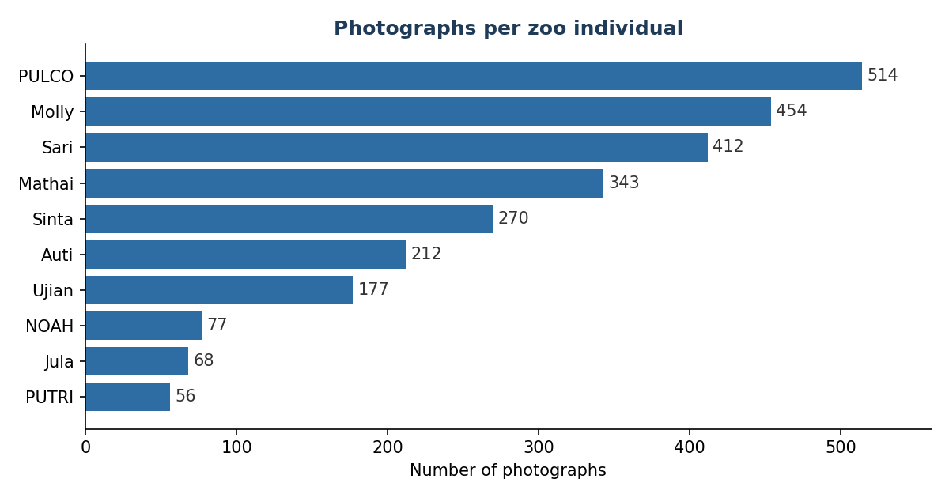
Figure 1. Photographs available per zoo animal. The dataset is strongly unbalanced, which the training corrects by sampling every animal equally often.

The internet images
To teach the model what an orangutan face looks like in general, several thousand images were collected from public sources such as iNaturalist, GBIF and web search. A small program downloaded them politely, paused between requests, rejected files that were too small or broken, and removed duplicates by comparing image fingerprints. It also recorded the source and licence of every image, which matters for both legal use and later reuse. About six thousand three hundred images were kept, and the detector turned them into 5,429 face crops. These crops become a background class that represents orangutans that are not in the zoo.

The BOS animals and the new individuals
The BOS Foundation provided photographs of thirty animals from its centres in Borneo, which gave 1,622 face crops. Early on these served as a pool of strangers, used only to test whether the system could reject an animal it had never learned. Later, five new zoo animals were added to bring the deployment gallery to fifteen. The distinction matters throughout the report: the thirty BOS animals are unknown for Versions 1, 2, 3 and 6, but they are supervised, known animals in Versions 4 and 5.

4. Building the Face Detector
The identifier needs an image that is already centred on a face. It cannot find the face on its own inside a full photograph. A detector is therefore trained first. The detector used here is YOLO, a well known family of object detectors that returns a box and a confidence score for each object it finds.

A two pass, human in the loop method
Drawing boxes by hand is slow. To avoid annotating thousands of images from scratch, the detector was built in two passes. A small and fast model was first trained on 520 boxes drawn by hand. This first model was then used to propose boxes on all the remaining photographs automatically. Every proposed box was checked by a person, corrected when needed, and only then kept. A larger and more accurate model was finally trained on this clean set. This is the human in the loop idea, where the machine does the tedious first pass and the human only reviews.
The reviewed boxes are stored in a single file that acts as the single source of truth for the whole project. Each entry records the image, the box, and a status of valid, to correct, or rejected. Every later step reads its crops from this file, which makes the data fully traceable.

A custom application to review the crops
The review itself was done through a small application built for this project. It shows one image at a time with the proposed box drawn on top, next to the cut out face. The reviewer can accept the box, adjust it by dragging its corners and edges, skip a doubtful image, or delete a bad one. Keyboard shortcuts make the work fast, so hundreds of crops can be checked in one sitting. The application saves after every action and remembers what has already been reviewed, so the work can be stopped and resumed across several days without losing anything. Photographs with several animals in the frame are sent to a separate screen where the reviewer picks the correct face. This review step, close to ten hours of work in total, is unglamorous but it is probably what contributed most to the final quality, because a model can only be as good as the images it learns from.

Results
The clean set lifted the detector from a first model at about 92 percent to a production model at 99.4 percent, with far fewer false boxes and far fewer missed faces. This production detector is kept unchanged in every later version. One unusual setting is worth noting. The training also flips images upside down, which is normally avoided, because orangutans often hang and climb head down, so an upside down face is a real case here.
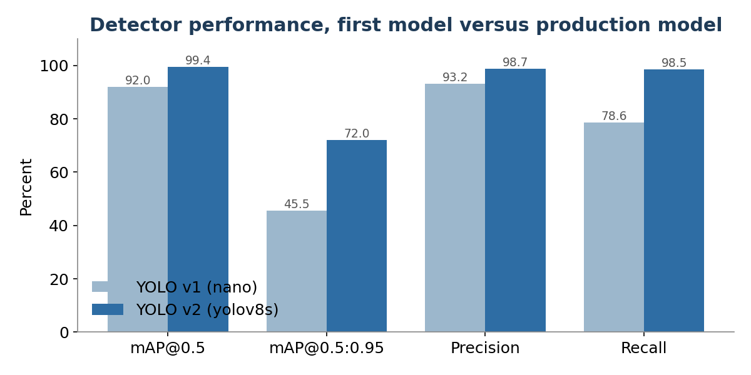
Figure 2. Detector performance before and after the clean second pass. Precision and recall rise together, which means fewer false boxes and fewer missed faces.
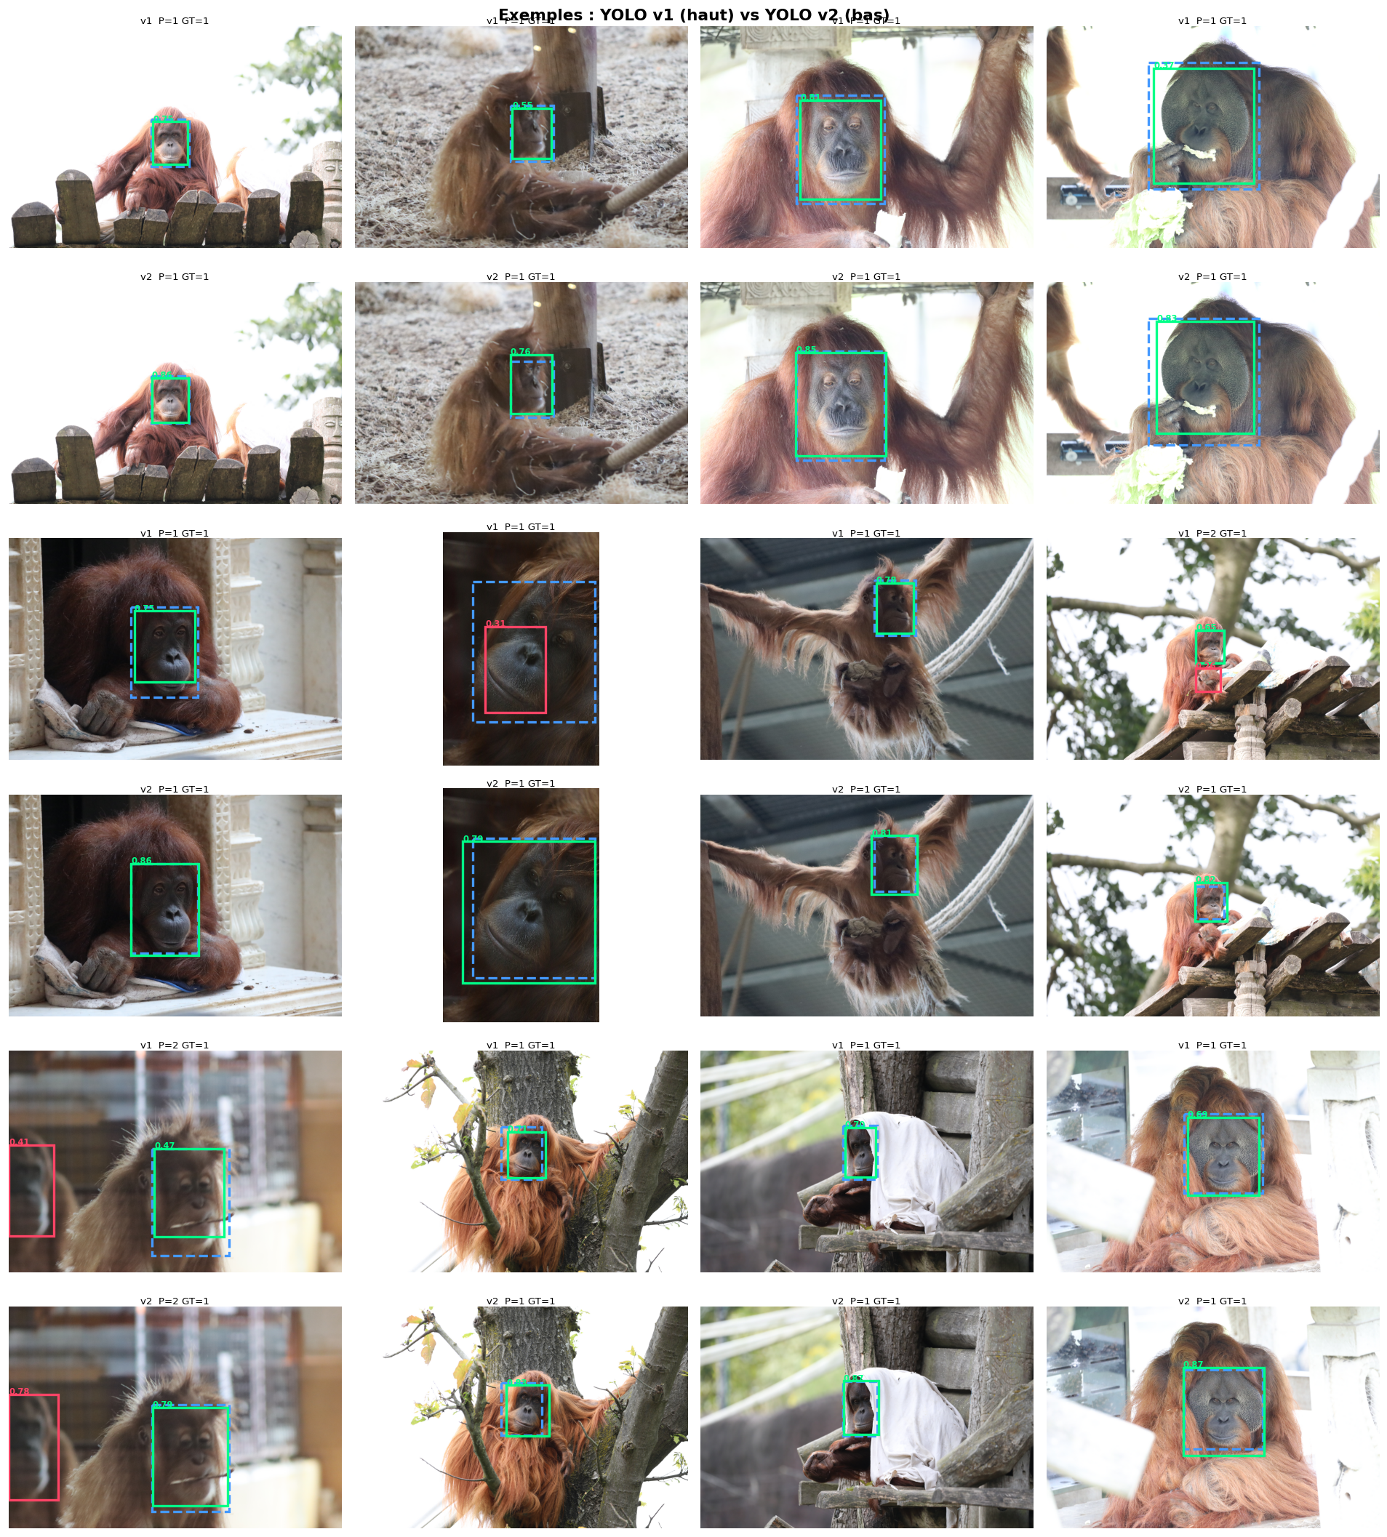
Figure 3. Example detections produced by the production detector on zoo photographs.

5. How the Models Are Trained
Since the same training ideas come back in every version, they are explained once here in plain words. A neural network is a large set of adjustable numbers called weights. Training is the process of slowly setting those numbers so that the network does the job we want.
The recipe is always the same loop. We show the network a small batch of images together with the correct answer. The network makes a guess. A formula called the loss measures how wrong the guess is, as a single number. The training then nudges every weight a little in the direction that would have made the loss smaller. One full pass over all the images is called an epoch, and we repeat for many epochs until the network stops improving. The key point is that we never tell the network how to recognise a face. We only tell it, through the loss, what a good answer looks like, and it discovers the how by itself.
Two more ideas appear everywhere. The first is transfer learning. Instead of starting from random weights, we start from a network already trained on millions of general images. It already knows edges, textures and shapes, so it only needs to be adjusted to our task, which is much faster and works far better on a small dataset. The second is data augmentation. Each time an image is shown, it is slightly changed at random, rotated, cropped, brightened or blurred. The network therefore almost never sees the exact same picture twice, which forces it to learn what stays constant about an animal rather than memorising a fixed photograph.
Watching for over fitting. The great danger on a small dataset is over fitting, where the network memorises the training images instead of learning to generalise. To catch this we keep a part of the data aside, never used for training, and we measure accuracy on it after each epoch. If training accuracy keeps rising while this held out accuracy stalls or falls, the network is memorising, and we stop. What exactly changes between the versions is the loss, that is, the definition of a good answer, and the tricks used to fight over fitting. The rest of the loop stays the same.

6. Version 1: A Closed Classifier
The first goal was simply a working system that could tell the ten zoo animals apart.
The network is a ResNet50, a standard image network, with a small final layer added that outputs one score per animal. Here the good answer defined by the loss is the correct name, so the network learns to push the score of the right animal above the others. Training happens in two stages. In the first stage the borrowed part of the network is frozen and only the new final layer learns, which quickly teaches it to read the existing features. In the second stage the whole network is unfrozen and adjusted gently, so it can learn features that are specific to orangutans without destroying what it already knew.
Because the dataset is small and unbalanced, several methods are combined to prevent memorising. Strong augmentation keeps the images varied. Balanced sampling shows rare animals as often as common ones. Mixup blends two images and asks the network to predict both names in proportion, which softens its decisions. Label smoothing tells the network not to be fully certain, which improves the honesty of its confidence. Weight limits and early stopping keep it from drifting into memorisation. Together these are the reason a network with millions of weights can be trained on only two thousand images without collapsing.
On a held out test set of clean crops the network is near perfect. A visual check confirmed that it looks at the eyes and the muzzle, which are exactly the areas an expert uses. The confusion matrix in Figure 4 shows that only NOAH and PUTRI are a little lower, since they share a similar look. Measured end to end on the whole collection with the fair benchmark, the classifier sits at 96.5 percent.
One animal stands out as harder. Although PULCO is the most photographed animal, it drops to about 89 percent end to end. Many of its photographs were taken very close through glass with a flash, which washes out the colours that help tell the animals apart, and its huge variety of poses spreads out its average appearance. This is a useful reminder that more images do not help if they are not varied and clean.
A closed classifier always returns one of the known names. Shown a stranger, it still answers a zoo name, often with high confidence, because its scores are forced to add up to a full choice among the ten. Two quick fixes were tried, refusing low confidence answers and comparing fingerprints to the training set, but neither is reliable, because the confidence of such a network is known to be poorly calibrated. This single limit, the inability to say unknown, is the reason for Version 2.
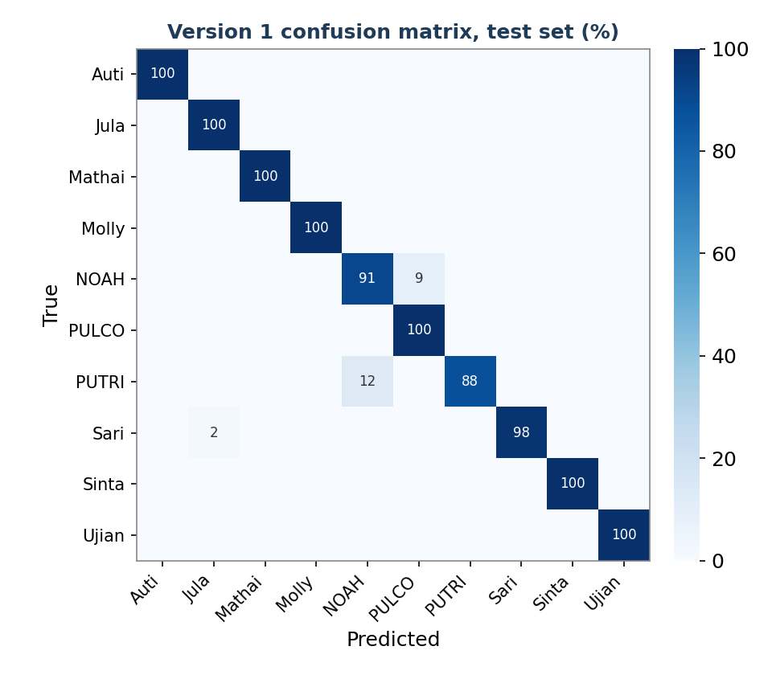
Figure 4. Confusion matrix of Version 1 on the clean test set. Recognition is almost perfect. The few confusions involve NOAH and PUTRI, which share a similar look.

7. Version 2: An Embedding Gallery for Open Set
The system had to reject strangers, and ideally without training a new network.
The same network from Version 1 is reused, but differently. Its final naming layer is removed, and the list of numbers that sits just before it is kept. This list is the fingerprint of the face, also called an embedding. For each animal, the fingerprints of all its images are averaged into one reference fingerprint called a prototype. A new face is compared to every prototype by cosine similarity, a simple measure of how much two fingerprints point in the same direction. If the best match is below a threshold, the animal is declared unknown.
The threshold is not picked by hand. Instead each animal is removed in turn and treated as if it were a stranger, and the threshold is chosen as the value that best separates real members from these simulated strangers. This procedure, which imitates the arrival of a new animal, gives a threshold with a real justification rather than a guess, here 0.4885.
Identification stayed high, but rejection of real strangers was far too low for the field. The reason is fundamental. The network was trained to name ten animals, not to produce fingerprints that separate individuals of one species. Its fingerprints are only moderately discriminative, which shows up in the benchmark as a small separability gap of 0.23 and a rejection score well below the specialised models that follow. Fixing that requires a network built for the job, which is Version 3.

8. Version 3: A Specialised Model with Angular Margin
Version 3 changes two things at once, the network and the training objective, and it is the foundation on which every later version is built.
The backbone is replaced by MegaDescriptor, a network trained by others on dozens of animal re identification datasets, from whales to gorillas. It already knows how to tell individual animals apart in general, which is exactly the skill we need. The small size version was chosen because it fits in the memory of the modest graphics card used for the project, while a larger and even stronger model would not.
The training objective is the real novelty. Rather than naming the animal, the network is asked to place each face on the surface of a sphere so that faces of the same animal point the same way and faces of different animals point in clearly different directions. The objective, called ArcFace, adds an angular margin, which means it is not enough for the right animal to be a little closer, it must be closer by a fixed safety gap. This forces wide, clean separation between animals. A refinement allows a noisy group to have several anchor directions rather than one, which is used for the very varied internet crops.
The 5,429 internet crops are added during training as a single extra class that means any other orangutan. The network therefore learns three things at once, what an orangutan face looks like in general, the fine differences between the ten zoo animals, and how to keep the zoo animals away from the general crowd. A stranger then naturally lands near that crowd and far from every zoo prototype, and is rejected. This builds the notion of unknown directly into the fingerprints, instead of adding a threshold afterwards as in Version 2.
Before this fine tuning, the specialised network was actually worse than the older one, at about 87 percent. It is the training with angular margin, not the change of network alone, that lifted accuracy to 99 percent. The objective mattered more than the model.
Version 3 is the reference model. Clean identification of the ten zoo animals reaches 99.2 percent, the separability gap jumps from 0.23 to 0.85, and rejection of animals it never saw is near perfect. Even for animals it had never met, the network grouped each one's photographs tightly together, a clear sign that it learned general face features rather than memorising sessions.
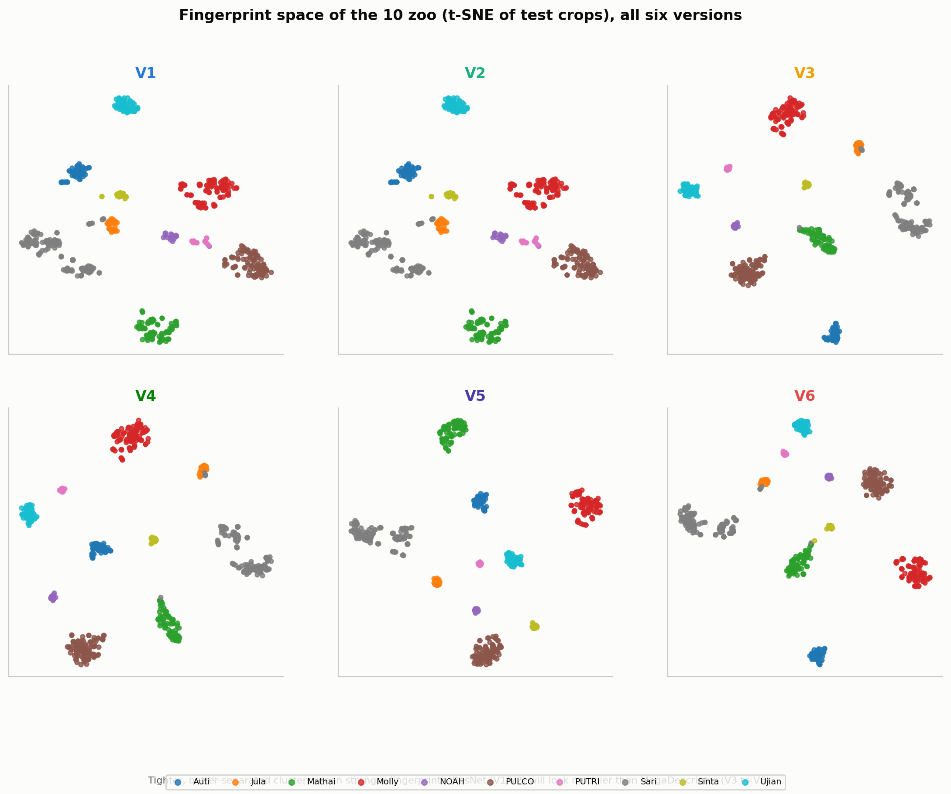
Figure 5. Fingerprint space of the ten zoo animals, shown for all six versions. In the ResNet versions the clusters overlap, while in the specialised versions they become tight and clearly separated.
The rejection can also be read directly. For each of the 1,622 unknown BOS faces we take its best similarity to any zoo animal. Almost all fall well below the threshold, so they are correctly rejected. Only about sixty cross it, and half of those are wrongly attracted to a single animal, Sinta, whose face seems to sit in a common region of the space. Raising the threshold slightly removes most of these errors.
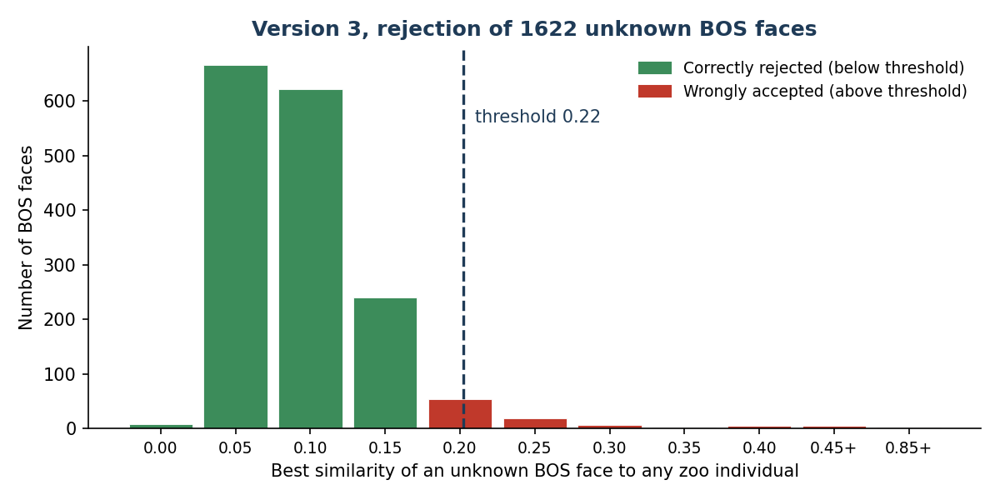
Figure 6. Rejection of unknown BOS faces by Version 3. Almost all unknown faces have a low similarity to every zoo animal and fall left of the threshold. Only about sixty are wrongly accepted.

9. The Field Robustness Problem
Before improving the model further, its robustness was tested by degrading the images on purpose and measuring how accuracy holds up. The result was a cold shower. The strong specialised model collapses under the very degradations that field photographs suffer from, while the older network holds up much better. Under moderate blur the specialised model falls close to chance, whereas the earlier ResNet still names most animals.
The concrete trigger was memorable. On a live screen test, confidence fell from 97 percent to almost zero as soon as the image was slightly degraded, for example a screen capture or a distant photograph. From this point on, solving the field weakness became the driving goal of the project. Everything from Version 4 to Version 6 exists for this reason.

10. Version 4: Forty Individuals and Field Augmentations
This version tried to answer the robustness problem by teaching the model damaged images directly, and at the same time to add the thirty BOS animals as known classes.
Starting from the Version 3 weights, the augmentation was made much harder. Images were shrunk to a small size and blown back up to imitate a face photographed from far away, and a strong blur was added. The idea was simple, if the model keeps failing on blur, show it a lot of blur during training. The gallery grew to forty animals, the ten original zoo animals plus the thirty BOS animals.
The gains were real but small. Low resolution improved by a few points and a light combined degradation by about four points, yet motion blur did not move at all and stayed close to chance under a moderate amount. Harder augmentation alone was not enough. Adding the thirty BOS animals also crowded the gallery, since some of them look alike. This line of work was therefore only a partial success. The real fix came from changing the objective in Version 5, not from more augmentation.
Version 4 is a forty animal identification gallery, so the BOS animals are known, not strangers. It is wrong to quote a BOS rejection rate for Version 4. Such a number belongs to the Version 3 setup, where these animals are held out as unknown. This confusion appeared in an early draft and is corrected in the benchmark of this report.

11. Version 5: Invariance and Curriculum
This version attacked the field weakness at its root, in the training objective, rather than by piling on more augmentation.
The central idea is an invariance objective. Each image is sent through the network twice, once clean and once damaged, and the network is told that the two fingerprints must be identical. In other words, we no longer only ask it to separate the animals, we also ask it to ignore the damage. This is the direct answer to the drop from 97 percent to zero, because it teaches the model that a blurred face and its clean version are the same animal.
Two more pieces complete the design. A spreading objective pushes look alike animals apart, and a curriculum raises the amount of damage stage by stage, gentle at first so the network can learn the animals, then harsher so it learns to resist. The model is chosen using a combined score that rewards both clean accuracy and accuracy on damaged images, so robustness is part of the goal from the start, not an afterthought. Version 5 also introduces the exemplar gallery, where an animal is stored as a set of varied fingerprints, twenty per zoo animal and fifteen per BOS animal, and a face is compared to the closest of them rather than to a single average.
This version is the turning point of the project. Under degradation it is the first model to stay accurate, holding around 95 percent where Versions 3 and 4 fall to chance, while keeping the high separability of the specialised family. Its gallery still covered forty animals, which is not the deployment target, so the same methods were carried to the real target in Version 6. As Section 14 shows, this forty animal task is also where the limits of the BOS animals become visible.

12. Version 6: The Production Model
The goal was to turn the research prototype into a robust tool for the zoo that could actually be shipped in the phone application.
Version 6 starts again from the Version 3 weights and reapplies the methods proven just before, the angular margin objective, the invariance objective and the curriculum. It focuses on the zoo alone. It adds the five new animals, bringing the gallery to fifteen, and drops the BOS animals from the shipped gallery because they were a test set, not a deployment target, and because they were crowding the space. A quality step scores every crop for brightness and sharpness and brightens the dark ones, so that only usable faces enter the gallery. Each animal is stored as twenty five exemplars, and the acceptance threshold is tuned with a simulation of field use.
Robustness is solved. In the fair benchmark Version 6 still names 93 percent of animals under moderate blur and 88 percent under a moderate combined degradation, where Version 3 falls to about 11 percent. Figure 7 shows the two training curves rising together, clean accuracy staying high while accuracy on damaged images climbs from about 60 to about 96 percent. The model becomes accurate and robust at the same time, which is the whole point.
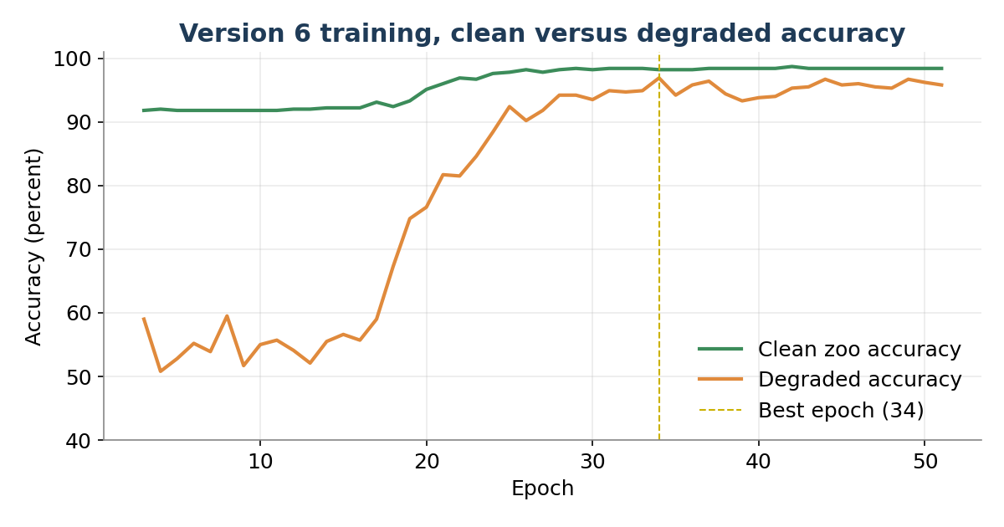
Figure 7. Version 6 training. Clean accuracy stays high while accuracy on damaged images climbs from about 60 to about 96 percent. The two rise together, which shows robustness and precision improving at once.
The Version 6 network and its fifteen animal gallery, with a threshold of 0.5371, are exactly the files embedded in the Android application. They are the version in use today.

13. Cross-Version Benchmark
All six versions were compared with a single fair protocol. The photographs were split by session, so that no image from a session used to build a gallery appears in the test set. For the controlled comparison every gallery was rebuilt the same way and restricted to the ten zoo animals present in every version, so the only thing that changes between the columns is the model itself. Each version was tested for rejection only on animals it never saw during training, Versions 1, 2, 3 and 6 against the thirty BOS animals, and Versions 4 and 5 against the five new zoo animals, because they had been trained on the BOS animals. Every rejection figure therefore uses a legitimate, never trained set of strangers. The per-version figures shown earlier, such as the Version 1 confusion matrix, the Version 3 rejection histogram and the Version 6 training curves, come from each version’s own run and are diagnostics of that single version. Only the numbers in this section, produced by the one shared protocol, should be used to compare the versions with one another.
Table 1. Metrics for the six versions on the shared ten zoo animals.
Metric | V1 | V2 | V3 | V4 | V5 | V6
Clean identification (10 zoo) | 96.5% | 96.5% | 99.2% | 99.2% | 99.7% | 99.2%
Separability gap | 0.23 | 0.23 | 0.85 | 0.86 | 0.91 | 0.88
Rejection ROC AUC | 0.83 | 0.83 | 0.998 | 0.99* | 0.99* | 0.999
Identification, moderate blur | 77% | 77% | 11% | 11% | 95% | 93%
Identification, moderate combined | 22% | 22% | 11% | 11% | 95% | 88%
Time per fingerprint (ms) | 20.8 | 18.4 | 31.5 | 30.9 | 41.9 | 35.5
The rejection score marked with an asterisk is measured against the five new zoo animals, not the BOS animals, because Versions 4 and 5 were trained on the BOS animals and cannot be scored for rejecting them. The clean identification figure is a per-crop average over a test set of 597 face crops across the ten animals, between 15 and 133 per animal.

Clean identification of good zoo crops saturates from Version 3 onward, so it is not where the versions differ. The first real jump is the separability gap, which rises from 0.23 for the ResNet family to 0.85 or more for the specialised family, and open-set rejection follows the same pattern, from 0.83 to near one. The metric that actually separates the versions is identification under degradation.
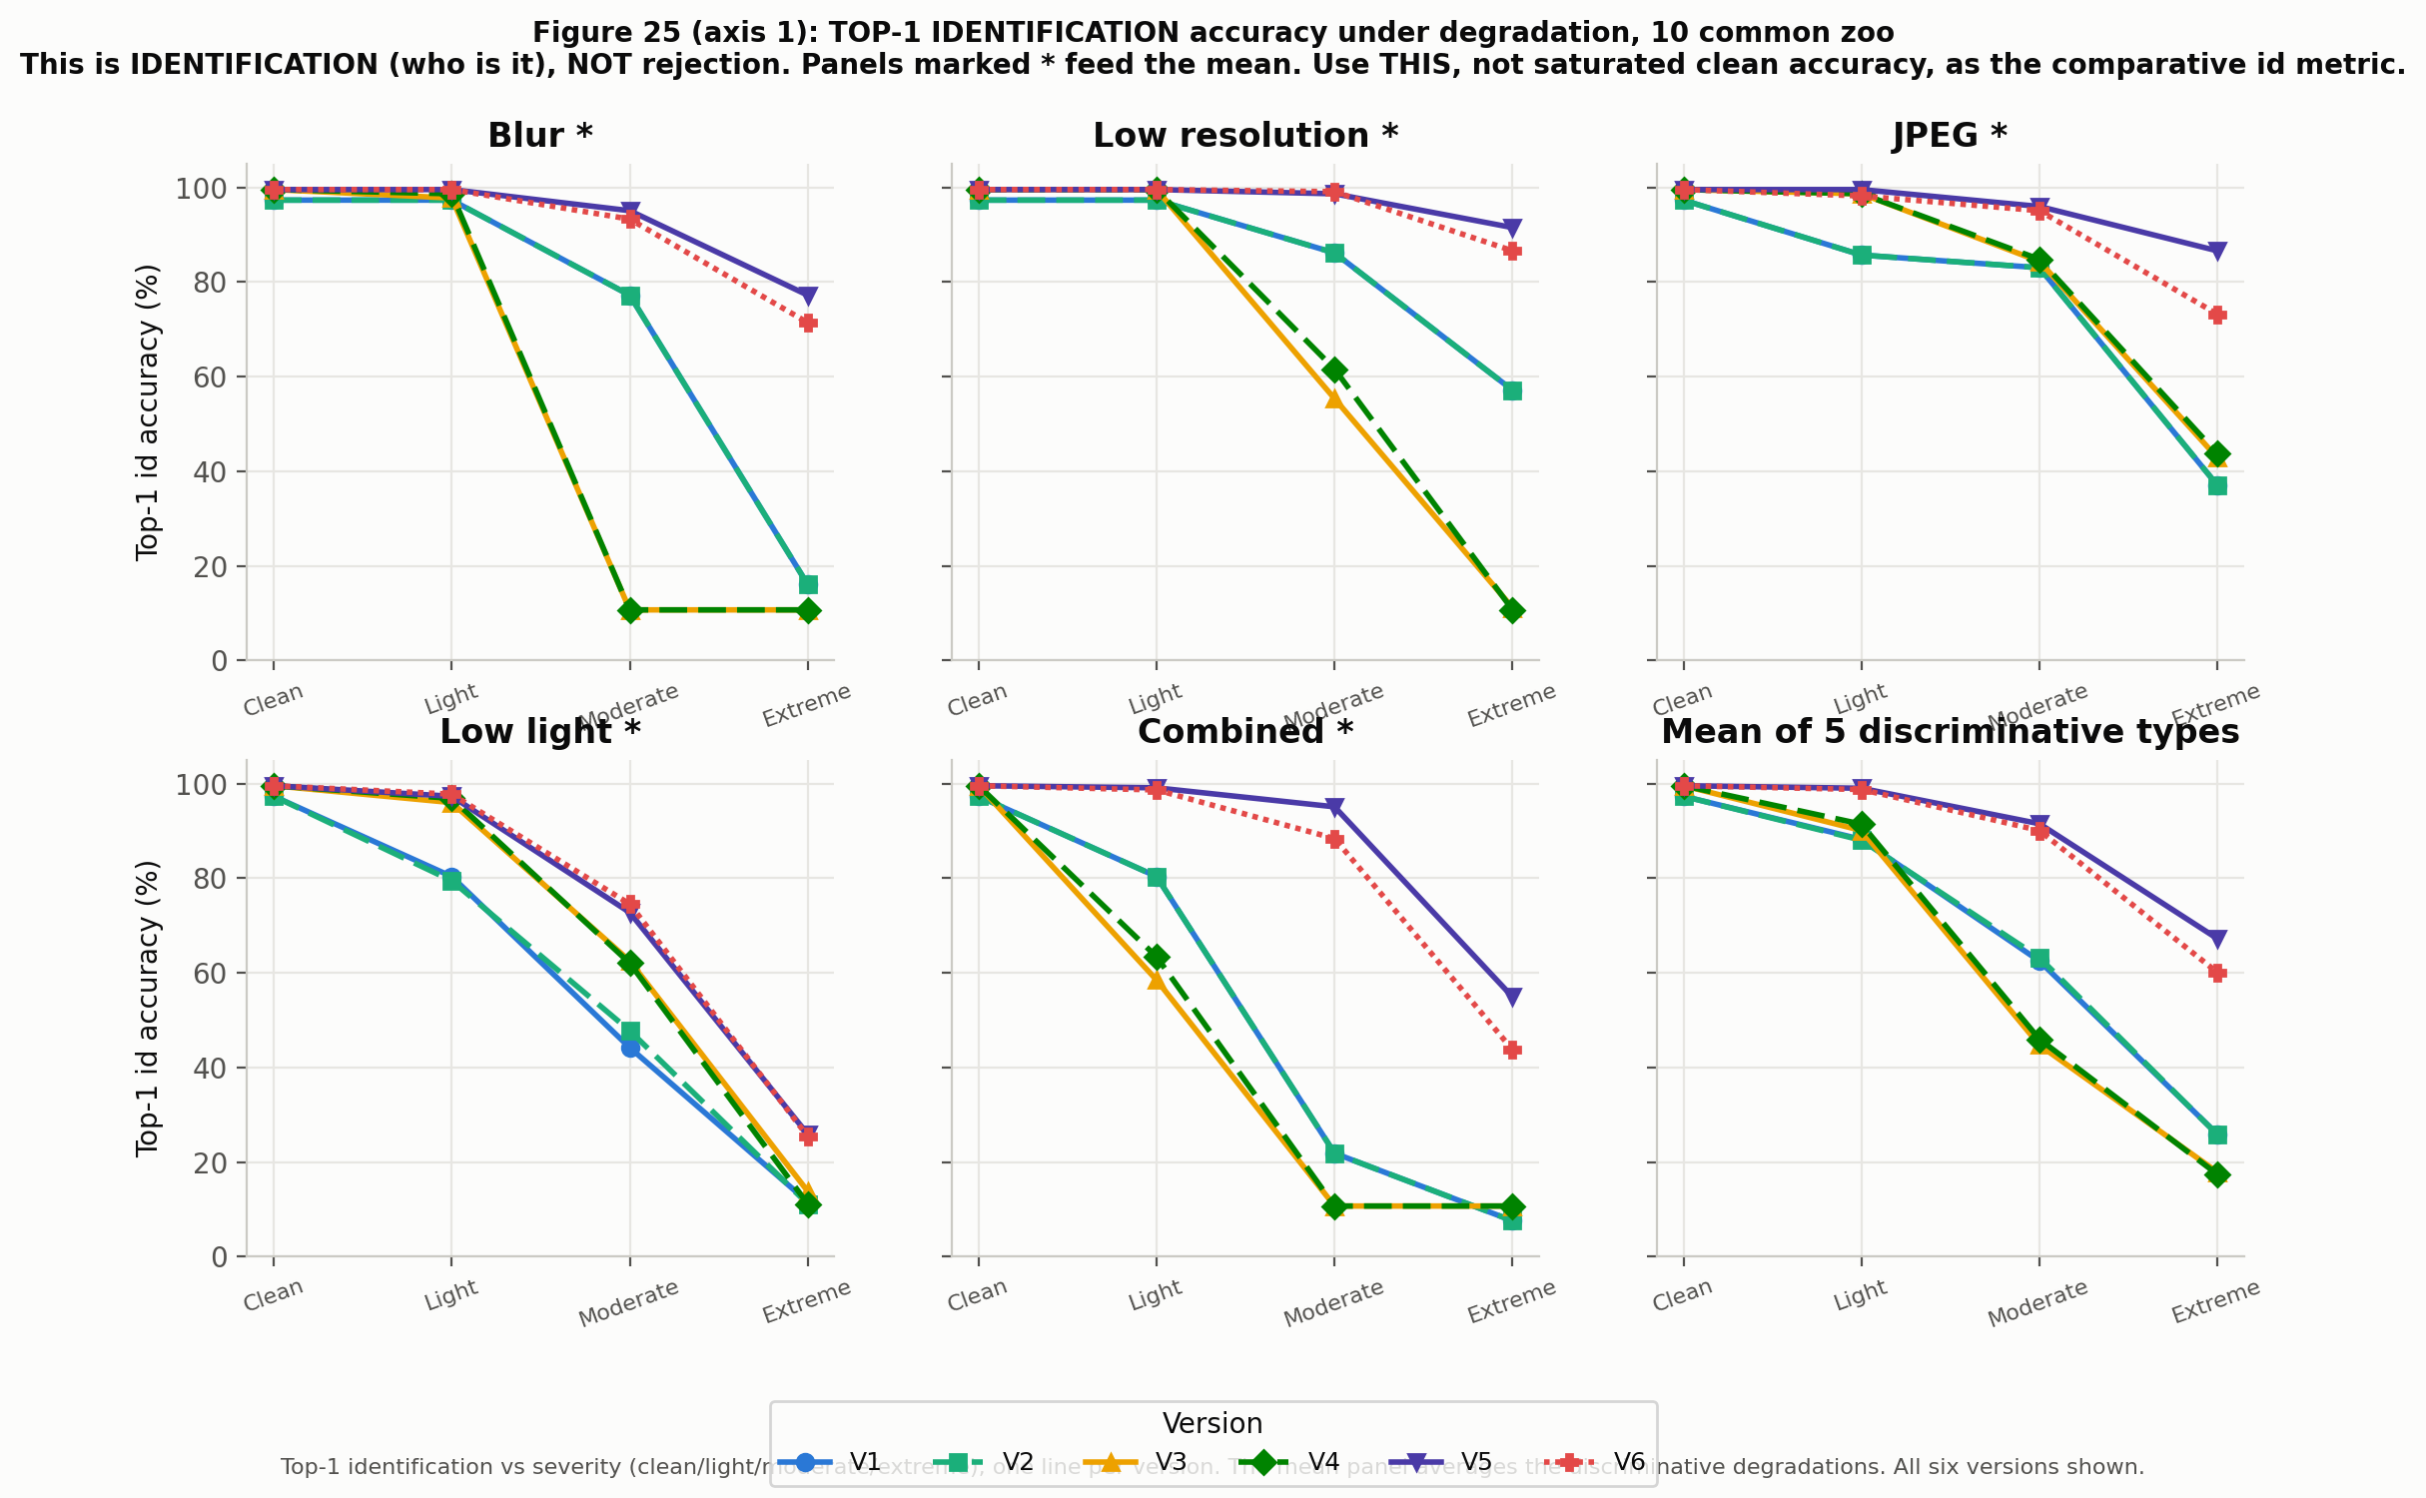
Figure 8. Top-1 identification accuracy under increasing degradation, one curve per version. Versions 3 and 4 fall to chance under moderate blur, while the invariance training keeps Versions 5 and 6 above ninety percent.
Versions 3 and 4 collapse to chance level as soon as blur becomes moderate, near 11 percent for a ten way choice. Version 5 introduced the invariance objective and the curriculum, and holds above 90 percent. Version 6 keeps that robustness for the deployed zoo model. This is why Version 5, and not Version 4, is the real robustness turning point.
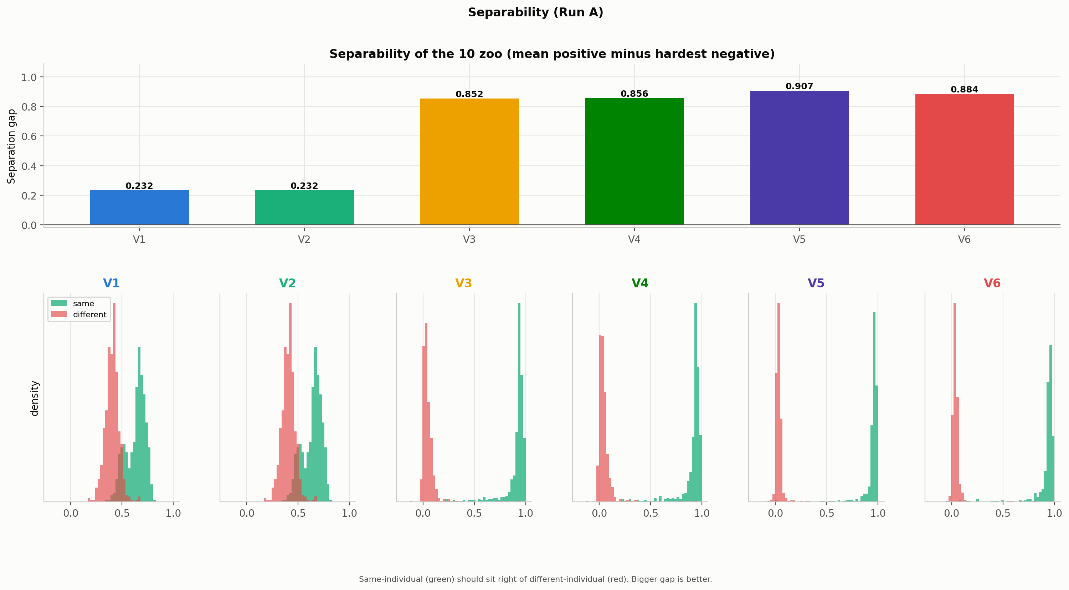
Figure 9. Separability across versions. The move from ResNet50 to MegaDescriptor with angular margin is the largest single improvement of the project.
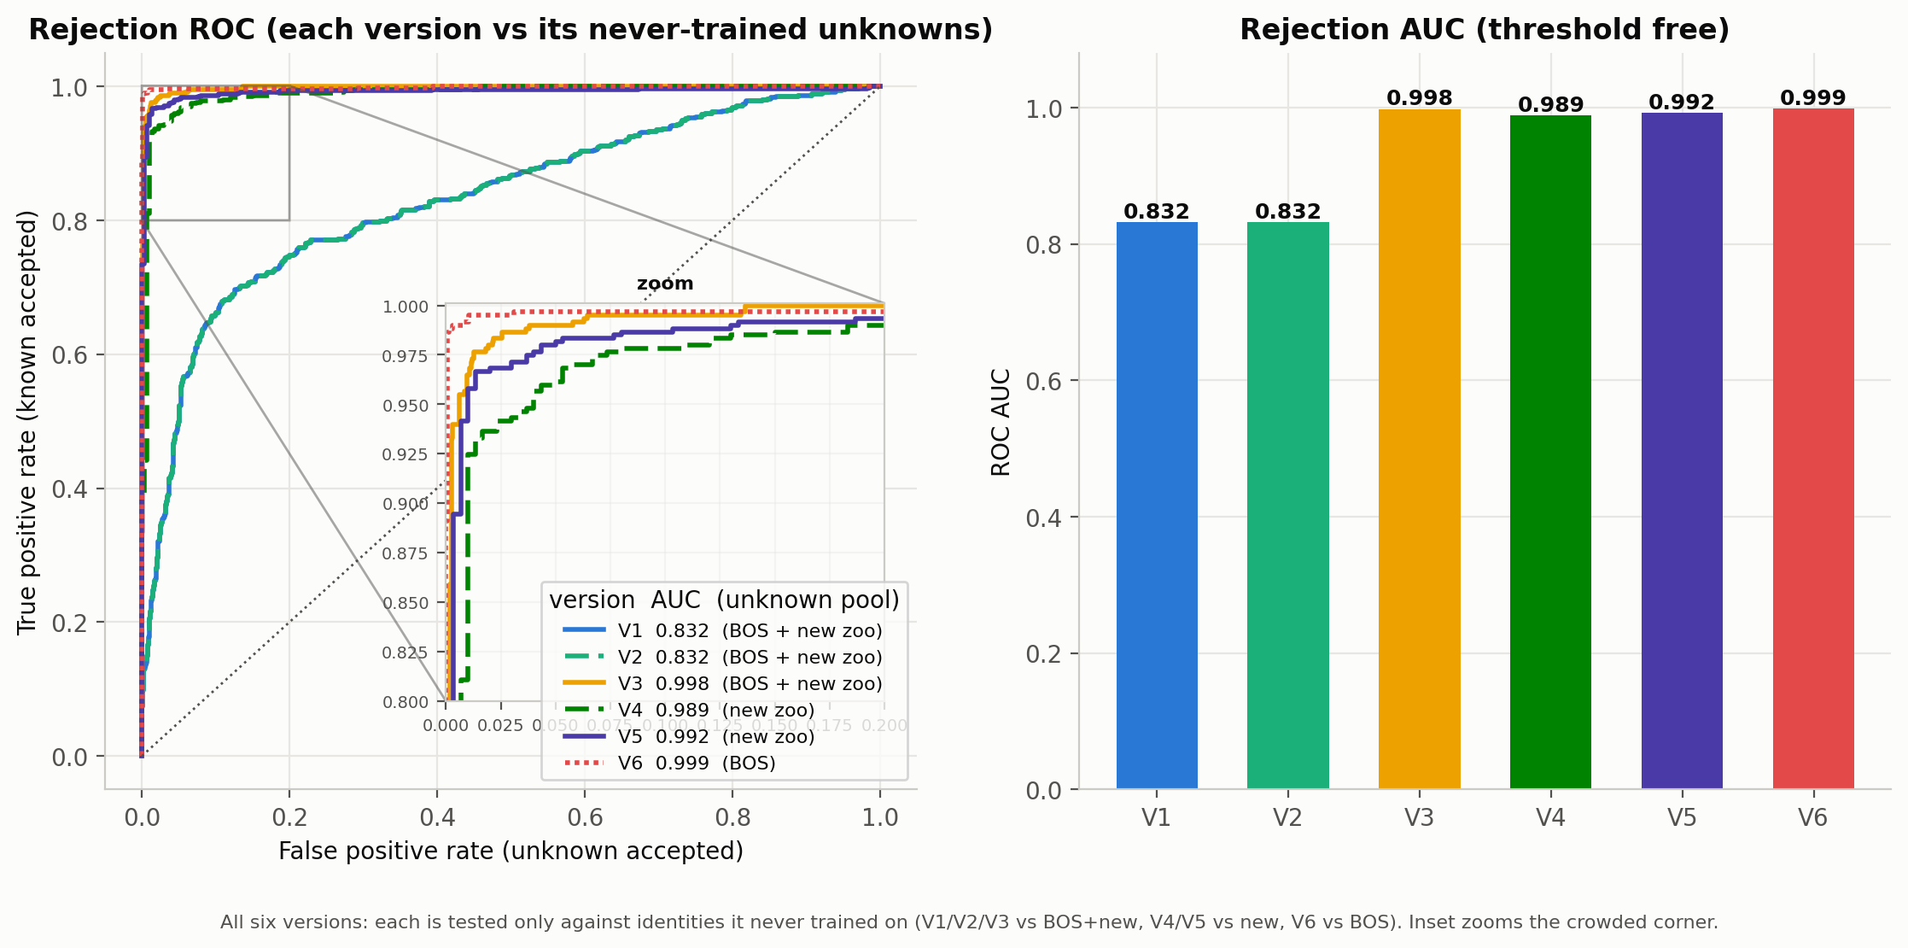
Figure 10. Open-set rejection quality. Each version is scored on a set of individuals it never saw during training.
Speed was never a problem. Figure 11 reports the time to turn one face into a fingerprint and compare it to the gallery, without the detector. Even the heaviest model stays near forty milliseconds on the test machine, far faster than a phone needs when it handles one photograph at a time.
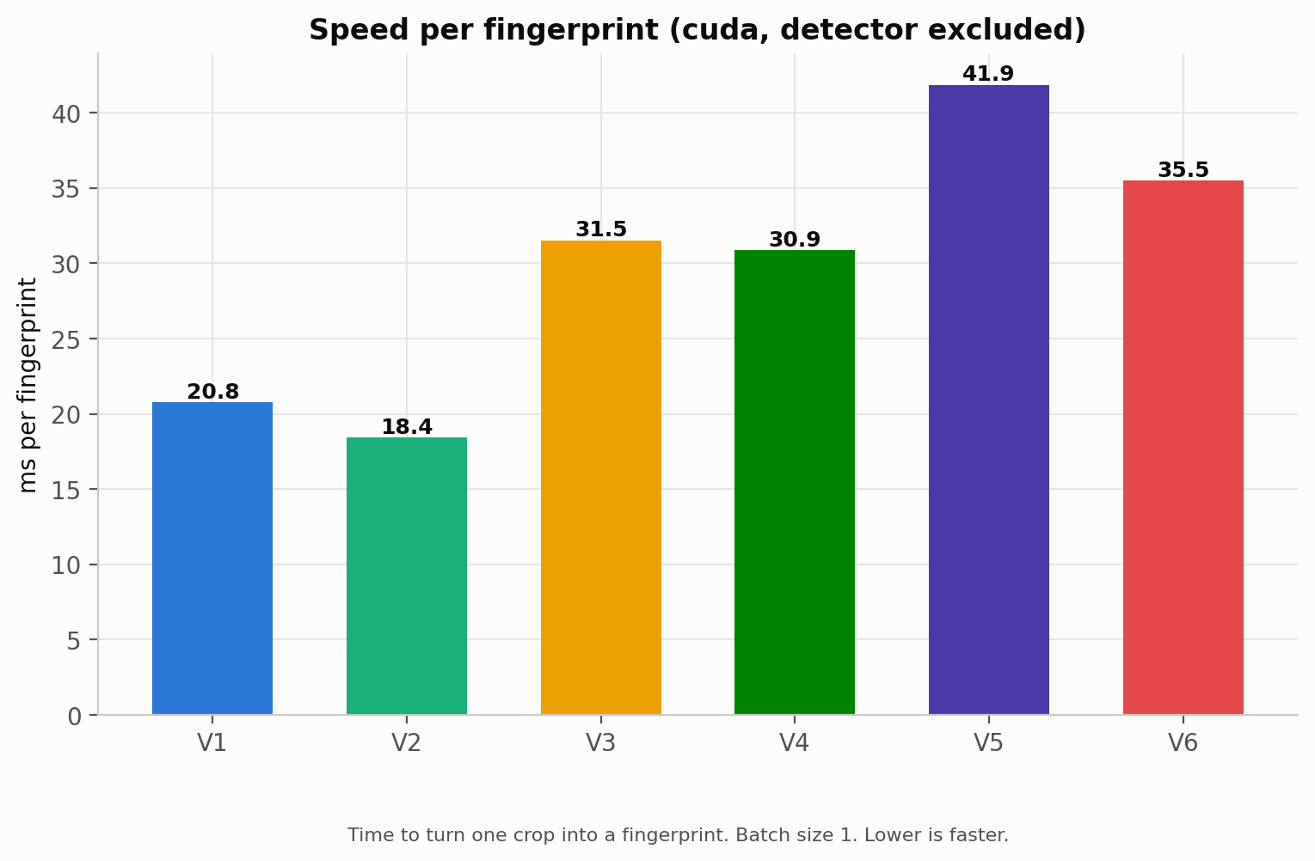
Figure 11. Identification speed on the test machine, detector excluded. All versions run in real time. The specialised network is slower than the earlier one but still very fast.

14. Why Version 6 and Not Version 5
On the shared ten zoo animals, Versions 5 and 6 look equivalent. The difference appears only when each model is evaluated on the full task it was actually trained for. This second view is descriptive, not a direct contest, because the number of animals differs between the versions and a forty way problem is harder than a fifteen way one.
Table 2. Each version on its own full task. Accuracy is shown as micro, per crop, over macro, per individual. These tasks involve different numbers of animals and are not directly comparable.
Version | Individuals it must recognise | Native accuracy (micro / macro) | BOS separability gap
V3 | 10 zoo | 99.2% / 99.2% | not applicable
V4 | 40 (10 zoo + 30 BOS) | 73.7% / 55.6% | -0.01
V5 | 40 (10 zoo + 30 BOS) | 87.5% / 79.5% | +0.06
V6 | 15 (10 zoo + 5 new) | 97.9% / 98.2% | not applicable

The BOS animals are almost inseparable. Version 4 cannot tell them apart at all, shown by a separability gap that is essentially zero and even slightly negative, which means a crop is as close to a wrong animal as to itself. Even Version 5, with a dedicated spreading objective, only reaches a weak positive gap. Averaged per animal, Version 5 identifies fewer than eighty percent of its forty animals. Version 6 dropped the BOS animals entirely and focused on the fifteen zoo animals of the real deployment target, where it reaches ninety eight percent. That is the reason Version 6 is the production model, even though on the narrow shared test the two versions are level.
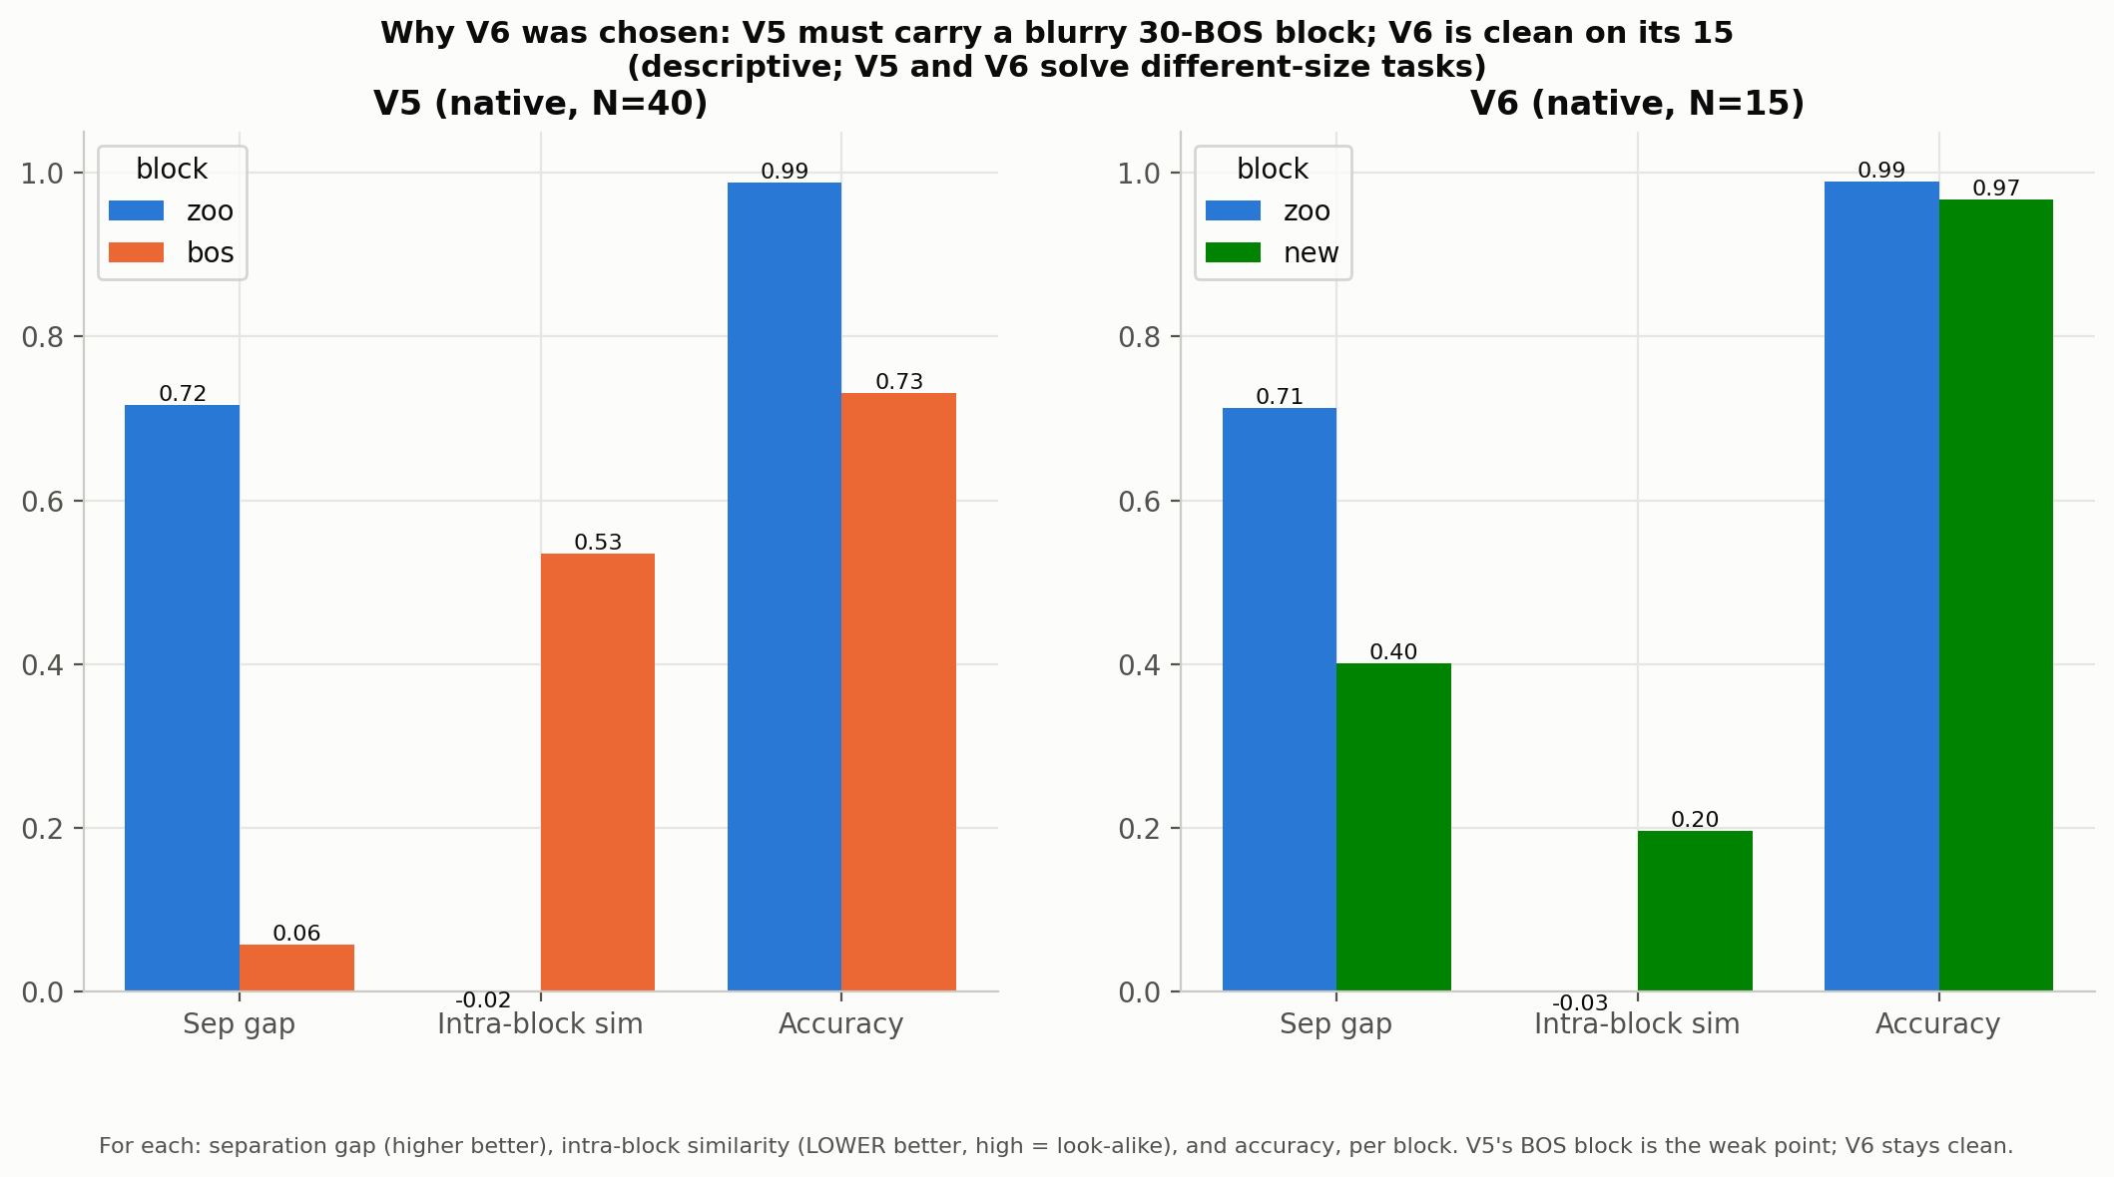
Figure 12. Version 5 against Version 6, per group. Version 5 must carry thirty poorly separated BOS animals, while Version 6 is clean on its fifteen zoo animals.
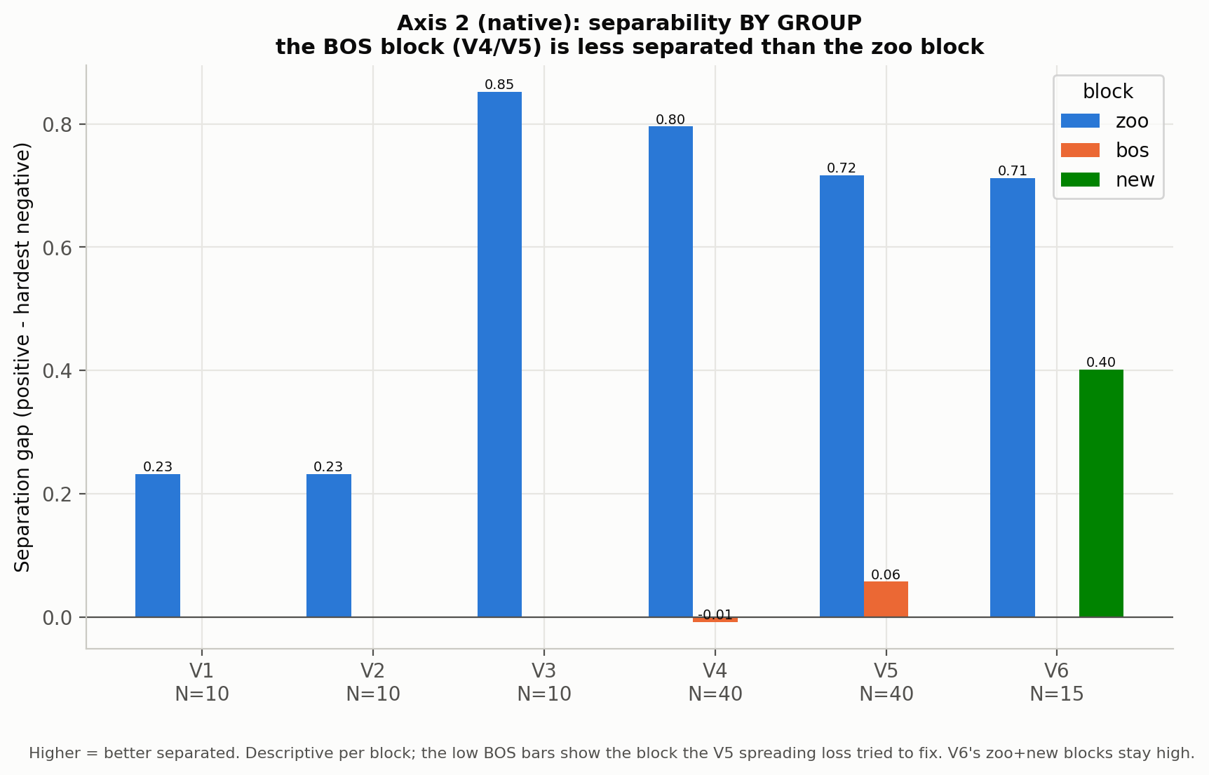
Figure 13. Separability within each group of animals. The BOS animals of Versions 4 and 5 are barely separated from one another, while the zoo animals stay well separated in every specialised version.
A note on the separability figures. Earlier drafts reported separation numbers that swung widely between versions, which looked like a regression. Those numbers used different definitions and different sets of animals. The single protocol used here, one measure recomputed the same way on the ten shared animals, removes that confusion, and the specialised versions are all strongly and evenly separated.

15. The Android Application
The trained network and its gallery are packaged into an Android application that runs fully offline. It carries the production detector, the Version 6 network and the fifteen animal gallery, and it asks for no network permission of any kind.
Workflow. The ranger takes a photo or picks one from the phone. The detector finds every face. Each face is turned into a fingerprint and compared to the gallery. An animal is named only when the best match passes the threshold and also stands clearly above the second best match. When the two best matches are too close, the application answers unknown, because a small gap means the model is not sure. The result screen shows the name, a coloured confidence bar and the three best guesses.
Editable gallery. Rangers can add a new animal from ten to twenty photographs, or add field photographs to an animal that is already known. Field photographs never overwrite the original reference. They are stored separately and must pass quality checks first, so a single bad photograph cannot corrupt recognition. The application also warns when a new animal looks like one already in the gallery.
Other features. The application handles several photographs in one batch, keeps a history of past scans, lets the user adjust the acceptance threshold, keeps automatic backups of the gallery, imports model updates as a single package, and offers a full reset to factory state. Everything stays on the phone.

Exporting the model to the phone
Getting the trained model onto the phone was a real engineering step and not a formality. The phone runs models in a mobile format called TFLite, so the model has to be converted from the format it was trained in. The detector converts easily, because its toolkit exports to TFLite directly on Windows. The identification network does not, because it is a transformer, and the usual Windows converters fail on its internal layers.
Several tools were tried on Windows and all failed on this network. One had been abandoned by its authors and no longer installs. Another stops on a normalisation layer inside the transformer. A third mixes up the dimensions of the attention layers. The official converter that does support this kind of network runs only on Linux.
The solution, used from Version 3 onward, is to run the conversion inside a small Linux system installed on the same Windows machine through WSL. A setup script installs Linux, a Python environment and the converter once. After that a single command launches the export from Windows, and the Linux side sees the project folder directly, so no files need to be copied. The export script loads the trained network, converts it to TFLite, and places the result straight into the phone application next to the detector and the gallery. Each version has its own small export script, and Version 6 produced the file that runs in the application today.

16. Adding a New Individual
The frozen network and editable gallery design makes growth easy, and it is worth spelling out because it is the operational heart of the tool. To add an animal, a ranger takes ten to twenty photographs of it under different angles and lights. The detector cuts out the faces, the network turns each into a fingerprint, and the fingerprints are combined into a new reference that is written into the gallery. The whole operation takes seconds on the phone, with no training and no connection.
This works because the network learned general orangutan face features during training, so it produces a stable fingerprint even for an animal it has never seen. This was proven with the thirty BOS animals, which the network had never met yet grouped correctly. The same idea handles change over time. Young animals grow and males develop cheek pads, so their reference can simply be refreshed with new photographs, again without touching the network. A full retraining is only needed for a different species or after years of drift.

17. Lessons Learned
Data quality was the best investment. The hand review of every training crop did more for accuracy than any change of architecture.
The input preparation must match the model exactly. Preparing the images the wrong way for the specialised network quietly ruined the fingerprints and cost several days of debugging.
Robustness must be tested early. A model can score almost perfectly on clean images and still collapse in the field, which is exactly what happened after Version 3.
Change the objective before piling on data. Version 4 showed that more augmentation alone does not fix robustness. The breakthrough came from the invariance objective of Version 5, which also produced the exemplar gallery that the final model relies on.
Data leakage is easy to miss. Splitting photographs of the same session between training and validation inflates the scores, which is why the split in the benchmark is done by session and why the five new animals still need a stricter test.
Confidence is not correctness. A closed classifier is always confident, even when wrong, which is the reason explicit rejection was needed.

18. Discussion and Limitations
The tradeoff between recognition and rejection. One number controls the balance of the whole system, the acceptance threshold. A low threshold recognises known animals even in poor conditions but lets more strangers through. A high threshold rejects strangers well but starts to refuse known animals photographed badly. There is no single value that is best for everything, so the threshold is a policy choice.
BOS identification remains open. Even the model built for the BOS animals separates them only weakly, so identifying them one by one is not yet reliable. This is why the deployed system focuses on the zoo, where recognition is strong, and treats the BOS animals as strangers to be rejected.
The new animals come from a single session. The five new zoo animals were photographed on one day, so their scores may be slightly optimistic because of shared background and lighting. A second session on another day would settle this.
Rejection pools are not all the same size. Versions 4 and 5 are scored for rejection only on the five new animals, a smaller and more uniform set than the thirty BOS animals used for the other versions, so their rejection score should be read within that group rather than compared one to one with the others.
A note on an early benchmark. An early benchmark scored Version 1 incorrectly by treating a closed classifier as a fingerprint model, and quoted a rejection rate for Version 4 that does not apply. The corrected benchmark, with its split by session and its legitimate stranger sets, is the one used throughout this report.

19. Conclusion and Next Steps
The project moved from a closed classifier that could not refuse a stranger to a robust mobile tool that identifies fifteen zoo orangutans offline, rejects unknown animals, and keeps its accuracy under field degradation. The decisive steps were the move to a specialised network with angular margin, the discovery that this model was fragile in real conditions, and the invariance training that fixed that fragility in the deployed Version 6.
The natural next steps are to confirm the origin of the five new animals with a second session, to gather a strictly separate test set for fully publishable figures, and to revisit the identification of the BOS animals once more images of each are available. The same pipeline could later extend to other species by retraining only the detector, since the identification method itself is not specific to orangutans.

Appendix A. Version Summary
Version | Backbone | Individuals | Key idea | Clean id | Deployed
V1 | ResNet50 | 10 | Closed classifier, no unknown | 96.5% | no
V2 | ResNet50 | 10 | Embedding gallery, open set | 96.5% | no
V3 | MegaDescriptor-T | 10 | Sub-center ArcFace, wild background | 99.2% | no
V4 | MegaDescriptor-T | 40 | Field augmentation, 40 individuals | 99.2% | no
V5 | MegaDescriptor-T | 40 | Invariance and curriculum | 99.7% | no
V6 | MegaDescriptor-T | 15 | Production, zoo only, quality pipeline | 99.2% | yes

Appendix B. Main Training Settings
Setting | Value
Detector | YOLO medium, mAP@50 = 99.4%, kept from Version 2 onward
Identifier backbone | MegaDescriptor-T-224 (Swin-Tiny), 768-dim, from Version 3 onward
Input normalisation | ImageNet for V1 and V2, mean = std = 0.5 for V3 to V6
Loss | Sub-center ArcFace, scale 64, margin 0.50 (V3, V4) then 0.35 (V5, V6)
Sub-centers | 1 per animal for V3 and V4, equivalent to standard ArcFace for the animals, then 2 per zoo animal from V5, and 5 for the wild class
Gallery | mean prototype (V2 to V4), 20 to 25 exemplars per animal with max scoring (V5, V6)
Acceptance threshold | 0.4885 (V2), 0.22 (V3), 0.5371 (V6, field calibrated)
Learning rate | backbone 1e-5, head 5e-4

