Answer 1 : Calculate to sum of the numbers between 0 and entered number.

Source Code :
1 /********************************************************/
2 /********************************************************/
3 /*************titaNWare**********************************/
4 /*********************x_titanyum_x@hotmail.com***********
5 /********************************************************/
6 /********************************************************/
7
8 #include <iostream>
9
10 using namespace std;
11
12 long sumForLoop(unsigned int);
13 long sumWhileLoop(unsigned int);
14 long sumDoWhileLoop(unsigned int);
15
16 int main (void)
17 {
18 unsigned int number;
19 char pause;
20
21 cout << "Please enter a number : ";
22 cin >> number;
23
24 cout << "for loop"
25 << "Sum of the numbers between "
26 << "0 and " << number << endl
27 << sumForLoop(number);
28
29 cout << "";
30
31 cout << "while loop"
32 << "Sum of the numbers between "
33 << "0 and " << number << endl
34 << sumWhileLoop(number);
35
36 cout << "";
37
38 cout << "do while loop"
39 << "Sum of the numbers between "
40 << "0 and " << number << endl
41 << sumDoWhileLoop(number);
42
43 cin >> pause;
44 return 0;
45 }
46
47 long sumForLoop(unsigned int number)
48 {
49 unsigned int counter;
50 long sum=0;
51
52 for(counter=number;counter>0;counter--)
53 {
54 sum += counter;
55 }
56 return sum;
57 }
58
59 long sumWhileLoop(unsigned int number)
60 {
61 unsigned int counter;
62 long sum=0;
63
64 counter=number;
65 while(counter > 0)
66 {
67 sum += counter;
68 counter--;
69 }
70 return sum;
71 }
72
73 long sumDoWhileLoop(unsigned int number)
74 {
75 unsigned int counter;
76 long sum=0;
77
78 counter = number;
79 do
80 {
81 sum += counter;
82 counter--;
83 }while(counter > 0);
84
85 return sum;
86 }
87
88
89
90

Screen shot 1 for program 1:
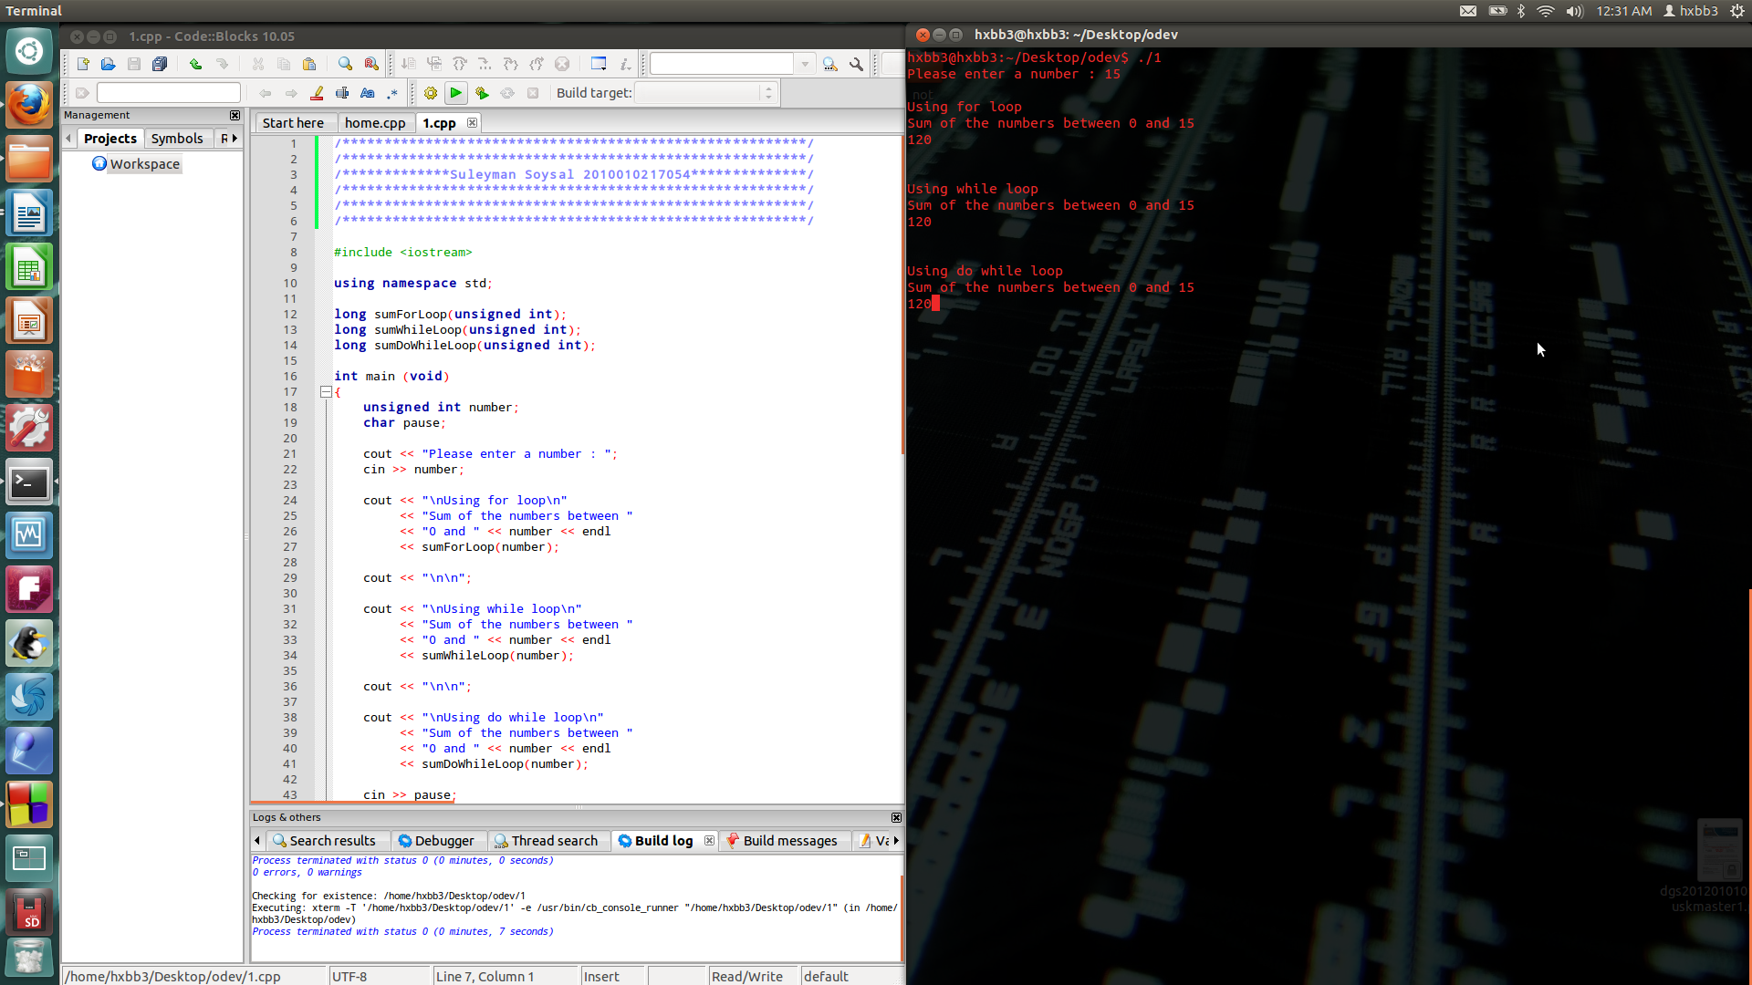

Screen shot for program 1 :

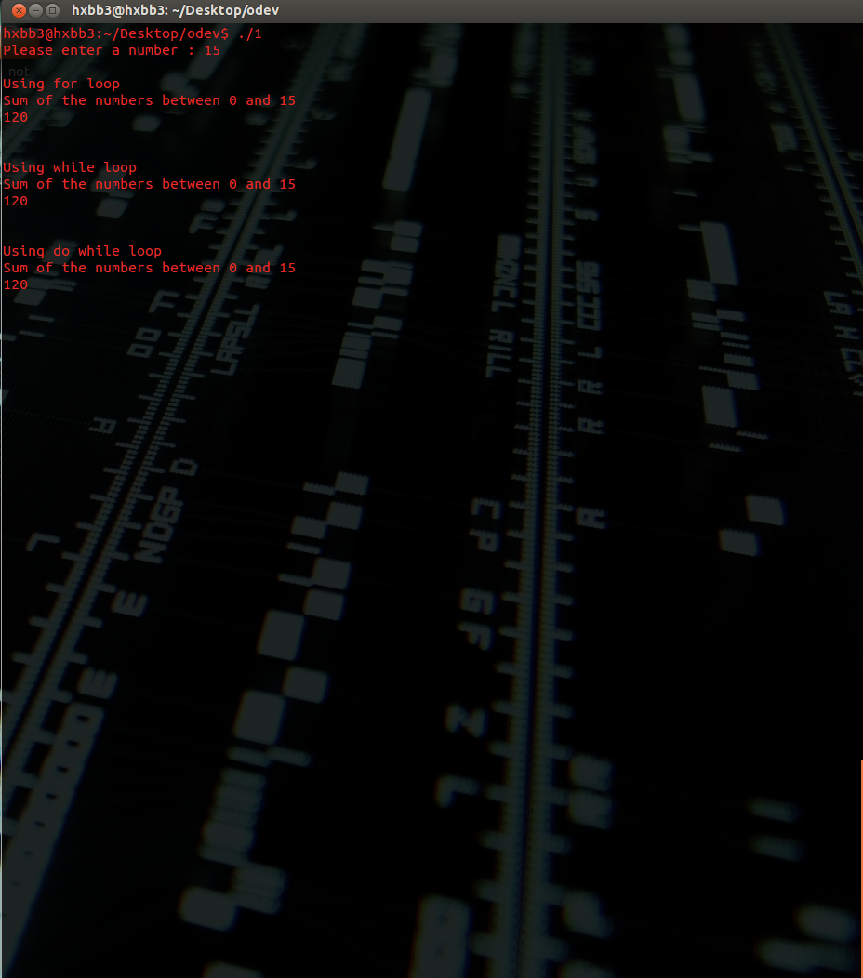

Answer 2 : Calculate x&y , x^y ,x|y , ~x for x=3AB and y=FC9.

Source code :

1 /********************************************************/
2 /********************************************************/
3 /********titaNWare***************************************/
4 /********************x_titanyum_x@hotmail.com************/
5 /********************************************************/
6 /********************************************************/
7
8 #include <iostream>
9 #include <cstdio>
10
11 using namespace std;
12
13 void printScreenBinary(unsigned int);
14
15 int main (void)
16 {
17 unsigned int hexNumber1 = 0x3AB;
18 unsigned int hexNumber2 = 0xFC9;
19 unsigned int andOp;
20 unsigned int orOp;
21 unsigned int xorOp;
22 unsigned int complementOp;
23 unsigned int pause;
24
25 andOp = hexNumber1 & hexNumber2;
26 orOp = hexNumber1 | hexNumber2;
27 xorOp = hexNumber1 ^ hexNumber2;
28 complementOp = ~hexNumber1;
29
30 printf("Number1... = %X= %d",hexNumber1,hexNumber1);
31 cout << "Binary = ";
32 printScreenBinary(hexNumber1);
33
34 cout << endl << endl;
35
36 printf("Number2... = %X= %d",hexNumber2,hexNumber2);
37 cout << "Binary = ";
38 printScreenBinary(hexNumber2);
39
40 cout << endl << endl;
41 cout << "------------------------------------------------------------";
42 cout << "Number1 & Number2 ";
43 cout << "Number 1 = " ;printScreenBinary(hexNumber1);
44 cout << "Number 2 = " ;printScreenBinary(hexNumber2);
45 cout << "Result is = ";printScreenBinary(andOp);
46 cout << "------------------------------------------------------------";
47
48 cout << endl << endl;
49 cout << "------------------------------------------------------------";
50 cout << "Number1 | Number2 ";
51 cout << "Number 1 = " ;printScreenBinary(hexNumber1);
52 cout << "Number 2 = " ;printScreenBinary(hexNumber2);
53 cout << "Result is = ";printScreenBinary(orOp);
54 cout << "------------------------------------------------------------";
55
56 cout << endl << endl;
57 cout << "------------------------------------------------------------";
58 cout << "Number1 ^ Number2 ";
59 cout << "Number 1 = " ;printScreenBinary(hexNumber1);
60 cout << "Number 2 = " ;printScreenBinary(hexNumber2);
61 cout << "Result is = ";printScreenBinary(xorOp);
62 cout << "------------------------------------------------------------";
63
64 cout << endl << endl;
65 cout << "------------------------------------------------------------";
66 cout << "~Number1";
67 cout << "Number 1 = " ;printScreenBinary(hexNumber1);
68 cout << "Result is = ";printScreenBinary(complementOp);
69 cout << "------------------------------------------------------------";
70
71 cin >> pause;
72 return 0;
73 }
74
75 void printScreenBinary(unsigned int number)
76 {
77 unsigned int counter;
78 unsigned int mask = 1 << 31;
79
80 for(counter=1;counter<=32;counter++)
81 {
82 if(number & mask) cout << "1";
83 else cout << "0";
84 number <<=1;
85
86 if(counter % 8 == 0)
87 cout << " ";
88 }
89 cout << "";
90 }
91
92

Screen shot for program 2 :

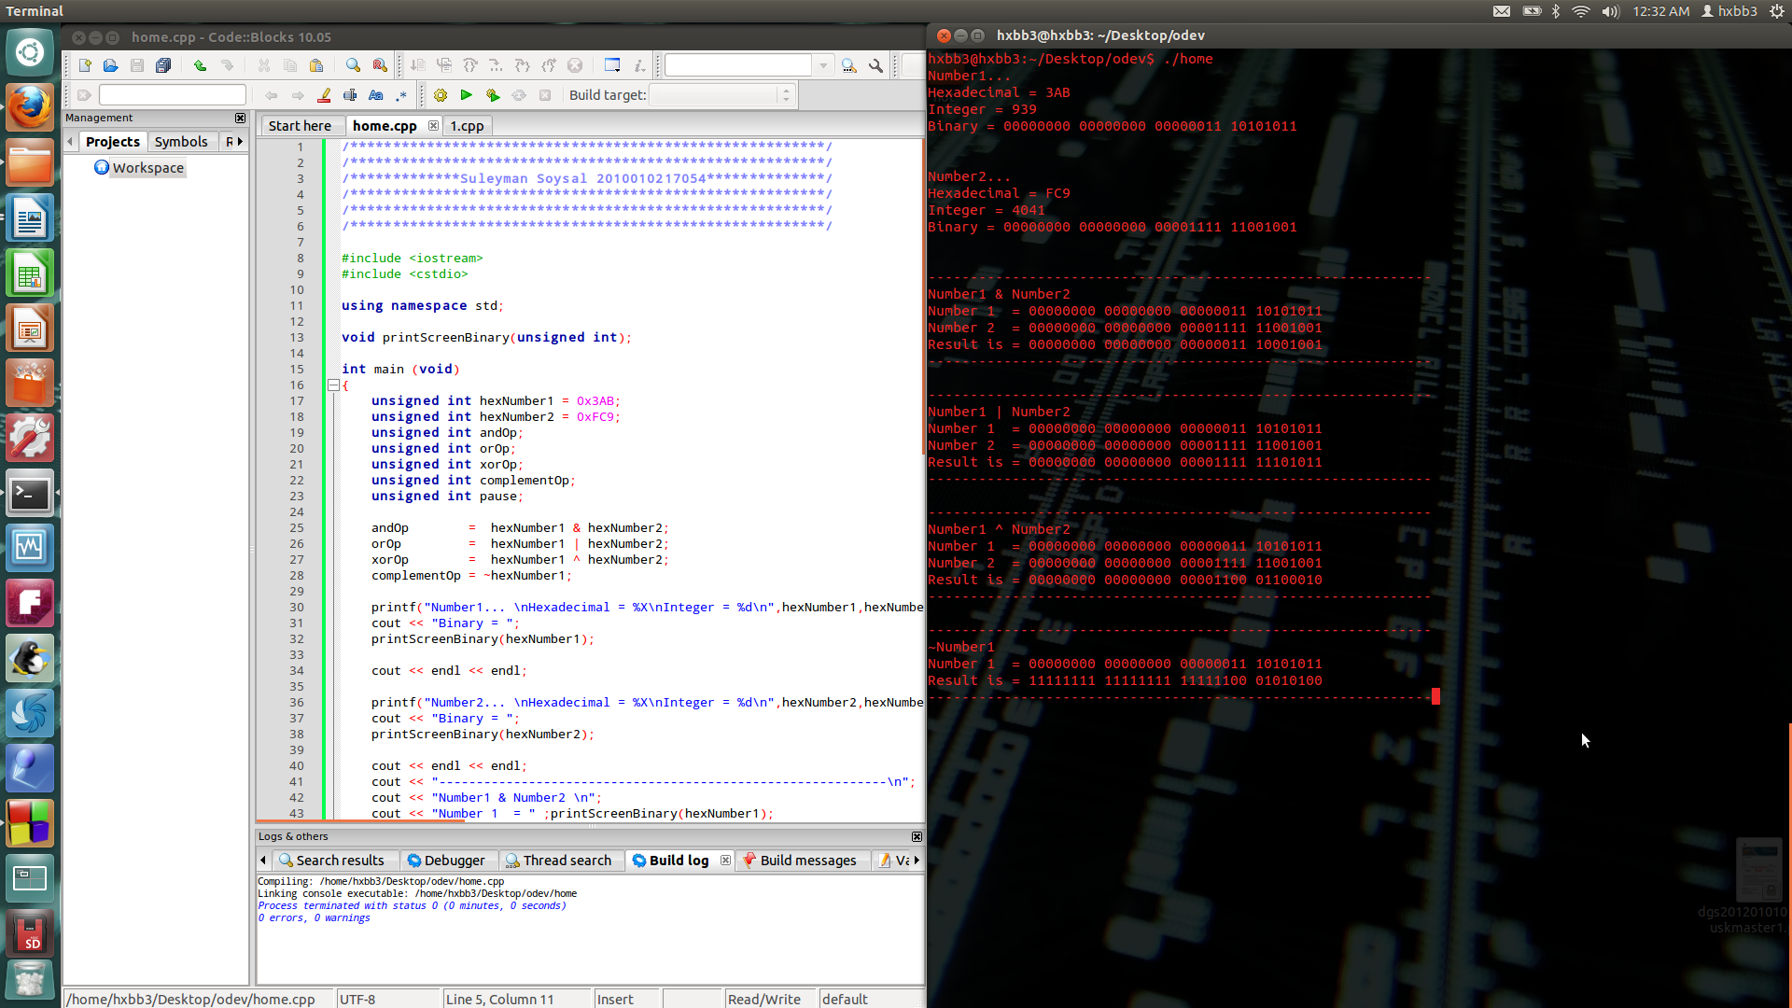

Screen shot 2 for program 2 :

