* **SUBJECT PM**
* **TOPIC:LSH(Locality Sensitive Hashing)IMPLEMENTAION**

**GROUP NO A\_9**

* **MEMBERS:**

**NIKHIL KEDAR 17u127**

**SOURABH KESHARWANI 17u355**

**ADARSH KHANDELWAL 17u102  
OMKAR KHANDELWAL 17u018**

**LSH(Locality Sensitive Hashing)IMPLEMENTAION**

Locality sensitive hashing (LSH) is one such algorithm. LSH has many applications, including:

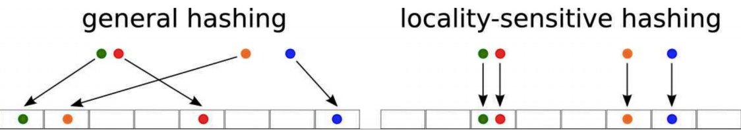

* Near-duplicate detection: LSH is commonly used to deduplicate large quantities of documents, webpages, and other files.
* Genome-wide association study: Biologists often use LSH to identify similar gene expressions in genome databases.
* Large-scale image search: Google used LSH along with PageRank to build their image search technology [VisualRank](https://research.google.com/pubs/pub34634.html" \t "_blank).
* Audio/video fingerprinting: In multimedia technologies, LSH is widely used as a fingerprinting technique A/V data.

**WORK BREAKDOWN STRUCTURE**