**PROJECT STRUCTURE AND CODE OVERVIEW**

**By Aniket Chakroborty**

**date- 11/10/2020**

Hi to all the awesome devs working on this project. In this document I am trying to explain the code overview and the project structure of our 2D RPG Fantasy game. Before we get started I assume that u have some knowledge with Godot(How Scenes and Nodes work, How Tileset works etc.). if not I strongly recommend you to check out the official documents of Godot or there are plenty of tutorials available on Youtube. Fork or Clone the **Project’s Master Branch from Github** and lets begin.

***1.Folder Structure:*** If you are an artist, a Dialogue maintainer, a sound dev or anyone knowing where all the files are and where to put something new is a must. That is why I have made a flow chart that will show you the full overview of the project folder structure.

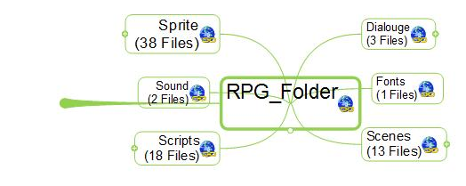

**Main Folder with Its SubFolders**

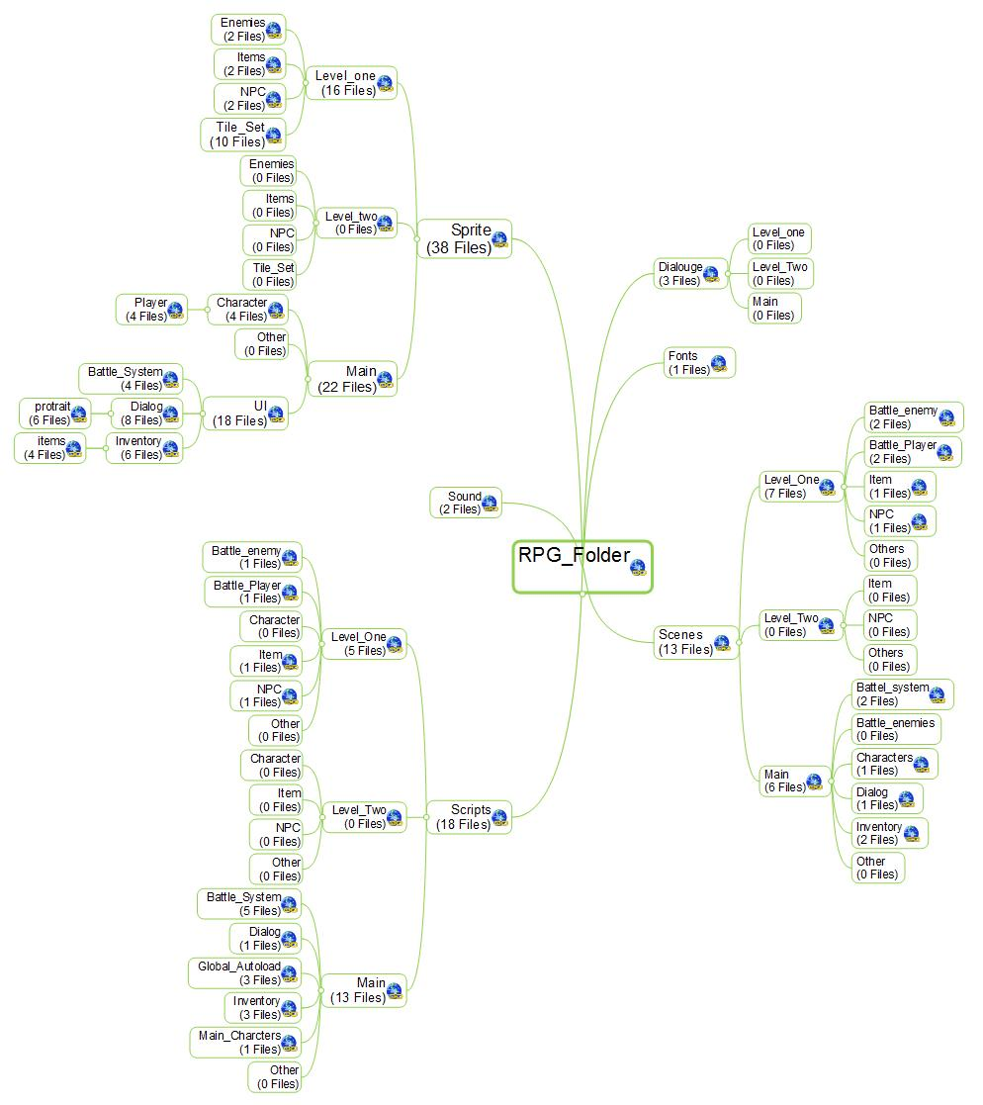

**The Whole Folder Structure**

I have done my best to draw this flow chart. If it is difficult to understand by looking go check out the folders of the project file and tally this with this chart and you will get an idea. But for starter Its very simple each department has its own folder. For example *We have a folder called Sprite which is for the art stuffs. Now Sprite has sub folders name main , level one etc. Main Sub-folder of the Sprite is for the main characters and things which will be universal through out the game. The Level folders are for individuals levels. Now Main Sub-Folder has its own Sub folders like for Ui / Characters etc. Like wise the Level-Sub folder has its own Sub Folders for particular things. This is true for every other folders like Scenes, Scripts , Sound etc. With some slight variations. If you go through the folders u will get a clear understanding of the structure. So If u have done something for example the main character art u now know where to put it.*

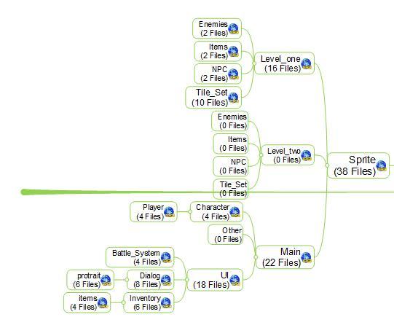

**Sprite Folder Structure**

**Why we have to use this detailed structure?:**- Because Godot is a very Path dependent Engine as far as coding is concerned. So suppose later in the development if we change or move assets here and there it will probably break the engine. So it is better from the start we maintain a strict folder structure to store and add assets and all the other stuffs.

**2.Code Overview:** Before you continue with this I assume u have some basic knowledge of Godot and its scripts. If not there are plenty of tutorials available for you to check. I will try my best to go thorough with this. As of now when I am writing there are these following feature than u can do with the Prototype – *1. You can Add Dialogue with quest and variations. 2. U can add an Battle system with multiple eneimes and Part(Max 3 For now), 3. U can add an Inventory System(No picking , throwing and using items from inventory yet.. I will impalement this as we go through the level 1 design)*

Now I will go through this how u can implement this on your own and use this to level design yourself.

**I. The Main Scene:** The main scene is anything which consist a level. Like Level_One, Dungeon, etc. One main scene can contains several NPCs, items , Quests , Dialogue with NPC’s etc.

Following is a demo main Scene where there is a dialogue system, a NPC, an Item for quest, Background etc.

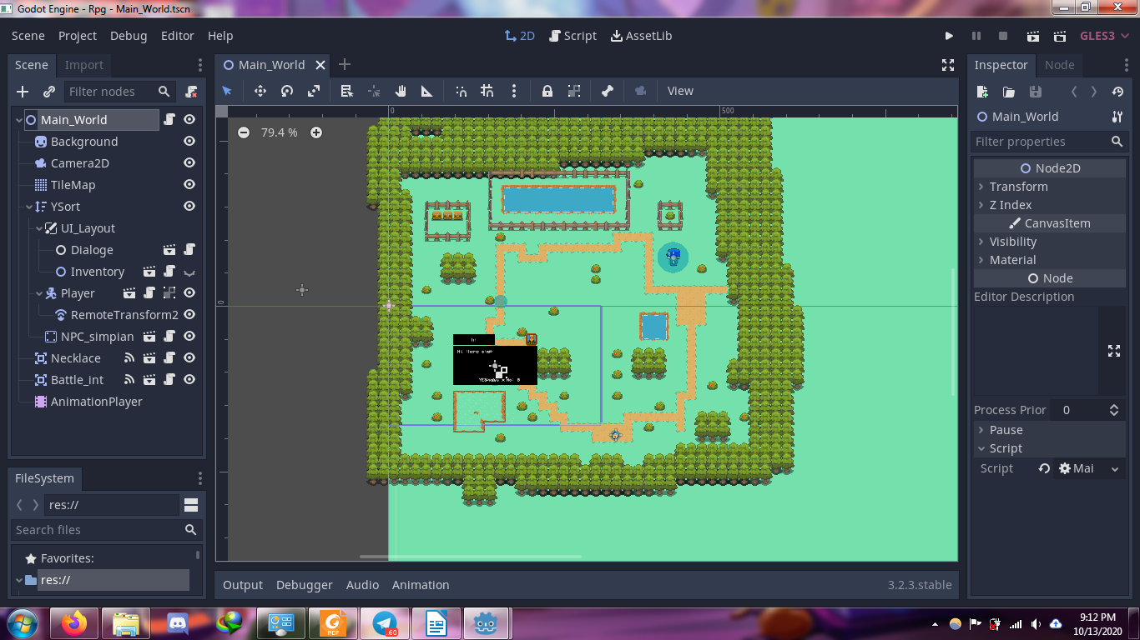

A Demo Main Scene Node Structure

U need to have someunderstanding with Godot Scene Structure to understand this. Here is an tutorial- https://www.youtube.com/watch?v=WUARiOGSGKY

**II. How to Initiate a battle :**  For now when u touch a specific object u will go through the battle scene. For exam in ourr main scene there is a node call **battle_int.** U can initiate this node on any scene and use this to trigger a battle. To initiate a battle u need to call a function into the **battle_int** node with 4 arguments. For an example if u want to initiate a battle when p[layer come close to the need u can use the area_enter signal and call - **GlobalBattle._update_battle_system(enemy_number,Party_number,enemy_type,player_type)**

enemy_number = Number of enemies in the battle

Party_number = Number of Players in the battle

enemy_type = This is an array of the enemy scenes path. U have to add path for every number of enemies u put

player_type = This is an array of the battle_player scenes path. U have to add path for every number of party memeber u put

what are the battle_enemy and battle_player I will talk about this later.

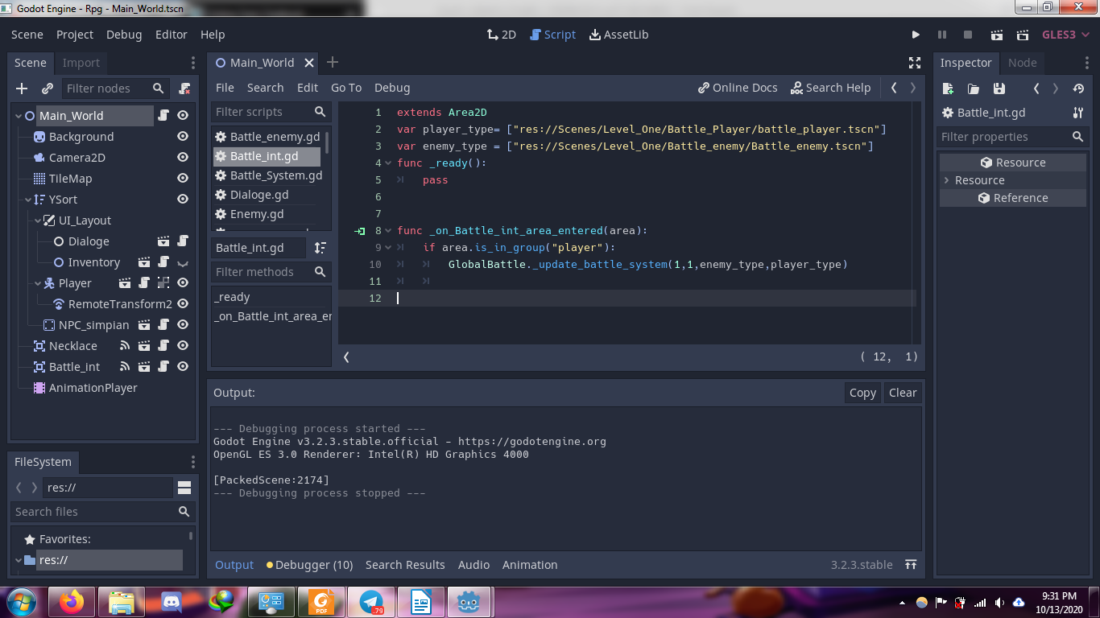

**An example Code of how to Initiate a Battle**

**III. What are Battle_enemy and Battle_player:**

Battle_Enemies: This are specific scene for each enemies u want that u will use in the battle.

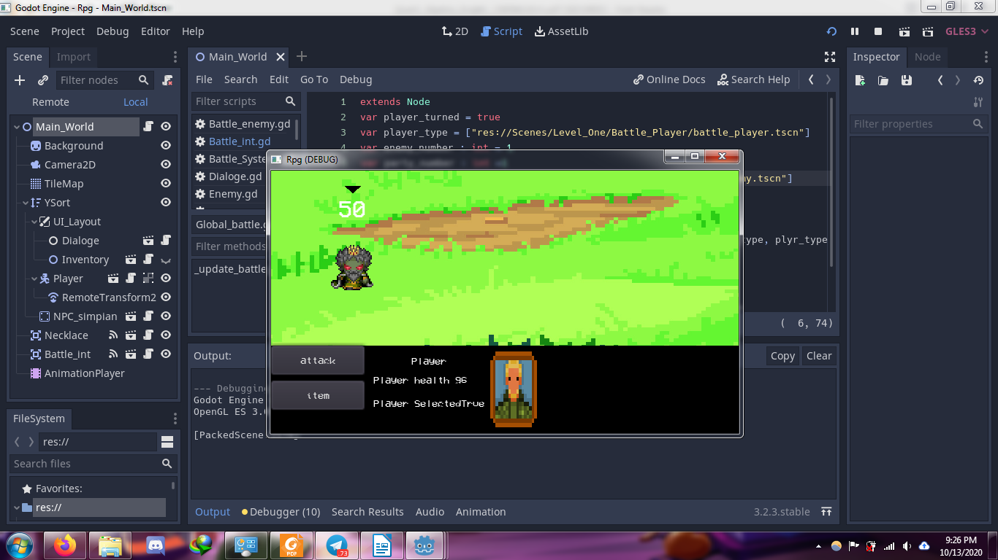

A u can find an example scene of the battle enemy in the C:\Users\COMRADE\Documents\GitHub\RPG\Scenes\Level_One\Battle_enemy . U can copy this scene and code change the image and initiate a battle using ur newly created battle_enemy scene path to check

Battle_Player : Same like Battle_player. U can find an example on C:\Users\COMRADE\Documents\GitHub\RPG\Scenes\Level_One\Battle_Player

**IV: How to add change background:** The background maybe created with Tileset node, Sprite Node etc. In this there is nothing much I can tell you with typing so here is are some Awesome tileset tutorials- https://www.youtube.com/watch?v=V9OoaOlXc_4&t=517s

https://www.youtube.com/watch?v=RPgTlxb7Bno&t=621s

https://www.youtube.com/watch?v=v75IMavnRUs&list=PL9FzW-m48fn2SlrW0KoLT4n5egNdX-W9a&index=7

**V:How to Initiate Dialogue:** I am using a plugin for Dialogue in Godot Called **Godot Dialogue System.**

Before you proceed you have to check out this video to learn about the plugin.- https://www.youtube.com/watch?v=P1wRejjKlLE&t=323s

After you watch this video created a dialouge here is how you initiate a dialogue-

For example to initiate a dialogue you need two arguments and called the function **DialogGlobal._requesting_dialog(_dialog_selection,"Opening")**

_dialog_selection: This is a string variable which will contain the path of the Baked Dialogue File.

“Opening” : This is a string which is the name of the Dialogue you want to play.

You can check out the prototype to see the demo Dialogue I have made to get a better understanding. And U must have watch the video above.

For Format and Syntax that have to maintain for Dialogue below are the links you must watch -

<https://www.youtube.com/watch?v=YrjDsC4gRZ8&t=565s> (Basic)

<https://www.youtube.com/watch?v=0TPhkknHdhk> (Branching

<https://www.youtube.com/watch?v=IsBlXNFifO4> (Syntax For Texture )

You don't have to go through full video . Just watch the part where he is talking about the Syntax and formating.

After u have watched those here is a full syntax of a single sentence of a particular Dialogue:

**<speaker>Simponi</speaker>**

**<dialog>I have never seen you before!! Are u a foreginer?</dialog>**

**<choiceJSON>{"Yes": 0, "No" : 1}</choiceJSON>**

**<image>Simponi</image>**

A single sentence means a complete sentence that will show on the dialogue box at a time.

**VI. How to add/Create NPC :** A NPC is a Static Body node with some typical nodes as his Child. Its a very simple node. U can find an example on C:\Users\COMRADE\Documents\GitHub\RPG\Scenes\Level_One\NPC. Copy it instantiate it on ur level. This particular example also show how to interact NPC with Dialogue.

**END:** I think I have covered most of the important part. I never write this kind of things. So please forgive any mistake that I have made. Feel Free to ask if u have any confusion.