Fiora’s Adventure Through 11 Dimensions
(Name is Not Finalized Yet)
A Fantasy 2D RPG Game for PC
A Game Design Documents
Author- Aniket Chakroborty Last Edited-10/04/2020

I. Game Overview
A. Plot: (Not Fixed Yet) The world of our story is Spirit Realm. There are Godds that are from the 5thdimension. They are higher dimension beings having a lot of power that lower dimensional beings can’t comprehend or ever hope to achieve. A5thdimensional being cannotenter the Spirit Realm because of the protection of The Spirit Energy Barrier. But a Spirit Realmindividual can become a 5thdimensional being with accumulation of enough knowledge and power. In the time of Old Godds, many individuals have ascended the Spirit Realm to become higher dimensional beings. As time went on, the higher dimensional beings started to formtheirown communities which eventually evolved into two factions, viz.the Nether faction and the Verdant Faction.Due to their differences in ideologies, they used to get into frequent clashes and this eventually turned into hatred to the point that they can stoop to any lows to kill the other faction’s member.Althoughthe Godds can’t descend into the lower realm, they can project their energyand do miracles, interact with the mortals, etc.
The Spirit Realm had no issues until one day a man named X (Lucifer??), a mortal, starts to gain powers that approaches a 5thdimensional being. He can go to any length for powers, but he has his own code and moral values to which he sticks. Lucifer is secretlybeing guided by the Nether faction.This was of no concern to the Verdant factionuntil Lucifer stumbled across the Testament of the old Godds,a sacred text that wasbelieved to have been deleted from the annals of history. The testament had hidden secrets that can be deciphered to reach a realm higher than the 6thRealm, a power wieldedby only the threeProtoGoddsand no other being.If Lucifer gains enough power to transcend into a5thDimensional being, he will be unstoppable as he can escape into the vast cosmos, allthe while gainingmore power and this made the Godds feel threatened. But, the Verdant factioncan’tinterfere into the Spirit Realm directly.They divided their energy into many parts and fused each part with a child.Inthe current storyline, Just like Fiora, a lot of kids are born throughout the Realm, (I will call them something later on, demigodds or something like that).
Their job is to create a portal with their energies absorbed from the Spirit Realm itself, thereby removing the barriersfor these Godds. Once they descended, they could kill Lucifer anytime. But right now, time is of the essence.The News of Lucifer having the Testament of the old Goddshas the verdant faction spring into action.There is a risk for the Godds to separate their energy like this as they will be weak for that period of time and if a part of their energy (Demigodd) dies inside the Spirit Realm, the energy will get trapped into the Spirit Realm itself,never to be attained by the Godds. But as the stakes stand currently, they have no choice but to take the risk of losing their energy forever.

Name: (Not Fixed Yet) Fiora’s Adventure Through 11 Dimensions

II. Core Gameplay
A. Main Game View: This game will be a 2d Top down RPG game for PC. Below is an example of how the game will look.
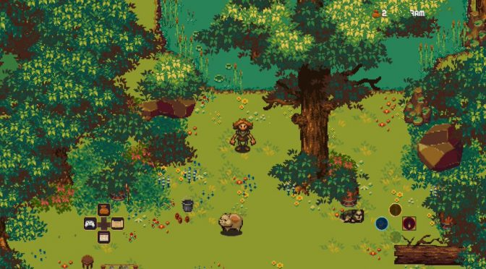
Your Task Will be complete quest, progress through level, Defeat Enemies,complete achievements. The game play and mechanics will be heavily depend on the way the story progress and how our writer feel.

B. Core Player Activity: The basic theme of the game play will be Interacting with NPC, Complete main quests and side quests, Defeat Bosses, Defeat Enemies(What will be our battle system and how we implement this will depend on the story),get items for inventory, Use items to unlock new levels / powers.

C. Game Controls: The game controls will be same as any other typical 2d RPG games. Here is an example of how the movement controls and interaction may look.

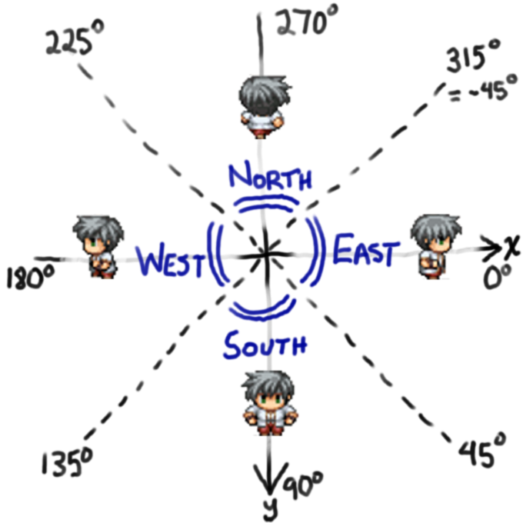
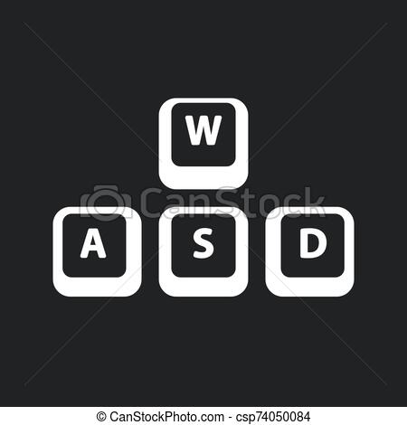
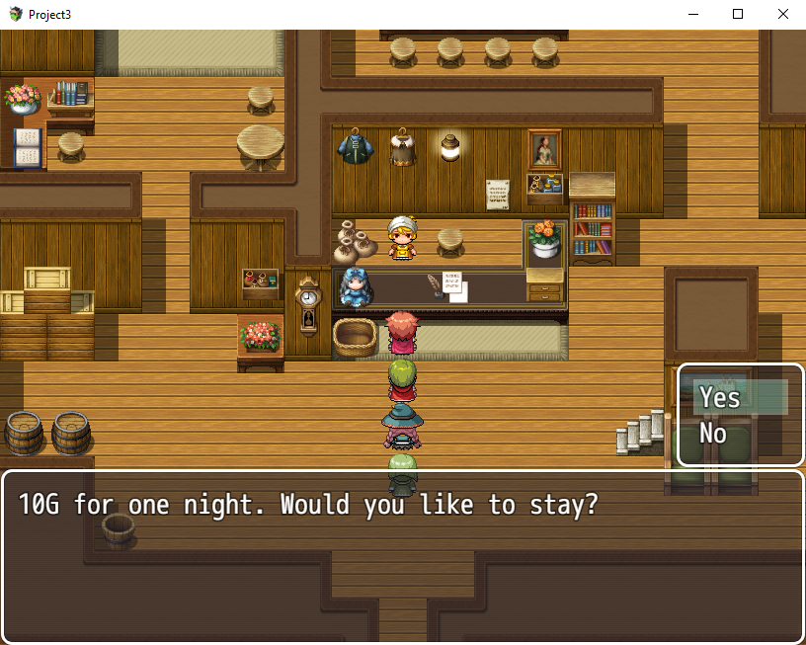


You get the idea. The keyboard bindings and movement will be same as typical 2d rpg game. In future we can also add the ability to customize the controls.

D. Game Interaction and Quest: As like all 2d rpg game we will have NPCs , We have conversation with the NPCs, we will get new quest. Some quest gives you essential items which can be used to progress through levels, some quest will give you items that can grant u special power etc.

NPC:

I. Main NPCs: One have to interact with this guys if they want to proceed further

II Pace-holder NPCs: One can ignore them.

Iii Side NPCs: They are also optional but interacting with them might give you special power

Quest:

I Main Quest: Mandatory for level progression

II Side Quest : one can ignore them but completing these will grant special items/power

E. Inventory: We will have an Inventory. It will Hold stuffs like special items,keys,Health Potions etc. An example of how the inventory will look.

F. Shop System: As the story is not finished yet I don't know if we will exactly implement a shop system per say. But we should have a similar thing like this. With shop one can buys items like health portion, mana portion, +atck, +def items etc. Here is and example of a shop and a shop interface.

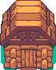

G. Economy: Now this is also another thing which can not be said for sure how we implement until the story is finished. But an economy means simply something by which u can buy stuff from shop. You will get Coins/Gems/Crystal buy killing enemies or by completing quests.

H. Enemies and Battle System: I am not sure about the mechanics of the battle system yet but here are some popular RPG games and their version of battle system. We will fix this after discussion maybe later in the way.

Or we can use mini games as battle system like if we complete that game we will defeat the enemies. Some mini game examples--

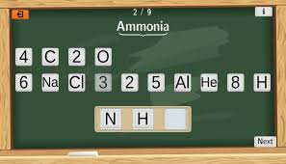

For enemies and enemy types this will be depend on our writer guy.

I. Game Levels and Level Progression: This is also a thing which can only be fixed after our writers fixed how they want to develop it. But as for a basic understanding there will be no level 1 , level 2 in our game. It will be more like a seamless story progression. One will move one world to another. One will enter dungeons complete a quest return back to their village…. U get the idea.

J. Misc Stuffs : Feel free to edit this GDD if you think something need to change or you want to add something.

IV. Development related Stuff:

A. Platform : This game will be developed for PC. IF we get enough players and love we may be add MOBILE support for the game.

B. Monetisation and Published Platform: This is a topic for discussion. Various options are their which we will discuss along the path of the development.

V. What Should We work on now:

A. Writing Related:

1. Fixed a Blue Print Of the story/lore.
2. Develop ideas how the interactions with NPC, Quest , Shop System, Inventory Will Look like.
3. Types of enemies/bosses. How one will involve with the enemies/bosses.
4. How Quest should look like.
5. Dialogue writing .
6. Cut scene Dialogues
7. Feel Free to add things here

B. Graphics Related:
1. Art style
2.UI style
3. Character and Fonts
4. Add Things here

C. Sound Related:

1. Music and Sfx
2.Add Things Here

D. Coding Related:

A general Prototype for now which includes
1. Player Movement
2. Interaction with NPC
3. Quest
4. Basic Inventory System

V. Last but not the least :

Every one Must have somekind of understanding with Trello and github. Below are the link for both. U have to join.

Trello - https://trello.com/invite/b/AJKxfR4L/26a22ea79d0e6a7cf579ff0534f67ec0/2d-fantasy-rpg

Github- https://github.com/titangamingglt/RPG

Feel free to edit, add stuff to this GDD.

And Finally I want to thank everyone who join this adventure of game development. Every word I say to thank you will not be enough.

