**Week 7**

**Hands-On Exercise 9: ES6 Features in React**

**Exercise 1: ES6 Features (map(), filter(), Destructuring, Spread Syntax)  
  
Scenario:** You need to create a React application named "cricketapp" with two components: ListOfPlayers and IndianPlayers. These components will demonstrate core ES6 features to handle player data. The home page will conditionally display one of these components based on a flag variable.

***ListOfPlayers.js:***    import React from 'react';  
    const ListOfPlayers = () => {  
      const players = [

        { name: 'Virat Kohli', score: 120 },

        { name: 'Rohit Sharma', score: 45 },

        { name: 'Shubman Gill', score: 80 },

        { name: 'KL Rahul', score: 110 },

        { name: 'Hardik Pandya', score: 65 },

        { name: 'Ravindra Jadeja', score: 90 },

        { name: 'Rishabh Pant', score: 30 },

        { name: 'Jasprit Bumrah', score: 5 },

        { name: 'Mohammed Shami', score: 12 },

        { name: 'Yuzvendra Chahal', score: 8 },

        { name: 'Shardul Thakur', score: 55 }

      ];

      const playersBelow70 = players.filter(player => player.score < 70);

      return (

        <div style={{ padding: '20px' }}>

          <h2>All Players & Scores</h2>

          <ul style={{ listStyleType: 'none', padding: '0' }}>

            {players.map((player, index) => (

              <li key={index} style={{ marginBottom: '10px' }}>

                <strong>{player.name}</strong>: {player.score}

              </li>

            ))}

          </ul>

          <hr />

          <h2>Players with Scores Below 70</h2>

          <ul style={{ listStyleType: 'none', padding: '0' }}>

            {playersBelow70.map((player, index) => (

              <li key={index} style={{ color: 'red', marginBottom: '10px' }}>

                <strong>{player.name}</strong>: {player.score}

              </li>

            ))}

          </ul>

        </div>

      );

    };

    export default ListOfPlayers;

***IndianPlayers.js:***

    import React from 'react';

const IndianPlayers = () => {

  const indianTeam = [

    'Virat Kohli', 'Rohit Sharma', 'Hardik Pandya', 'Jasprit Bumrah',

    'Rishabh Pant', 'Ravindra Jadeja', 'Shubman Gill', 'Mohammed Shami'

  ];

  const [

    oddPlayer1, oddPlayer2, oddPlayer3, oddPlayer4,

    evenPlayer1, evenPlayer2, evenPlayer3, evenPlayer4

  ] = indianTeam.map((player, index) => ({ player, index: index + 1 }));

  const T20players = ['Surya Kumar Yadav', 'Sanju Samson'];

  const RanjiTrophyPlayers = ['Sarfaraz Khan', 'Mayank Agarwal'];

  const mergedPlayers = [...T20players, ...RanjiTrophyPlayers];

  return (

    <div style={{ padding: '20px' }}>

      <h2>Indian Team Players (Destructuring)</h2>

      <div style={{ display: 'flex', justifyContent: 'space-around' }}>

        <div>

          <h3>Odd Team Players</h3>

          <ul>

            <li>{oddPlayer1.player}</li>

            <li>{oddPlayer2.player}</li>

            <li>{oddPlayer3.player}</li>

            <li>{oddPlayer4.player}</li>

          </ul>

        </div>

        <div>

          <h3>Even Team Players</h3>

          <ul>

            <li>{evenPlayer1.player}</li>

            <li>{evenPlayer2.player}</li>

            <li>{evenPlayer3.player}</li>

            <li>{evenPlayer4.player}</li>

          </ul>

        </div>

      </div>

      <hr />

      <h2>Merged Players (T20 & Ranji)</h2>

      <ul>

        {mergedPlayers.map((player, index) => (

          <li key={index}>{player}</li>

        ))}

      </ul>

    </div>

  );

};

export default IndianPlayers;

***App.js:***

    import React from 'react';

import './App.css';

import ListOfPlayers from './components/ListOfPlayers.js';

import IndianPlayers from './components/IndianPlayers.js';

function App() {

  const flag = true;

  return (

    <div className="App">

      <h1>Cricket App Dashboard</h1>

      {flag ? (

        <ListOfPlayers />

      ) : (

        <IndianPlayers />

      )}

    </div>

  );

}

export default App;

***Output:***

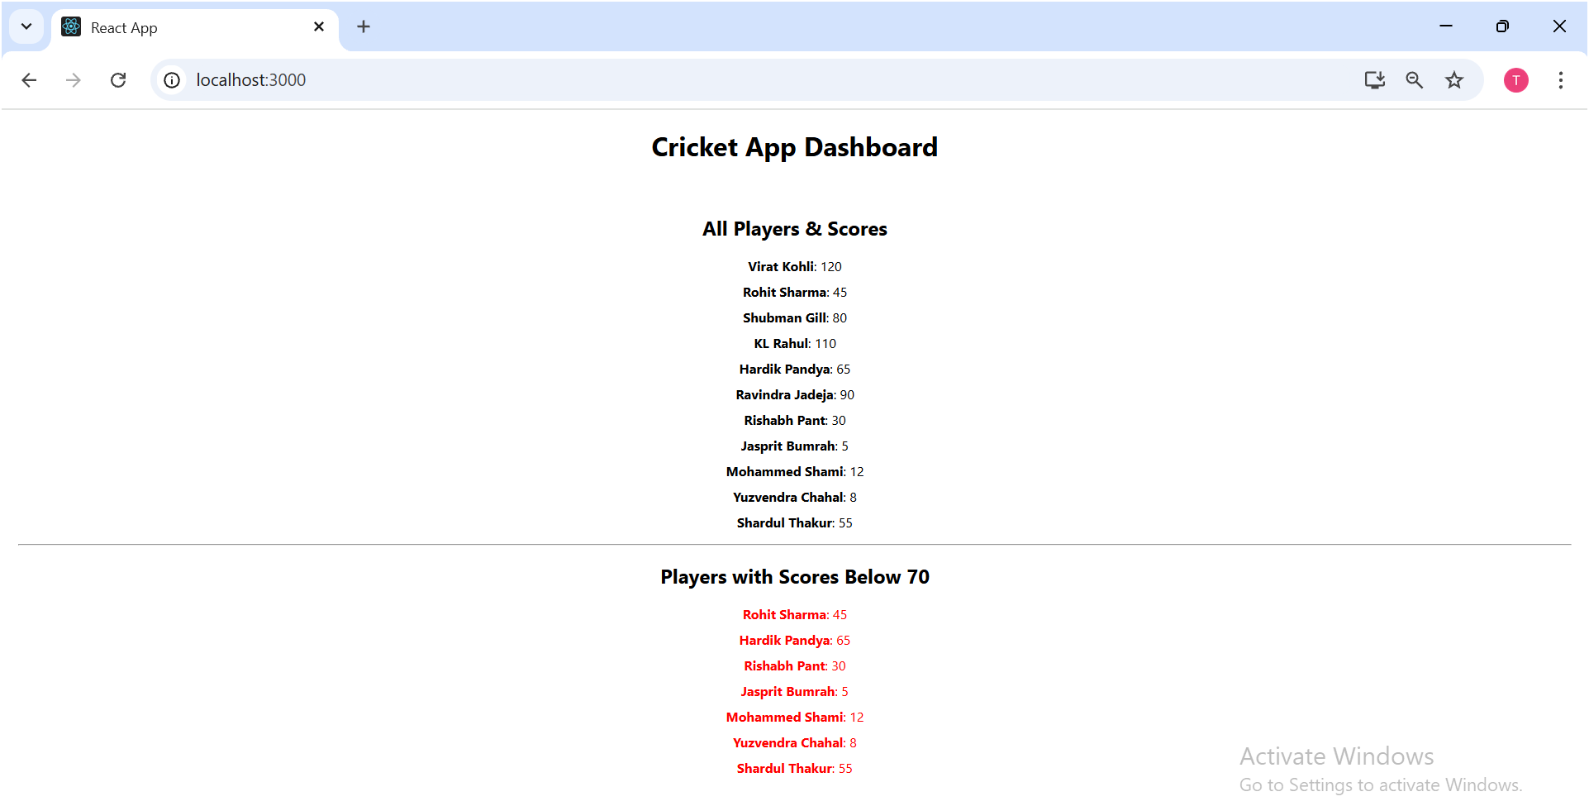

**Hands-On Exercise 10: JSX Fundamentals and Styling**

**Scenario:** You need to create a React application named officespacerentalapp to display office space details. The application should use JSX to create elements, display an image, show details from an object, loop through a list of objects, and apply conditional inline CSS based on rent.

***App.js:***import React from 'react';

import './App.css';

const OFFICE_IMAGE_URL = "./src/office.png";

function App() {

  const pageHeading = "Office Space";

  const officeImage = (

    <img

      src={OFFICE_IMAGE_URL}

      width="25%"

      height="25%"

      alt="Office Space"

      style={{

        maxWidth: '300px',

        height: 'auto',

        borderRadius: '8px',

        boxShadow: '0 2px 4px rgba(0,0,0,0.1)'

      }}

    />

  );

  const singleOffice = {

    Name: "DBS",

    Rent: 50000,

    Address: "Chennai"

  };

  const officeList = [

    { Name: "Tech Hub", Rent: 75000, Address: "Bangalore" },

    { Name: "Innovate Co-Work", Rent: 45000, Address: "Hyderabad" },

    { Name: "Global Towers", Rent: 90000, Address: "Mumbai" },

    { Name: "City Center Offices", Rent: 58000, Address: "Delhi" }

  ];

  return (

    <div className="App" style={{ textAlign: 'center', padding: '20px' }}>

      <h1>{pageHeading}, at Affordable Range</h1>

      {officeImage}

      <hr style={{ margin: '30px auto', width: '50%' }} />

      <div style={{ marginBottom: '40px' }}>

        <h2>Single Office Details:</h2>

        <h3>Name: {singleOffice.Name}</h3>

        <h3 style={{ color: singleOffice.Rent < 60000 ? 'red' : 'green' }}>

          Rent: Rs. {singleOffice.Rent}

        </h3>

        <h3>Address: {singleOffice.Address}</h3>

      </div>

      <hr style={{ margin: '30px auto', width: '50%' }} />

      <h2>More Office Spaces:</h2>

      <div style={{ display: 'flex', flexWrap: 'wrap', justifyContent: 'center', gap: '20px' }}>

        {officeList.map((office, index) => (

          <div key={index} style={{

            border: '1px solid #ddd',

            padding: '15px',

            borderRadius: '8px',

            boxShadow: '0 2px 5px rgba(0,0,0,0.1)',

            width: '280px',

            textAlign: 'left',

            backgroundColor: '#f9f9f9'

          }}>

            <h3>Name: {office.Name}</h3>

            <h3 style={{ color: office.Rent < 60000 ? 'red' : 'green' }}>

              Rent: Rs. {office.Rent}

            </h3>

            <h3>Address: {office.Address}</h3>

          </div>

        ))}

      </div>

    </div>

  );

}

export default App;

***Output:***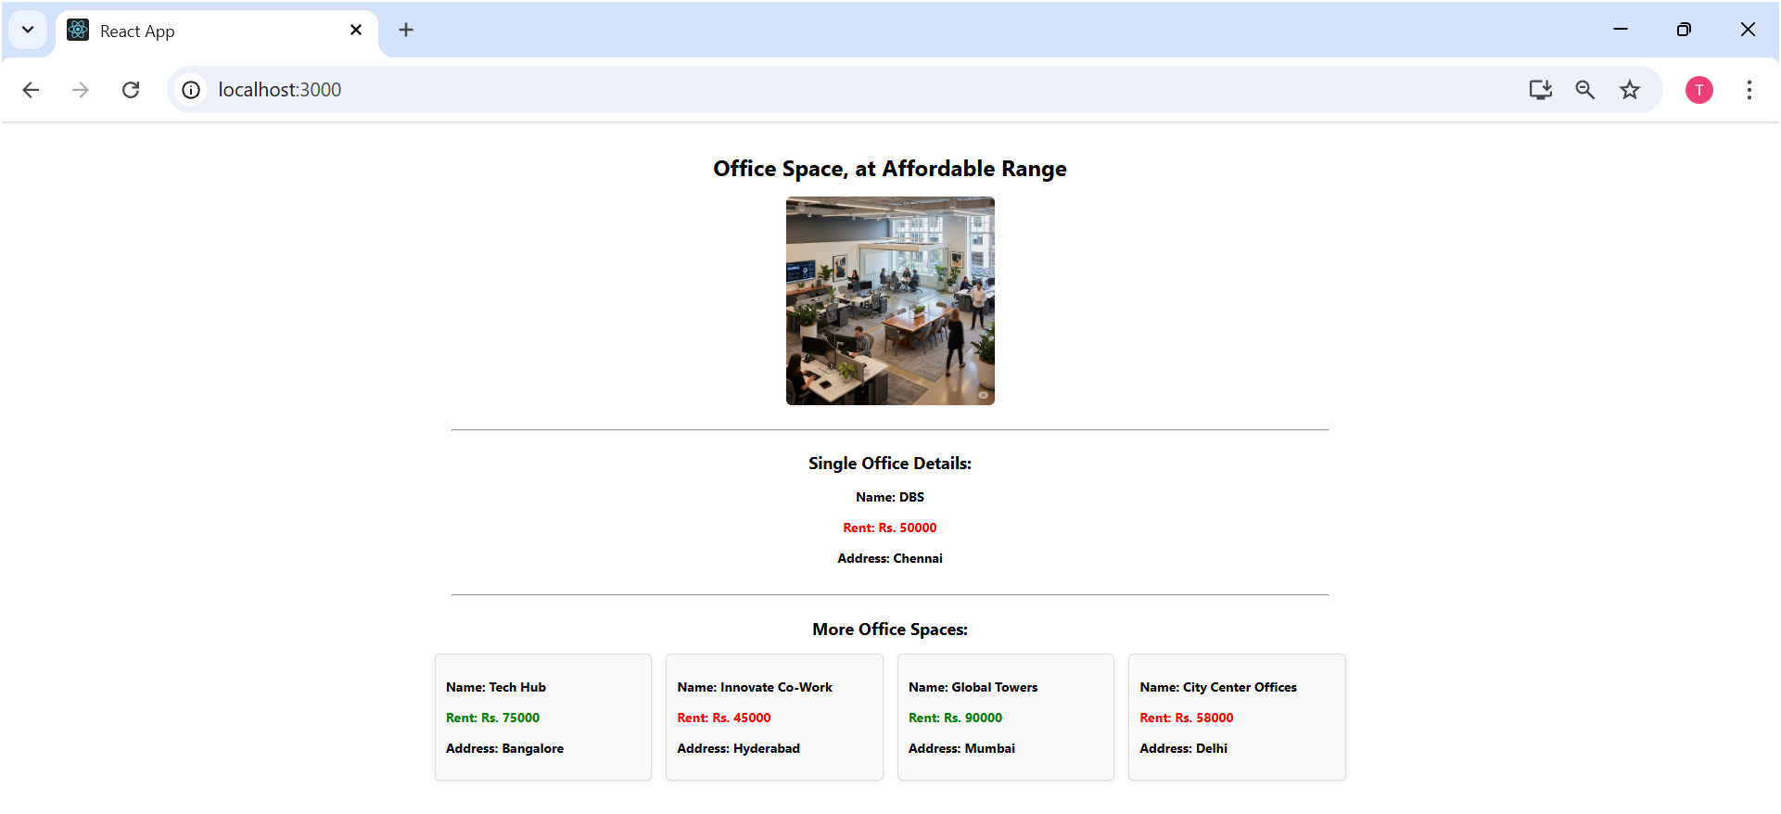

**Hands-On Exercise 11: React Events and Event Handling**

**Scenario:** You need to create a React application named eventexamplesapp to demonstrate various event handling concepts, including button clicks, counter manipulation, passing arguments to event handlers, and a currency converter.  
  
***Counter.js:***

    import React from 'react';

class Counter extends React.Component {

  constructor(props) {

    super(props);

    this.state = {

      count: 0,

      inputValue: '',

      isHovered: false

    };

    this.increment = this.increment.bind(this);

    this.decrement = this.decrement.bind(this);

    this.sayHello = this.sayHello.bind(this);

    this.handleInputChange = this.handleInputChange.bind(this);

    this.handleMouseEnter = this.handleMouseEnter.bind(this);

    this.handleMouseLeave = this.handleMouseLeave.bind(this);

  }

  increment() {

    this.setState(prevState => ({

      count: prevState.count + 1

    }));

    console.log('Counter Incremented:', this.state.count + 1);

  }

  decrement() {

    this.setState(prevState => ({

      count: prevState.count - 1

    }));

    console.log('Counter Decremented:', this.state.count - 1);

  }

  sayHello() {

    alert("Hello! Member1");

    console.log("Say Hello method invoked.");

  }

  handleIncrementAndSayHello = () => {

    this.increment();

    this.sayHello();

  }

  handleInputChange(event) {

    this.setState({ inputValue: event.target.value });

    console.log('Input value changed:', event.target.value);

  }

  handleMouseEnter() {

    this.setState({ isHovered: true });

    console.log('Mouse entered counter area');

  }

  handleMouseLeave() {

    this.setState({ isHovered: false });

    console.log('Mouse left counter area');

  }

  handleKeyPress = (event) => {

    if (event.key === 'Enter') {

      const value = parseInt(this.state.inputValue);

      if (!isNaN(value)) {

        this.setState(prevState => ({

          count: prevState.count + value,

          inputValue: ''

        }));

        console.log(`Added ${value} to counter via Enter key`);

      }

    }

  }

  handleDoubleClick = () => {

    this.setState({ count: 0 });

    console.log('Counter reset via double click');

  }

  render() {

    const { count, inputValue, isHovered } = this.state;

    return (

      <div

        style={{

          margin: '20px',

          padding: '15px',

          border: '1px solid #ccc',

          borderRadius: '8px',

          textAlign: 'center',

          backgroundColor: isHovered ? '#f0f0f0' : 'white',

          transition: 'background-color 0.3s ease'

        }}

        onMouseEnter={this.handleMouseEnter}

        onMouseLeave={this.handleMouseLeave}

      >

        <h2 onDoubleClick={this.handleDoubleClick} style={{ cursor: 'pointer' }}>

          Counter: {count} {isHovered && '(Hovered!)'}

        </h2>

        <p style={{ fontSize: '12px', color: '#666' }}>

          Double-click the counter to reset

        </p>

        <div style={{ margin: '10px 0' }}>

          <input

            type="number"

            value={inputValue}

            onChange={this.handleInputChange}

            onKeyPress={this.handleKeyPress}

            placeholder="Enter number and press Enter"

            style={{

              margin: '5px',

              padding: '8px',

              borderRadius: '4px',

              border: '1px solid #ccc',

              width: '200px'

            }}

          />

        </div>

        <div>

          <button

            onClick={this.handleIncrementAndSayHello}

            style={{

              margin: '5px',

              padding: '10px 20px',

              backgroundColor: '#4CAF50',

              color: 'white',

              border: 'none',

              borderRadius: '5px',

              cursor: 'pointer'

            }}

          >

            Increment & Say Hello

          </button>

          <button

            onClick={this.increment}

            style={{

              margin: '5px',

              padding: '10px 20px',

              backgroundColor: '#2196F3',

              color: 'white',

              border: 'none',

              borderRadius: '5px',

              cursor: 'pointer'

            }}

          >

            Increment

          </button>

          <button

            onClick={this.decrement}

            style={{

              margin: '5px',

              padding: '10px 20px',

              backgroundColor: '#f44336',

              color: 'white',

              border: 'none',

              borderRadius: '5px',

              cursor: 'pointer'

            }}

          >

            Decrement

          </button>

        </div>

      </div>

    );

  }

}

export default Counter;

***App.js:***

import React from 'react';

import './App.css';

import Counter from './components/Counter';

const App = () => {

  const sayWelcome = (message) => {

    alert(message);

    console.log(`Say Welcome method invoked with message: "${message}"`);

  }

  const handleClick = (event) => {

    alert("I was clicked");

    console.log("Button clicked:", event.target.textContent);

    console.log("Synthetic Event Type:", event.type);

  }

  const handleRightClick = (event) => {

    event.preventDefault(); // Prevent context menu

    alert("Right click detected!");

    console.log("Right click event:", event.type);

  }

  const handleFormSubmit = (event) => {

    event.preventDefault();

    const formData = new FormData(event.target);

    const email = formData.get('email');

    alert(`Form submitted with email: ${email}`);

    console.log("Form submission prevented and handled");

  }

  const handleFocus = (event) => {

    event.target.style.backgroundColor = '#e3f2fd';

    console.log("Input focused");

  }

  const handleBlur = (event) => {

    event.target.style.backgroundColor = 'white';

    console.log("Input blurred");

  }

  const handleChange = (event) => {

    console.log("Input value changed to:", event.target.value);

  }

  return (

    <div className="App" style={{ padding: '20px', maxWidth: '800px', margin: '0 auto' }}>

      <h1>Event Handling Examples</h1>

      <Counter />

      <div style={{ margin: '20px 0', padding: '15px', border: '1px solid #ddd', borderRadius: '8px' }}>

        <h3>Button Events</h3>

        <button

          onClick={() => sayWelcome("welcome")}

          style={{ margin: '5px', padding: '10px 20px', backgroundColor: '#4CAF50', color: 'white', border: 'none', borderRadius: '5px', cursor: 'pointer' }}

        >

          Say Welcome

        </button>

        <button

          onClick={handleClick}

          style={{ margin: '5px', padding: '10px 20px', backgroundColor: '#008CBA', color: 'white', border: 'none', borderRadius: '5px', cursor: 'pointer' }}

        >

          Click on me

        </button>

        <button

          onContextMenu={handleRightClick}

          style={{ margin: '5px', padding: '10px 20px', backgroundColor: '#ff9800', color: 'white', border: 'none', borderRadius: '5px', cursor: 'pointer' }}

        >

          Right Click Me

        </button>

      </div>

      <div style={{ margin: '20px 0', padding: '15px', border: '1px solid #ddd', borderRadius: '8px' }}>

        <h3>Form Events</h3>

        <form onSubmit={handleFormSubmit} style={{ display: 'flex', flexDirection: 'column', gap: '10px', maxWidth: '300px' }}>

          <input

            type="email"

            name="email"

            placeholder="Enter your email"

            onFocus={handleFocus}

            onBlur={handleBlur}

            onChange={handleChange}

            style={{ padding: '8px', borderRadius: '4px', border: '1px solid #ccc' }}

            required

          />

          <button

            type="submit"

            style={{ padding: '10px', backgroundColor: '#9c27b0', color: 'white', border: 'none', borderRadius: '5px', cursor: 'pointer' }}

          >

            Submit Form

          </button>

        </form>

        <p style={{ fontSize: '12px', color: '#666', marginTop: '10px' }}>

          Try focusing/blurring the input field and submitting the form

        </p>

      </div>

    </div>

  );

}

    export default App;

***Output:***

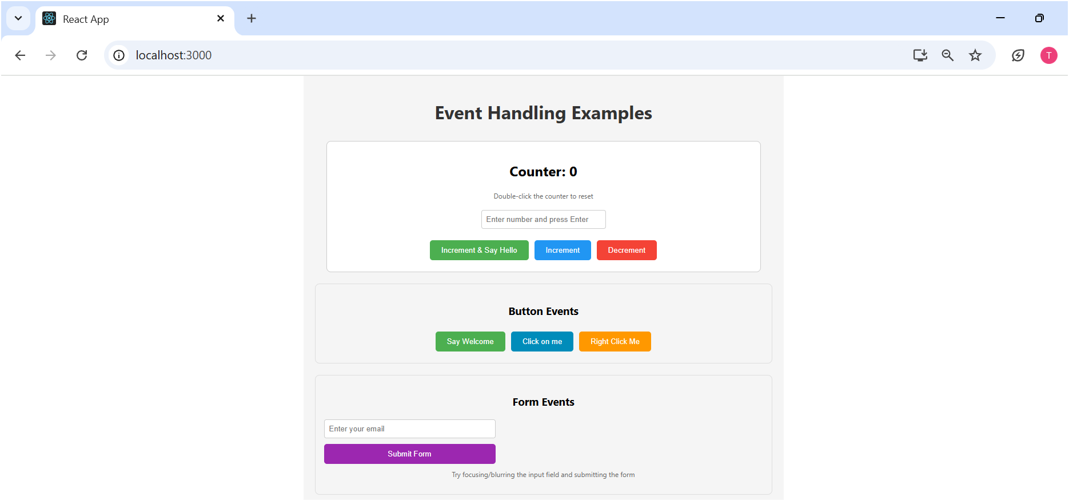

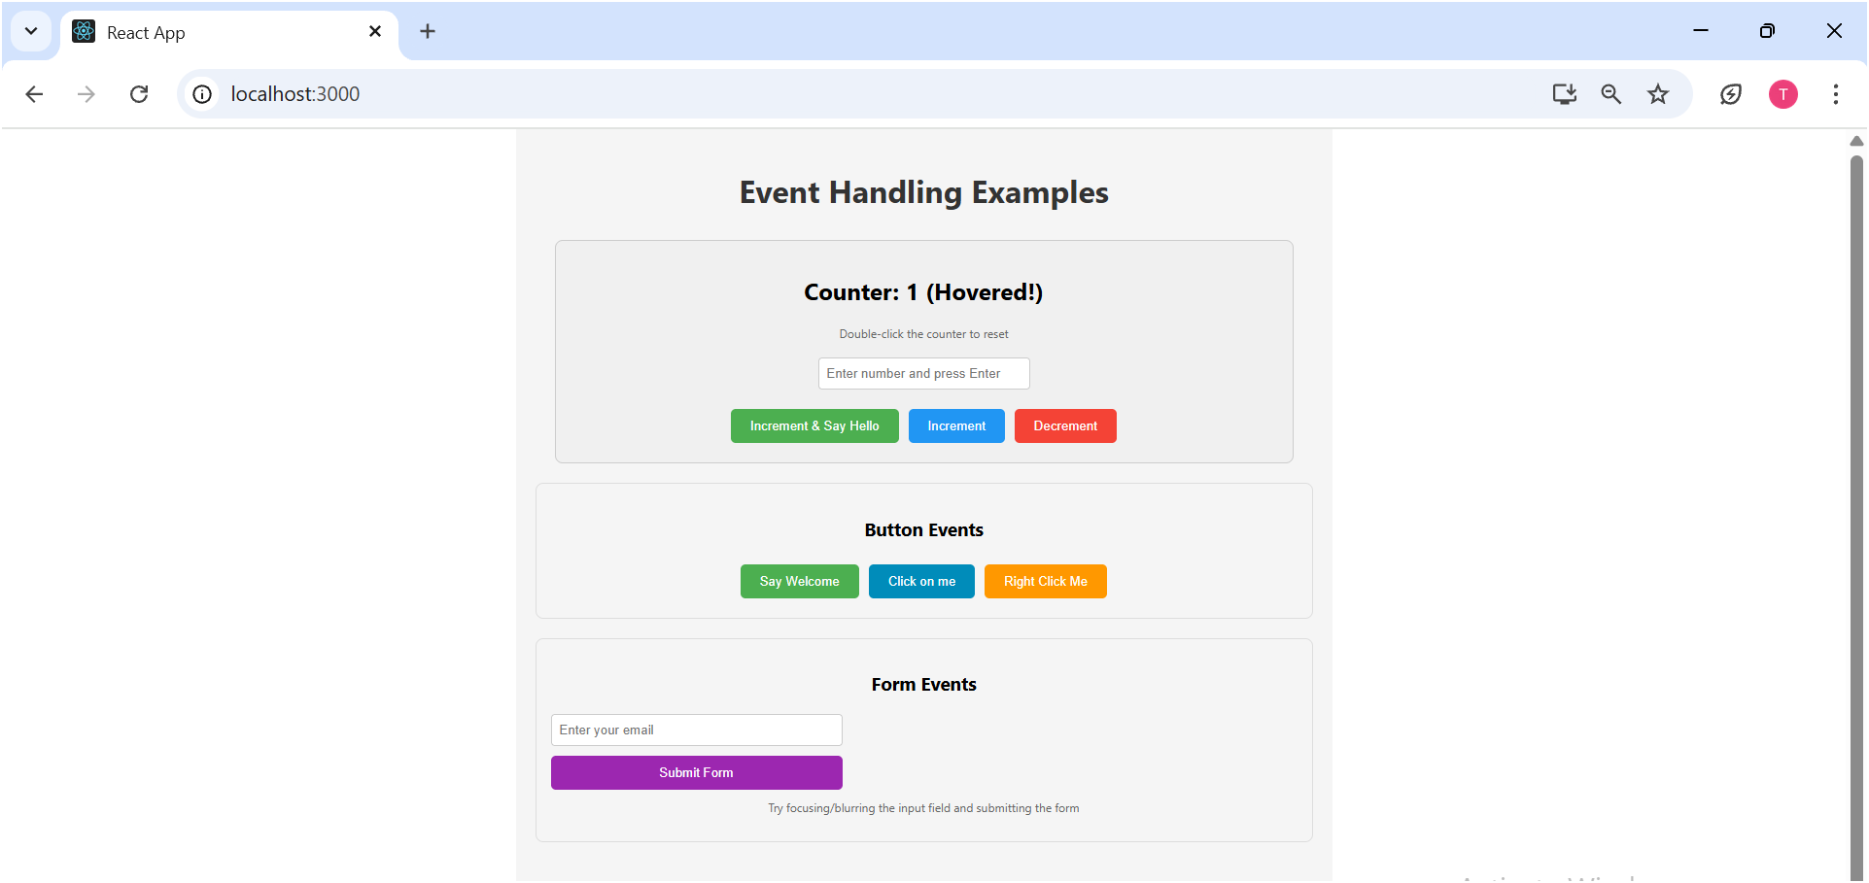

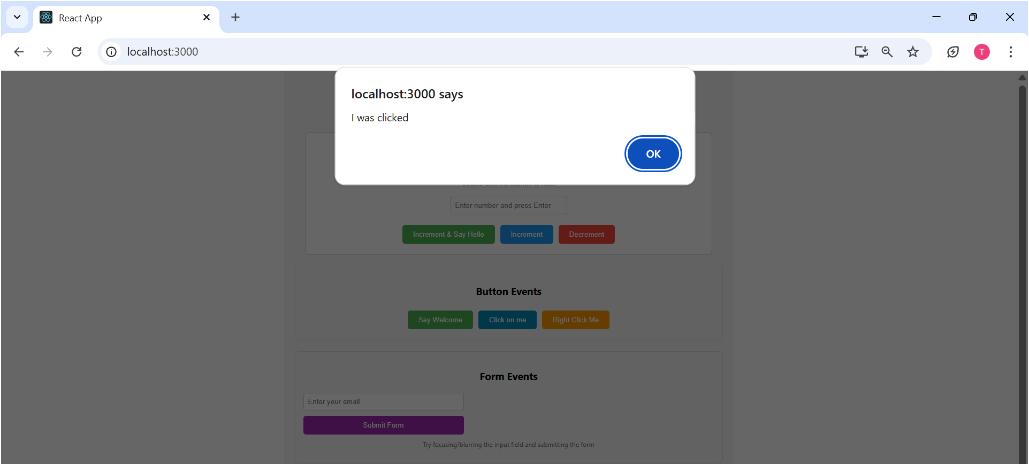

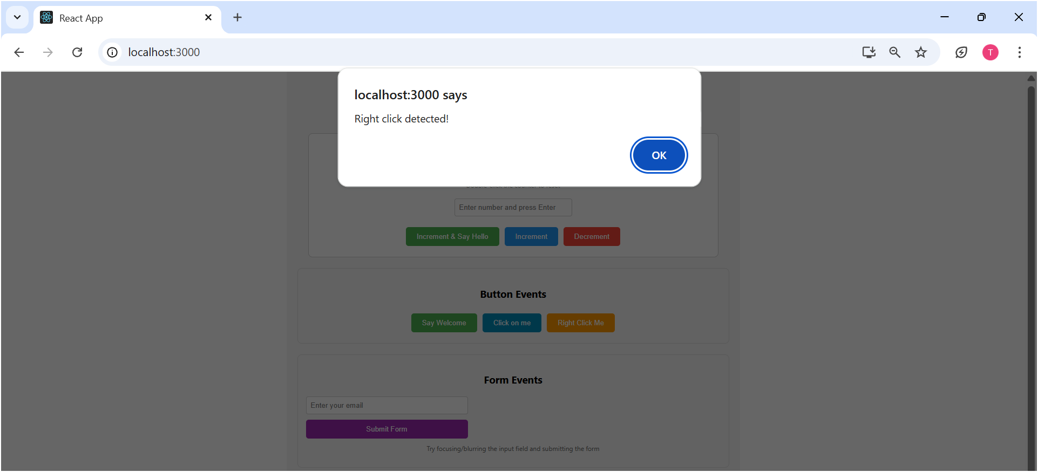

**Hands-On Exercise 12: Conditional Rendering in React**

**Scenario:** You need to create a React application named ticketbookingapp where the content displayed changes based on whether a user is logged in or not. Guest users can browse flight details, while logged-in users can book tickets. The UI should dynamically switch between a "Guest page" and a "User page" with corresponding Login/Logout buttons.

App.js:  
  
    import React from 'react';

    import './App.css';

    import Greeting from './components/Greeting';

    import LoginButton from './components/LoginButton';

    import LogoutButton from './components/LogoutButton';

    class App extends React.Component {

      constructor(props) {

        super(props);

        this.state = { isLoggedIn: false };

        this.handleLoginClick = this.handleLoginClick.bind(this);

        this.handleLogoutClick = this.handleLogoutClick.bind(this);

      }

      handleLoginClick() {

        this.setState({ isLoggedIn: true });

      }

      handleLogoutClick() {

        this.setState({ isLoggedIn: false });

      }

      render() {

        const isLoggedIn = this.state.isLoggedIn;

        let button;

        if (isLoggedIn) {

          button = <LogoutButton onClick={this.handleLogoutClick} />;

        } else {

          button = <LoginButton onClick={this.handleLoginClick} />;

        }

        return (

          <div className="App" style={{ textAlign: 'center', padding: '50px' }}>

            <h1>Flight Ticket Booking</h1>

            <Greeting isLoggedIn={isLoggedIn} />

            {button}

            {isLoggedIn ? (

              <div style={{ marginTop: '30px', border: '1px dashed green', padding: '20px' }}>

                <h3>Welcome, User!</h3>

                <p>You can now access the booking form.</p>

                <button style={{ padding: '10px 20px', backgroundColor: '#007bff', color: 'white', border: 'none', borderRadius: '5px' }}>Book Your Flight</button>

              </div>

            ) : (

              <div style={{ marginTop: '30px', border: '1px dashed blue', padding: '20px' }}>

                <h3>Flight Details:</h3>

                <p>Flight ABC123: London to New York - Departure: 10:00 AM</p>

                <p>Flight XYZ456: Paris to Tokyo - Departure: 02:00 PM</p>

                <p>Please log in to book tickets.</p>

              </div>

            )}

          </div>

        );

      }

    }

    export default App;

***Output:***

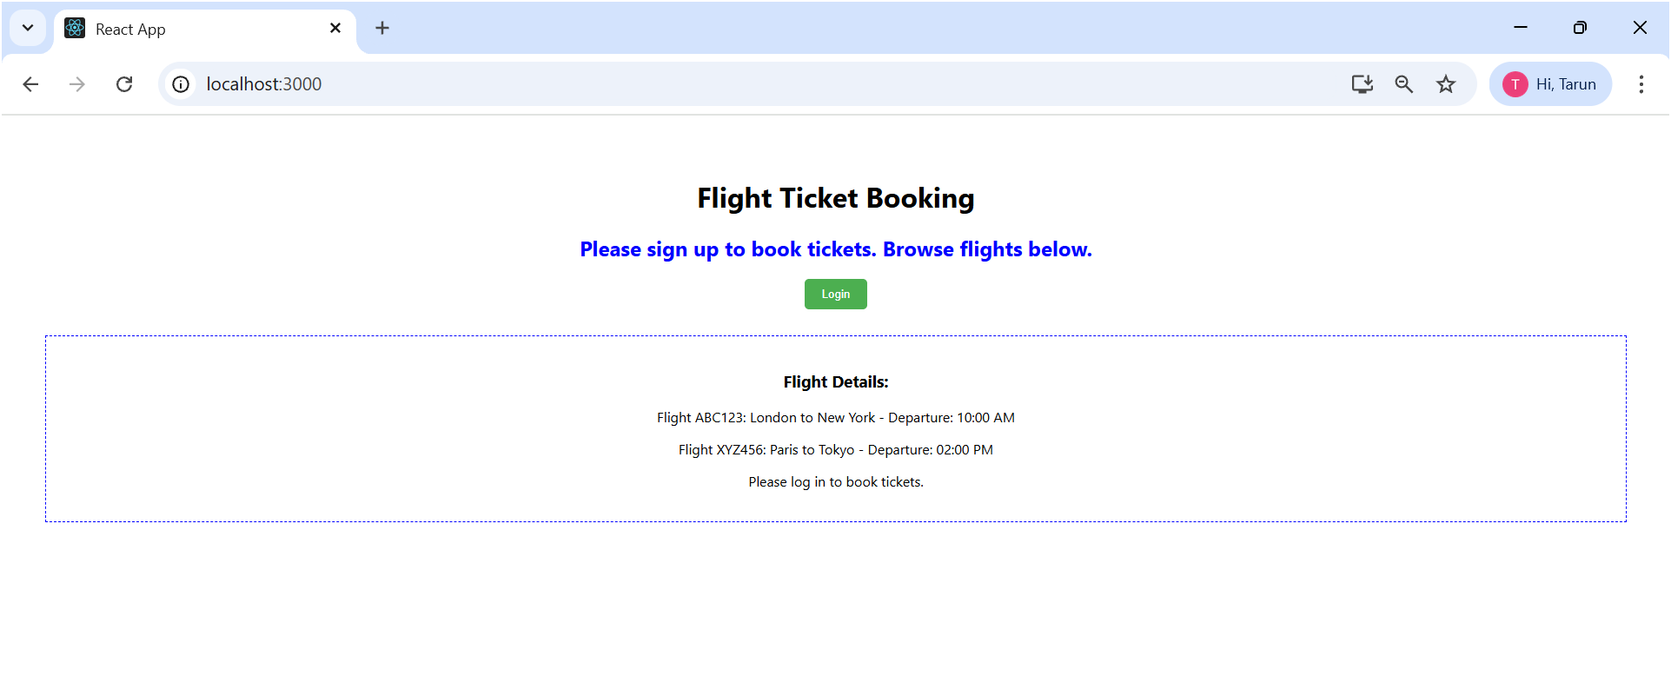  
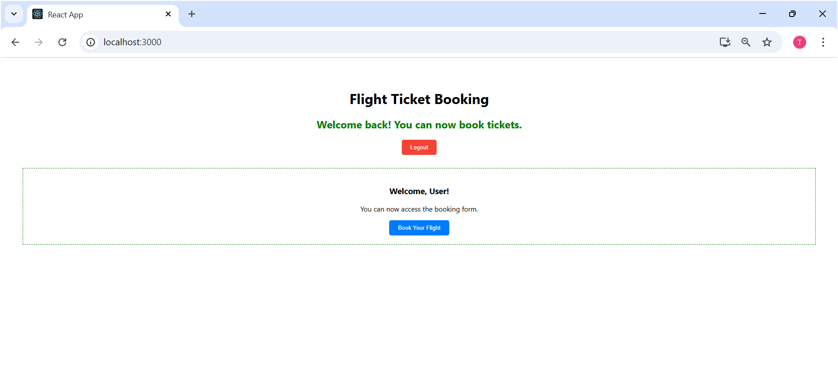

**Hands-On Exercise 13: Advanced Conditional Rendering & List   
 Rendering**

**Scenario:** You need to create a React application named bloggerapp that displays different types of content: "Book Details", "Blog Details", and "Course Details". The application should demonstrate various ways of conditional rendering and efficient list rendering.

***BookDetails.js:***

    import React from 'react';

    export const books = [

      { id: 101, bname: 'Master React', price: 670 },

      { id: 102, bname: 'Deep Dive into Angular 11', price: 800 },

      { id: 103, bname: 'Mongo Essentials', price: 450 },

    ];

    function BookDetails(props) {

      return (

        <div style={{ padding: '10px', borderRight: '2px solid green', height: '100%' }}>

          <h1>Book Details</h1>

          <ul>

            {props.books.map(book => (

              <li key={book.id} style={{ listStyleType: 'none', marginBottom: '15px' }}>

                <h3>{book.bname}</h3>

                <h4>Price: {book.price}</h4>

              </li>

            ))}

          </ul>

        </div>

      );

    }

    export default BookDetails;

***BlogDetails.js:***

    import React from 'react';

    function BlogDetails(props) {

      const blogPosts = [

        { id: 201, title: 'React Learning', author: 'Stephen Biz', content: 'Welcome to learning React!' },

        { id: 202, title: 'Installation', author: 'Schewzdenier', content: 'You can install React from npm.' },

      ];

      return (

        <div style={{ padding: '10px', borderRight: '2px solid green', height: '100%' }}>

          <h1>Blog Details</h1>

          {blogPosts.map(blog => (

            <div key={blog.id} style={{ marginBottom: '20px' }}>

              <h3>{blog.title}</h3>

              <h4>{blog.author}</h4>

              <p>{blog.content}</p>

            </div>

          ))}

        </div>

      );

    }

    export default BlogDetails;

***CourseDetails.js:***

    import React from 'react';

    function CourseDetails(props) {

      const courses = [

        { id: 301, name: 'Angular', date: '4/5/2021' },

        { id: 302, name: 'React', date: '6/3/2020' },

      ];

      return (

        <div style={{ padding: '10px', height: '100%' }}>

          <h1>Course Details</h1>

          {courses.map(course => (

            <div key={course.id} style={{ marginBottom: '20px' }}>

              <h3>{course.name}</h3>

              <h4>{course.date}</h4>

            </div>

          ))}

        </div>

      );

    }

    export default CourseDetails;

***App.js:***

    import React, { useState } from 'react';

    import './App.css';

    import BookDetails, { books } from './components/BookDetails';

    import BlogDetails from './components/BlogDetails';

    import CourseDetails from './components/CourseDetails';

    function App() {

      const [showBooks, setShowBooks] = useState(true);

      const [showBlogs, setShowBlogs] = useState(true);

      const [showCourses, setShowCourses] = useState(true);

      const toggleVisibility = (setter) => {

        setter(prev => !prev);

      };

      return (

        <div className="App" style={{ textAlign: 'center', padding: '20px' }}>

          <h1>Blogger App Dashboard</h1>

          <div style={{ marginBottom: '30px' }}>

            <button onClick={() => toggleVisibility(setShowBooks)} style={{ margin: '5px', padding: '10px 15px' }}>

              Toggle Book Details ({showBooks ? 'Hide' : 'Show'})

            </button>

            <button onClick={() => toggleVisibility(setShowBlogs)} style={{ margin: '5px', padding: '10px 15px' }}>

              Toggle Blog Details ({showBlogs ? 'Hide' : 'Show'})

            </button>

            <button onClick={() => toggleVisibility(setShowCourses)} style={{ margin: '5px', padding: '10px 15px' }}>

              Toggle Course Details ({showCourses ? 'Hide' : 'Show'})

            </button>

          </div>

          <div style={{ display: 'flex', justifyContent: 'center', alignItems: 'flex-start', border: '1px solid #ccc', padding: '20px', borderRadius: '8px', boxShadow: '0 2px 5px rgba(0,0,0,0.1)' }}>

            {showBooks && (

              <div style={{ flex: 1, minWidth: '300px', padding: '10px' }}>

                <BookDetails books={books} />

              </div>

            )}

            {showBlogs ? (

              <div style={{ flex: 1, minWidth: '300px', padding: '10px' }}>

                <BlogDetails />

              </div>

            ) : (

              <div style={{ flex: 1, minWidth: '300px', padding: '10px', color: 'gray' }}>

                <h2>Blog Details Hidden</h2>

              </div>

            )}

            {(() => {

              let courseContent;

              if (showCourses) {

                courseContent = (

                  <div style={{ flex: 1, minWidth: '300px', padding: '10px' }}>

                    <CourseDetails />

                  </div>

                );

              } else {

                courseContent = (

                  <div style={{ flex: 1, minWidth: '300px', padding: '10px', color: 'gray' }}>

                    <h2>Course Details Hidden</h2>

                  </div>

                );

              }

              return courseContent;

            })()}

          </div>

        </div>

      );

    }

    export default App;

***Output:***

