AWS Automation with Lambda & Boto3
Project Documentation
AWS Region: us-east-1

1. Project Overview
This project automates six common AWS operational tasks using Python 3.12 and Boto3, packaged as individual AWS Lambda functions. Each function is triggered either on a schedule or by an AWS event via Amazon EventBridge, executes least-privilege IAM permissions scoped through inline policies, and logs its activity to Amazon CloudWatch Logs for auditability.
Of the six assignments defined in the brief, four have been completed end-to-end (build, test, verify, schedule) and are documented in full below. The remaining two are in progress.

1.1 Submission Status
# | Assignment | Trigger Type | Status
1 | Automated S3 Bucket Cleanup | Manual / on-demand | Complete
2 | EBS Snapshot Creation & Cleanup | EventBridge (weekly schedule) | Complete
3 | EC2 Auto-Tagging on Launch | EventBridge (event pattern) | Complete
4 | Daily AWS Cost Alert | EventBridge (daily schedule) | Complete
5 | Restore EC2 from Latest Snapshot | Manual / on-demand | In Progress
6 | Audit S3 Buckets for Public Access | EventBridge (daily schedule) | In Progress

1.2 Common Setup Applied to Every Assignment
- AWS Region: us-east-1, used consistently across all resources
- Lambda Runtime: Python 3.12
- Execution model: each Lambda function runs under its own dedicated IAM role with an inline, least-privilege policy — no wildcard *FullAccess managed policies were attached
- Every IAM role includes the standard CloudWatch Logs permissions (logs:CreateLogGroup, logs:CreateLogStream, logs:PutLogEvents) so execution output is visible for auditing
- A $1 AWS Budget alert was configured before any resources were created, as a cost safety net
- Test/throwaway resources (EC2 test instances, temporary snapshots) were cleaned up immediately after screenshots were captured, to avoid ongoing charges

2. Assignment 1 — Automated S3 Bucket Cleanup
Objective: Automatically delete objects older than 30 days from an S3 bucket.
Bucket: herovirs3asign1
Lambda Function: s3-cleanup-function
IAM Role: lambda-s3-cleanup-role
Trigger: Manual / on-demand invocation via the Lambda console Test button

2.1 Steps Followed
- Created an S3 bucket named herovirs3asign1 in us-east-1 with default settings (Block Public Access left enabled, since public access is not required for this task)
- Uploaded sample test files (file1.txt, file2.txt, and later file3.txt / file4.txt) to the bucket to exercise the cleanup logic
- Created a dedicated IAM role, lambda-s3-cleanup-role, trusted by the Lambda service
- Attached an inline policy scoped to only the herovirs3asign1 bucket, granting s3:ListBucket on the bucket and s3:DeleteObject on its objects, plus the standard CloudWatch Logs permissions
- Created the Lambda function s3-cleanup-function (Python 3.12) using this role, and deployed the cleanup code
- For testing, temporarily lowered the age threshold from 30 days to 1 minute so freshly uploaded files would qualify for deletion without waiting a month
- Invoked the function manually via a test event and confirmed, via CloudWatch Logs, exactly which object keys were deleted
- Verified in the S3 console that only files younger than the threshold remained
- Reset the threshold to the production value of 30 days and redeployed before final submission

2.2 IAM Inline Policy
{
"Version": "2012-10-17",
"Statement": [
{
"Effect": "Allow",
"Action": ["s3:ListBucket"],
"Resource": "arn:aws:s3:::herovirs3asign1"
},
{
"Effect": "Allow",
"Action": ["s3:DeleteObject"],
"Resource": "arn:aws:s3:::herovirs3asign1/*"
},
{
"Effect": "Allow",
"Action": [
"logs:CreateLogGroup",
"logs:CreateLogStream",
"logs:PutLogEvents"
],
"Resource": "arn:aws:logs:*:*:*"
}
]
}

2.3 Lambda Function Code
import boto3
from datetime import datetime, timezone, timedelta

BUCKET_NAME = "herovirs3asign1"
AGE_THRESHOLD = timedelta(days=30) # switch to timedelta(minutes=1) only while testing

s3 = boto3.client("s3")

def lambda_handler(event, context):
now = datetime.now(timezone.utc)
deleted = []

paginator = s3.get_paginator("list_objects_v2")
for page in paginator.paginate(Bucket=BUCKET_NAME):
for obj in page.get("Contents", []):
age = now - obj["LastModified"]
if age > AGE_THRESHOLD:
s3.delete_object(Bucket=BUCKET_NAME, Key=obj["Key"])
deleted.append(obj["Key"])
print(f"Deleted: {obj['Key']} (age: {age})")

print(f"Total deleted: {len(deleted)} -> {deleted}")
return {"deleted_objects": deleted, "count": len(deleted)}

2.4 Evidence

IAM Role
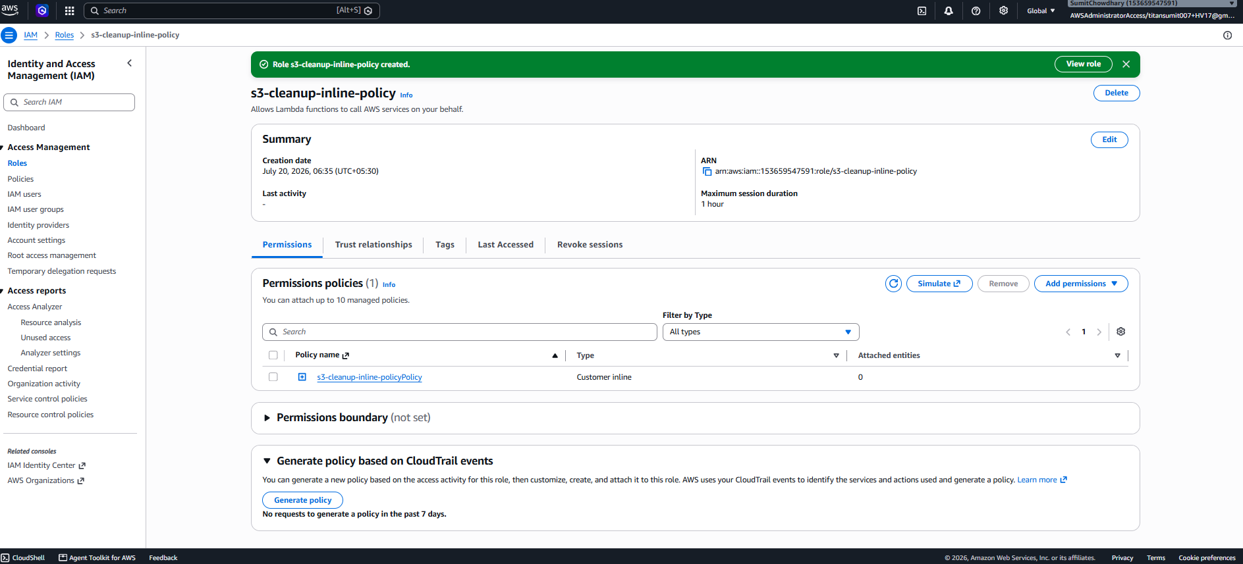

Lambda Configuration
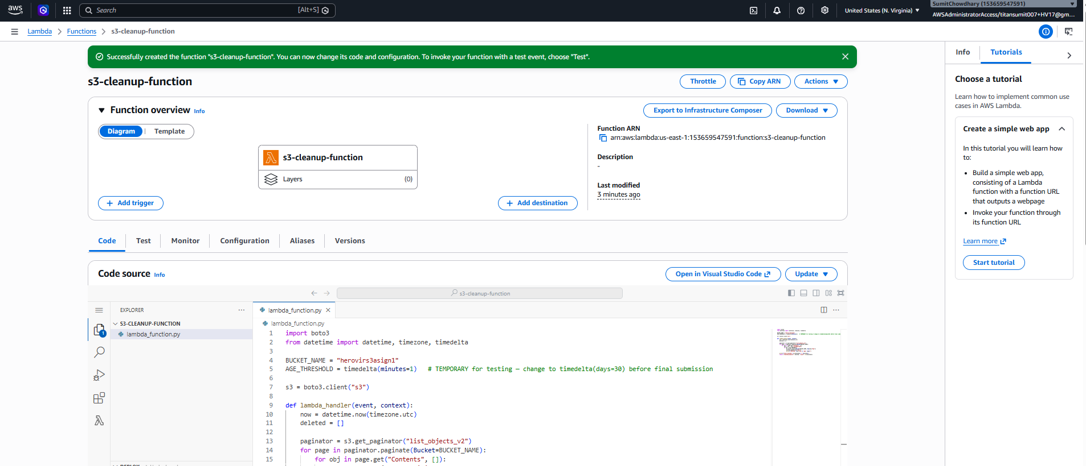

Test Invocation / Output
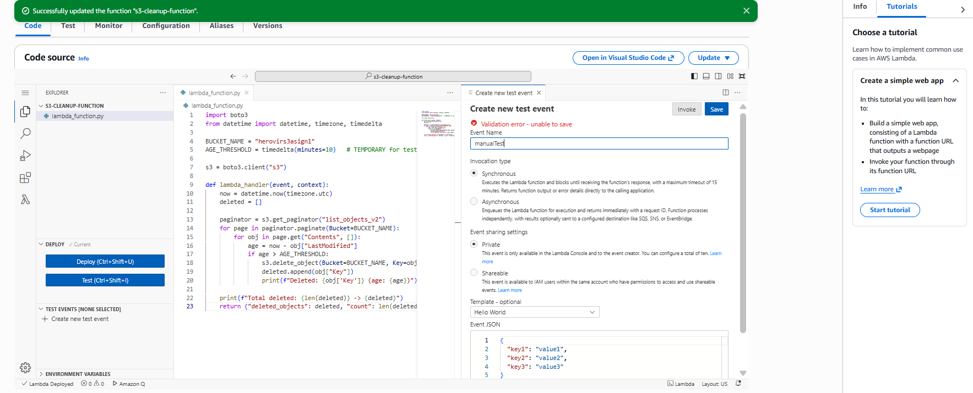

CloudWatch Logs
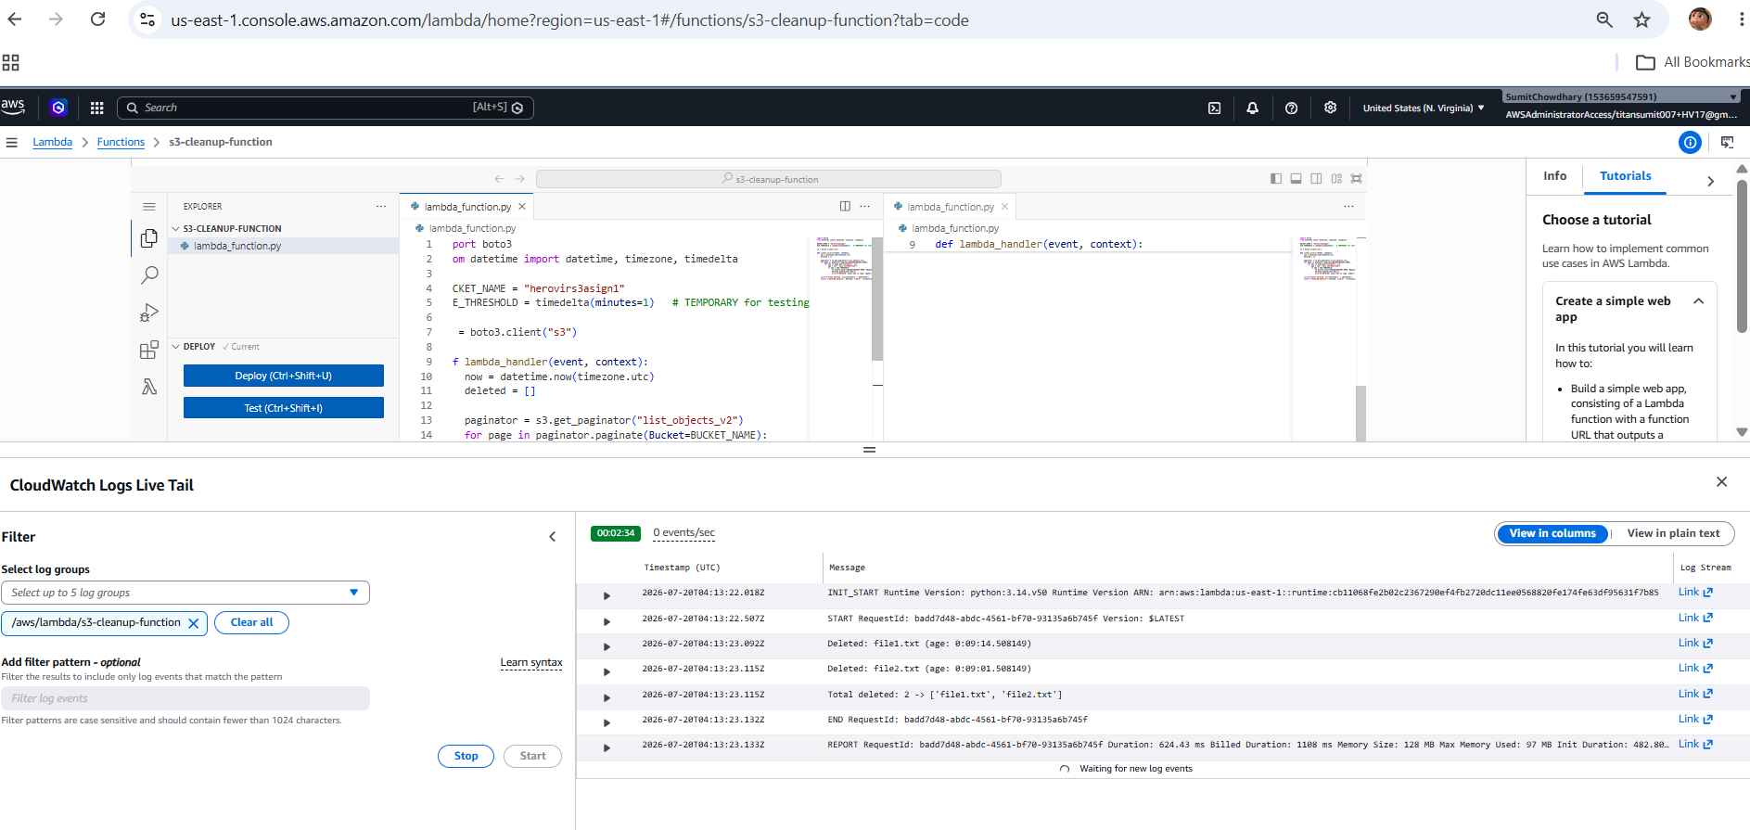

Final Result — Bucket Cleaned
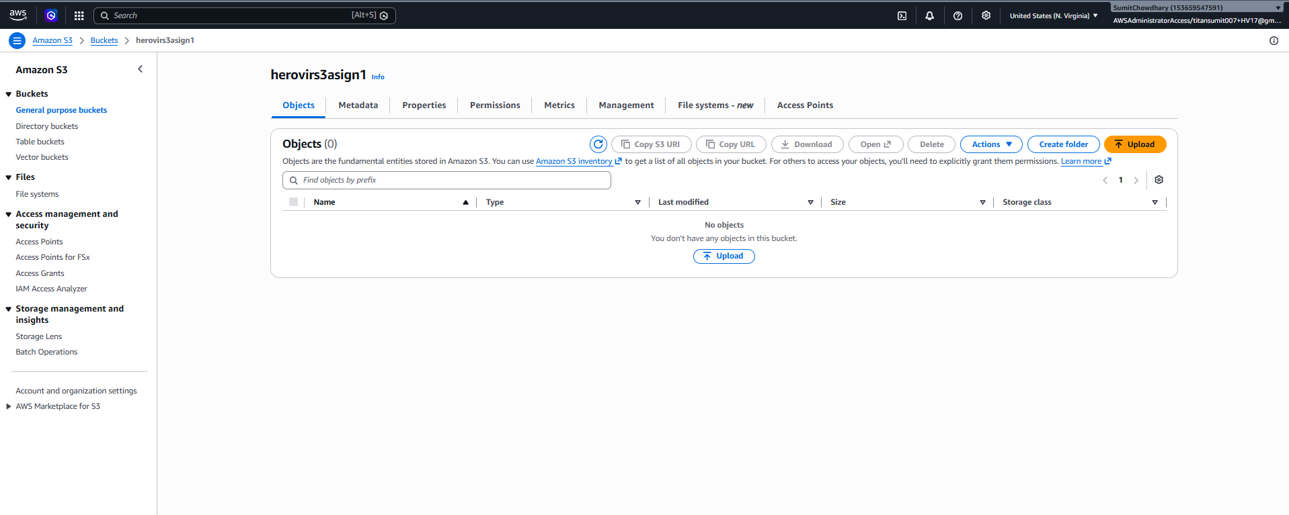

3. Assignment 2 — Automated EBS Snapshot Creation and Cleanup
Objective: Create a snapshot of an EBS volume on a schedule, and delete snapshots older than the retention period.
Volume ID: vol-0a5f8145eca191784
Lambda Function: ebs-snapshot-function
IAM Role: lambda-ebs-snapshot-role
Trigger: Amazon EventBridge — scheduled rule running weekly (rate: 7 days)

3.1 Steps Followed
- Created a 1 GiB gp3 EBS volume in us-east-1a and noted its Volume ID
- Created a dedicated IAM role, lambda-ebs-snapshot-role, trusted by the Lambda service
- Attached an inline policy granting ec2:CreateSnapshot, ec2:DescribeSnapshots, ec2:DeleteSnapshot, and ec2:CreateTags — these EC2 snapshot actions do not support resource-level ARN scoping the way S3 does, so Resource is set to * as an accepted, documented exception to least-privilege
- Created the Lambda function ebs-snapshot-function, pasted in the code with the real Volume ID, and deployed it
- Invoked the function manually, confirming a new snapshot was created and tagged CreatedBy=Lambda-Backup
- Verified the new snapshot's presence in the EC2 console under Snapshots
- Created an EventBridge rule (weekly-ebs-snapshot-trigger) on a 7-day rate schedule, targeting the Lambda function, so backups continue automatically
- Pushed the final code and policy to GitHub

3.2 IAM Inline Policy
{
"Version": "2012-10-17",
"Statement": [
{
"Effect": "Allow",
"Action": [
"ec2:CreateSnapshot",
"ec2:DescribeSnapshots",
"ec2:DeleteSnapshot",
"ec2:CreateTags"
],
"Resource": "*"
},
{
"Effect": "Allow",
"Action": [
"logs:CreateLogGroup",
"logs:CreateLogStream",
"logs:PutLogEvents"
],
"Resource": "arn:aws:logs:*:*:*"
}
]
}

3.3 Lambda Function Code
import boto3
from datetime import datetime, timezone, timedelta

VOLUME_ID = "vol-0a5f8145eca191784" # <-- paste your real volume ID here
RETENTION = timedelta(days=30)
TAG_KEY, TAG_VALUE = "CreatedBy", "Lambda-Backup"

ec2 = boto3.client("ec2")

def lambda_handler(event, context):
snap = ec2.create_snapshot(
VolumeId=VOLUME_ID,
Description="Automated backup via Lambda",
TagSpecifications=[{
"ResourceType": "snapshot",
"Tags": [{"Key": TAG_KEY, "Value": TAG_VALUE}]
}]
)
new_snap_id = snap["SnapshotId"]
print(f"Created snapshot: {new_snap_id}")

now = datetime.now(timezone.utc)
deleted = []
paginator = ec2.get_paginator("describe_snapshots")
for page in paginator.paginate(
OwnerIds=["self"],
Filters=[{"Name": f"tag:{TAG_KEY}", "Values": [TAG_VALUE]}]
):
for s in page["Snapshots"]:
age = now - s["StartTime"]
if age > RETENTION and s["SnapshotId"] != new_snap_id:
ec2.delete_snapshot(SnapshotId=s["SnapshotId"])
deleted.append(s["SnapshotId"])
print(f"Deleted snapshot: {s['SnapshotId']} (age: {age})")

print(f"Created: {new_snap_id}, Deleted: {deleted}")
return {"created": new_snap_id, "deleted": deleted}

3.4 Evidence

IAM Role
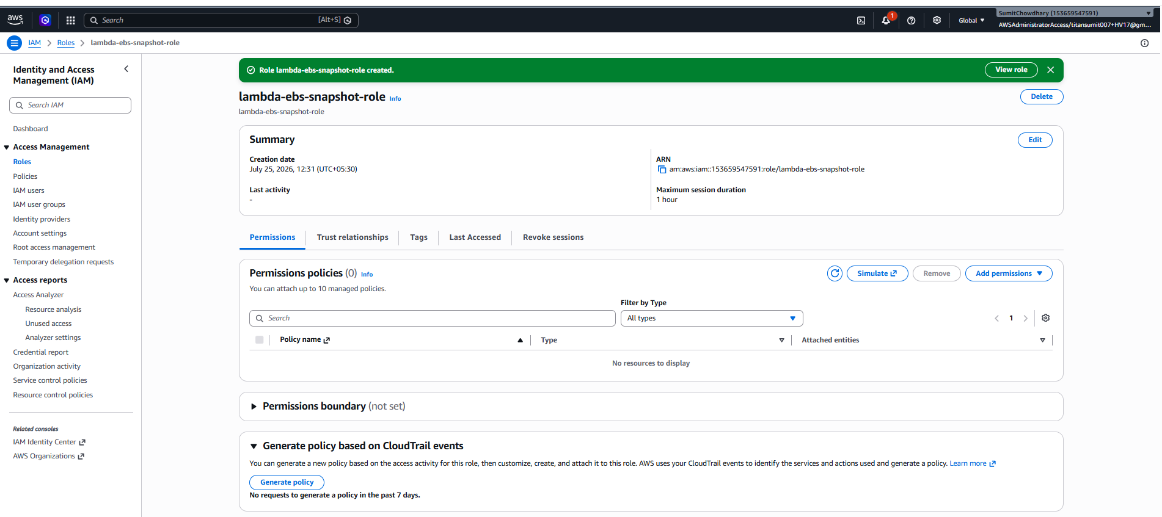

Lambda Configuration
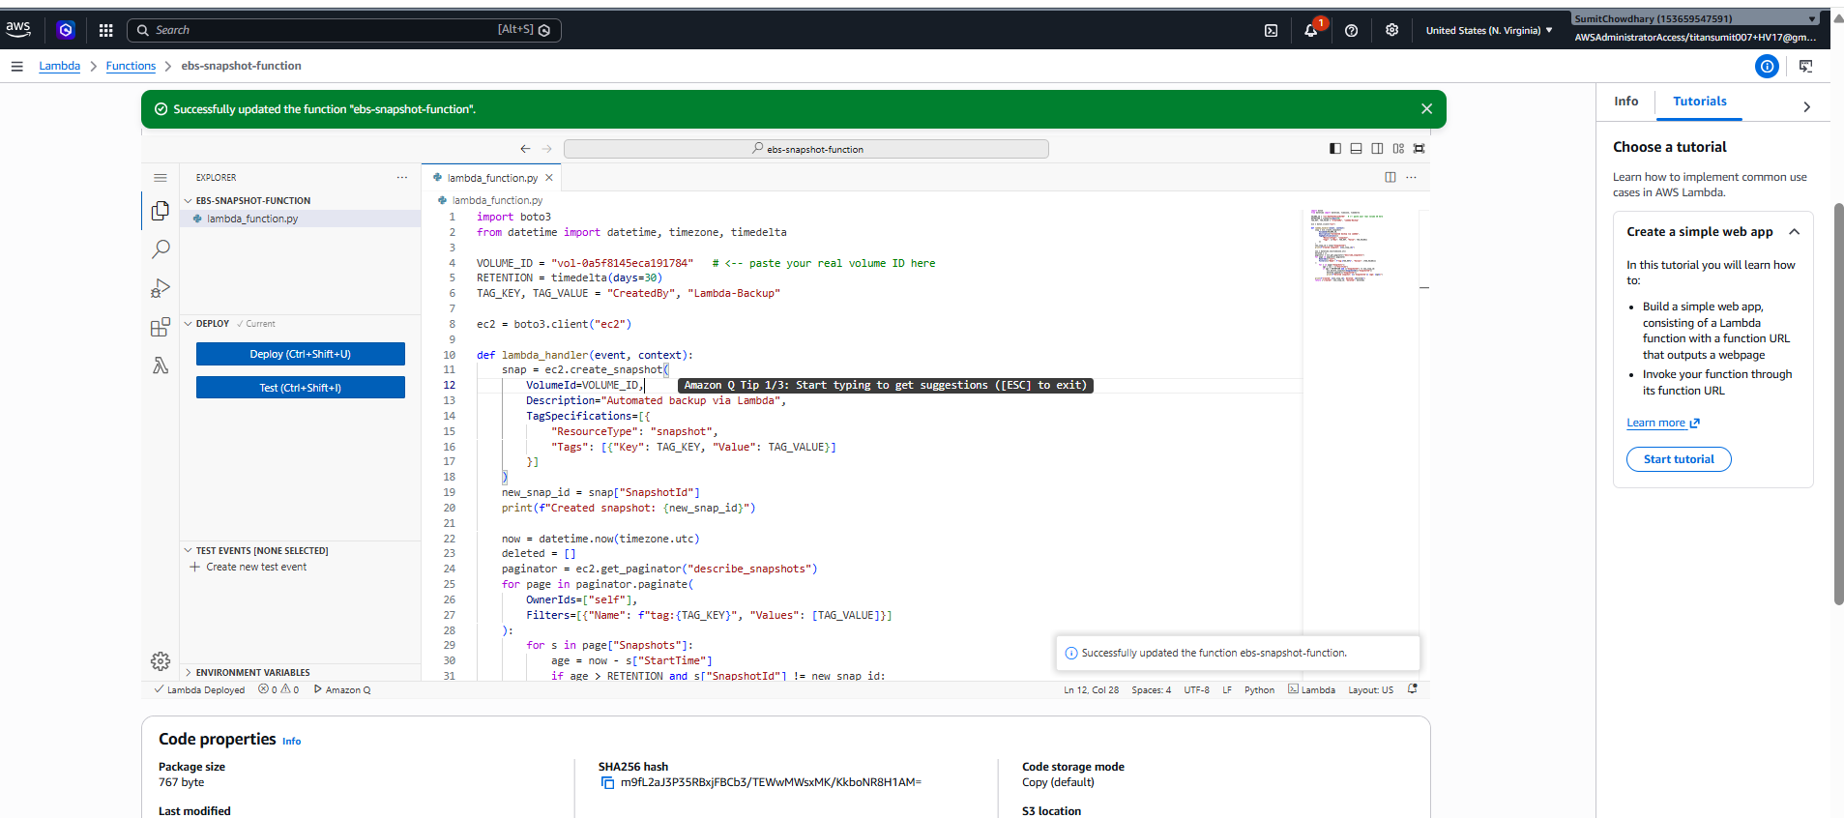

Test Invocation / Output
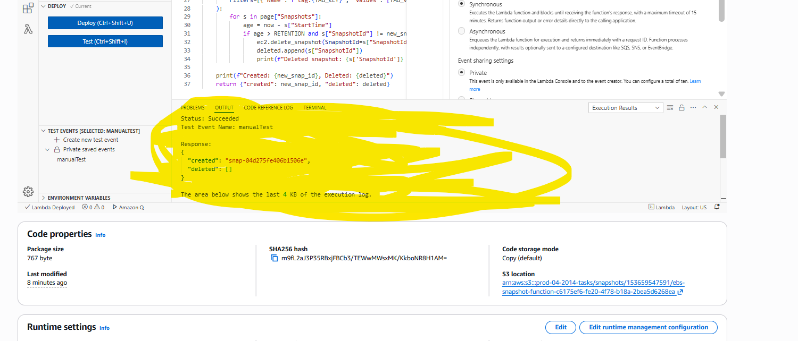
Note: a dedicated CloudWatch Logs screenshot was not separately captured for this assignment — the test invocation output above confirms successful execution via the returned snapshot ID.

Final Result — Snapshot Created
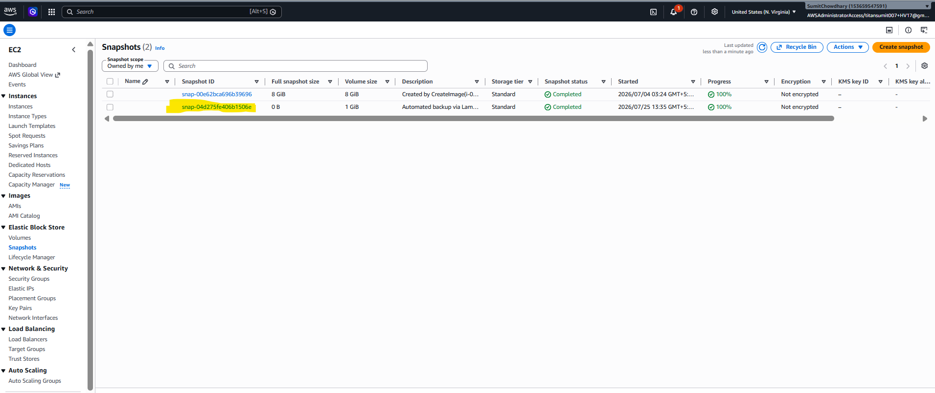

4. Assignment 3 — Auto-Tagging EC2 Instances on Launch
Objective: Automatically tag newly launched EC2 instances for resource tracking, ownership, and cost allocation.
Lambda Function: ec2-autotag-function
IAM Role: lambda-ec2-autotag-role
Trigger: Amazon EventBridge event pattern — source aws.ec2, detail-type EC2 Instance State-change Notification, state running

4.1 Steps Followed
- Created a dedicated IAM role, lambda-ec2-autotag-role, trusted by the Lambda service
- Attached an inline policy granting ec2:CreateTags and ec2:DescribeInstances, plus the standard CloudWatch Logs permissions
- Created the Lambda function ec2-autotag-function, which extracts the instance ID from the incoming EventBridge event and tags the instance with LaunchDate (current date) and Owner
- Created an EventBridge rule with a custom event pattern matching EC2 instances entering the running state, targeting this Lambda function
- Launched a real t3.micro test EC2 instance (no key pair, since login was not needed) to trigger the rule end-to-end
- After a short delay, confirmed in the EC2 console that the LaunchDate and Owner tags had been applied automatically
- Reviewed CloudWatch Logs to confirm the function executed and logged the tagged instance ID
- Terminated the test instance immediately after capturing screenshots, to avoid ongoing EC2 charges

4.2 IAM Inline Policy
{
"Version": "2012-10-17",
"Statement": [
{
"Effect": "Allow",
"Action": ["ec2:CreateTags", "ec2:DescribeInstances"],
"Resource": "*"
},
{
"Effect": "Allow",
"Action": [
"logs:CreateLogGroup",
"logs:CreateLogStream",
"logs:PutLogEvents"
],
"Resource": "arn:aws:logs:*:*:*"
}
]
}

4.3 Lambda Function Code
import boto3
from datetime import date

ec2 = boto3.client("ec2")

def lambda_handler(event, context):
instance_id = event["detail"]["instance-id"]

ec2.create_tags(
Resources=[instance_id],
Tags=[
{"Key": "LaunchDate", "Value": str(date.today())},
{"Key": "Owner", "Value": "auto-tag-lambda"},
]
)
print(f"Tagged instance {instance_id} with LaunchDate and Owner")
return {"tagged_instance": instance_id}

4.4 Evidence

IAM Role
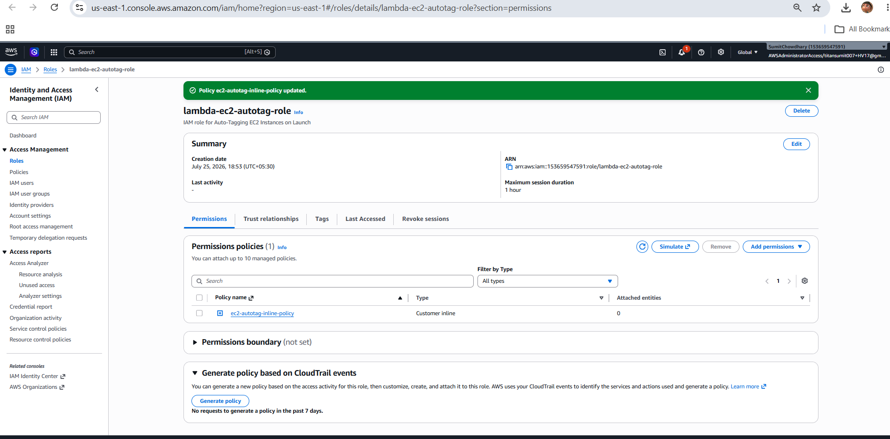

Lambda Configuration
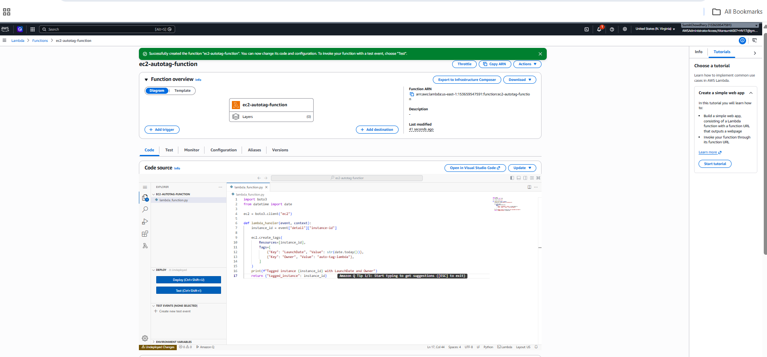

Test Invocation / Output — Test Instance Launched
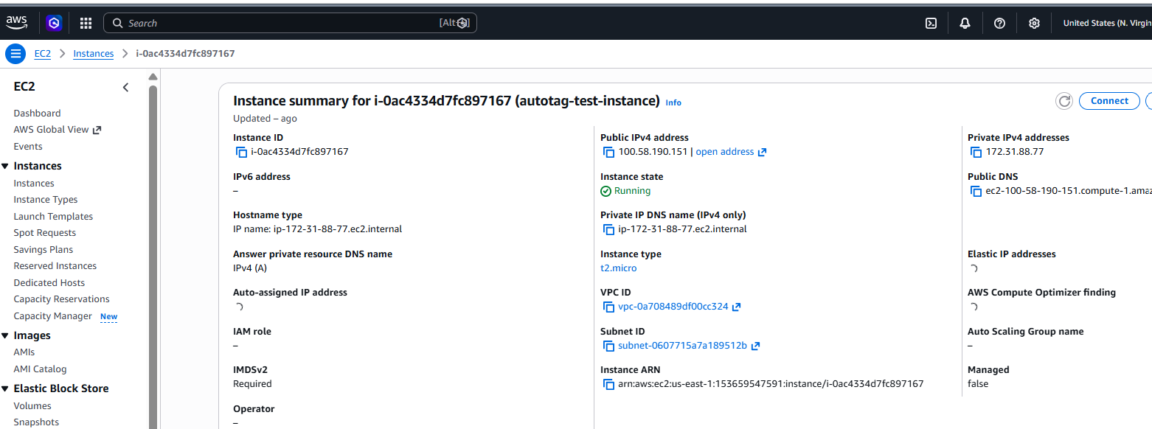

CloudWatch Logs
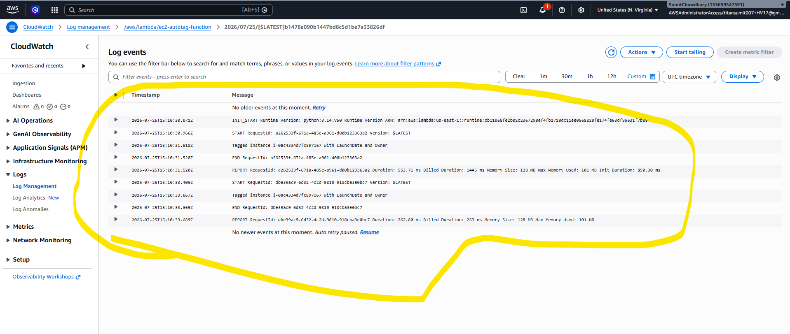

Final Result — Instance Tagged with LaunchDate and Owner
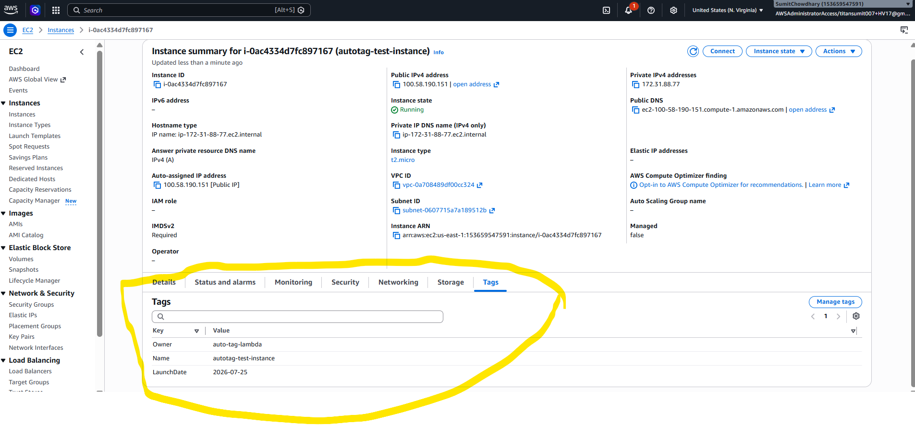

4.5 Bonus Consideration (Discussed, Not Implemented)
The Owner tag could be populated dynamically rather than hardcoded, by looking up the IAM identity that launched the instance via CloudTrail: calling cloudtrail.lookup_events with a ResourceName filter set to the instance ID, then extracting userIdentity.arn from the matching RunInstances event. This is a common follow-up question in technical interviews on this topic.

5. Assignment 4 — Daily AWS Cost Alert Using Cost Explorer API and SNS
Objective: Send an automated alert when month-to-date AWS spend exceeds a defined threshold.
Lambda Function: cost-alert-function
IAM Role: lambda-cost-alert-role
SNS Topic: aws-cost-alerts
Trigger: Amazon EventBridge — scheduled rule running daily at 06:00 UTC

5.1 Steps Followed
- Created an SNS topic, aws-cost-alerts, and subscribed an email address, confirming the subscription from the inbox before testing
- Created a dedicated IAM role, lambda-cost-alert-role, trusted by the Lambda service
- Attached an inline policy granting ce:GetCostAndUsage (Resource: *, since Cost Explorer does not support finer scoping) and sns:Publish scoped to the specific topic ARN, plus the standard CloudWatch Logs permissions
- Created the Lambda function cost-alert-function, which queries month-to-date UnblendedCost via the Cost Explorer API and publishes an SNS alert if spend exceeds the threshold
- Increased the function timeout to 10 seconds, since Cost Explorer can respond slowly compared to typical API calls
- Temporarily set the threshold to $0.01 to force-test the alert path, invoked the function manually, and confirmed receipt of the SNS email alert
- Reviewed CloudWatch Logs to confirm the retrieved spend amount was logged correctly
- Created an EventBridge rule (daily-cost-alert-trigger) on a daily cron schedule (0 6 * * ? *), targeting the Lambda function
- Pushed the code and policy to GitHub
Note: at the time of this documentation, the committed lambda_function.py still has THRESHOLD_USD set to the test value (0.01) rather than the intended production value, and the SNS ARN contains a real AWS account ID. Both are flagged here for review before final submission.

5.2 IAM Inline Policy
{
"Version": "2012-10-17",
"Statement": [
{
"Effect": "Allow",
"Action": ["ce:GetCostAndUsage"],
"Resource": "*"
},
{
"Effect": "Allow",
"Action": ["sns:Publish"],
"Resource": "arn:aws:sns:us-east-1:153659547591:aws-cost-alerts"
},
{
"Effect": "Allow",
"Action": [
"logs:CreateLogGroup",
"logs:CreateLogStream",
"logs:PutLogEvents"
],
"Resource": "arn:aws:logs:*:*:*"
}
]
}

5.3 Lambda Function Code
import boto3
from datetime import date, timedelta

THRESHOLD_USD = 0.01 # TEMPORARY low value to force-test the alert path
SNS_TOPIC_ARN = "arn:aws:sns:us-east-1:153659547591:aws-cost-alerts"

ce = boto3.client("ce")
sns = boto3.client("sns")

def lambda_handler(event, context):
today = date.today()
start_of_month = today.replace(day=1).isoformat()
tomorrow = (today + timedelta(days=1)).isoformat()

response = ce.get_cost_and_usage(
TimePeriod={"Start": start_of_month, "End": tomorrow},
Granularity="MONTHLY",
Metrics=["UnblendedCost"],
)
amount = float(response["ResultsByTime"][0]["Total"]["UnblendedCost"]["Amount"])
print(f"Month-to-date spend: ${amount:.2f}")

if amount > THRESHOLD_USD:
sns.publish(
TopicArn=SNS_TOPIC_ARN,
Subject="AWS Cost Alert",
Message=f"Month-to-date spend is ${amount:.2f}, exceeding the ${THRESHOLD_USD} threshold."
)
print("Alert published.")

return {"month_to_date_spend": amount}

5.4 Evidence

IAM Role
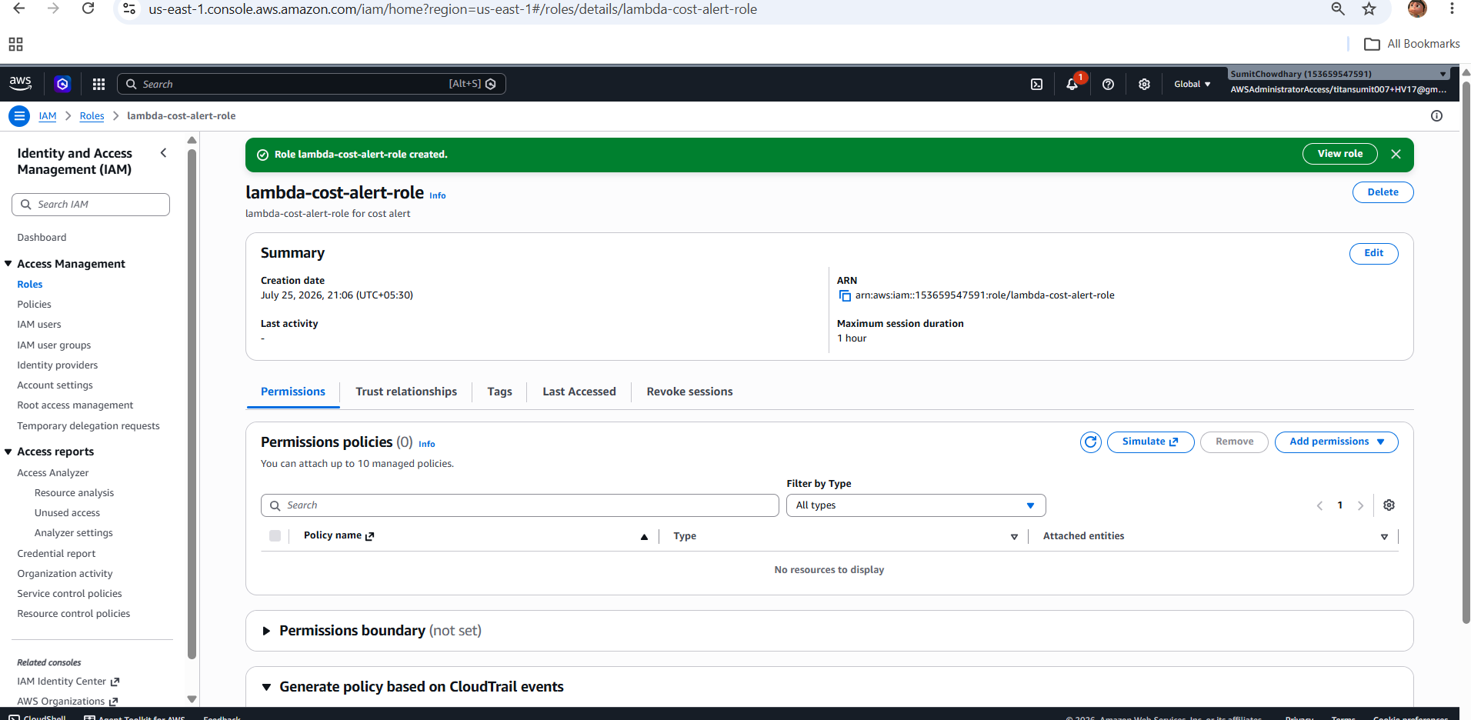

Lambda Configuration
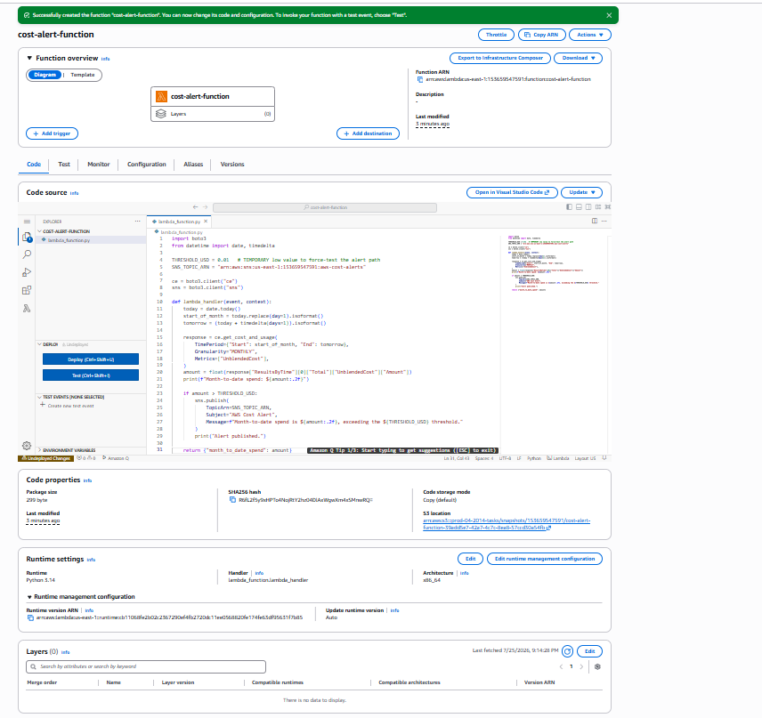

Test Invocation / Output
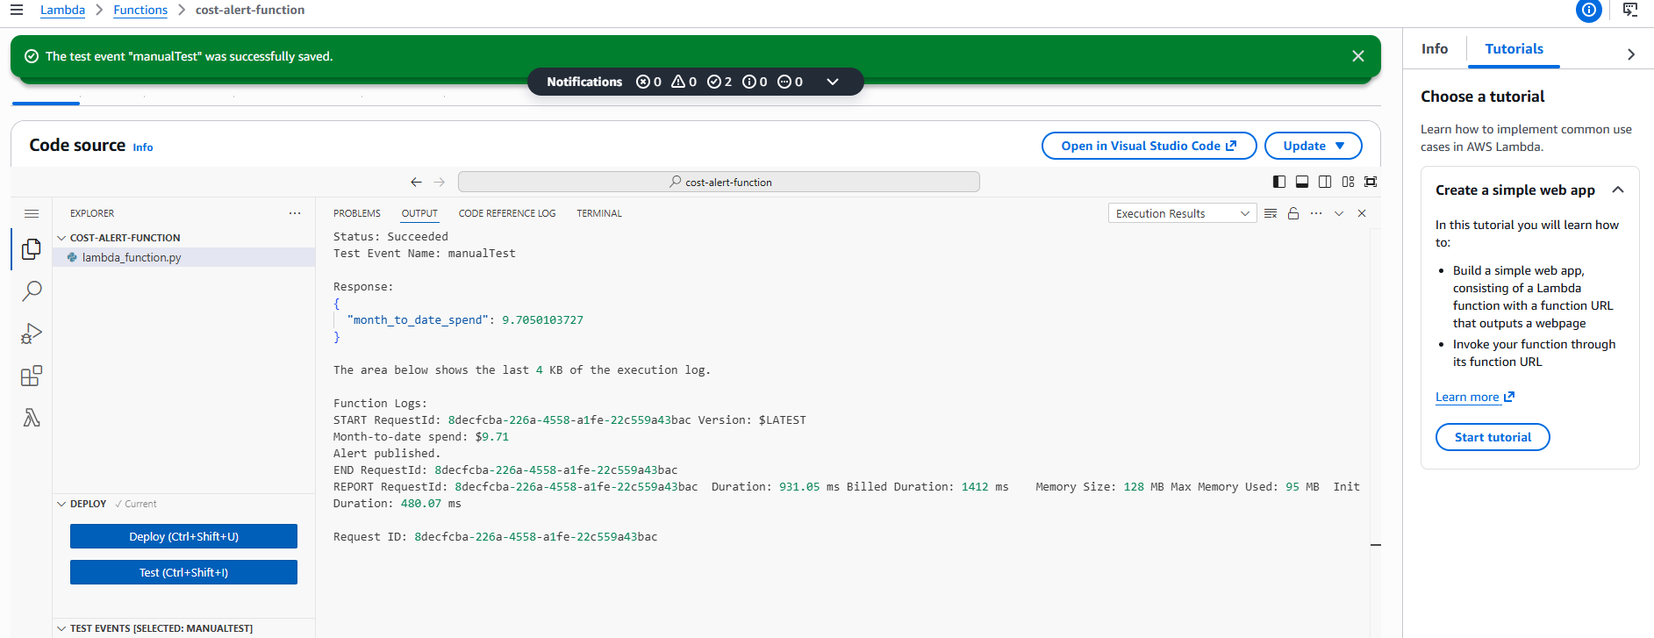

CloudWatch Logs
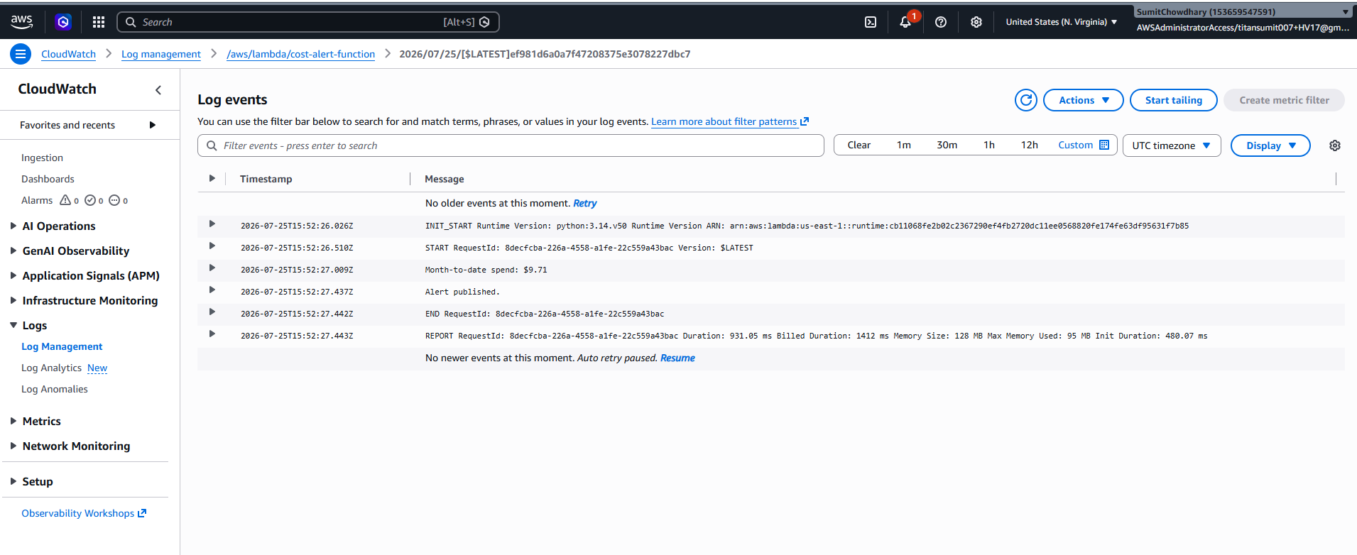

Final Result — SNS Cost Alert Email
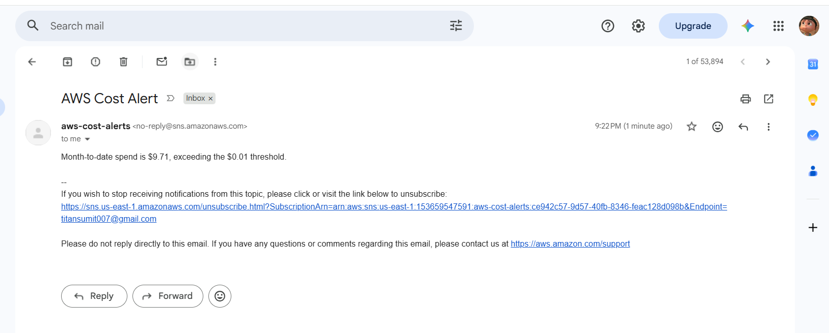

6. Assignment 5 — Restore an EC2 Instance from the Latest Snapshot
Status: In Progress. This assignment automates disaster recovery by finding the most recent snapshot of a given volume, registering it as an AMI, and launching a new EC2 instance from that AMI. It builds directly on the snapshot created in Assignment 2. Code, IAM policy, and screenshots have not yet been finalized and will be added in a follow-up submission.

7. Assignment 6 — Audit S3 Buckets for Public Access and Notify
Status: In Progress. This assignment scans every S3 bucket in the account, checking Block Public Access configuration, bucket policy status, and ACL grants, and publishes an SNS alert naming any bucket found to be publicly accessible. Code, IAM policy, and screenshots have not yet been finalized and will be added in a follow-up submission.

8. Repository
All source code, IAM policy JSON files, and screenshots referenced in this document are maintained in the project's GitHub repository, organized into one folder per assignment (assignment-1-s3-cleanup through assignment-6-s3-public-audit), each containing lambda_function.py, iam_policy.json, and a screenshots/ subfolder.

9. Cleanup
All test and throwaway resources created for verification purposes — the EC2 test instance in Assignment 3, and any short-lived resources used to force-test alert paths — were terminated or deleted immediately after the required screenshots were captured, to avoid unnecessary AWS charges.

