## New KB Article: FedEx Mobile In-App PUSH Notifications

*Note: Although the information pertains to both FedEx Mobile Android and iPhone applications, iPhone screenshot examples are used for this article.*

**Overview**

With FedEx Mobile for Android and iPhone Applications, **all** users can register to receive, view and manage existing tracking notifications through an in-app PUSH notification feature which can be enabled or disabled via the user’s phone settings at any time.

Non-logged in users can request PUSH Notifications for any valid tracking number entered in the Tracking search field.

Logged-in users can request PUSH Notifications for a single shipment from their tracking summary list.

**Notes**

* Profiles are controlled by each mobile user. Because FedEx Tracking notifications contain secured shipping information, users who request a notification via the FedEx Tracking application on FedEx.com, will not receive the notification until they login to the FedEx app.
* Notifications for Multi-piece shipments cannot be requested at this time.

**PUSH Notification Process**

To use PUSH Notifications, users must first give FedEx consent to have tracking information sent to their mobile device. Once consent is complete, users will receive a confirmation message.

1. Permissions and consents can be managed through the user’s mobile device settings screen. Users can unsubscribe to stop receiving all PUSH Notifications at any time.
2. PUSH Notification preferences can be managed via the FedEx app settings menu.
3. PUSH Notification messages display on the mobile device home screen. When swiped or tapped, the user is taken to the shipment summary screen within the mobile app that shows the details for the tracked shipment.

**PUSH Notification Process Flow**

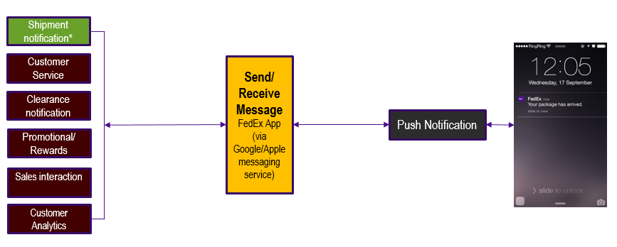

**Anonymous State**

**Find the PUSH Notifications Feature**

1. Launch the FedEx Mobile App for Android or iPhone. The FedEx menu screen will display.
2. Enter a tracking number in the Track, Scan, Search field at the top of the screen, or click on the Track icon, and then tap Search to proceed. The user will be taken to the Tracking Summary screen.
3. Slide the button to ON to enable Notifications.

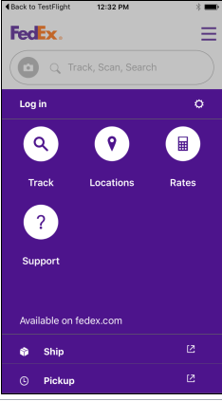 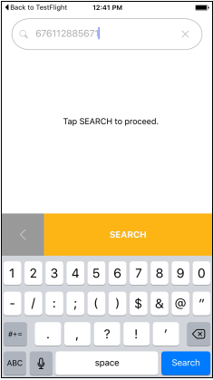 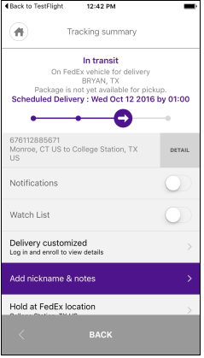

**Register / Opt-in to PUSH Notifications**

An End User License Agreement will display for users who have opened the FedEx app for the first time. Agree to the Terms and Agreement and then click to continue.

A one-time opt-in consent is initially required prior to receiving PUSH Notifications. Users can enable/disable PUSH notifications via the device settings at any time.

A Message will display on the screen advising the user that “FedEx” would like to send Notifications which may include alerts, sounds, and icon badges.

1. Click Don’t Allow to decline enabling Notifications. If Notifications are not initially allowed, Notifications can be configured later in the device Settings menu.
2. Click OK to proceed to the option for enabling Notifications.

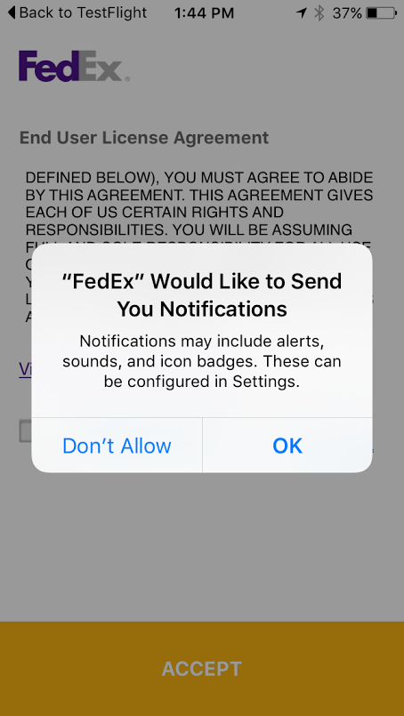 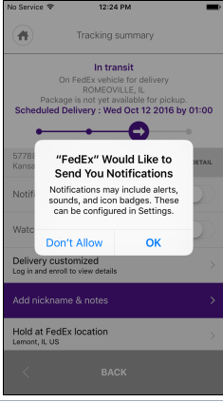

**Receive PUSH Notifications**

Whenever a status update is available, Notifications are delivered to the opted-in user’s mobile device on the top of the Home screen. The FedEx app does not have to be launched in order to receive Notification alerts.

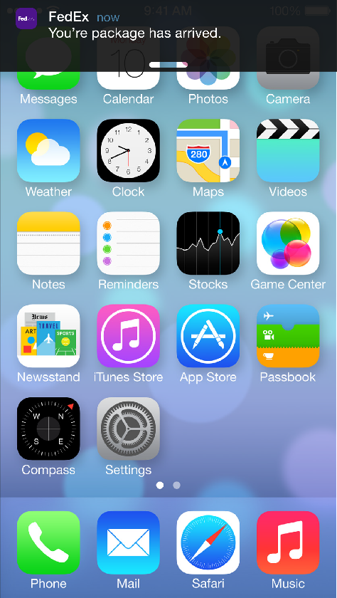

**View PUSH Notifications**

* Click the alert, and then slide to review the details.

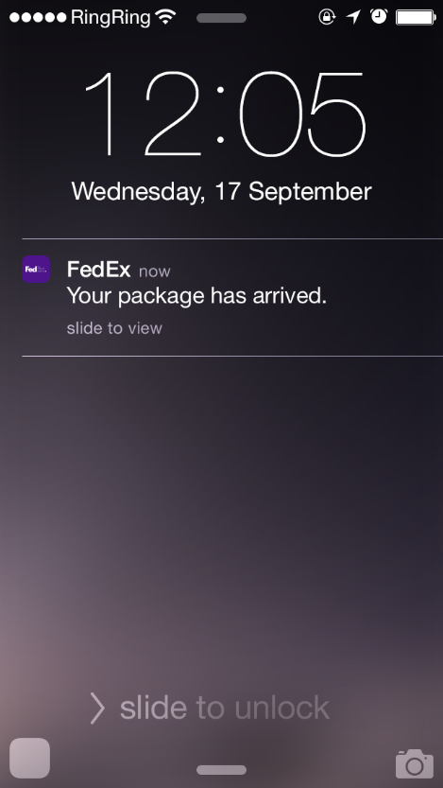

**Logged - in State**

Secured (Logged-in users) can request push notifications for a single shipment.

1. From the Tracking Summary screen, click on a shipment. The Tracking summary will display.
2. Slide the button to ON to enable Notifications.

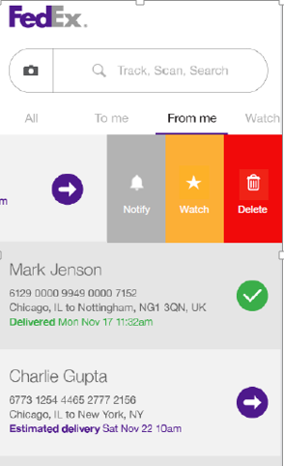 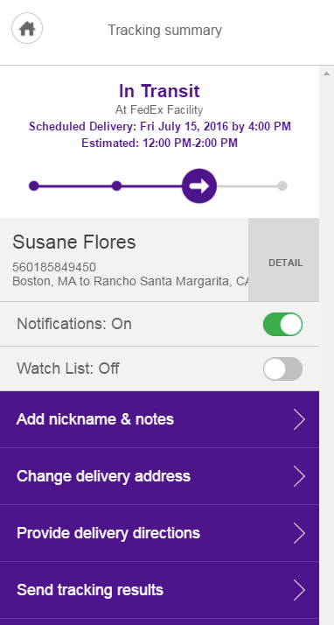

**Manage PUSH Notification Preferences**

Manage Notifications preferences by specifying only certain status types to have pushed to the device.

1. Click the Settings icon on the FedEx App Home screen to go to the FedEx App Settings.
2. Click Notifications from the menu.
3. Set Notifications for each individual shipment from the Tracking screen by sliding the button to ON to enable a specific preference.

**Note:** Changes will apply to future selections.

1. Click the Save button.

Preference options include:

* FedEx received the package
* Delivery exception occurred
* Estimated delivery updates
* Delivery has been made

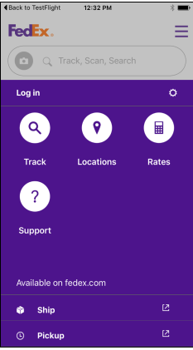 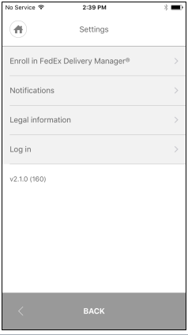 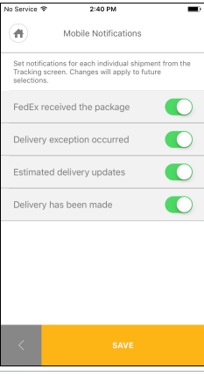

**Configure Notifications in Settings**

If Notifications are not initially allowed to be pushed to the mobile device, Notifications can be configured later in the device Settings menu.

**Note:** When prompted, Don’t Allow to decline enabling Notifications would have initially been clicked by the user.

When a user attempts to enable PUSH Notifications later, a message will display on the screen instructing them to go to settings to enable PUSH Notifications for FedEx to send tracking information.

1. Click the Settings option to be taken to the mobile device’s Settings menu. Pressing the Not Now button will decline the offer.

**Note:** The mobile device Settings option is different from the Settings in the FedEx Mobile Application.

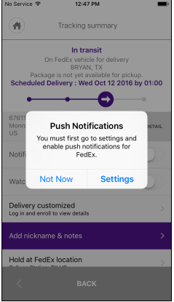 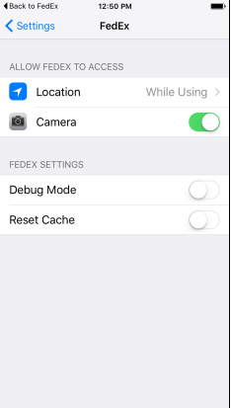

1. Locate and click the FedEx Mobile app icon.
2. Enable the Notifications feature by sliding the enable symbol to ON.

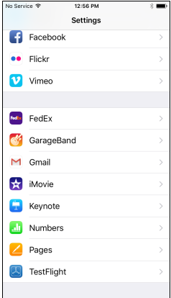 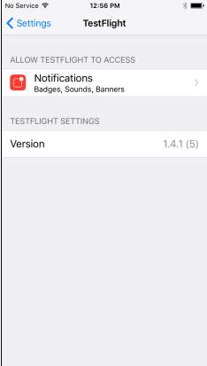

**Support for Push Notifications**

Key Terms

|  |  |
| --- | --- |
| Key Terms | Description |
| Subscribe/Register/Opt-in | User is registering device to subscribe for a specific set of notifications for an individual tracking number. |
| Unsubscribe | User is unregistering device for an individual tracking number.  User does not want to receive any notifications as PUSH for that tracking number to device. |
| Stop all PUSH | User does not want to receive any PUSH Notifications anymore. This includes existing subscriptions for tracking numbers. |

Multi-Piece Shipments

Existing business rules regarding multi-piece shipments for Global SMS apply to mobile PUSH Notification requests. If a customer follows a child tracking number, notifications will return data based on the Master for certain notification types.

* If Multi-Piece Shipment, verify that the user is using the master tracking number to request notifications vs. the child tracking number.
* Escalate to Development if the tracking number receiving Notifications is a child tracking number.

**Expected Results:** Mobile app should show the master tracking number if user tracks a child tracking number, but the mobile app does not show the child tracking numbers when user tracks a master tracking number.

Secure Data

Secured data will not be returned as PUSH messages. Only data that is acceptable per legal will be delivered to an anonymous user.

Duplicate Messages

The mobile device has a unique token, and therefore will not receive duplicate messages (i.e. device signed up for Delivery Manager).

Escalate to Development if users receive delivery notifications twice.

**Expected Results:** Duplicate messages will behave per existing Tracking Notifications rules and the message will be considered unique by token, notification type, language, and format.

Offline Devices

Devices which are offline will not receive PUSH messages. Once online, users will receive the latest (most recent) messages.

**Note:** Most recent message will be stored for at least 2 weeks.

**Behavior for Uninstalled Apps**

* When a user completely uninstalls the FedEx Mobile app but has active subscriptions, opt-in subscriptions will continue.
* Users have the ability to go into the device’s app manager and leave the app installed but clear any saved data (cache).
  + If data is cleared by the user, the locally saved subscriptions would be deleted.
  + The device would continue to receive notifications, and since the app is still installed, the user would see them.
  + Upon visiting the Shipment Summary for an item, the app would show it as unsubscribed.
  + If the user re-subscribes, the new subscription would overwrite the old one.
    - Escalate to Development if the user is receiving duplicate notifications due to an overwriting error.

**Notification Types**

|  |  |  |  |
| --- | --- | --- | --- |
| Notification Type | Notification Code  (inSight Code) | Valid OpCo’s | Tracking Bucket |
| Tendered to FedEx | 13 | FX, FDEG, FXSP, FDFR | Tendered |
| Shipment in Route – Day Before | 16 | FX, FDEG, FDFR, FXSP | EDN |
| Shipment in Route – Day Of | 17 | FX, FDEG, FDFR, FXSP | EDN |
| Estimated delivery updated (Ship date) | 31 | FX, FDEG, FDFR, FXSP | EDN |
| Recipient Portal-Delivered | 23 | FX, FDEG, FDFR, FXSP, FX Cargo, FX Custom Critical | Delivered |
| Delivery Issue-Clearance Delay | 21 | FX, FDEG, FDFR | Exception |
| Delivery Issue-Int’l Shipment Release | 22 | FX, FDEG, FDFR | Exception |
| Shipment Exception | 24 | FX | Exception |
| Estimated delivery updated | 26 | FX | Exception |
| Hold at Location | 19 | FX, FDEG | Exception |
| Delivery Issue – Delivery Exception | 18 | FX, FDEG, FXSP, FDFR | Exception |
| Delivery Option Confirmed | 29 | FX, FDEG, | Exception |

**Sr. Analysis Support Notes**

* The notification server manages user profiles.
* InSight sends Data not Notifications. Although InSight backend may send the relevant data to the ENS team, it does not mean the notification will be sent to the user.
* ENS and/or SAP teams determine whether or not the notification was actually sent to the customer.
* Insight Backend manages the registration of PUSH NOI (notification of interest) for a tracking number and generate notification triggers as the package travels through the system, similar to email/SMS notification (in-transit, delivered, exception etc.), until it is delivered.
* The user’s token, vendor, and vendor app id uniquely identifies their PUSH notification requests.

END OF DOCUMENT