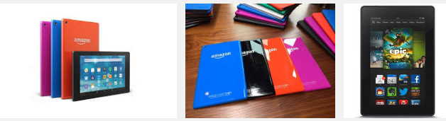

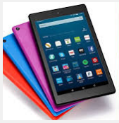



**We will be giving away 8 All-New AMazon Fire HD Tablet, 8" HD Display, Wi-Fi, 32 GB**

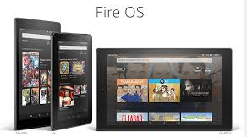

**November 21, 2016 through December 30, 2016**

***Fedex***

**Perfect attendance give Away**

***Note* If you receive any:***

***No Call No Shows, E-Outs, LOA’s, Un-Excused Absents and Tardys, Dr.’s Notes***

***you will NOT be ELLIGIBLE from the contest.***