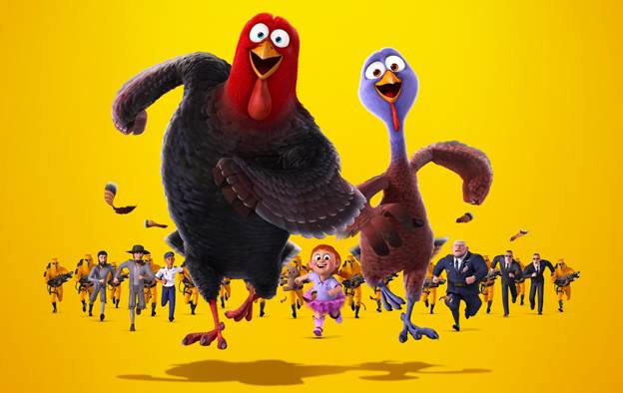

**HARTE HANKS FAMILY MOVIE NIGHT**

**FRIDAY NOVEMBER 11**

**6:00 PM UNTIL ABOUT 10:00PM**

**FREE TO ALL HARTE HANK’S EMPLOYEES AND FAMILY!**

•      **COTTON CANDY**

•      **KETTLE CORN**

•      **BOUNCY HOUSE**

•      **HOTDOG CHIPS AND WATER**

•      **MOVIE STARTS AS SOON AS IT GETS DARK**

**\*Alcoholic beverages are not permitted\***

**\*Bring lawn chairs for the movie as seating will not be provided\***

**\*Be prepared to have fun\***