**Training Reinforcement Request: Lite Shipping-Ground Pickups Now Available for Credit Card Shippers! - Dotcom rep review – HOT**

CA/French agents are not aware that customers can now schedule a Ground Pickup in the non-logged in state (without using an account).  Below is the reference to KB 17371.

**Lite Shipping:  Ground Pickup – Canada Credit Card Shippers**

Previously, Lite Shipping Canada and Intra-Canada shippers (secured & anonymous) were not able to schedule a Ground pickup. They only had options to select to use an “already scheduled pickup at their location” or “drop their package off at the nearest FedEx location”.

They would be presented with an alert message and provided with ‘Bill to account’ payment options only (i.e. no credit card payment).

**Previous View**

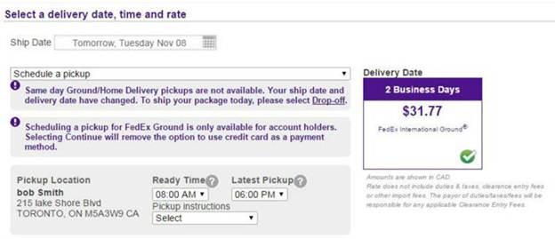

Now, the alert message is removed, and Lite Shipping Canada and Intra-Canada anonymous (non-logged in) shippers have the option to schedule a Ground pickup without being charged any fee, as Pickups are free in Canada.

**Current View**

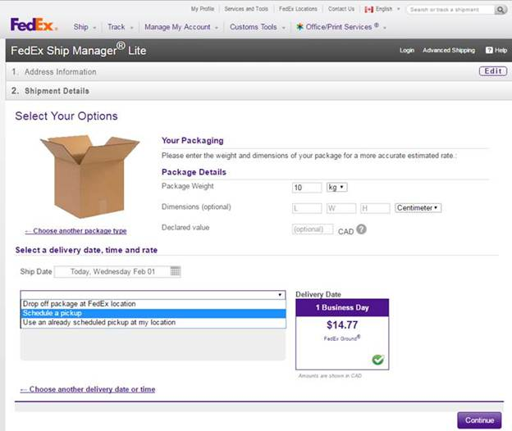

|  |  |
| --- | --- |
| Call Type: | **LITE SHIPPING** |
| Problem Type: | **CREDIT CARD** |
| Problem Type: | **GROUND PICKUP** |
| Resolution: | *[select applicable]* |