**NAME: MBONIMANA Tite**

**REG NO: 221004133**

**CLASS NO: BIT GROUP TWO**

**PROJECT NAME: PARENT IN CLASS**

**1.PLANNING**

Parents are limited to what take place at school (specifically in class) with their children.

Parents really would like to engage in their child’s studies but they are limited due to different factors (job, life, etc.)

**Parent in class** is an online system that helps parents to access what goes on with his/her child at schools especially in class and allow them interact with teachers and school leaders (parent in class). To summarise parents will be in class virtually.

**2. Design**

Functional requirements

* Admin can register another admin
* Admin can update any info to the system
* Admin can add or delete student
* Admin can add or delete parent
* Admin can add or delete teacher
* Admin can modify any info to the system
* Parent can register/signup with the system
* Parent can log into the system
* Parent can access his child’s information regarding academics
* Parent can print out the documents (His child’s report, school document, etc.)
* Parent can leave comment or request
* Teacher can register with the system
* Teacher can add student’s marks
* Teacher can print out some reports
* Teacher can leave comment for certain parent
* Teacher/school leader can upload announcements

**3. Development**

*As the system is configured to serve for the academic purpose, its backend looks like this:*

* *The system, is built in the way that no unauthorized user can access it (in other words it is secured)*

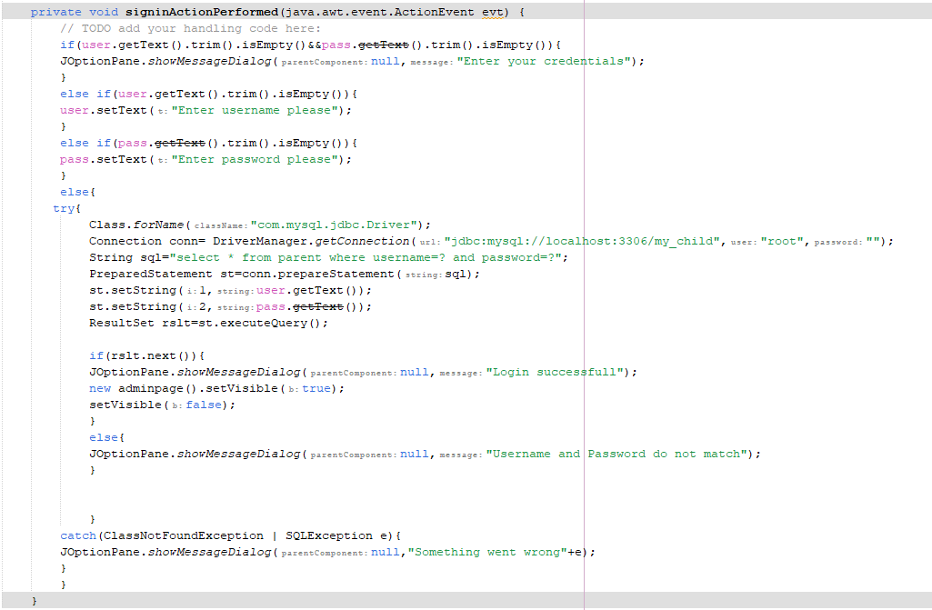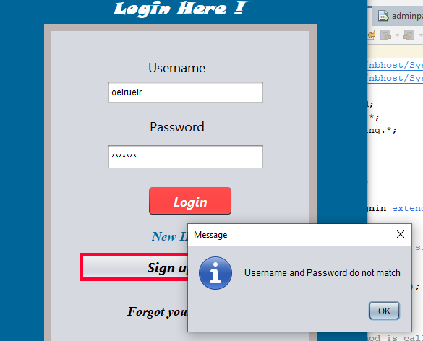

* *Parent is limited to access the info of other children other than his/her i.e. parent will access any child’s info by using children’s identity*
* *The system verifies the user credentials to allow access to the system*

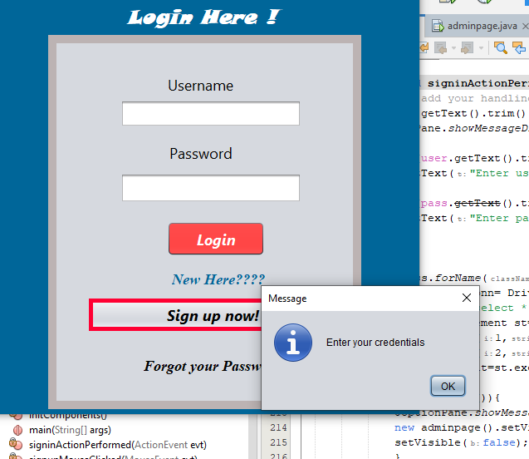

* *At home page of the parent, parent can view student marks, and teacher’s comment regarding discipline*
* *At teacher’s page, teacher can upload student’s marks and comment accordingly*
* *At the admin page, admin can add, delete or modify user’s information*
* *The system can generate kinds of report accordingly*
* *We have used NetBeans as platform that also helped as run and test our codes*
* *SQL also was used to create database for the system*

**4.Testing**

During this stage, of course we faced some challenges including:

* Syntax errors were most common errors to face

(writing codes badly), but with the help of internet, we corrected those errors

* Others were that we found other necessary unrealized features during testing stage

To sum up, these were the common challenges we faced but of course we handled them, and buy now the system is serving as intended

**5.Deployment**

Here by the help of different software, we developed the system. Among the software are:

* JDK
* NETBEANS
* XAMPP
* And GIT HUB

These are what helped us in development, installation, testing and deploment