**Set Constant Duty**

Garrett - Set the PWM to a constant 80% duty.  Most of our customers in high performance don’t want to use the PWM command.  They want it to run at a constant knowSn flow, and return excess fuel to the tank.

Aymeric - The duty cycle has a resolution of 0.5, means 1% = 2. So in the main.c, you can maybe force the variable ui8_PWM_dc_mat to 160 (line 1041). Then it will send 80% command to the matlab layer, which will be converted to a requested speed.If you want more place in the microcontroller, you can in this case command the function PWMReadDC() and interrupt_PWMCapture() in pwm.c

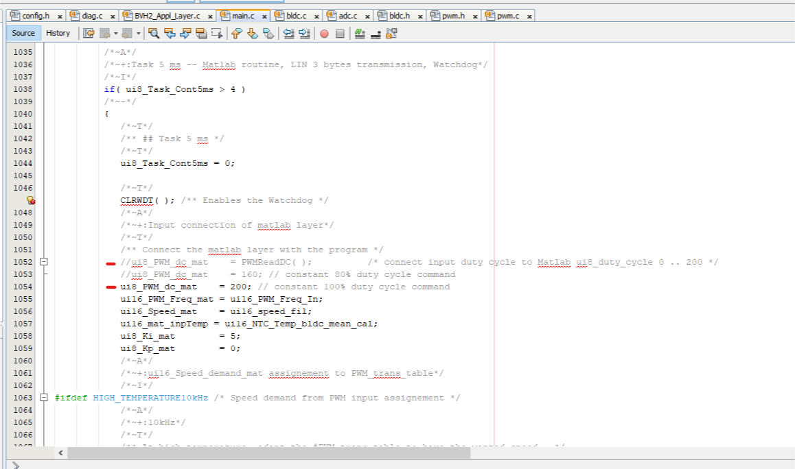

**Fixed PWM (stop controller from adjusting speed based on pressure)**

Garrett - I’m trying to command a constant 80% duty in the way you suggested; however, it seems to correlate to speed, not duty cycle to the pump.  When I increase pressure, the duty cycle to the pump increases.  Is there a way to make it a constant 80% duty to the pump?

Aymeric - Yes, it is conform that what I understood you need… I thought you wanted fixed speed…But now you have a preprocessing option: def_fixed_PWM to activate and configure. (see in config.h line 250 or 251) I don’t really remember which one you have to use. The function can be read in main.c line 764 to 770. It should work

