7.3.26 - Saturday
- Circuit Design Pattern – Take the complete knowledge
- At most character in a string using Java 8 – Mphasis
- Complete the Home work of HTML
- Rent – To be given
- Sukanya Check Deposit amount for this year -

Asked in Mphasis – 7th March 26 - Saturday
- Agentic AI – what is this and how to use this ?
Ans:
  - understands a goal
  - makes a plan
  - carries out tasks on its own

- Prompt – Explain this
Ans: Prompt = Your request
- How did you use in your project - Agentic AI

- Design Pattern in Microservices
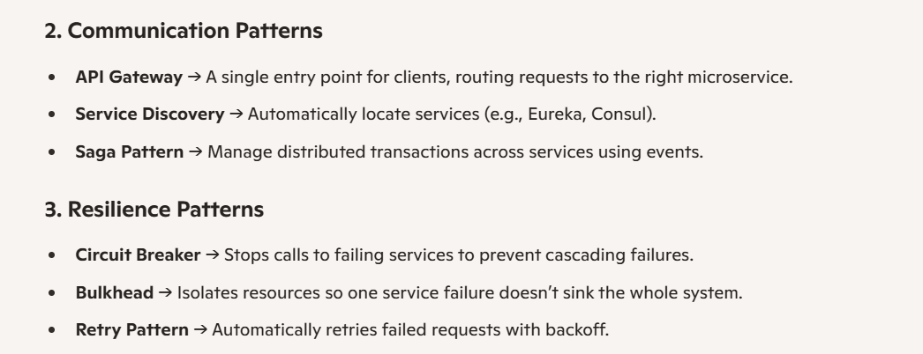
- Circuit Design Pattern – Explain
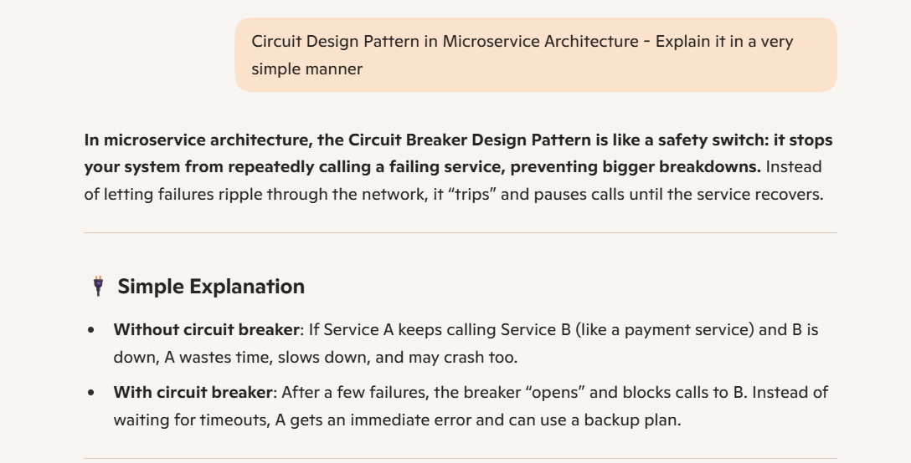
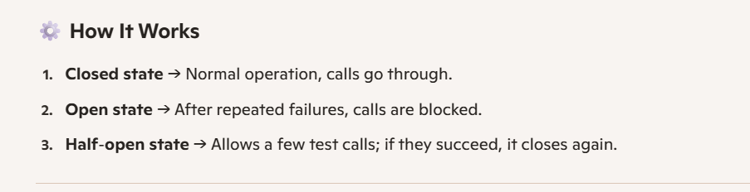
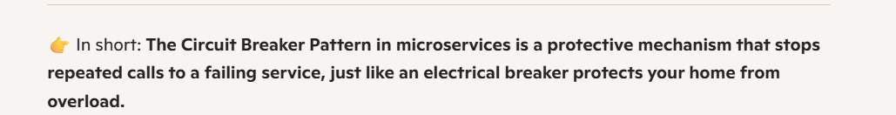

- Where to configure Circuit Breaker in the code ?

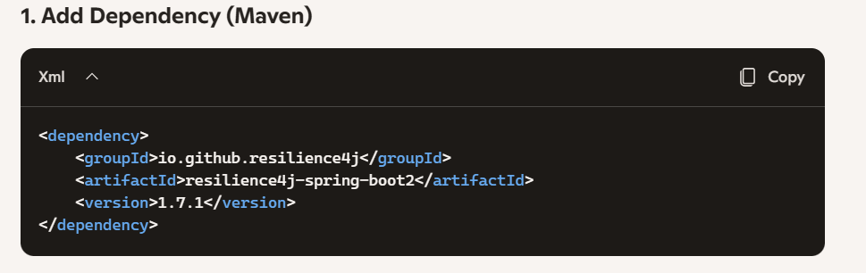

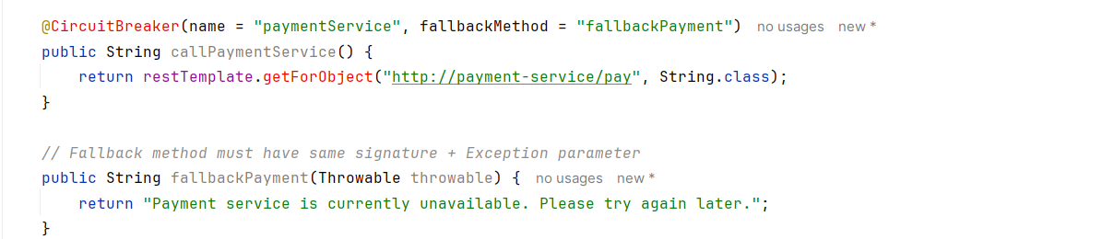

- React Js - Not worked
- Jenkins Deployment for your project - Explain
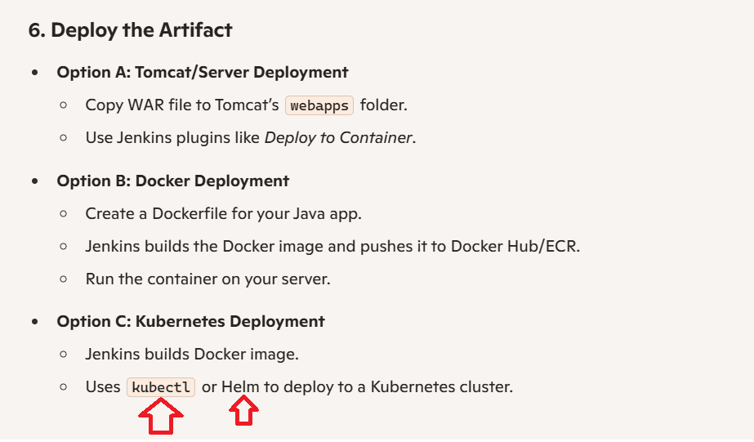
- How did you do migration from Java 8 to Java 17 - what issues you got
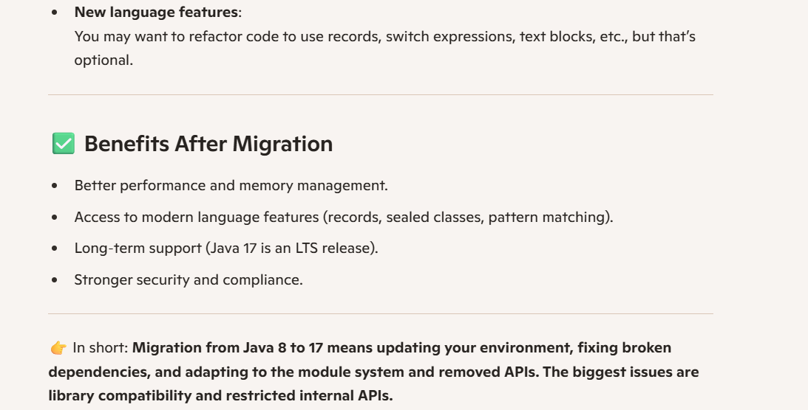

- One program - at most character in string str = "haradhan" using Java 8
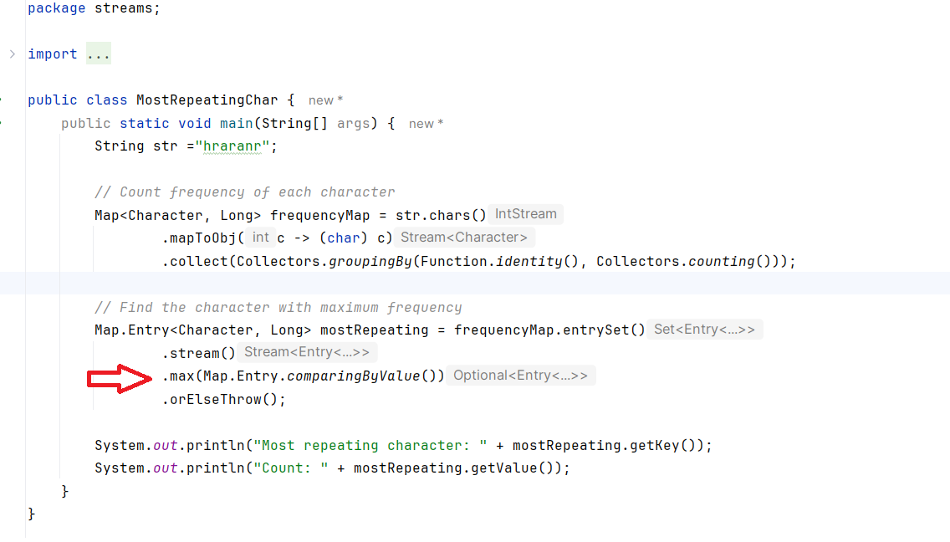

6.3.26 - Friday
- Home Loan – Done
- Rent – To be given
- Sukanya Check Deposit amount for this year -
Complete the Homework – HTML – Done – Next home work to do for tomorrow(7th March)
- Practice Kafa
- Practice Queries
- Practice Microservices – rest-demo, my-microservices_api_gateway – application.yml(predicates) , oauth2-demo
- Notes – check jwt, oauth2-demo
- HTML Tutorial – 15 Minutes
- Transaction Page in Banking

5.03.26 – Thursday
- Comple the Home work today – done
- Practice some queries
- Palindrome of the string – need to do
- FlatMap example below:
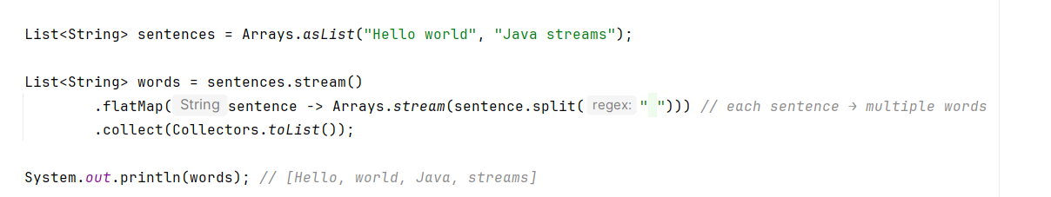

- Logic for Palindrome
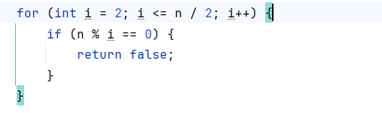

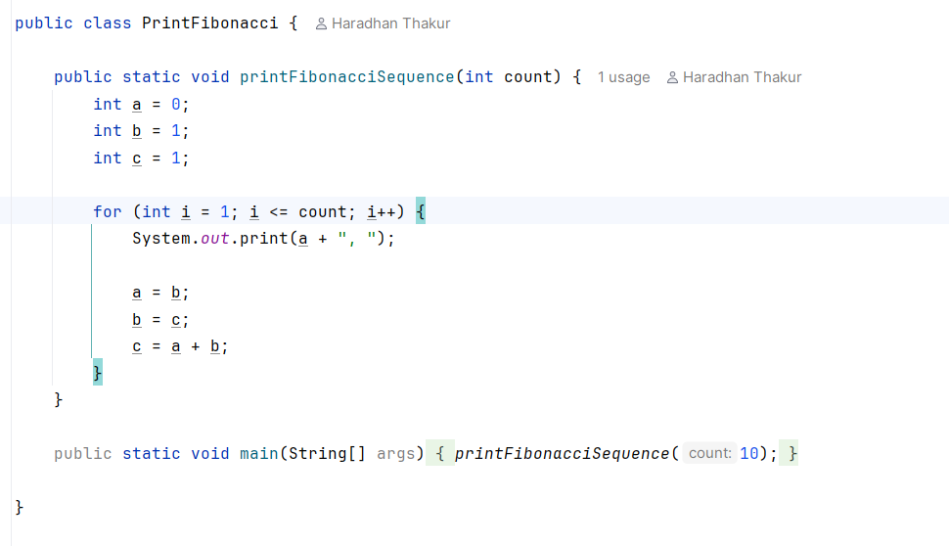

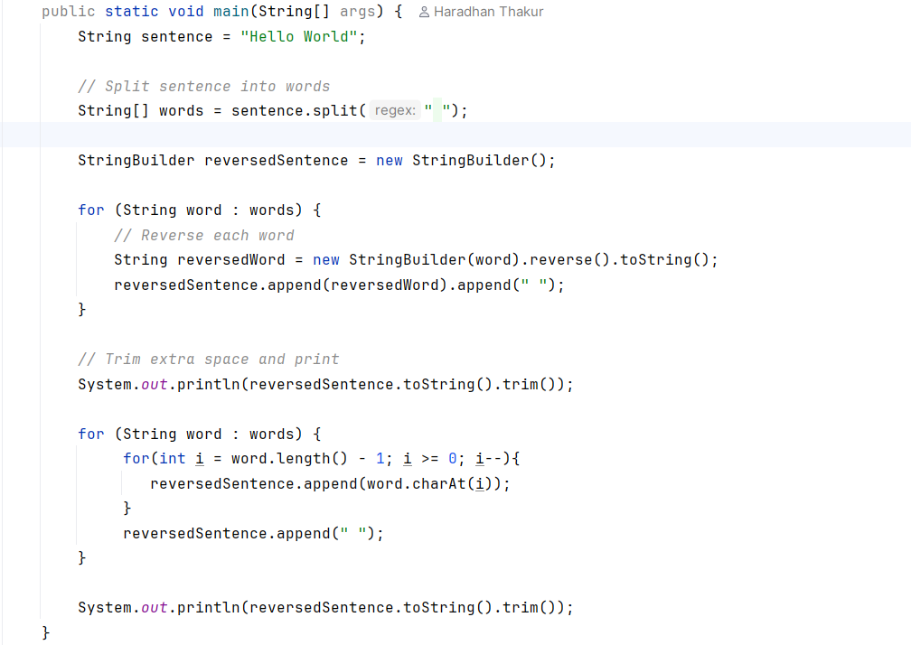

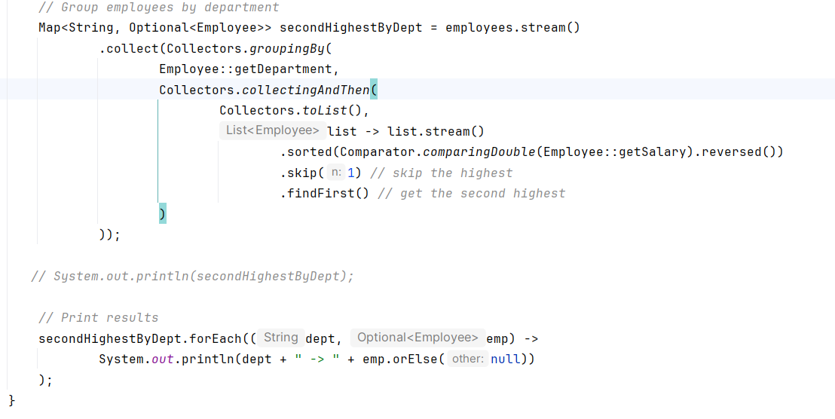

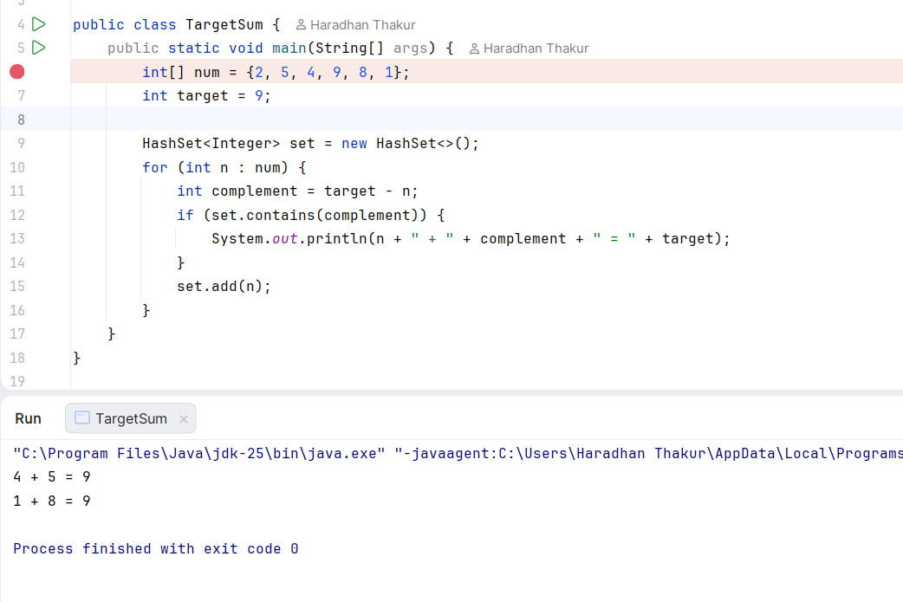

Think abou it: CancelZeroSumSubsequencesImportant\

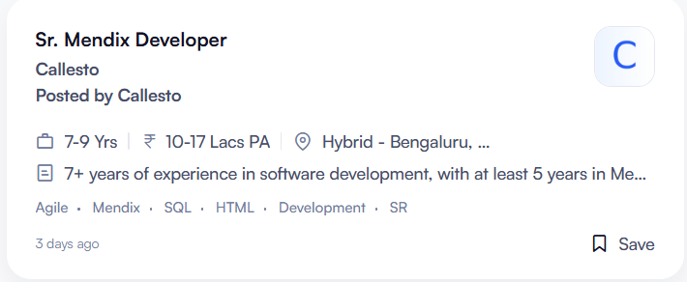

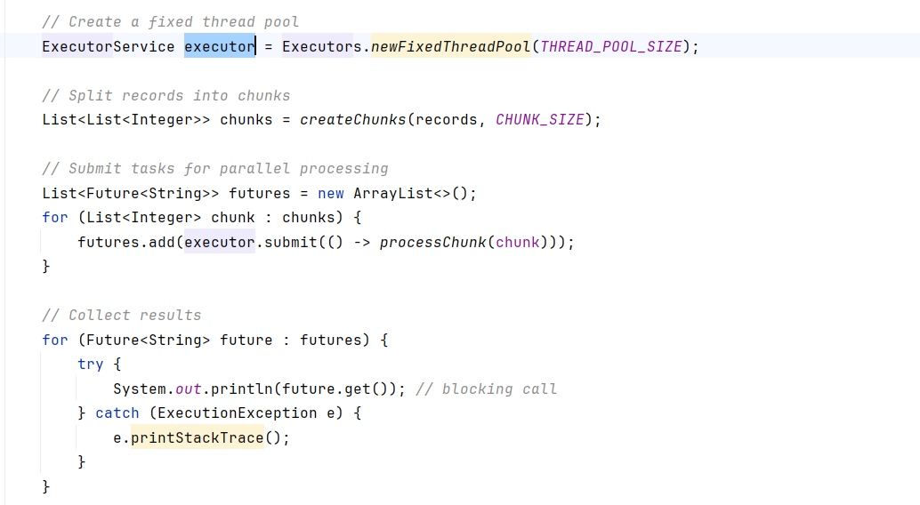

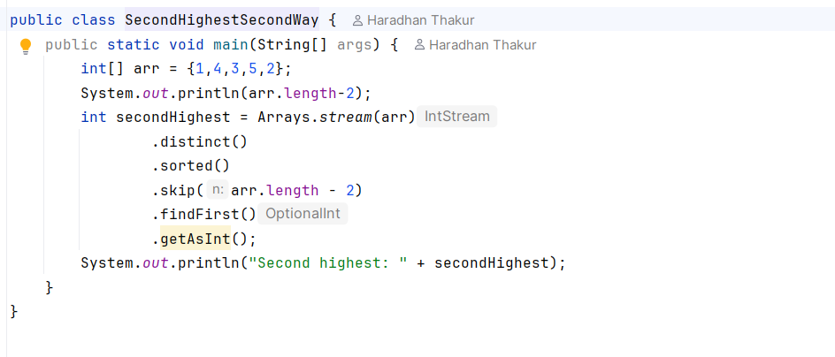

Do the HTML homework tomorrow –
- Terraform
- Cloudops
- Kafka

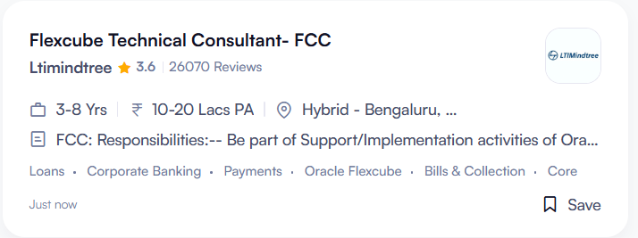

- How many years of experience do you have in Financial markets or trading systems?

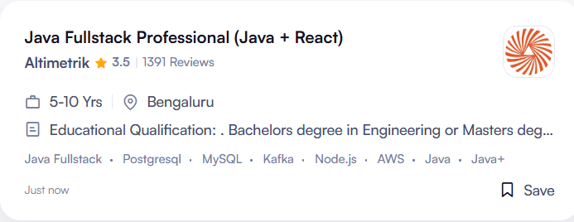

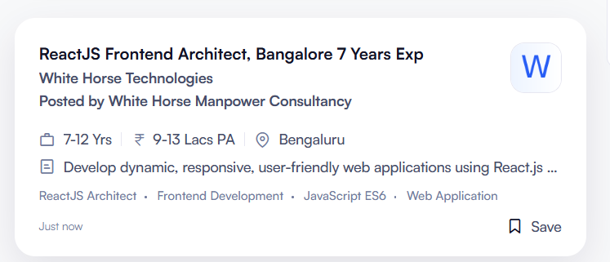

*************************************************************************************************************************

4.3.26, Wednesday
- Aws Lambda, AWS, Amazon Ec2, EKS, Kubernetes, Amazon Web Services Ec2, Docker, Aws Migration – 15 minutes
- streams projects – 20 minutes
- GraphQL - Done
- AWS API Gateway
- Software Solution Architect – Banking design

what are the pages, I need to design for the Savings account ? please explain

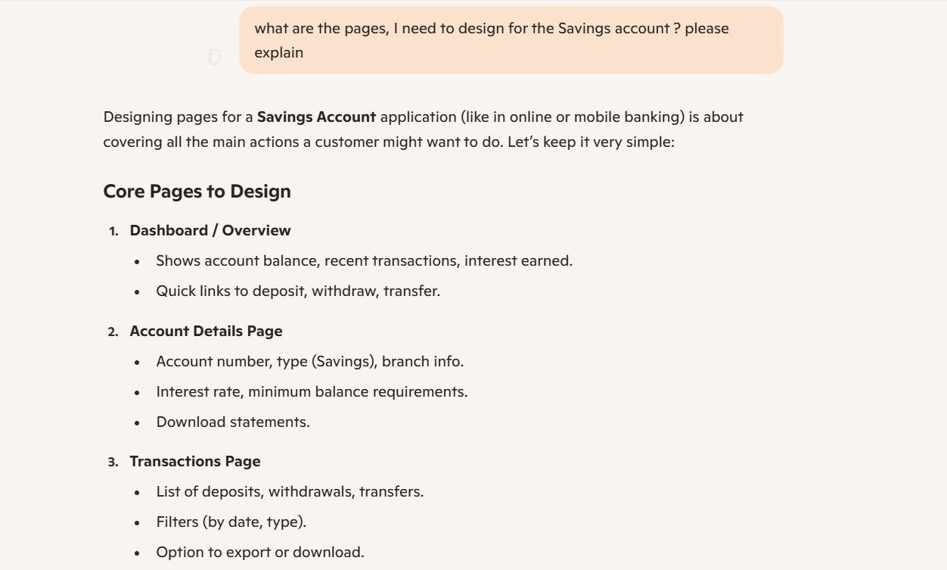

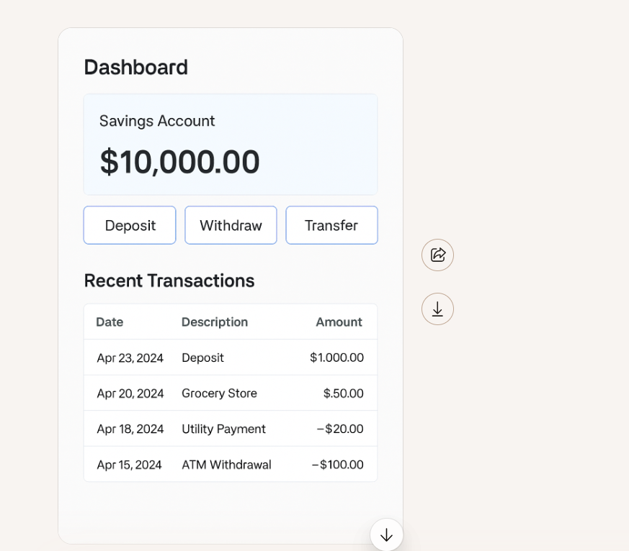

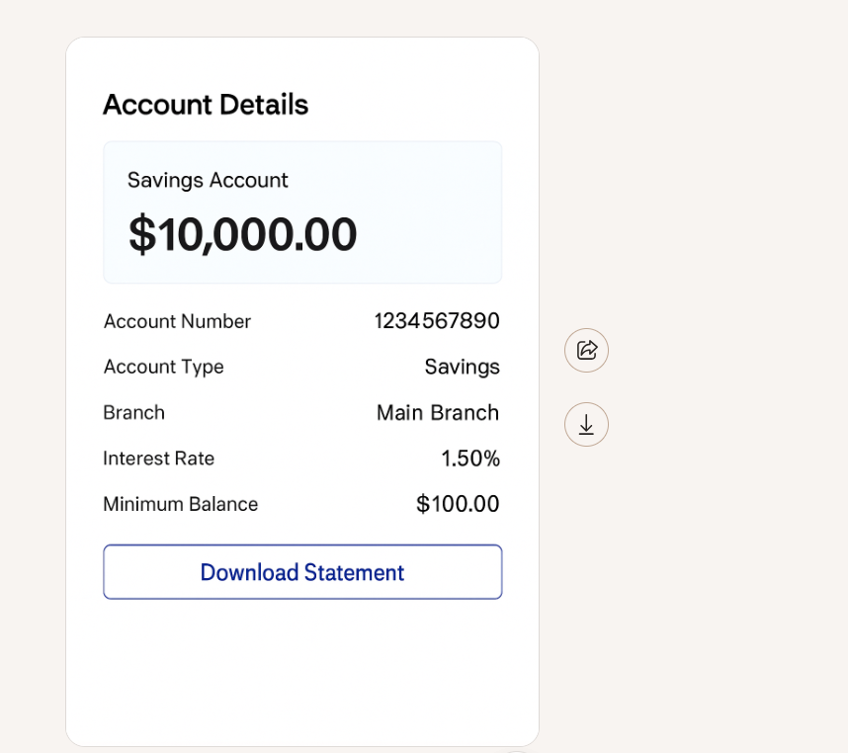

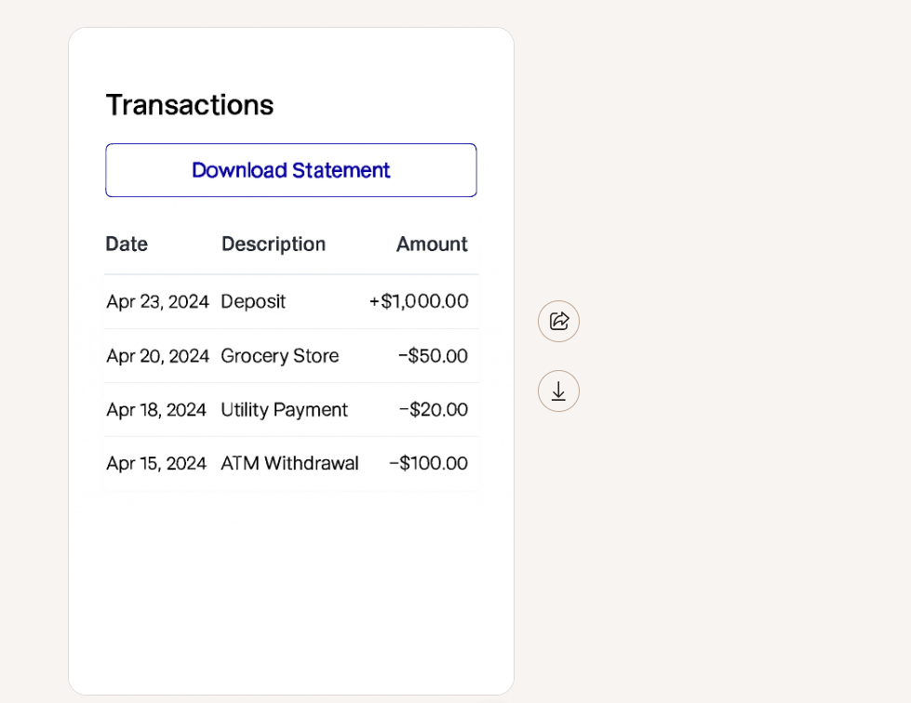

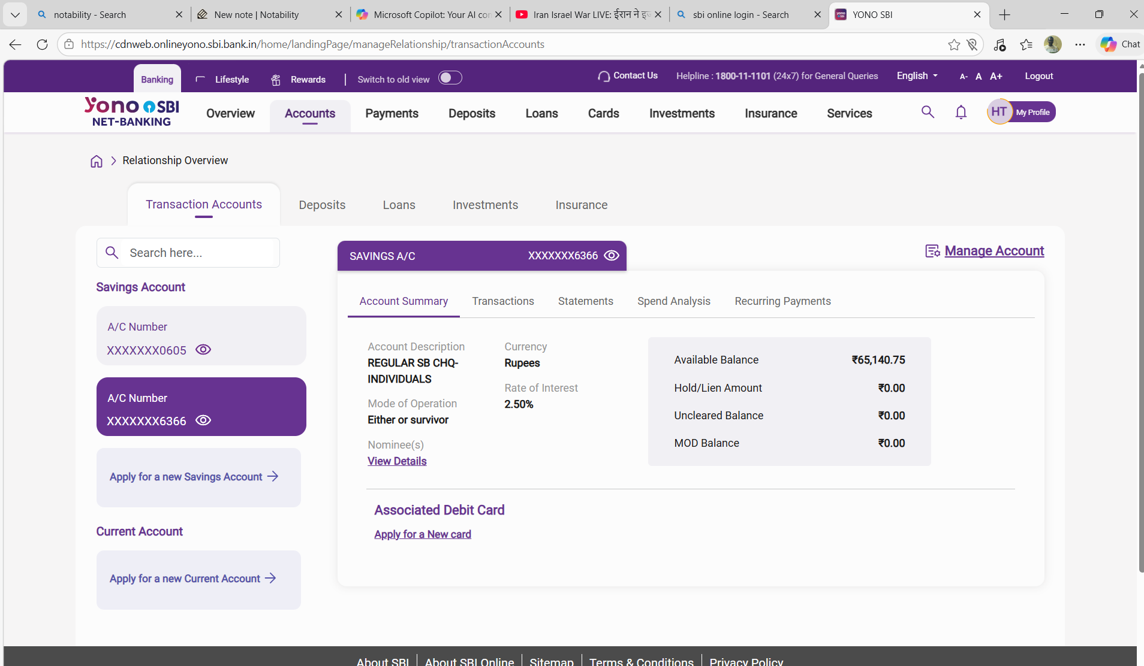

- Kafka – 1 hr
- gRPC
- RabbitMQ
- OAuth2, JWT, RBAC, API rate limiting, Security Headers (CORS, HSTS, CSP)
- AWS X-Ray, Open Telemetry, Prometheus, Grafana, ELK Stack
- Kubernetes (EKS), Docker, Terraform, Jenkins, AWS Lambda
- AWS Native Services
- Performance Testing, Performance Engineering, Load Runner, JMeter
- React js
- CSS
- Javascript
- Agentic AI, Generative AI, Large Language Model, Application
- Node Js Developer
- Event-Driven Architecture
- Terraform
- Mean/Mern Stack – Express – Architecture – Node – Full

3.3.26, Tuesday
- restcrud project 15 min
- streams projects – 20 minutes
- Circuit Breaker Pattern – 10 min
- Components of microservices
- Give the test of wells fargo tomorrow – 4.3.26 – after 4 PM

******************************************************************************************************
Q. All of a sudden, the production env in software goes down after six months. How can we know this?





