26th Feb – Oauth2

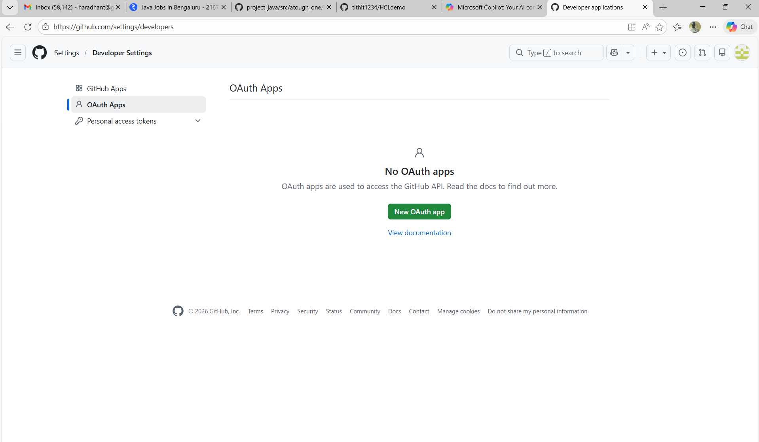

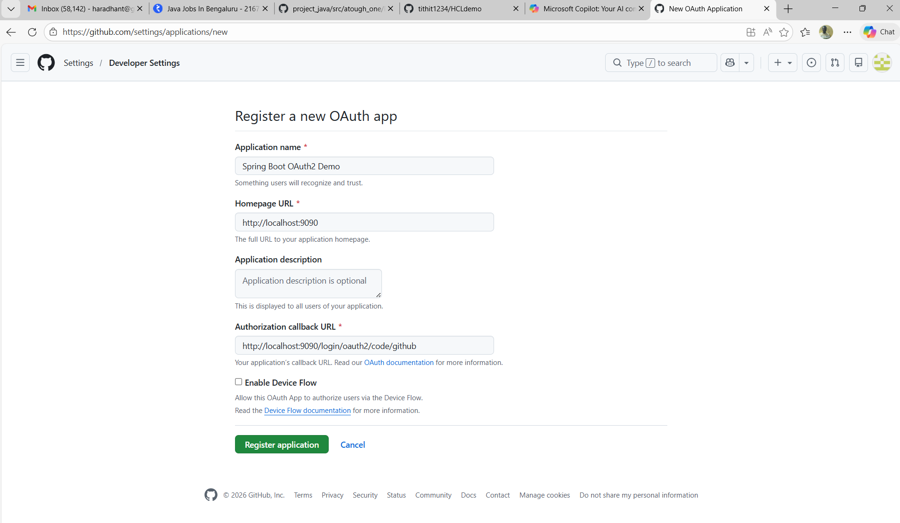

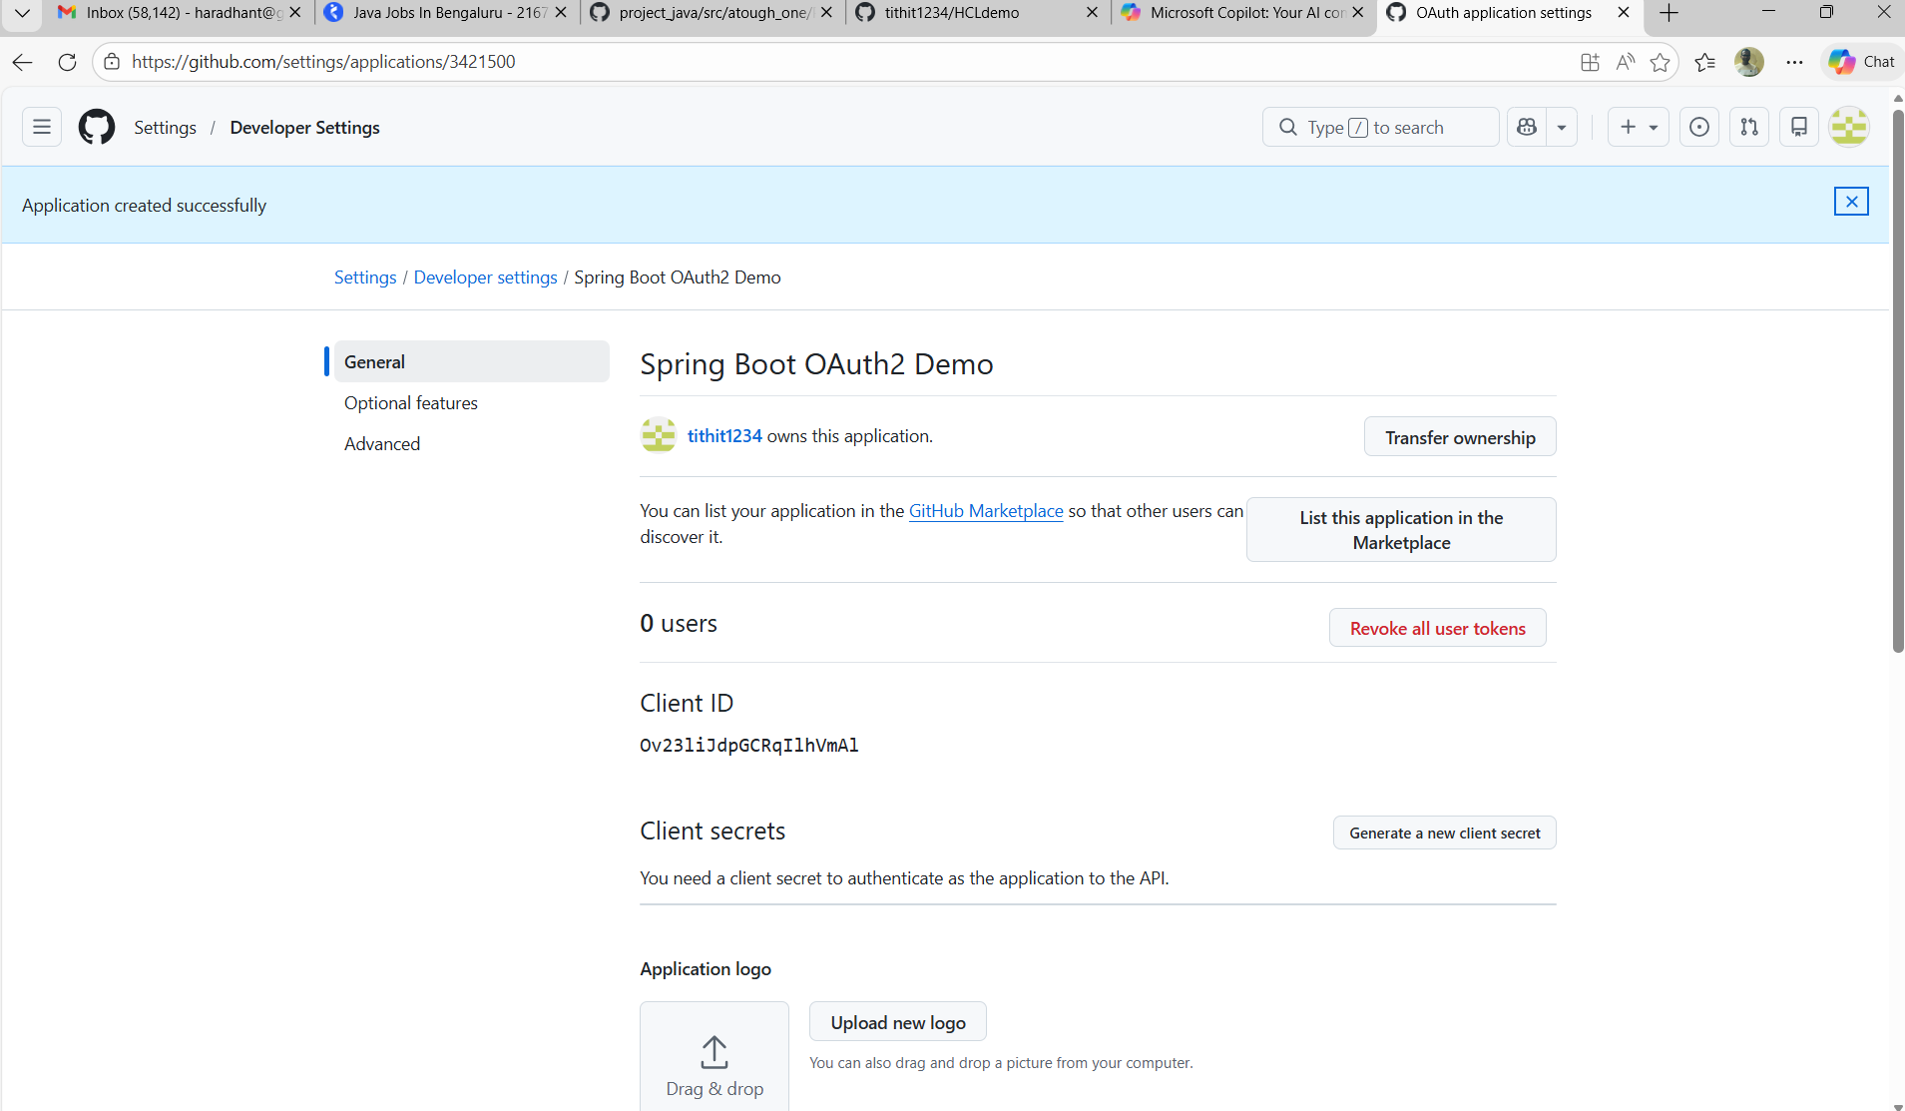

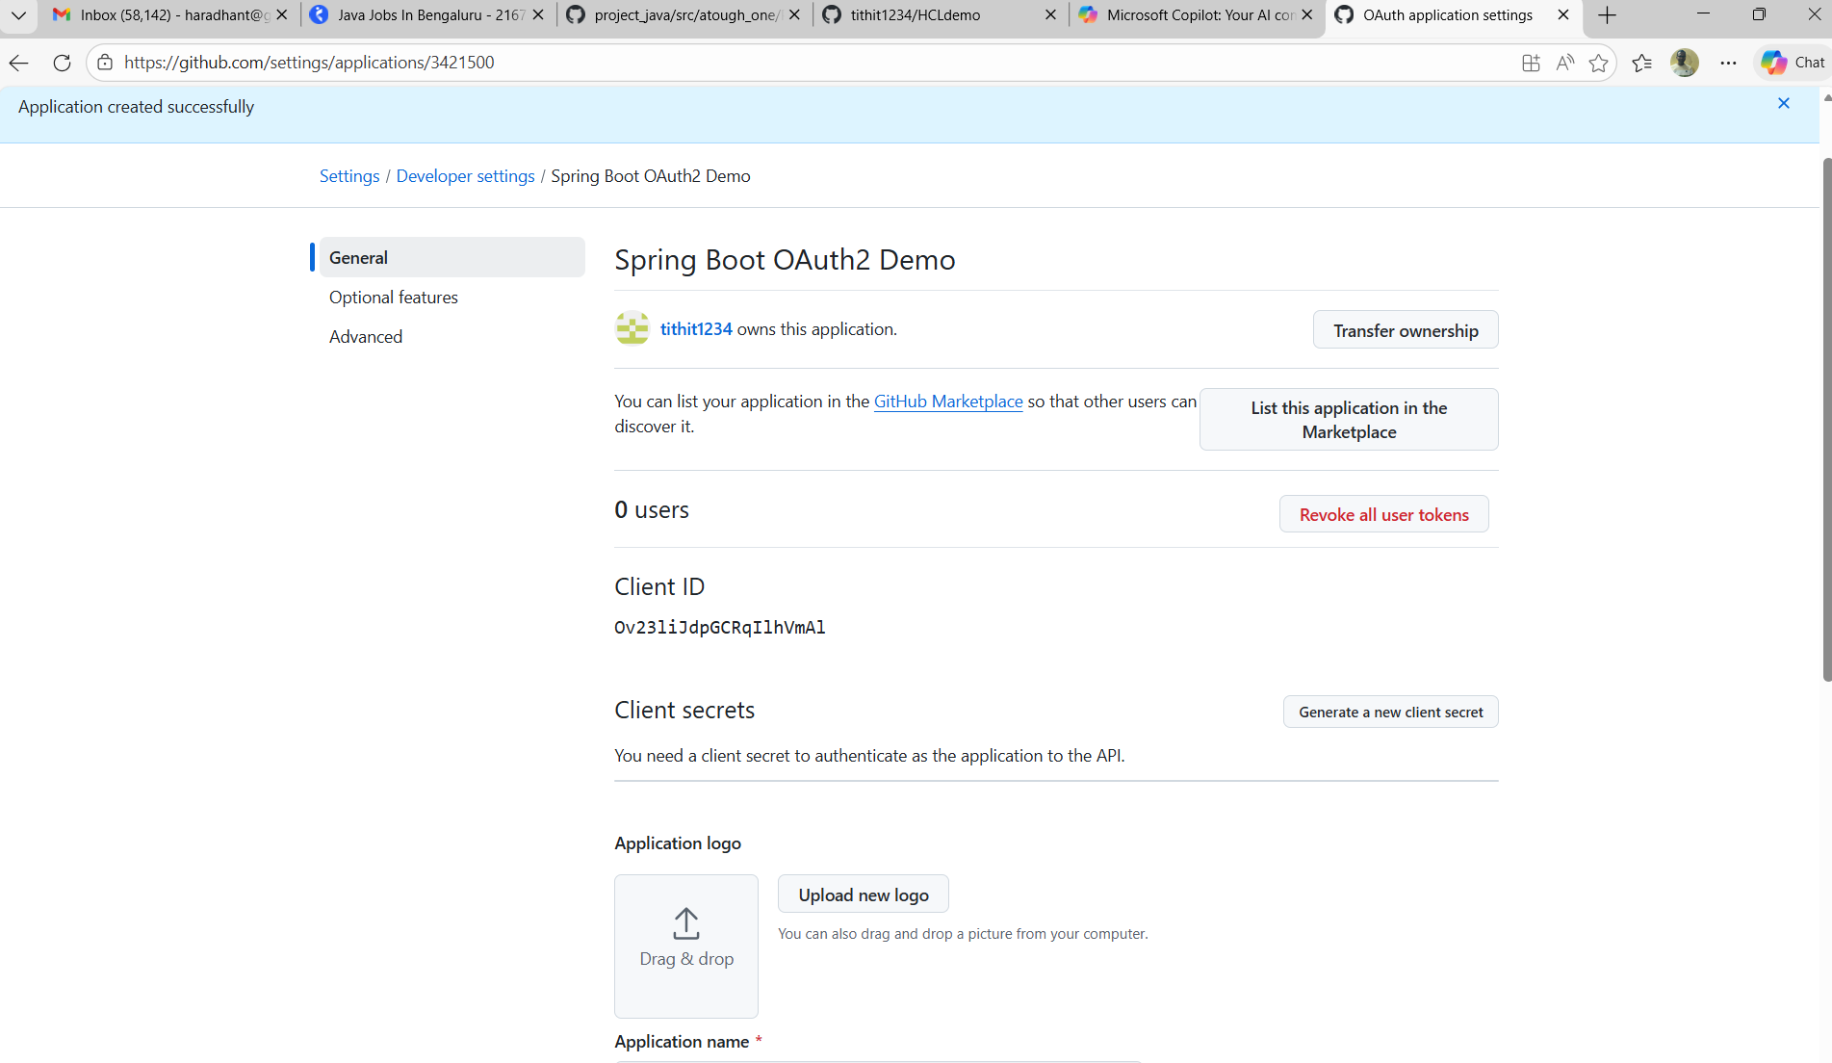

client-id
Ov23liJdpGCRqIlhVmAl

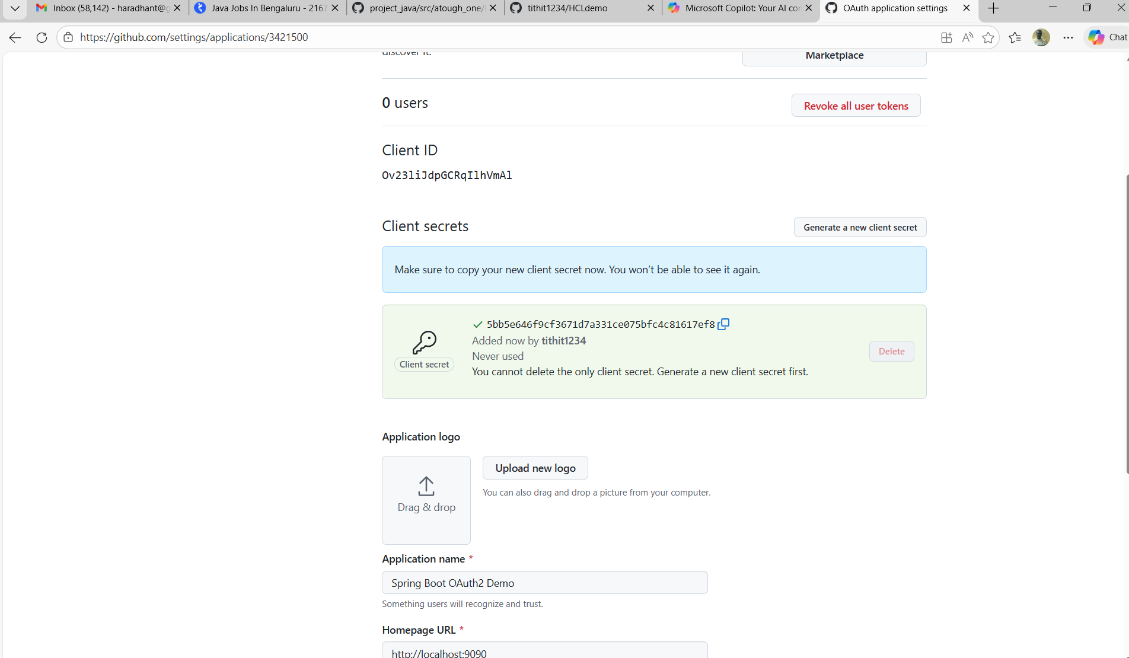

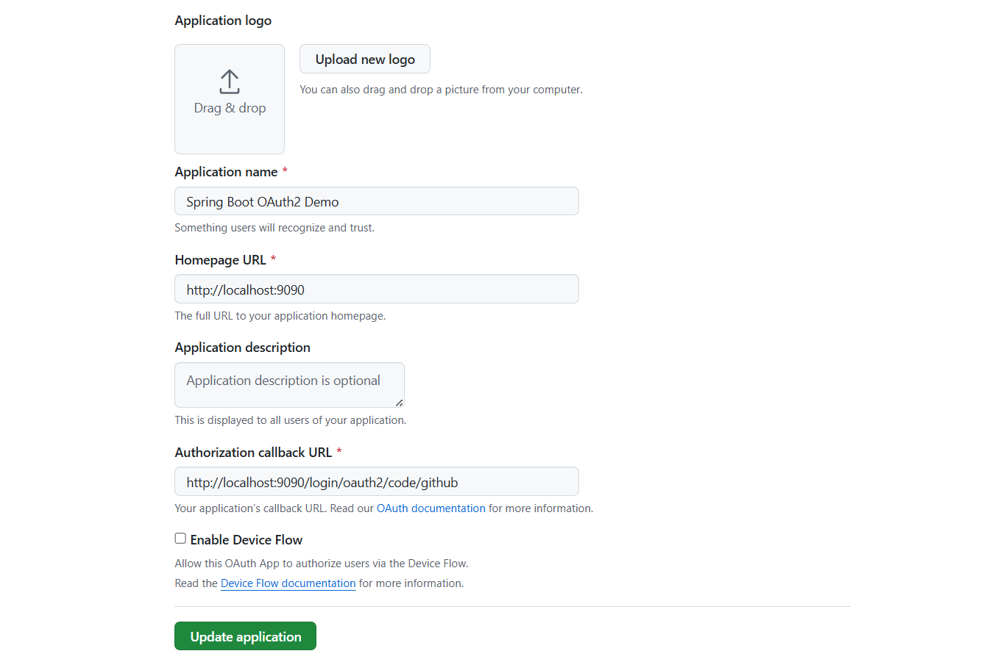

client-secret
5bb5e646f9cf3671d7a331ce075bfc4c81617ef8

- The login page of GitHub Opens

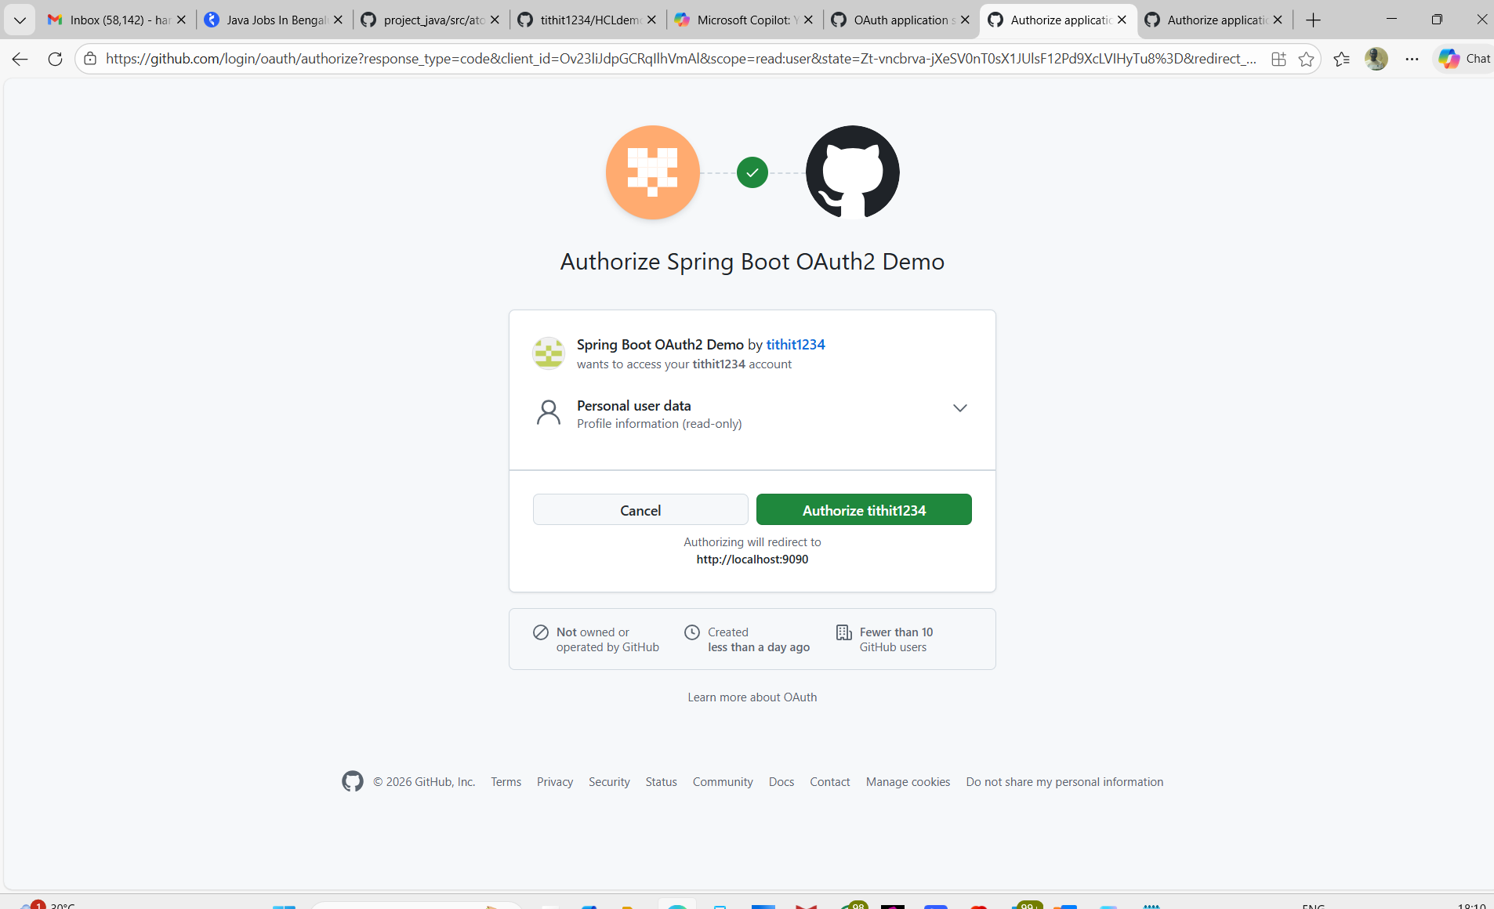

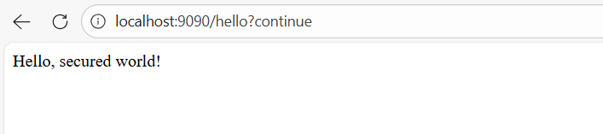

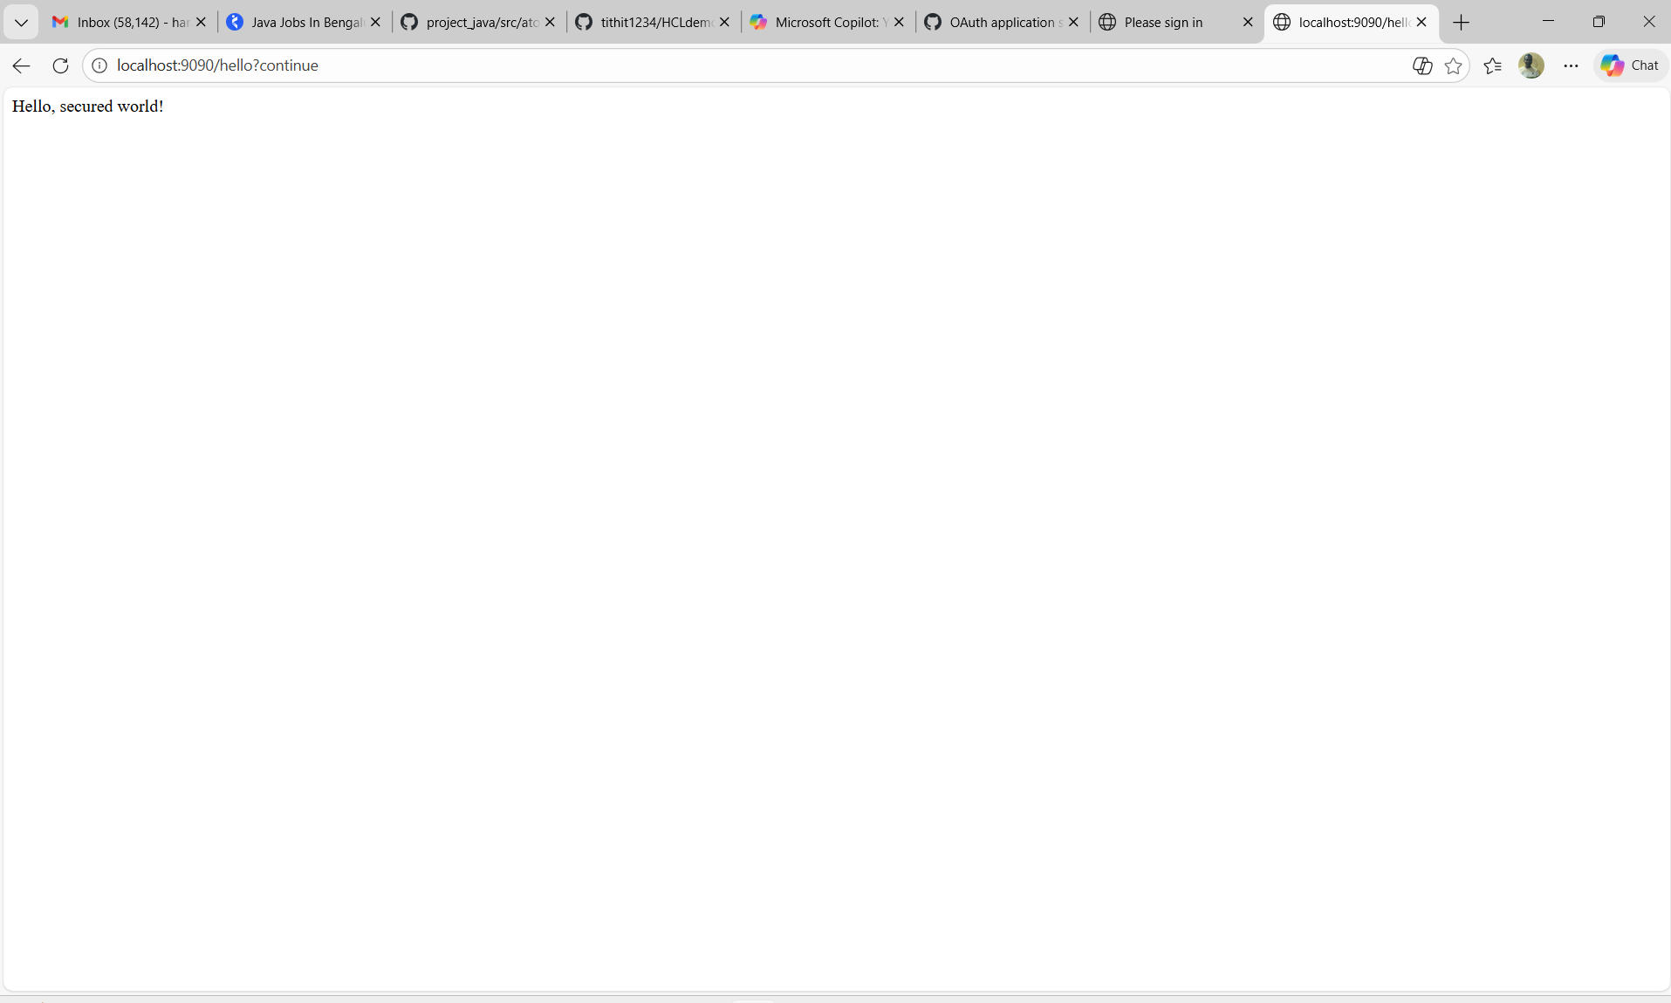

**********************

Homepage URL

Authorization callback URL
http://localhost:9090/login/oauth2/code/github

**************************************************************

