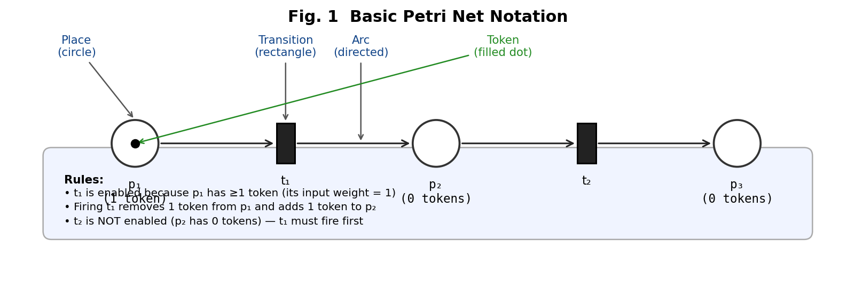
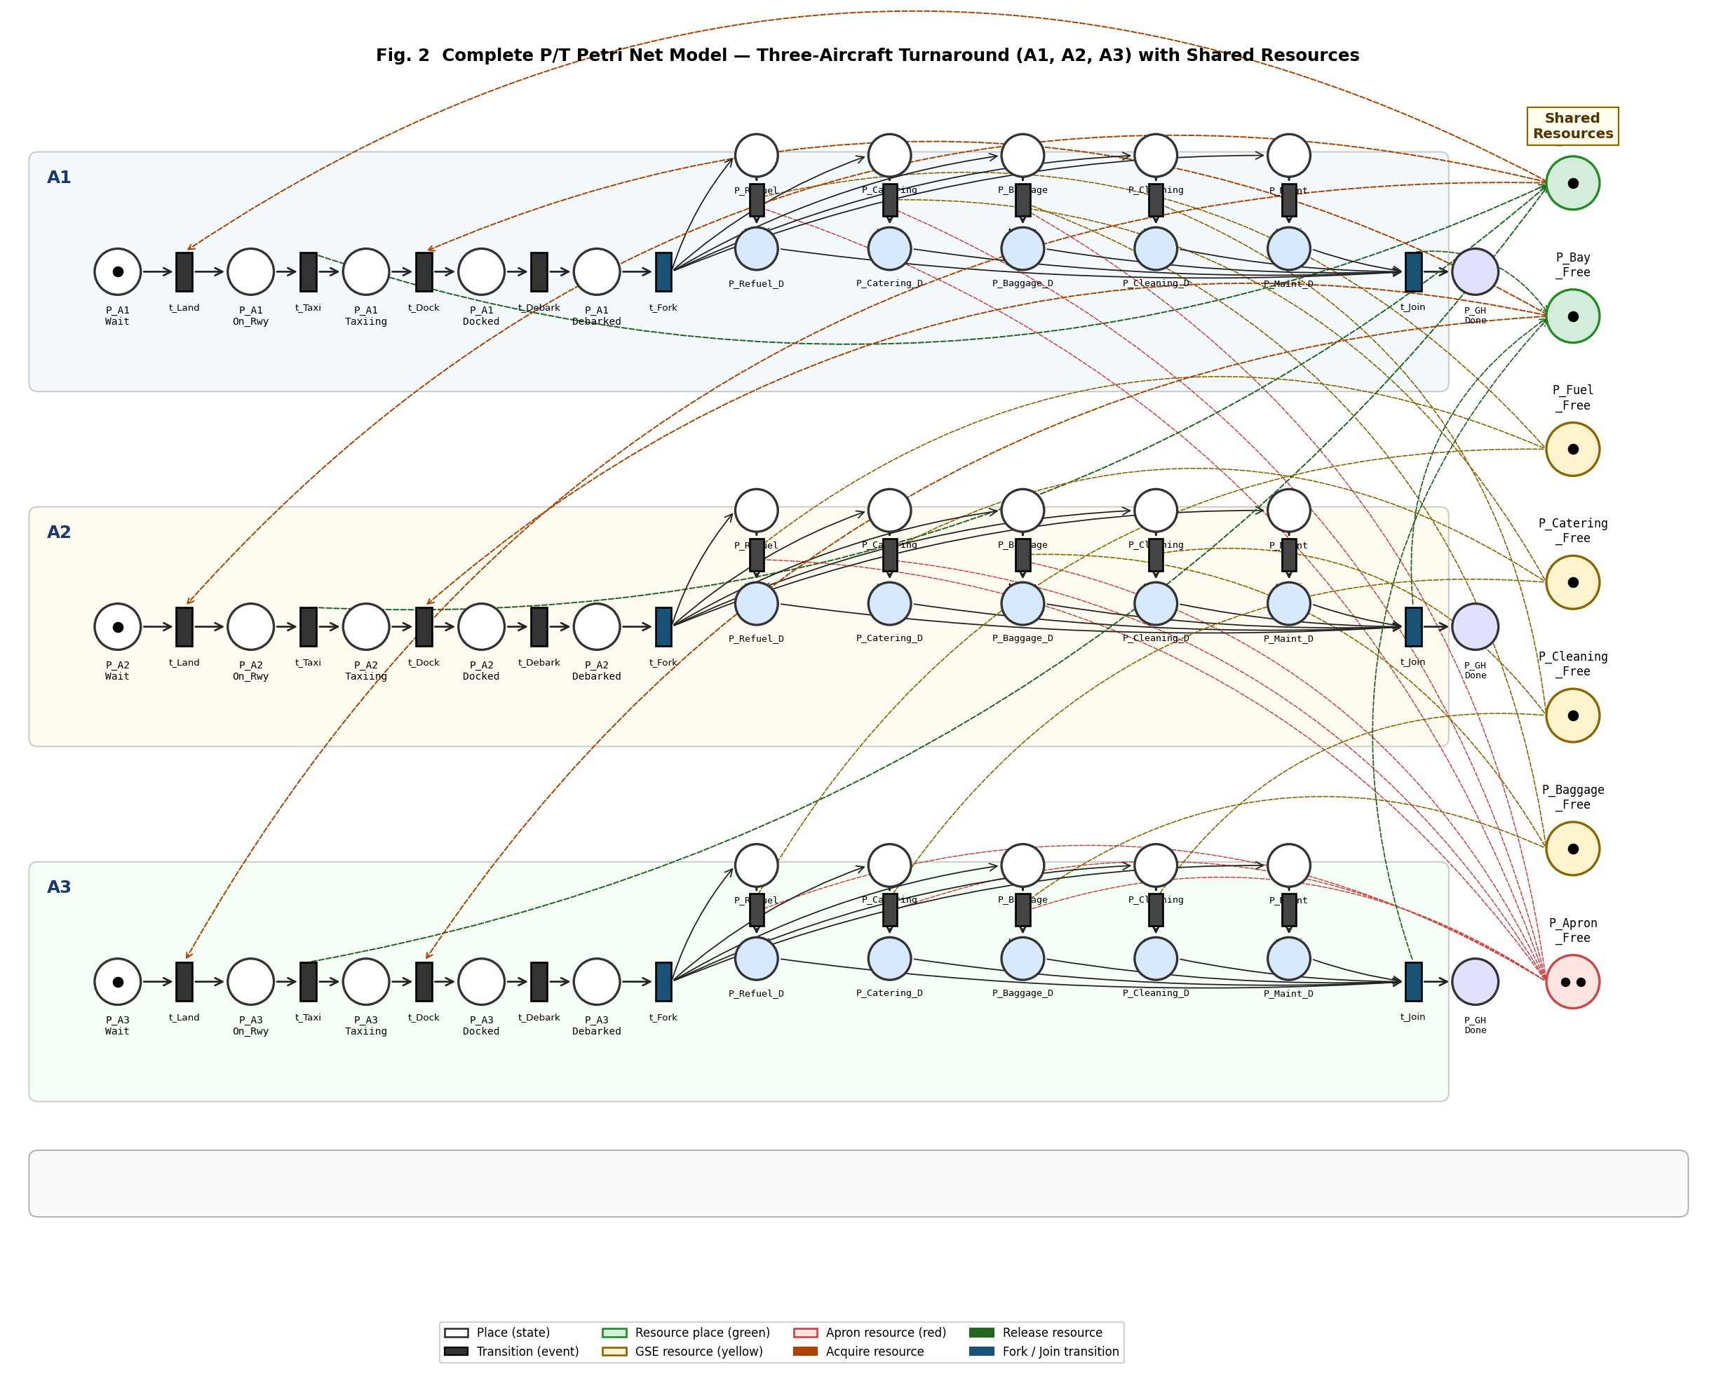
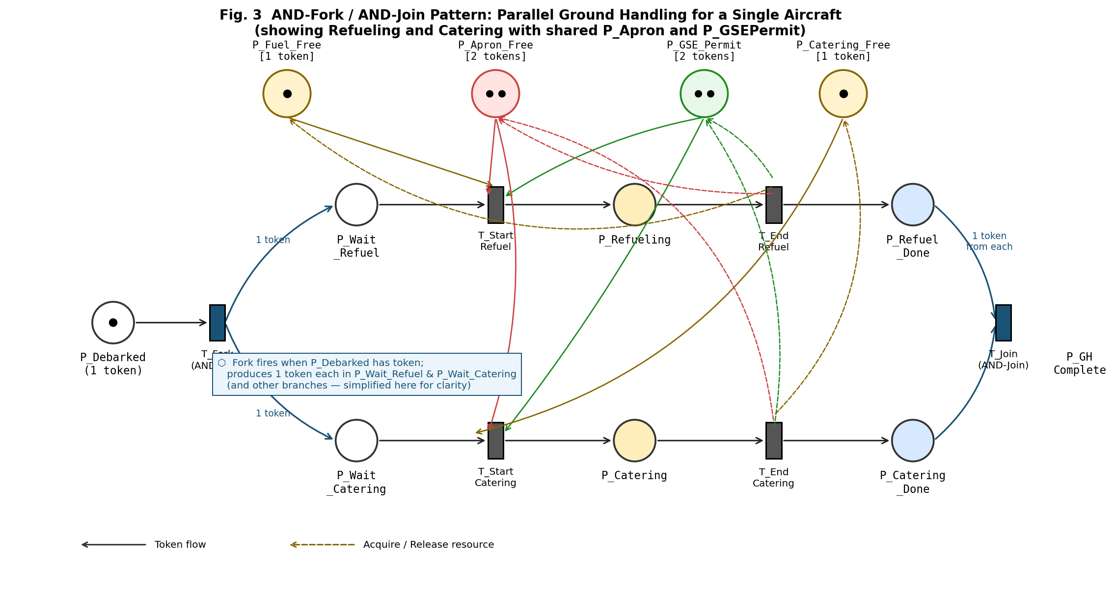
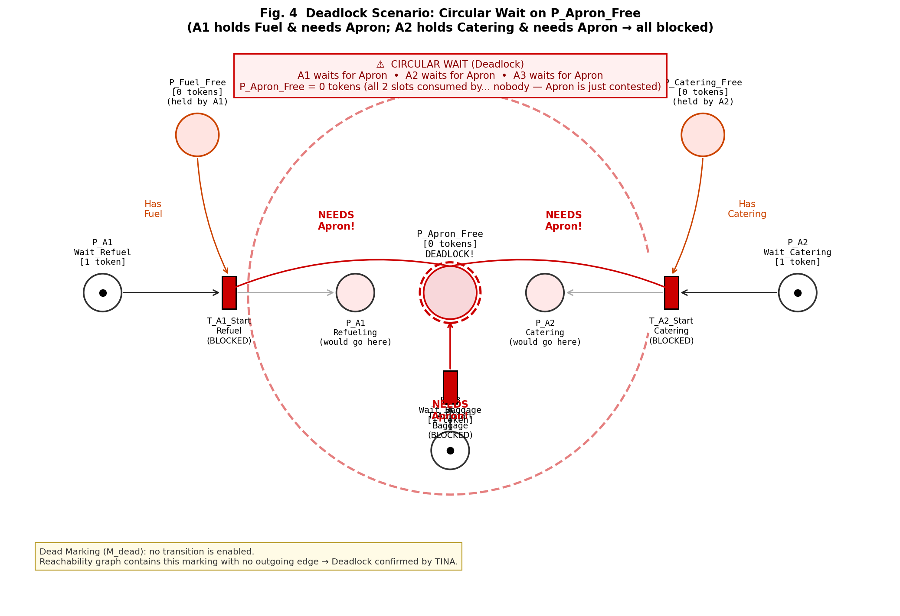
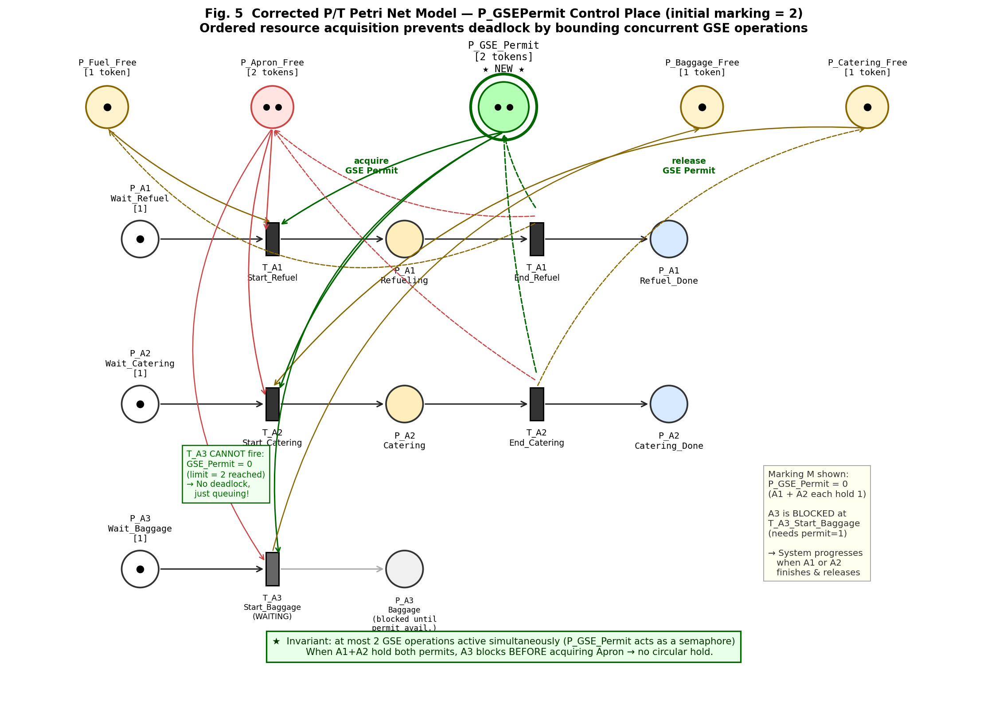
Fig. 5. The corrected Petri Net model showing the P_GSEPermit control place with initial marking of 2 tokens. Each ground handling transition acquires a GSE permit before entering the apron zone, preventing deadlock through ordered resource acquisition.

Safety Property Verification
- Safety Property Verification Results
Property | Description | Result
S1 | Runway mutual exclusion | Satisfied
S2 | Gate mutual exclusion | Satisfied
S3 | No pushback during refueling | Satisfied
S4 | Boarding precondition (all GH done) | Satisfied
S5 | Apron zone capacity ≤ 2 | Satisfied
S6 | No refueling during boarding | Satisfied
All safety properties were verified to hold in the corrected model. The structural constraints encoded in the Petri Net (single tokens in resource places, precondition arcs on transitions) effectively enforce the required safety invariants, including the new S6 property ensuring no refueling occurs during boarding.

Liveness Property Verification
- Liveness Property Verification Results
Property | Description | Result
L1 | Aircraft completion (land → takeoff) | Satisfied
L2 | Ground handling completion | Satisfied
L3 | No starvation (resource access) | Satisfied
All liveness properties were satisfied in the corrected model, confirming that every aircraft that enters the system will eventually complete the turnaround process and depart. The GSE permit mechanism ensures fair access to apron zone resources, preventing indefinite starvation of any process.

Discussion

Effectiveness of the Petri Net Model
The Place/Transition Petri Net proved to be an effective formalism for modeling the aircraft turnaround process. The natural representation of concurrency through independent transitions, resource sharing through shared places, and synchronization through precondition arcs aligns well with the structure of ground handling operations.
The model successfully captures the key aspects of the turnaround process: sequential phases (arrival, ground handling, departure), parallel operations within the ground handling phase, resource contention for shared GSE and apron space, and safety constraints on operation ordering.

Deadlock Prevention Strategy
The ordered resource acquisition strategy implemented through GSE permit tokens is analogous to the well-known deadlock prevention technique of imposing a total ordering on resource acquisition [3]. This approach mirrors Petri Net controller designs used in manufacturing systems [13][16], and its application here demonstrates the cross-domain applicability of formal deadlock prevention techniques. In the context of airport operations, this translates to a dispatching policy that limits the number of GSE vehicles simultaneously operating in the apron zone.
This finding has practical implications for ground handling coordinators: implementing a simple permit-based system for apron zone access can prevent deadlock situations that might otherwise cause significant delays—delays whose operational impact has been quantified in prior simulation studies [8][11].

Scalability Considerations
The current model considers three aircraft, one gate, and limited GSE. While this captures the essential concurrency patterns, real-world airports operate at much larger scales. The state space explosion problem is a known limitation of model checking approaches [15]. For larger scenarios, techniques such as symmetry reduction, partial order reduction, or hierarchical modeling could be employed to manage state space size.

Limitations
This study has several limitations. First, the model uses untimed Petri Nets, which do not capture the temporal duration of operations. Time Petri Nets supported by TINA could extend this analysis to include timing constraints. Second, the model assumes deterministic resource allocation, whereas real-world operations involve stochastic elements such as equipment failures and weather delays. Third, the model considers a simplified airport configuration; real airports have multiple gates, runways, and GSE fleets.

Conclusion
This paper presented a formal verification approach for the aircraft turnaround process using Place/Transition Petri Nets and the TINA model checking tool. We modeled the complete turnaround workflow for three aircraft sharing limited airport resources, including one runway, one gate, and constrained ground support equipment.
Through state space analysis, we identified a potential deadlock condition arising from circular wait on apron zone resources during parallel ground handling operations. We proposed and verified a control mechanism based on ordered resource acquisition (GSE permit tokens) that eliminates the deadlock while maintaining full concurrency where possible.
Using LTL model checking, we verified six safety properties and three liveness properties, confirming that the corrected model ensures mutual exclusion on critical resources, proper sequencing of safety-critical operations including the critical no-boarding-during-refueling constraint, and eventual completion of all processes.
The results demonstrate that formal verification using Petri Nets provides rigorous, mathematically-backed guarantees about the correctness of concurrent ground handling operations—guarantees that cannot be achieved through testing or simulation alone [8][11]. This approach can serve as a complement to existing Standard Operating Procedures, helping to identify potential issues before they manifest in real operations.
Future work includes extending the model with Time Petri Nets to analyze timing constraints, scaling to larger airport configurations using compositional verification techniques, and incorporating fault tolerance scenarios such as GSE equipment failures.

Acknowledgment
The author would like to thank Assoc. Prof. Dr. Wiwat Vatanawood and Asst. Prof. Dr. Nuengwong Tuaycharoen for their guidance and supervision. The author also thanks the Air Traffic Control officers who provided valuable domain knowledge about aircraft turnaround operations.

References
- International Air Transport Association (IATA), Airport Handling Manual (AHM), 41st ed., IATA, 2021.
- A. Norin, “Airport Turnaround Management: Modeling and Analysis of Ground Handling Operations,” Ph.D. dissertation, Linköping University, 2018.
- A. Silberschatz, P. B. Galvin, and G. Gagne, Operating System Concepts, 10th ed., Wiley, 2018.
- International Civil Aviation Organization (ICAO), “Annex 6: Operation of Aircraft - Part I: International Commercial Air Transport,” 11th ed., ICAO, 2022.
- IATA, “Ground Operations Manual (IGOM),” 10th ed., IATA, 2023.
- E. M. Clarke, O. Grumberg, D. Kroening, D. Peled, and H. Veith, Model Checking, 2nd ed., MIT Press, 2018.
- RTCA, “DO-178C: Software Considerations in Airborne Systems and Equipment Certification,” RTCA, 2011.
- S. Saggar, M. Tomasella, G. Cattaneo, and A. Matta, “Enhanced Operational Management of Airport Ground Support Equipment for Better Aircraft Turnaround Performance,” in Proc. Winter Simulation Conf. (WSC), 2021, pp. 1–12.
- T. Murata, “Petri Nets: Properties, Analysis and Applications,” Proceedings of the IEEE, vol. 77, no. 4, pp. 541–580, Apr. 1989.
- M. Silva, J. Julvez, C. Mahulea, and C. R. Vazquez, “On fluidization of discrete event models: observation and control of continuous Petri nets,” Discrete Event Dynamic Systems, vol. 21, pp. 427–497, 2011.
- A. Kierzkowski, J. Rezyński, T. Kisiel, E. Mardeusz, and O. Prentkovskis, “Modelling the Sustainable Development of the Ground Handling Process Using the PERT-COST Method,” Sustainability, vol. 17, no. 24, p. 11278, 2025.
- R. Johnstone, G. Eng, and J. Betts, “Modelling Baggage Handling Systems Using Petri Nets,” in Proc. Winter Simulation Conf., 2014, pp. 2550–2561.
- J. Ezpeleta, J. M. Colom, and J. Martinez, “A Petri Net Based Deadlock Prevention Policy for Flexible Manufacturing Systems,” IEEE Trans. Robot. Autom., vol. 11, no. 2, pp. 173–184, 1995.
- B. Berthomieu, P. O. Ribet, and F. Vernadat, “The tool TINA — Construction of Abstract State Spaces for Petri Nets and Time Petri Nets,” Int. Journal of Production Research, vol. 42, no. 14, pp. 2741–2756, 2004.
- E. M. Clarke, W. Klieber, M. Novacek, and P. Zuliani, “Model Checking and the State Explosion Problem,” in Tools for Practical Software Verification, Springer, 2012, pp. 1–30.
- Y. Feng, K. Xing, M. Zhou, and H. Liu, “Liveness Analysis and Deadlock Control for Automated Manufacturing Systems With Multiple Resource Requirements,” IEEE Trans. Syst. Man Cybern. Syst., vol. 50, no. 3, pp. 1100–1114, 2020.
- M. Uzam, D. Liu, B. Berthomieu, G. Gelen, Z. Zhang, A. M. Mostafa, and Z. Li, “On Deadlock/Livelock Studies Based on Reachability Graph of Petri Nets by Using TINA,” IEEE Access, vol. 12, 2024.

