CS4187 Computer Vision and Interactivity

Homework Assignment #2

Total Marks: 15 Points

**Deadline: 2020.11.13, 23:59:59PM**

**Question 1: Straight line detection (5 Points)**

Please write a program using OpenFrameworks,c

Note: please detect and draw the lines on the road only, and ignore the lines anywhere else.

For submission, please submit your code and a screen-captured video demo.

[Demo video](https://canvas.cityu.edu.hk/files/6502787/download?download_frd=1)

**Grading Breakdown:**

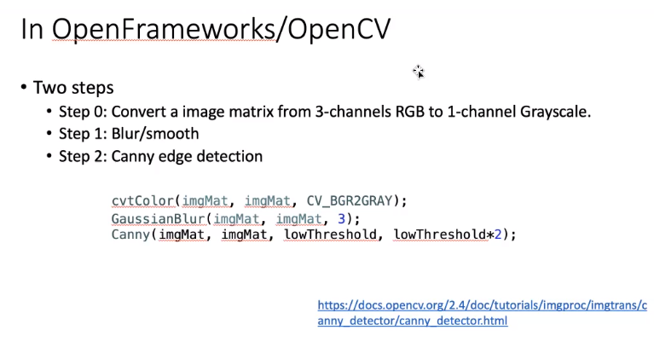

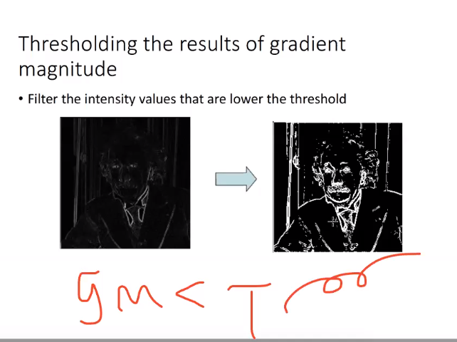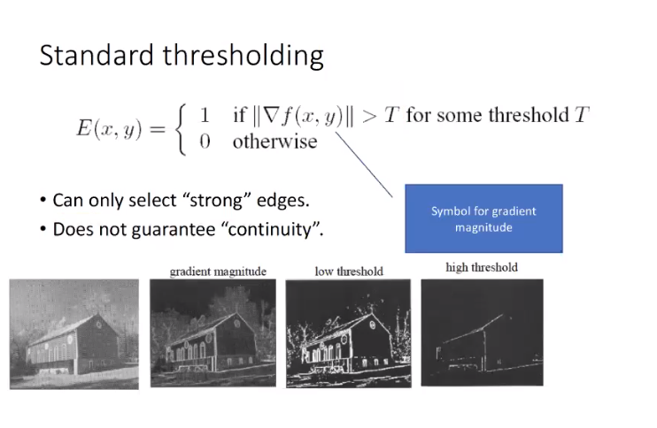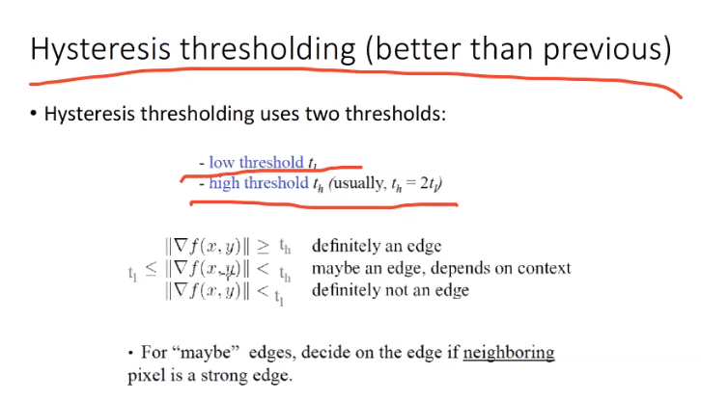

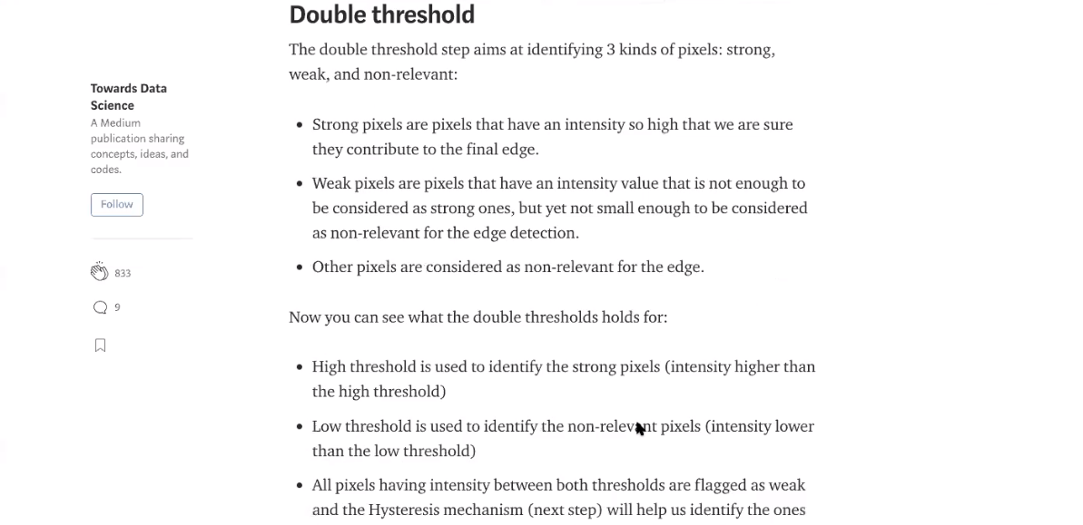

* Slider for the threshold of edge detection (1 point)
* Slider for the threshold of line detection (1 point) 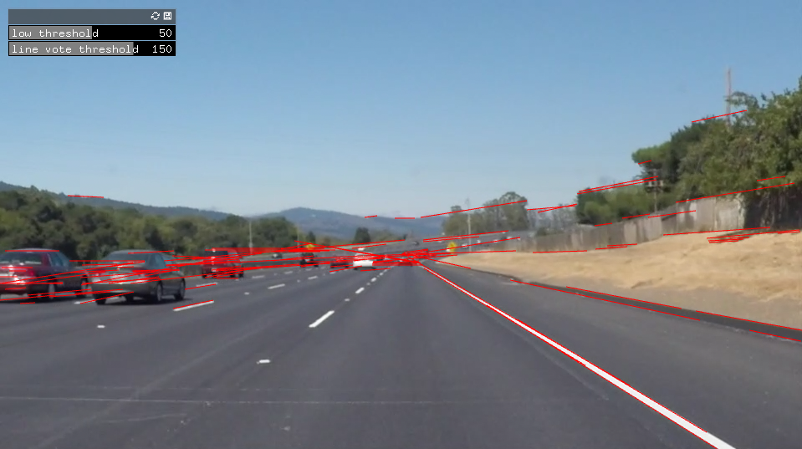
* Interactive indication of region of interest (2 points)
* Drawing red lines on the lanes (1 point) 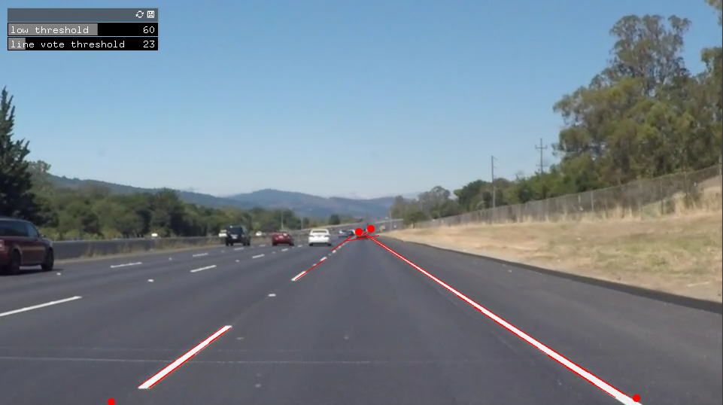

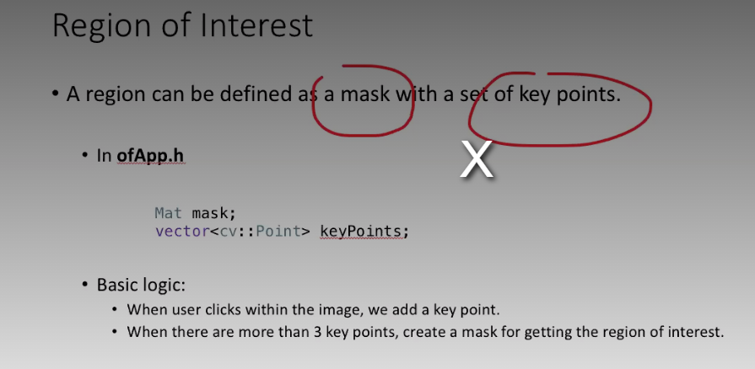

**Question 2: Circle Detection (5 Points)**

Make a pair of glasses by printing out and cutting the file “[glasses.pdf”](https://canvas.cityu.edu.hk/files/6502789/download?download_frd=1).

Please write a program using OpenFrameworks, to capture the real-time color image stream from a webcam. In addition, your program should detect the circles in the paper model of the glasses, and draw the following pattern at the position of the circle.

This means when the user wears the pair of glasses, and sit/stand in front of the webcam, he/she can see these patterns drawn at his/her eyes’ positions J Note that the pattern should only be drawn at the eyes’ positions.

Here is a [demo video.](https://canvas.cityu.edu.hk/files/6502790/download?download_frd=1)

For submission, please submit your code and a screen-captured video demo

**Grading Breakdown:**

* Color image from Webcam (1 point)
* Slider for the threshold of edge detection (1 point)
* Drawing circle only at the glasses model (3 points)

**Question 3: Edge Detection (5 points)**

Create an interactive application using OpenFrameworks, fulfilling the following interaction steps.

Step 1: Draw a line sketch on a piece of paper Step 2: Take a photo of it

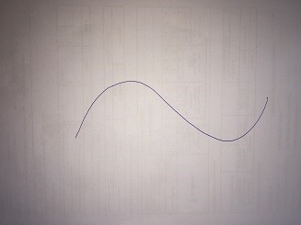

Step 3: Process the photo with your program, so that when you open the program, you will see a circle moving smoothly along the line your just sketched.

Here is a [demo video.](https://canvas.cityu.edu.hk/files/6502788/download?download_frd=1)

Please test your program with the following sketch patterns (**draw by yourself**).

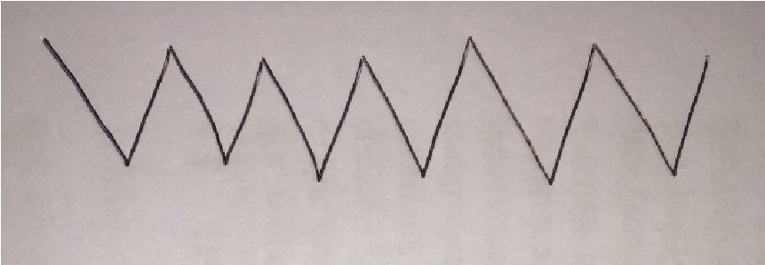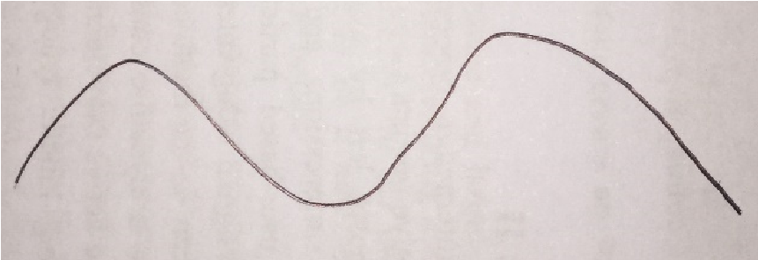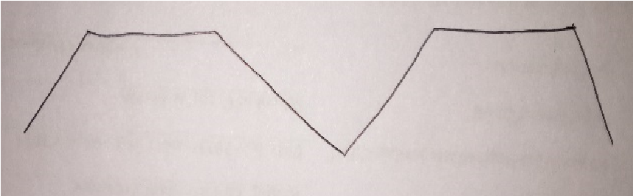

For submission, please submit your code and three screen-captured video demo.

**Grading Breakdown:**

* Slider for the threshold of edge detection (1 point)
* Circle moving along the 3 types of sketched patterns mentioned above (3 points in total, with 1 point for each pattern)

- Circle moving smoothly (1 point)

**Submission Method:**

Please write a report, stating your name and student No., to explain briefly your solution for each question, and zip it with your code and demo video, and submit the zip file to the canvas.