|  |  |  |
| --- | --- | --- |
|  |  | CSCU9N5 Assignment  Multimedia and HCI |

Date:10/11/2019

# Web-based multimedia application design and prototype



## Student Number:2636568

## Contents

# User personas………………………………………………………………….3

# Scenarios…………………………………………………………………………4

# Product description…………………………………………………………4

# Design description…………………………………………………………..5

# Navigation map………………………………………………………………..6

# Building prototype………………………………………………………...14

# Additional tools………………………………………………………........15

# Usability testing………………………………………………………........16

# Reference………………………………………………………....................16

User Personas

## 1.John snow, Stirling

**Status:**  second year student in University of Stirling (20-year-old).

**Archetype:** Native speaker

**Motivation:** diligent, responsibility and active for asking question in the class.

**Goal:** Understand the how the logic gates work and how can combination between two gates and how to use NAND gate to be another gate like AND or NOR gates. And preparing for the test.

**Frustrations:** He don’t understand in the lecture class even though he asks the lecturer and he can’t find the website that describe concepts of logic gate and the step of combination clearly. Also, he can’t contact with the web owner to ask the question.

**Bio: He is smart student** in many subjects but he usually gets the problem with mathematic subject. He loves for Coding in the program. That’s why he designs the study Computer science. He is going to study CSCU9V4(System of computer).

## 2.Daniel Lee, Japan

**Status:** second year student in University of Stirling (19-year-old).

**Archetype:** International student.

**Motivation:** hard working and more responsibility and bookworm.

**Goal:** Understand the how the use truth table and combination table when he tries 2 or 3 combination also how to use simulation to create circuit diagram using logic gate. And preparing for the test.

**Frustrations:** He don’t understand in the lecture class especially read more detail in slide lecture because the English language skill. And He don’t know how to draw diagram in his assignment.

**Bio: He has been studying in University for 2 years. His** English skill is better than the first time he came. He is smart for mathematic modules. And he is studying **BSc Software Engineering** in Scotland. Also, He is going to study CSCU9V4(System of computer) which is compulsory modules in this year.

Scenarios

## John snow

After he finish the lecture. He come to Library for **using PC** and start to use the website to find how logic gate work by using google website. When he accesses to this website, He will **use navigation bar** searching the logic gate name or click many buttons with have logic gate names in website. Also He can find the NAND gate transformation by click the button NAND gate. He can click the button with name “**Logic gate combination**” and website have to show many step or videos. If he doesn’t understand or want suggest to improve to content in website or give the feedback, He can find **HELP** button to contact the web owner or chatting by using Facebook or Messenger.

## Daniel Lee

He wants to study a lot about this module. He **uses his laptop** to find the website. He wants to start at the beginning so He want to look the homepage about how to start this content. **He wants to look the step** about how to use truth table and combination input. Also, his lecturer guides him to use simulation website to create the circuit with logic gate, he don’t want to open another website because he can use this website that include simulation website for using, don’t need to spend many time to find in Google.

Product description

After we create persona and scenarios, we have to describe the product. The product is **eLearning web-based multimedia.** We have to looking at two personas, both are likely to **use computer and internet** to find information, so we should design and create website which is **based on computer (not smartphone) for support our persona improve skills.** We cannot denied that the internet makes education available everywhere and attracts learners all generations.

According to our personas, they are students who want to use website aim to education such as preparing the exam, learning concept in modules (CSCU9V4) and apply for their assignment.

Design description

After we notice that our persona goals can classify to 3 aims, Learning(concept in modules(CSCU9V4) ),testing (Preparing for Exam) and Applying(For Assignment).First of All, We have to gather current materials like notes ,images and videos about the topics then we have to classify the level of contents that we are going to create because two personas have different level for learning, for example, John is in intermediate level but Daniel is pre-intermediate.

#### **Homepage**

After we gather materials, we have to design HOMEPAGE which is the first page when our personas want to look. In the Homepage, we want to use

In Page 6, We use navigation bar for accessibility. We can use to access the different html files or new webpage. We use homepage for introducing user what we are going to look in this website. We use high quality picture to make visitor look website for longer period of time meaning you will focus in our content. Adding slide control will put picture context quickly compared without controls. Because many users don’t want to spend a lot of time in picture slide, we have some heading and sub detail (no more than 2 lines) for decrease user timing and one button for access content quickly.

We use short Video (no more than 10 minute which make less focus in user) to represent the content why user(students) want to learn this subject (Logic gate) without full screen(we don’t want user spend more time for scroll down to look content ) and some text.

Finally, we use 3 icons for represent the three aims (tutorial, exercise with solution and simulator) including heading with detail. In icon, we circular background to create gap between icons. We will have three buttons for access to our contents to avoid user use using navigation bar every time to access.

In the homepage, we want to access four html files. Homepage is the first page visitor will look and they can access to any pages they want to. Not only use homepage to another page, we can look any pages using navigation bar (you can see in navigation map).

## Navigation map



/Users/titiratseeharach/Downloads/web.pdf

#### **Tutorial page**

We design in two different pages, first we design introduction which is shown suggestion in the text and table (is shown the topic we will learn). In the table we use the different color for emphasize the level of modules (which one is easy and difficult),it will help user choose the suitable topics. The topic inside table can click though module not just click in the fixed bar.

In the topics, we use picture, text (short paragraph) and underline which help users learn easily compared with using long paragraph because most users don’t want to look long period. In some topics, we might have more than 3 contents (in NAND gate). Except in the difficult part, we use videos help user understand step by step in calculation process. The videos must not longer than 10 minutes for concentration in users.

The different between two frameworks are we make the heading and text in the middle align while we create other pages in left align.

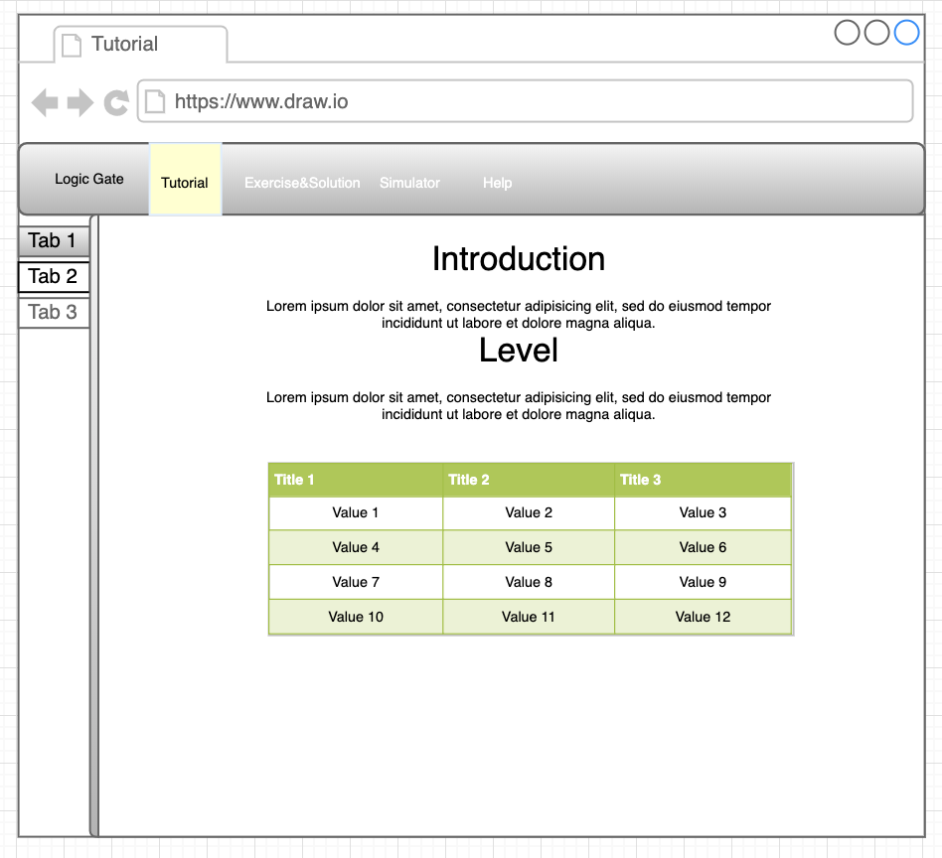



#### **Exercise and Solution page**

We design in two different pages with similar to Tutorial page. In the introduction page, we have heading and text suggestion about which tests are suitable also we use three color highlights the different levels

In the Exercise page, we store the Exercise and solution in PDF form by creating buttons because most user will spend a lot of time for calculation. In the solution button, we might create password to protect cheating. Also, these exercises are the same Computer science lecturer. In the website, I assume that users want to prepare for the exam and lecturer allow student to see the answer sheet. When you click button, we will see full screen page, there are many options like download or highlight keyword when users study. We use underline to separate text and files. We have video showing the solution (make users understand the calculation step by step). The video will display in ration 16:9. We can click full screen which help user to look screen with fit in their computers. Also, the videos must not longer than 10 minutes for concentration in users(might have more than one video). (in CSCU9V4) who want to see the student do in the tutorial group when they do exercise)



#### **Simulator Page**

We design this page similar to Tutorial page (not in the introduction page). We use the pictures same size and have some headers (the name of free website) and Text with highland important text and buttons access to the webpage we mention to users to use it.

/Users/titiratseeharach/Downloads/web-Page-4.pdf

#### **Contact Us Page**

We create this help by having heading (align in left) and text to describe some detail how to contact web owner. We create by form with put your name and email address and comment to give the feedbacks or have problem when you use this website. We also have two button the first (submit submit) align in the left and reset button align in right. Both are small grey button.

/Users/titiratseeharach/Downloads/web-Page-6.pdf

Building prototype

## Homepage

In homepage, we want to make homepage be nest. We want to use background in white team because we don’t want users to focus too much if we want users want to focus in elements contents in homepage for example users will focus in pictures than text in homepage. As the result I said before, we will use picture become first element to attract visitors to look our website. We don’t need more picture to increase user timing. Also using slide control (left and right arrows and three spots under the picture) make users can control website which is the key for make visitors spend a lot of time in our website. We use three picture which we blur part of pictures to make users focus in the heading and detail. Then we create blue button to make contract the pictures.

In navigation bar, we use dark grey color making contrast with white background. For the title, we use the color change for make users know that this title can click. Also, when we access to Homepage, we create the highlight in Home title in navigation which make users notice we look in Homepage.

We use video to represent about why we have to learn logic gates. If we use long text. Users will be boring to look the text in long time.

Then we use icon to make people understand like for doing exercises, we use the paper (In homepage website) represent about users can check about which exercise did they make correct or wrong. Also, we create grey buttons for accessibility (Users might not to click in navigation bar every time) except help function (This one, we don’t want user to focus it).

## Tutorial Page

In introduction page, we want to use background in white team and dark grey color bar which have the same function in Homepage. The additional elements we have is the dark sidebar which we want to represent many topics or content in CSCU9V4 modules and make contract with white background. Also, we can scroll up and down inside this bar for without open full screen webpage. It makes users easier to access the topics they don’t clear. Also, we use table to show the topics which is suitable for users’ level. Users will know that we should know which topics to study before move another level.

When we access some topic, we inspire from **w3school website template** so we can notice the orange color in the name topics we choose/click. We design the main topic we don’t want to click in white background and black font. Another topic, we use hover (Orange tab) to show that this tab can access.

In the main content, we represent small picture in the first paragraph about the sign of Logic name. The second one we show table picture and detail describe about what this table show and the third paragraph we show the equation. Except in NAND topic, we get 4 paragraph which showing big picture. We use long horizontal line to divide paragraph for reading. In addition, we use different highlight color and underline some text (Not include the first heading) in keyword for learner to read in the short time and understand. All fonts are black and grey (make visitors are easy to read). In the Upper-intermediate topics we have different template, we use only video to describe step by step which make users understand easier in the short time(no more than 10 minute).

## Exercise and Solution Page

In introduction page, we want to use background in white team and dark grey color bar which have the same function in Homepage. Also, we have is the dark sidebar which we want to represent many topics of exercise in CSCU9V4 modules and make contract with white background. We use highlight color for access though the new page.

When we click inside exercise page, we use large font for Heading which make users to look at it. Also, we use text underline to make users notice what to do about this page or caution. We use different button color, users will not confuse when they click. Also, we have some video for showing solution step by step which no more than 10 minutes.

## Simulator Page

In this page, we want to use background in white team and dark grey color bar which have the same function in Homepage. But in the fixed sidebar, we just have one tab. The user wants to find many free simulator websites so we just use only one page to make them easier to access simulator websites. We use picture to illustrate the website users want to access and we use highlight color to notify users look at text. Then we use blue buttons to notify users to click access though the simulator websites.

## Contact Page

In this page, we want to use background in white team and dark grey color bar which have the same function in Homepage. Also, we have fixed sidebar with one tab to represent about where we are. When user want to give feedback and help anything. We want full name or first name and email address for reply back. In the form, we create textbox same width and height except in comment box which we have to create wider than two textboxes. We create the send button in left side. Most users are likely to click from left to right. Another button is delete function which clear all information we type in this form.

Additional tools

We use bootstrap4 and html to create template and structure and insert pictures and videos in our website and CSS file for decoration in our template for example font size, text align and picture/videos size. Finally, we use JavaScript with jQuery library making function in button or tab display to another page. Because this website is based on study and prepare for exam. We use many videos to help users understand so we don’t want to use animation for this website which make user don’t focus in study content like keyword text.

Usability testing

Before open website, we have to ask one question and we want notice the timing, feeling and process of access website when we start question.

1. When I access to Homepage. What I want to look in this homepage in the first time? (see the process and timing)
2. I want to find the topic in tutorial like NAND gate, what should I do?
3. I am not confident about what I learned. I want to practice the exercise after I learn to make sure that I am ready for the exam in April. I finish the exercise that my lecturer gave and the answer is same in this website. What should I do?
4. I want to use the simulator for using in Assignment and try to make circuit using logic gate. What should I do.
5. I want to give the feedback to the web owner. What should I do?

Reference

For tutorial fixed bar

<https://www.w3schools.com/css/default.asp>

In product description

( <https://steelkiwi.com/blog/e-learning-website-development-top-12-tips-for-creating-a-successful-marketplace/>)

Homepage

<https://www.oswebdesign.co.uk/blog/why-your-website-photos-are-just-as-important-as-your-design>

<https://elearningindustry.com/build-successful-elearning-websites-key-tips-principles-follow>

Video links

# Karnaugh Maps – Introduction

<https://www.youtube.com/watch?v=3vkMgTmieZI>

<https://www.youtube.com/watch?v=FPrcIhqNPVo>

SOP and POS

<https://www.youtube.com/watch?v=K2cpJex0o_A>

and some videos are in the Picture folder.