1.6.2 Packet Tracer - Configure Basic Router Settings
Physical Mode Lab Report

Topology
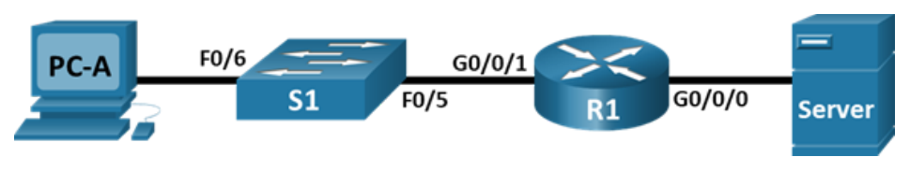
Network topology: PC-A -> S1 -> R1 -> Server

Addressing Table
Device | Interface | IP Address / Prefix | Default Gateway
R1 | G0/0/0 | 192.168.0.1 /24  2001:db8:acad::1 /64  fe80::1 | N/A
R1 | G0/0/1 | 192.168.1.1 /24  2001:db8:acad:1::1 /64  fe80::1 | N/A
R1 | Loopback0 | 10.0.0.1 /24  2001:db8:acad:2::1 /64  fe80::1 | N/A
PC-A | NIC | 192.168.1.10 /24  2001:db8:acad:1::10 /64 | 192.168.1.1  fe80::1
Server | NIC | 192.168.0.10 /24  2001:db8:acad::10 /64 | 192.168.0.1  fe80::1
Original addressing table image:
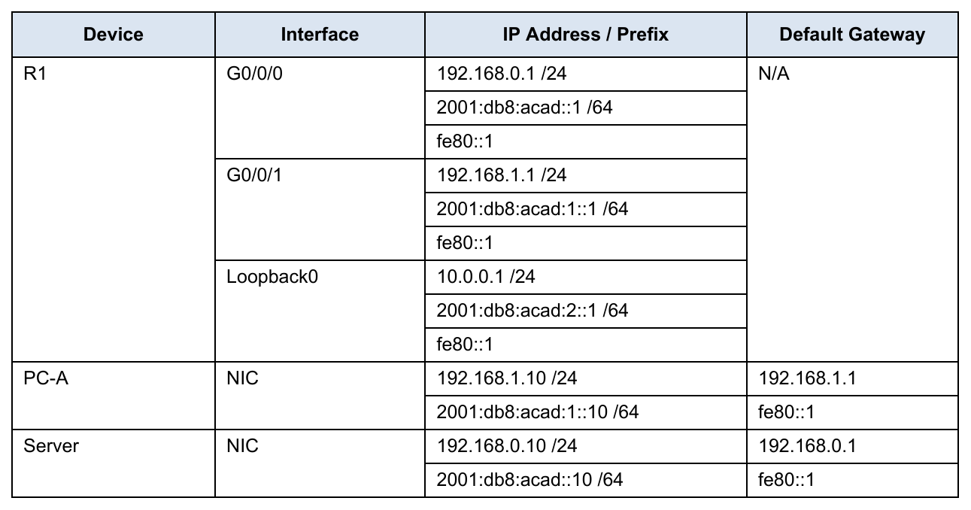

R1 Configuration Commands
Use these commands on R1 after cabling PC-A RS232 to the router Console port.
enable
configure terminal
hostname R1
ip domain-name ccna-lab.com
service password-encryption
security passwords min-length 12
username SSHadmin secret 55Hadm!n2020
crypto key generate rsa general-keys modulus 1024
enable secret $cisco!PRIV*
line console 0
password $cisco!!CON*
exec-timeout 4 0
login
exit
line vty 0 4
password $cisco!!VTY*
transport input ssh
exec-timeout 4 0
login local
exit
banner motd #Unauthorized access is prohibited.#
login block-for 120 attempts 3 within 60
ipv6 unicast-routing
interface gigabitEthernet0/0/0
description Link to Server
ip address 192.168.0.1 255.255.255.0
ipv6 address 2001:db8:acad::1/64
ipv6 address fe80::1 link-local
no shutdown
exit
interface gigabitEthernet0/0/1
description Link to S1 / PC-A LAN
ip address 192.168.1.1 255.255.255.0
ipv6 address 2001:db8:acad:1::1/64
ipv6 address fe80::1 link-local
no shutdown
exit
interface loopback0
description Loopback interface
ip address 10.0.0.1 255.255.255.0
ipv6 address 2001:db8:acad:2::1/64
ipv6 address fe80::1 link-local
exit
end
clock set 18:00:00 25 Jun 2026
copy running-config startup-config

Verification Commands
show ip interface brief
show ipv6 interface brief
show ip route
show version
show startup-config
show running-config | section vty
show version | include register

Task Questions - Answers

1. What would be the result of reloading the router prior to completing the copy running-config startup-config command?

Restarting the router before saving the current configuration will cause any recent changes to be discarded. The device will reload with the configuration stored in NVRAM.

2. Were the pings from PC-A to the Server successful?

Yes. Once all devices are configured correctly, PC-A should be able to communicate with the Server using both IPv4 and IPv6 without any issues.

3. Was remote access to R1 using the Loopback IPv4 address successful?

Yes. Establishing an SSH connection to the Loopback0 IPv4 address is successful when the correct login credentials are entered.

4. Was remote access to R1 using the Loopback IPv6 address successful?

Yes. The router also accepts SSH connections through its Loopback0 IPv6 address using the same username and password.

5. Why is the Telnet protocol considered to be a security risk?

Telnet does not encrypt transmitted information, making usernames and passwords visible to attackers. SSH secures the connection by encrypting all exchanged data.

6. What is the name of the IOS image that the router is running?

The IOS image can be identified with the show version command. In Packet Tracer, a Cisco 4321 router commonly uses the isr4300-universalk9.16.06.04.SPA.bin image.

7. How much NVRAM does the router have?

The router's NVRAM capacity can be viewed with show version. A typical Cisco 4321 ISR in Packet Tracer provides approximately 32768 KB of NVRAM.

8. How much Flash memory does the router have?

The show version command also displays the available Flash memory. A common value is around 3223551 KB.

9. What would be the boot process if the configuration register was 0x2142?

With a configuration register of 0x2142, the router ignores the saved startup configuration during boot. This mode is mainly used for password recovery.

10. How are passwords presented in the startup configuration output?

Passwords are stored in an encrypted or hashed format. Passwords protected by service password-encryption are encrypted, while secret passwords appear as hashes.

11. What is the result of using show running-config | section vty?

This command displays only the VTY configuration section from the running configuration, making it easier to review remote access settings.

12. What code is used in the routing table to indicate a directly connected network?

The letter C identifies networks that are directly connected to the router.

13. How many route entries are coded with a C code in the routing table?

There are three directly connected routes, which are 192.168.0.0/24, 192.168.1.0/24, and 10.0.0.0/24.

14. What command changed the status of the Gigabit Ethernet ports from administratively down to up?

The no shutdown command enabled the interfaces and changed their state to up.

15. What is the meaning of the [up/up] part of the show ipv6 interface brief output?

The first up indicates that the interface is physically operational, while the second up confirms that the line protocol is functioning correctly.

16. What is the IPv6 address assigned to Server after changing it from static IPv6?

The Server automatically receives an IPv6 address from the 2001:db8:acad::/64 network using SLAAC. The exact address depends on the device's MAC address.

17. What is the default gateway assigned to Server after changing it from static IPv6?

The default gateway is automatically assigned as fe80::1, which is the router's link-local IPv6 address.

18. From PC-B/PC-A, was the ping to the R1 default gateway link-local address successful?

Yes. The hosts were able to successfully reach the router's link-local gateway address fe80::1.

19. From Server, was the ping to the R1 IPv6 unicast address 2001:db8:acad::1 successful?

Yes. The Server successfully communicated with the router using its global IPv6 address.

Reflection Questions - Answers (Rewritten)
20. If a technician suspects that an interface was not enabled, what show command could be used?

The show ip interface brief command quickly displays the operational status of all interfaces, allowing you to determine whether an interface is enabled or disabled.

21. If a technician suspects that an interface was assigned an incorrect subnet mask, what show command could be used?

The show running-config command can be used to verify the IP address and subnet mask configured on each interface.

Original Task Pages

Tasks Page 1
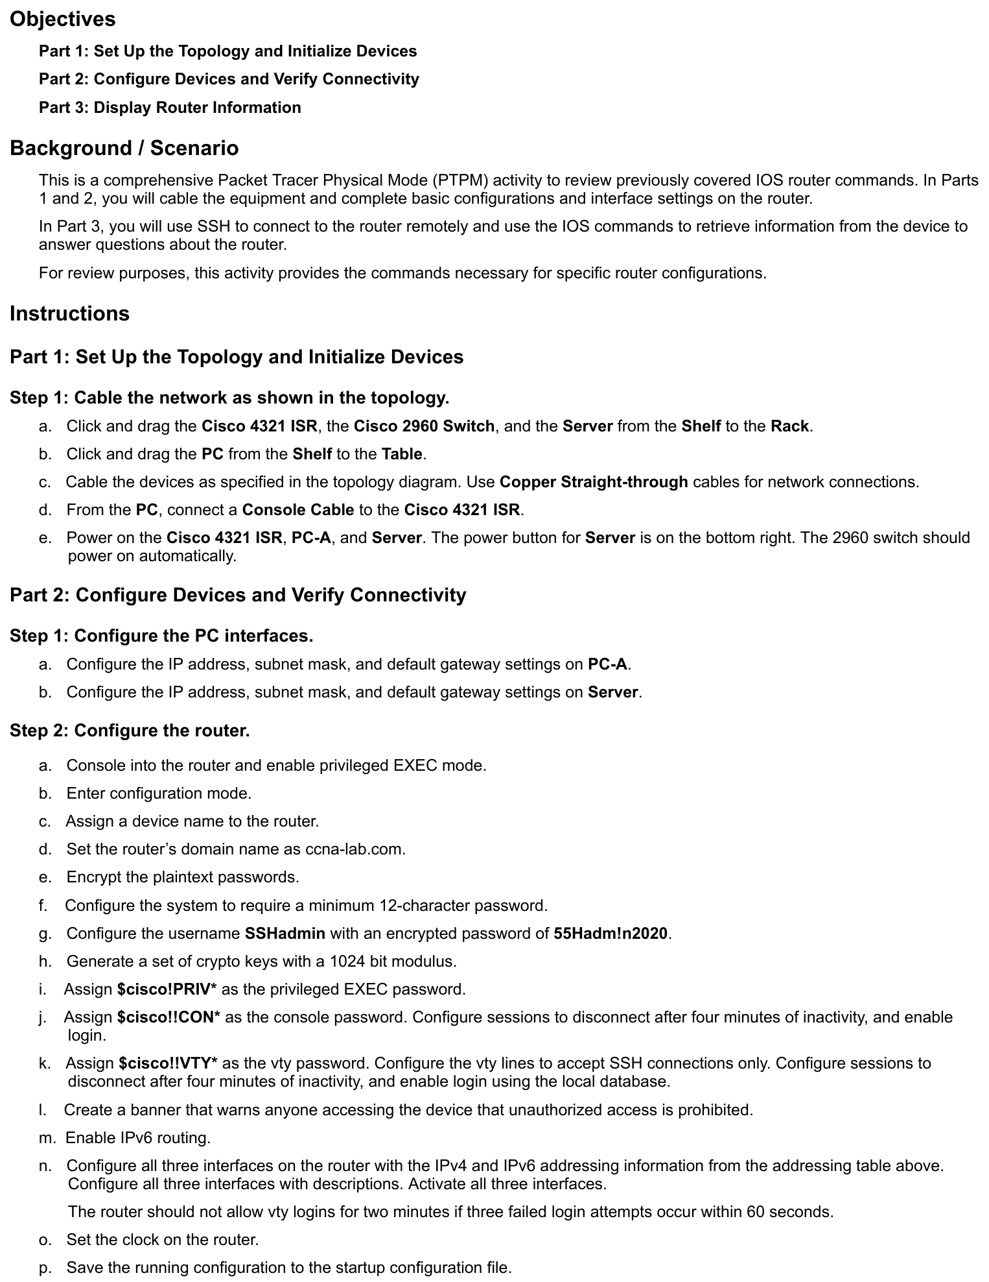

Tasks Page 2
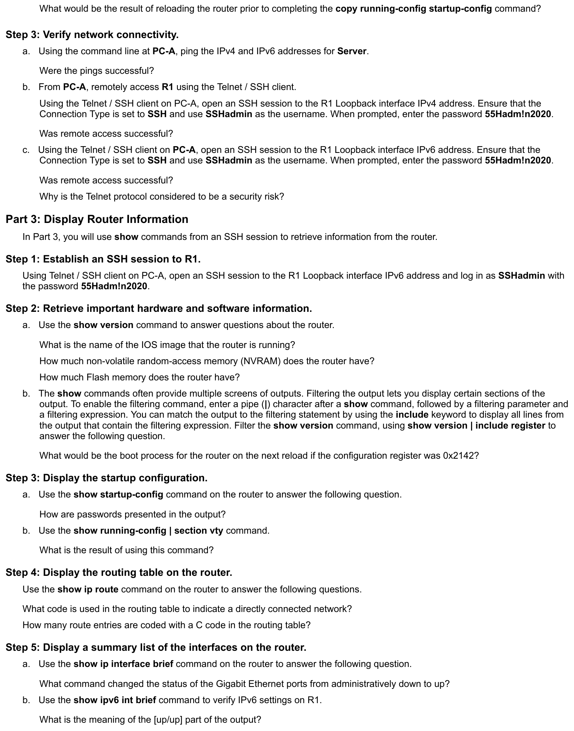

Tasks Page 3
