**Nama : Titis Eka Setyawati  
NIM : 18090049  
Kelas : 5B**

1. **Source Code**

Latihan1.php : application/controllers

Latihan2.php : application/controllers

latihan2.php : view-application/views

Model1.php : application/models

1. **URL**

[http://localhost/pustaka_booking/Latihan1](http://localhost/pustaka_booking/index.php/Latihan1)

[http://localhost/pustaka_booking/Latihan1/penjumlahan/3/4](http://localhost/pustaka_booking/index.php/Latihan1/penjumlahan/3/4)

[http://localhost/pustaka_booking/Latihan2/penjumlahan/3/4](http://localhost/pustaka_booking/index.php/Latihan2/penjumlahan/3/4)

1. **Capture Hasil**

**Latihan 1**

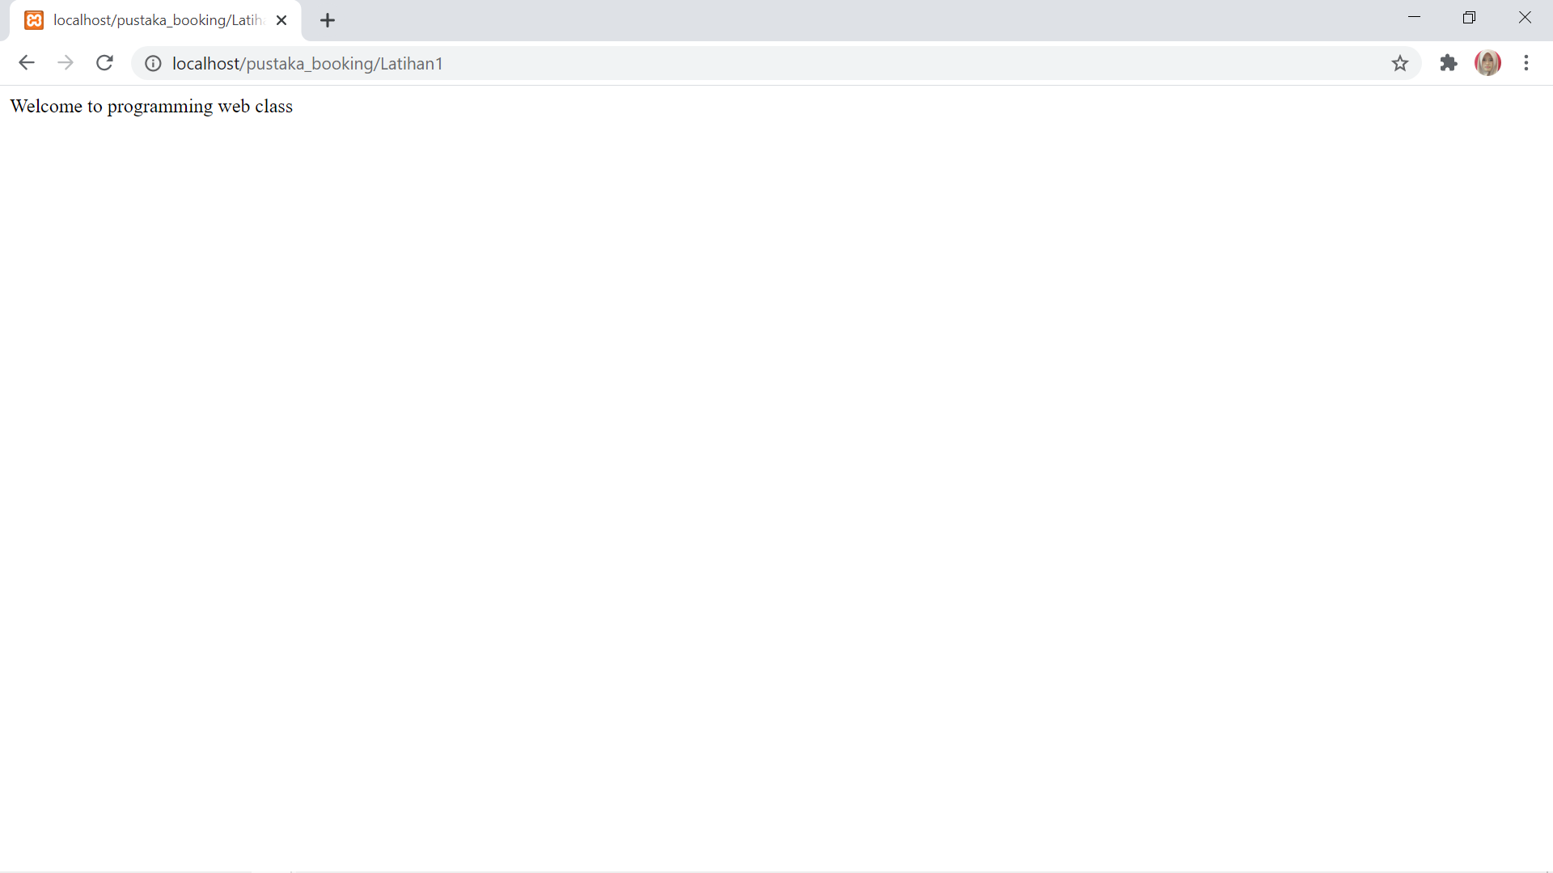

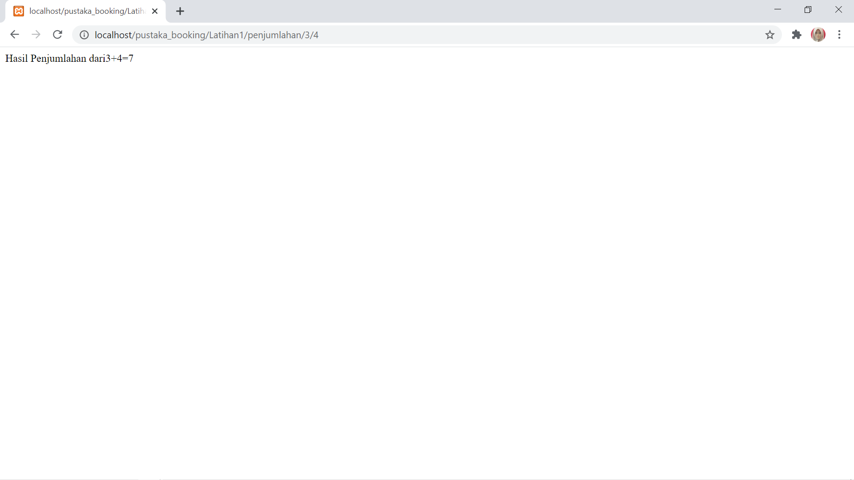

**Latihan 2**

