SWD392 – SOFTWARE ARCHITECTURE AND DESIGN
PROJECT ASSIGNMENT / LAB

EBANK LOGIN SYSTEM
TienPhong Bank – Ebank Project

Assignment 01 – Use Case Model
User Requirement Document (URD)

Student: Trần Bá Sơn Tùng
Roll Number: HE 163855
Class: SWD392_SE1931-NET
Lecturer: ANNV22

— Hanoi, June 2026 —

Table of Contents
I. Record of Changes 3
II. Software Requirement Specification 3
1. Context Diagram 3
2. Use Case Modelling 3
2.1 Actors 3
2.2 UC Diagrams 3
2.2.1 UCs for User 3
2.3 Activity Diagrams 4
2.3.1 Login 4
2.3.2 Select Language 5
3. Use Case Specifications 6
3.1 User Authentication 6
3.1.1 Login 6
3.1.2 Select Language 7
4. Non-Functional Requirements 8
4.1 External Interfaces 8
4.2 Quality Attributes 8
4.2.1 Usability 8
4.2.2 Performance 8
4.2.3 Security 8
4.2.4 Reliability 8

I. Record of Changes
Date | A* / M, D | In charge | Change Description
21/06/2026 | A | <Student Name> | Initial version – Use Case Model for the Ebank Login System.
*A - Added M - Modified D - Deleted

II. Software Requirement Specification

1. Context Diagram
The Ebank Login System is a console application module extracted from the TienPhong Bank – Ebank project. Its purpose is to authenticate a bank customer before access to e-banking services is granted. The system interacts with a single human actor (the User) and three external data stores: the account store (accounts.csv), the activity log (log.txt), and the language resource files (En.properties and Vi.properties).
The context diagram below shows the external entities and the main data exchanged with the system for release 1.0.
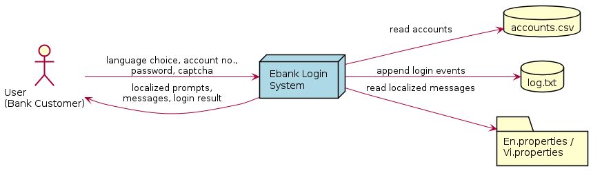
Figure 1. Context Diagram – Ebank Login System

2. Use Case Modelling

2.1 Actors
An actor represents the role played by all users of the same type when interacting with the system. The Ebank Login System has one human actor.
# | Actor | Description
1 | User (Bank Customer) | The end user who interacts with the Ebank console. The User selects the interface language, enters an account number, password and captcha, and is authenticated against the account store.

2.2 UC Diagrams

2.2.1 UCs for User
The User can select a language, log in, or exit. The Login use case includes four sub use cases that are always executed as part of the login process: checking the account number, checking the password, verifying the captcha, and authenticating the credentials against the account store.
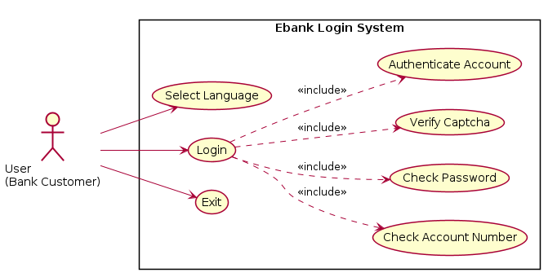
Figure 2. Use Case Diagram – User

2.3 Activity Diagrams

2.3.1 Login
- Summary: The User authenticates by entering a valid account number, password and captcha; the system then verifies the credentials against the account store and reports the result.
- Dependency: Includes Check Account Number, Check Password, Verify Captcha and Authenticate Account.
- Actors: User (Bank Customer).
- Preconditions: The application is running, a language has been selected, and the account store (accounts.csv) is available.
Activity Diagram:
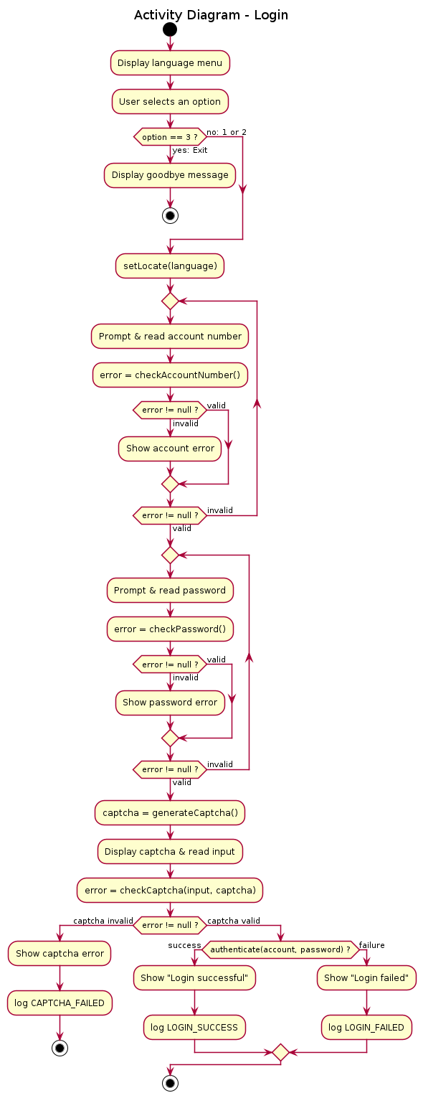
Figure 3. Activity Diagram – Login

2.3.2 Select Language
- Summary: The User chooses the interface language (Vietnamese or English) from the main menu; all subsequent prompts and messages are displayed in the chosen language.
- Actors: User (Bank Customer).
- Preconditions: The application is running and the main menu is displayed.
Activity Diagram:
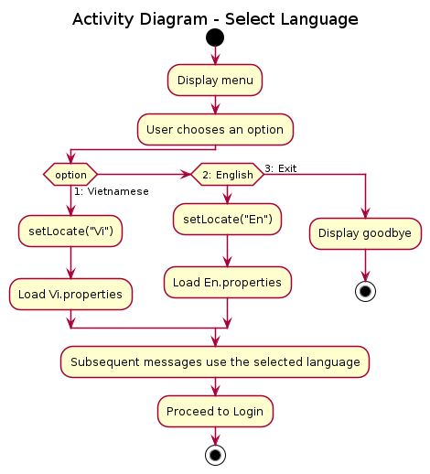
Figure 4. Activity Diagram – Select Language

3. Use Case Specifications

3.1 User Authentication

3.1.1 Login
Primary Actors | User (Bank Customer) | Secondary Actors | None
Trigger | The User selects a language from the main menu to start the login process.
Description | As a bank customer, I want to log into the Ebank system by providing a valid account number, password and captcha, so that I can securely access my e-banking services. The interface is available in English and Vietnamese.
Preconditions | The application is running; a language has been selected; account data exists in accounts.csv.
Postconditions | On success the User is authenticated and a LOGIN_SUCCESS event is logged. On failure an error message is shown and a LOGIN_FAILED or CAPTCHA_FAILED event is logged.
Main Sequence | 1. The User selects a language (1 = Vietnamese, 2 = English).  2. The system loads the matching resource bundle and prompts for the account number.  3. The User enters the account number.  4. The system validates the account number (exactly 10 digits). [Alt A1]  5. The system prompts for the password.  6. The User enters the password.  7. The system validates the password (>= 6 characters, containing letters and digits). [Alt A2]  8. The system generates and displays a random captcha.  9. The User enters the captcha.  10. The system verifies the captcha. [Alt A3]  11. The system authenticates the account number and password against the account store. [Alt A4]  12. The system displays "Login successful", logs LOGIN_SUCCESS, and returns to the menu.
Alternative Sequences | A1 (step 4) – Invalid account number: the system shows a localized error and repeats from step 3.  A2 (step 7) – Invalid password: the system shows a localized error and repeats from step 6.  A3 (step 10) – Invalid captcha: the system shows a captcha error, logs CAPTCHA_FAILED, and returns to the main menu.  A4 (step 11) – Authentication failure (account not found, wrong password, or account LOCKED): the system shows "Login failed", logs LOGIN_FAILED, and returns to the main menu.

3.1.2 Select Language
Primary Actors | User (Bank Customer) | Secondary Actors | None
Trigger | The User opens the application and the main menu is displayed.
Description | As a bank customer, I want to choose the interface language so that all prompts and messages are shown in a language I understand.
Preconditions | The application is running and the main menu (1. Vietnamese, 2. English, 3. Exit) is displayed.
Postconditions | The chosen language resource bundle (Vi.properties or En.properties) is loaded and used for all messages.
Main Sequence | 1. The system displays the main menu.  2. The User selects option 1 (Vietnamese) or 2 (English).  3. The system calls setLocate and loads the corresponding properties file.  4. The system proceeds to the Login use case using the selected language.
Alternative Sequences | Step 2 – The User selects 3: the system displays a goodbye message and terminates.  Step 2 – The User enters an invalid option: the system shows an "invalid option" message and redisplays the menu.

4. Non-Functional Requirements

4.1 External Interfaces
- User Interface: Text-based console; keyboard input and standard output. The menu and all messages are localized (English / Vietnamese).
- Hardware Interfaces: None specific; any machine able to run a Java Runtime Environment.
- Software Interfaces: Java SE 8 or later; reads and writes local files (accounts.csv, log.txt, En.properties, Vi.properties) through the file system.
- Communication Interfaces: None; the application is a standalone console program with no network connection.

4.2 Quality Attributes

4.2.1 Usability
- The menu and all messages are available in both English and Vietnamese.
- Invalid input produces a clear, localized error message and re-prompts the User without crashing.
- A first-time user can complete a login attempt within about one minute.

4.2.2 Performance
- Each validation and authentication completes in well under one second for the sample data set.
- Captcha generation is linear in the captcha length (6 characters).

4.2.3 Security
- Account number and password formats are validated before authentication.
- A random captcha is generated for every login attempt to deter automated input.
- Account status (ACTIVE / LOCKED) is enforced; LOCKED accounts cannot log in.
- Every login attempt is recorded in log.txt with a timestamp and result.

4.2.4 Reliability
- Missing or unreadable resource files are handled gracefully (a warning is shown and a safe fallback is used) instead of terminating the program.

