SWD392 – SOFTWARE ARCHITECTURE AND DESIGN
PROJECT ASSIGNMENT / LAB

EBANK LOGIN SYSTEM
TienPhong Bank – Ebank Project

Assignment 02 – Analysis Model
Static & Dynamic Modeling

Student: <Full Name>
Roll Number: <RollNumber>
Class: <Class>
Lecturer: <Lecturer>

— Hanoi, June 2026 —

Table of Contents

I. Record of Changes
Date | A* / M, D | In charge | Change Description
21/06/2026 | A | <Student Name> | Initial version – Analysis Model for the Ebank Login System.
06/07/2026 | M | <Student Name> | Aligned with the design/implementation: the Login control class is named Ebank (formerly EbankService).
*A - Added M - Modified D - Deleted

II. Static Modeling

1. Context Modeling
Static modeling defines the boundary of the system and the external entities with which it exchanges data. The Ebank Login System interacts with one human actor (the User) and three external data stores: the account store (accounts.csv), the activity log (log.txt), and the language resource files (En.properties / Vi.properties). The context model below summarizes these boundaries.
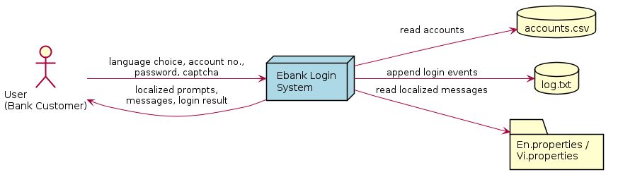
Figure 1. Context Model – Ebank Login System

2. Entity Classes
The analysis identifies a single persistent business entity: Account. It is the only data the system stores and retrieves, and it is persisted as rows in accounts.csv. The activity log (log.txt) holds event records but is write-only and is therefore not modeled as a business entity.
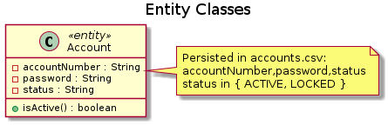
Figure 2. Entity Class – Account
Attribute | Type | Description
accountNumber | String | Unique 10-digit account identifier (acts as the key).
password | String | Account password (stored as plain text in the sample data set).
status | String | Account state: ACTIVE or LOCKED. Only ACTIVE accounts may log in.

III. Object & Class Structuring

1. Login

a. Class Diagram
The robustness (View of Participating Classes) diagram below shows the boundary, control and entity objects that collaborate to realize the Login use case.
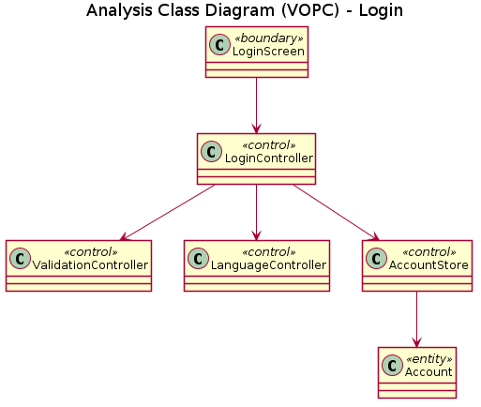
Figure 3. VOPC – Login

b. Class Description
Analysis Class | Stereotype | Responsibility | Realized by
LoginScreen | «boundary» | Handles all console interaction for login: shows prompts, reads account number, password and captcha, and displays results. | Main, LoginUI
LoginController | «control» | Orchestrates the Login use case: coordinates validation, captcha generation, authentication and event logging. | Ebank
ValidationController | «control» | Validates the format of account number, password and captcha; returns localized error messages. | ValidatorService
LanguageController | «control» | Loads the selected language bundle and supplies localized messages. | LanguageService
AccountStore | «control» (DAO) | Retrieves accounts from the data store and appends login events to the log. | AccountDAO, FileHelper
Account | «entity» | Represents a bank account (account number, password, status). | Account

2. Select Language

a. Class Diagram
Selecting a language involves a boundary object (the menu screen), a control object that switches the locale, and the language resource that it loads.
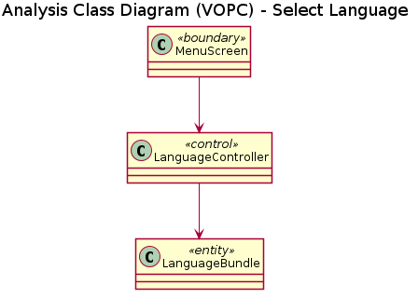
Figure 4. VOPC – Select Language
MenuScreen (boundary) is realized by Main; LanguageController (control) by LanguageService; LanguageBundle (entity) by the loaded En/Vi.properties resource bundle.

IV. Dynamic Interaction Modeling

1. Login

a. Communication Diagram
The communication diagram below shows the numbered message exchange between the participating objects during a login attempt.
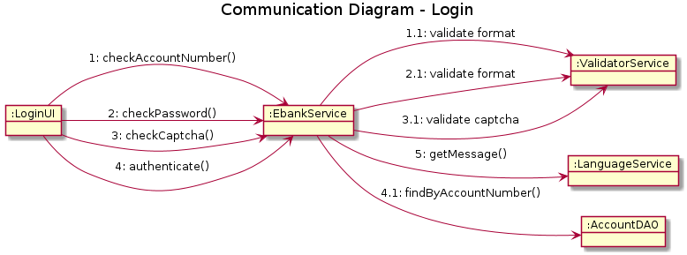
Figure 5. Communication Diagram – Login

b. Sequence Diagram
The analysis-level sequence diagram shows the same collaboration ordered over time.
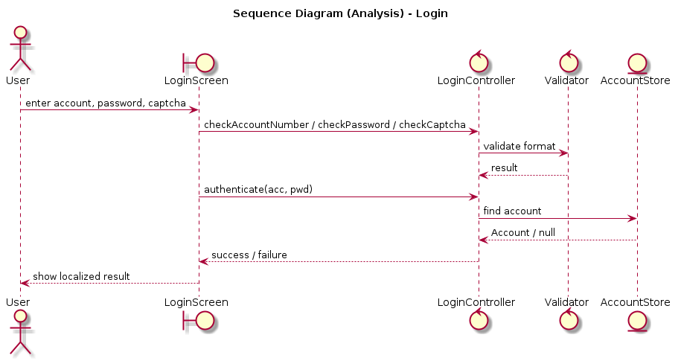
Figure 6. Sequence Diagram (Analysis) – Login

2. Select Language

a. Communication Diagram
Switching language is a short interaction: the menu screen asks the controller to set the locale, which loads the corresponding resource bundle.
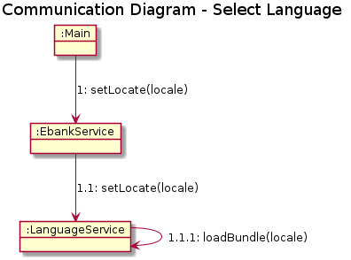
Figure 7. Communication Diagram – Select Language

V. Finite State Machine

1. Login Session
A login session progresses through entering the account number, entering the password, verifying the captcha and authenticating, and ends in either LoggedIn or Failed. Invalid format keeps the session in the same input state (the user is re-prompted).
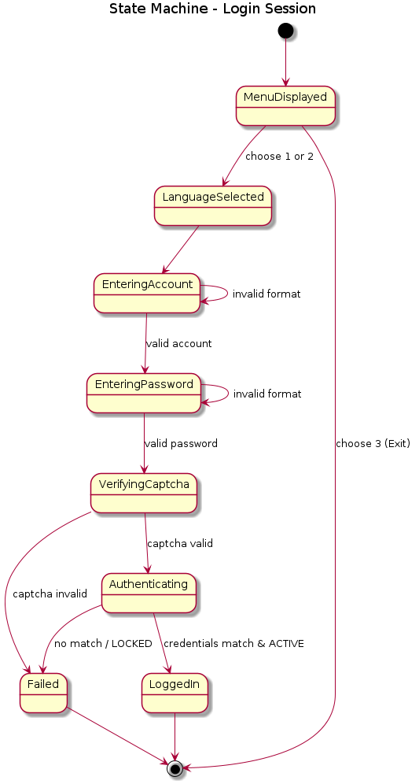
Figure 8. State Machine – Login Session

2. Account Status
Each account is in one of two states. Only an ACTIVE account can be authenticated; a LOCKED account is rejected even when the credentials are correct.
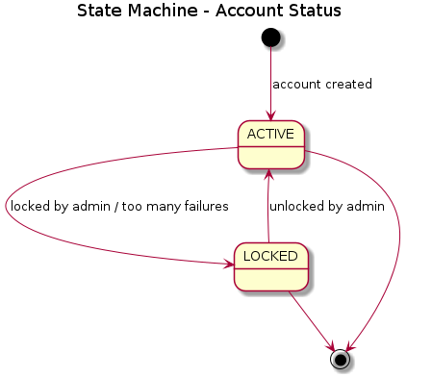
Figure 9. State Machine – Account Status

