SWD392 – SOFTWARE ARCHITECTURE AND DESIGN
PROJECT ASSIGNMENT / LAB

EBANK LOGIN SYSTEM
TienPhong Bank – Ebank Project

Assignment 03 – Design Model
User Interface, Architecture & Detailed Design

Student: <Full Name>
Roll Number: <RollNumber>
Class: <Class>
Lecturer: <Lecturer>

— Hanoi, June 2026 —

Table of Contents

I. Record of Changes
Date | A* / M, D | In charge | Change Description
21/06/2026 | A | <Student Name> | Initial version – Design Model for the Ebank Login System.
06/07/2026 | M | <Student Name> | Aligned with the implemented code: renamed EbankService to Ebank; added Locate enum; setLocate(Locate); localized menu via menu.* keys; UTF-8 bundles with Vietnamese diacritics.
*A - Added M - Modified D - Deleted

II. User Interface Design
The application is a console program, so each "screen" is a block of text printed to standard output. All texts are localized through En.properties / Vi.properties, loaded as UTF-8 so the Vietnamese interface displays full diacritics.

1. User Authentication

1.1 Login

1.1.1 Language Menu Screen
The first screen lets the user choose the interface language or exit. It is rendered from the menu.* resource keys, so after a language is selected the menu itself is re-displayed in that language.
=====[ TIEN PHONG BANK - EBANK ]=====
1. Vietnamese
2. English
3. Exit
Select an option: _
Screen 1. Language menu (default English)

1.1.2 Login Input Screen
After a language is chosen, the system asks for the account number, the password and a generated captcha, in the selected language.
Enter account number: 1234567890
Enter password: ******
Captcha: A1b2C3
Enter captcha: _
Screen 2. Login inputs (English)
Nhập số tài khoản: 1234567890
Nhập mật khẩu: ******
Captcha: A1b2C3
Nhập captcha: _
Screen 3. Login inputs (Vietnamese)

1.1.3 Result Screen
On completion the system prints a localized result and returns to the menu.
Login successful! Welcome to Ebank.

-- or --

Login failed. Invalid credentials.
Screen 4. Login result

III. High-Level Design

1. Software Architecture
The system follows a classic 3-Layer (N-Layer) architecture. Each layer depends only on the layer directly beneath it; the presentation layer never accesses the data layer directly.
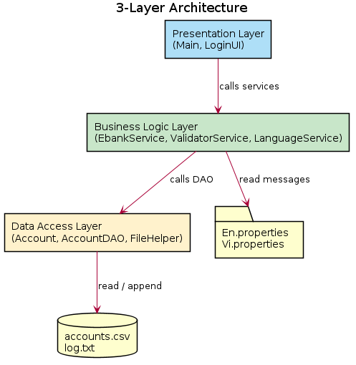
Figure 1. 3-Layer Architecture

1.1 Sub-Systems / Components

1.1.1 Presentation Layer
- Main – entry point; prints the language menu and routes the chosen option.
- LoginUI – drives the login dialog (account, password, captcha) and shows results.

1.1.2 Business Logic Layer
- Ebank – façade/orchestrator for the login use case (Facade pattern – single entry point to the business layer); also generates captcha and authenticates.
- ValidatorService – format validation for account number, password and captcha.
- LanguageService – loads the resource bundle and returns localized messages.
- Locate – enum (EN, VI) that identifies the language bundle; passed to setLocate(Locate) as required by the assignment guideline.

1.1.3 Data Access Layer
- AccountDAO – data-access object that hides file details from the business layer.
- FileHelper – reads accounts.csv and appends to log.txt.
- Account – entity / data transfer object passed between layers.
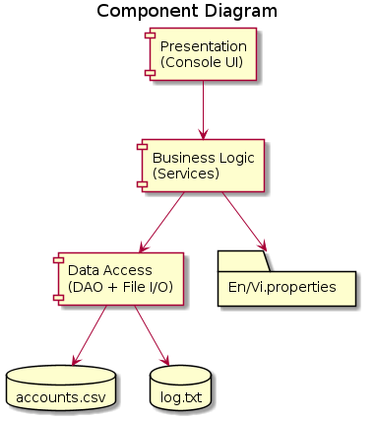
Figure 2. Component view

1.2 External Interfaces
- accounts.csv – account records read by the data layer.
- log.txt – append-only login event log.
- En.properties / Vi.properties – localized message bundles.

2. Package Diagram
The source code is organized into three packages that mirror the three layers.
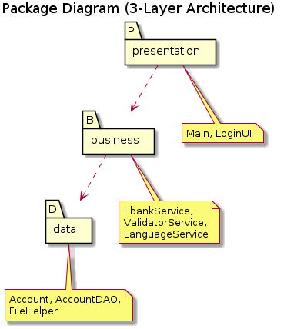
Figure 3. Package Diagram

3. Database Design
The system uses a lightweight file-based data store instead of a relational database. The account data is kept in a CSV file; login events are appended to a text log.

3.1 accounts.csv
Field | Type | Key | Description
accountNumber | String(10) | PK | Unique account number, exactly 10 digits.
password | String |  | Account password (plain text in the sample data).
status | String |  | ACTIVE or LOCKED.
Format: comma-separated values with a header row (accountNumber,password,status).

3.2 log.txt
Each login attempt appends one line in the format: "yyyy-MM-dd HH:mm:ss | <accountNumber> | <EVENT>", where EVENT is LOGIN_SUCCESS, LOGIN_FAILED or CAPTCHA_FAILED.

IV. Detailed Design

1. Login

1.1 Class Diagram
The design class diagram below shows the attributes, operations and relationships of all classes that implement the login feature, grouped by layer.
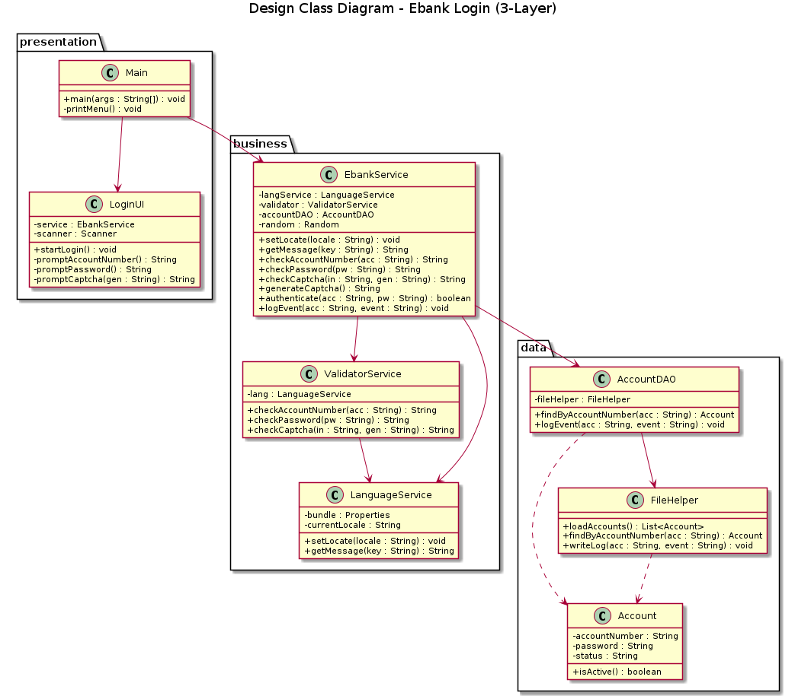
Figure 4. Design Class Diagram – Ebank Login

1.2 Sequence Diagram – Login
The sequence diagram shows the runtime collaboration for a full login attempt, including validation loops, captcha verification, authentication against the store, and logging.
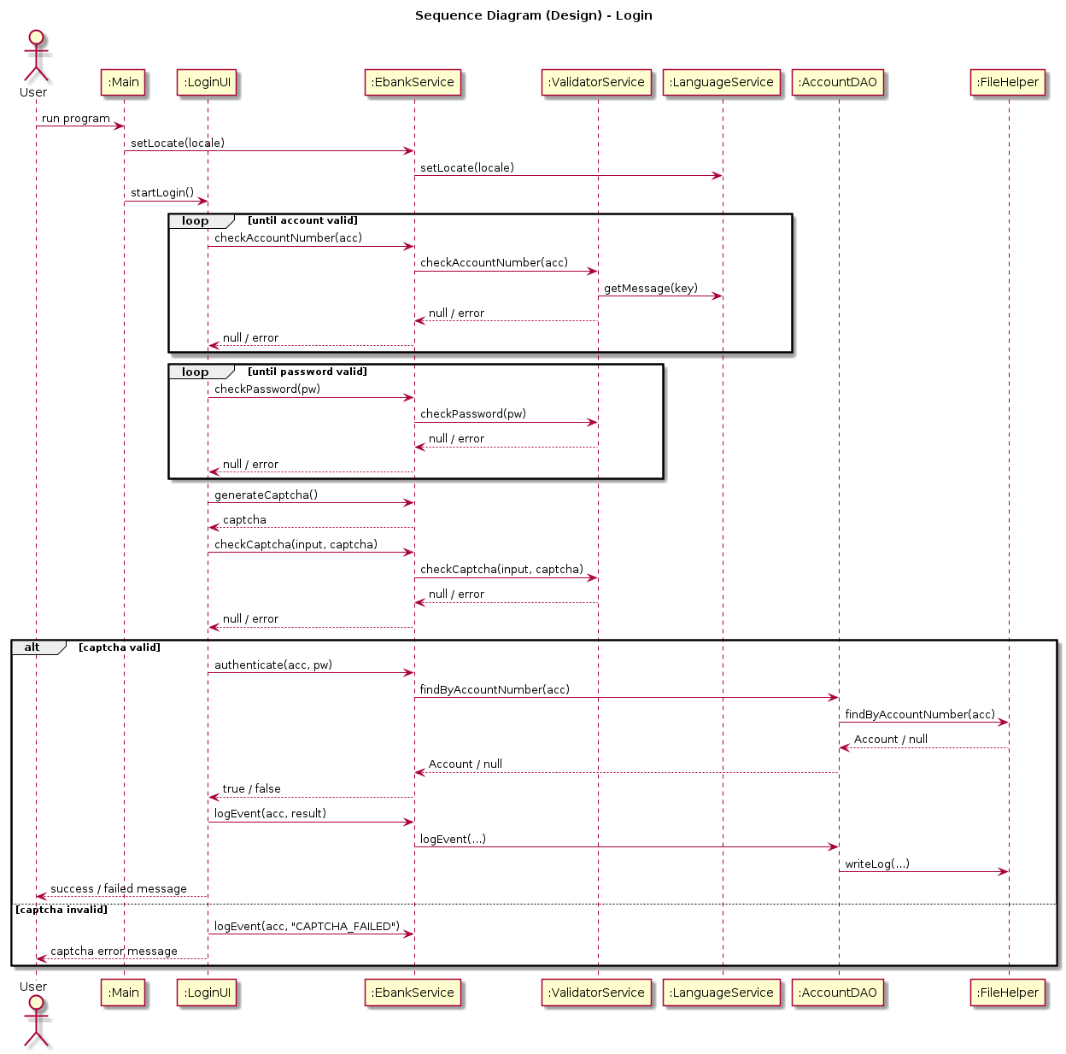
Figure 5. Sequence Diagram (Design) – Login

2. Select Language

2.1 Class Diagram
Selecting a language uses a subset of the same classes: Main (presentation) calls Ebank.setLocate(Locate) (business), which delegates to LanguageService to load the UTF-8 resource bundle identified by the Locate enum (see Figure 4).

2.2 Sequence Diagram – Select Language
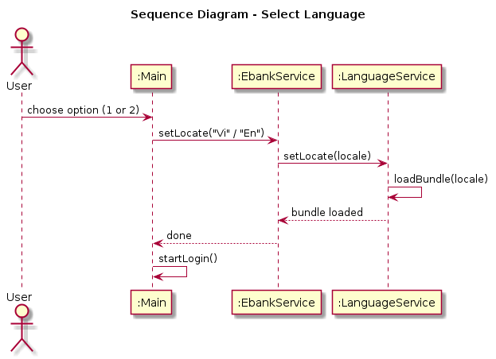
Figure 6. Sequence Diagram (Design) – Select Language

