SWD392 – SOFTWARE ARCHITECTURE AND DESIGN
PROJECT ASSIGNMENT / LAB

EBANK LOGIN SYSTEM
TienPhong Bank – Ebank Project

Course Project Report
SWD392 – Ebank Login System

Student: <Full Name>
Roll Number: <RollNumber>
Class: <Class>
Lecturer: <Lecturer>

— Hanoi, June 2026 —

Table of Contents

Record of Changes
Date | A* / M, D | In charge | Change Description
21/06/2026 | A | <Student Name> | Initial version – Course Project Report for the Ebank Login System.
06/07/2026 | M | <Student Name> | Aligned with the implemented code: renamed EbankService to Ebank across the report; source path updated to src/business/Ebank.java.
*A - Added M - Modified D - Deleted

I. Overview

I.1 Project Information
Item | Value
Project name | Ebank Login System (TienPhong Bank – Ebank)
Course | SWD392 – Software Architecture and Design
Document | Course Project Report
Architecture | 3-Layer (N-Layer) console application
Date | June 2026

I.2 Project Team
# | Full Name | Roll Number | Role
1 | <Full Name> | <RollNumber> | Developer / Author

II. Requirement Specification

II.1 Problem Description
The Ebank Login System is a console module extracted from the TienPhong Bank – Ebank project. It provides a secure, bilingual (English / Vietnamese) login: the user selects a language, then authenticates with an account number, a password and a captcha. Credentials are checked against a stored account list, only ACTIVE accounts are admitted, and every attempt is logged.

II.2 Major Features
- Bilingual interface (English / Vietnamese) driven by properties files.
- Account number, password and captcha validation.
- Random captcha generation per login attempt.
- Authentication against a stored account list with ACTIVE / LOCKED status.
- Audit logging of every login outcome.

II.3 Context Diagram
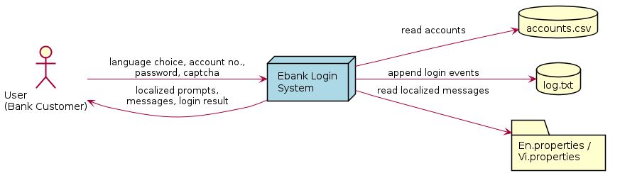
Figure 1. Context Diagram

II.4 Nonfunctional Requirements
- Usability – bilingual, clear localized errors, never crashes on invalid input.
- Performance – validation/authentication under one second for the sample data.
- Security – format validation, per-attempt captcha, ACTIVE/LOCKED enforcement, audit log.
- Reliability – graceful handling of missing/unreadable resource files.
- Maintainability – clean 3-layer separation; a language is added via a new properties file.

II.5 Functional Requirements

II.5.1 Actors
# | Actor | Description
1 | User (Bank Customer) | Selects a language and authenticates with account number, password and captcha.

II.5.2 Use Cases

II.5.2.1 Diagram
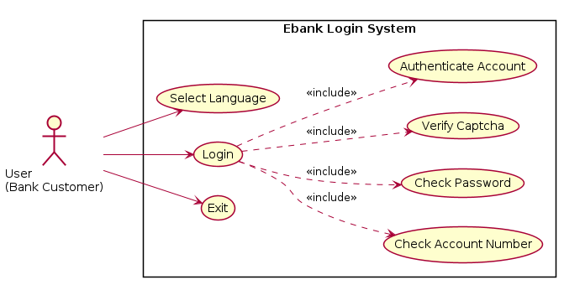
Figure 2. Use Case Diagram

II.5.2.2 Use Case Descriptions
The main use case is Login; it includes Check Account Number, Check Password, Verify Captcha and Authenticate Account. The Select Language use case switches the locale. Full specifications are provided below.
Primary Actors | User (Bank Customer) | Secondary Actors | None
Trigger | The User selects a language to begin login.
Description | As a bank customer, I want to log in with a valid account number, password and captcha so that I can securely access e-banking.
Preconditions | Application running; language selected; accounts.csv available.
Postconditions | On success: authenticated and LOGIN_SUCCESS logged. On failure: error shown, LOGIN_FAILED / CAPTCHA_FAILED logged.
Main Sequence | 1. Select language. 2. Enter & validate account number (10 digits). [A1]  3. Enter & validate password (>=6, letters+digits). [A2]  4. Generate captcha; enter & verify captcha. [A3]  5. Authenticate credentials against the store (ACTIVE). [A4]  6. Show "Login successful"; log LOGIN_SUCCESS.
Alternative Sequences | A1/A2 – invalid format: show error and re-prompt.  A3 – invalid captcha: log CAPTCHA_FAILED, return to menu.  A4 – wrong credentials or LOCKED: show "Login failed", log LOGIN_FAILED.

b. Business Rules
ID | Business Rule
BR-01 | Account number must be exactly 10 numeric digits.
BR-02 | Password must be >= 6 characters and contain letters and digits.
BR-03 | A new random captcha is generated for every login attempt.
BR-04 | Only ACTIVE accounts may log in.
BR-05 | Every login attempt is logged with a timestamp.

II.5.3 Activity Diagram
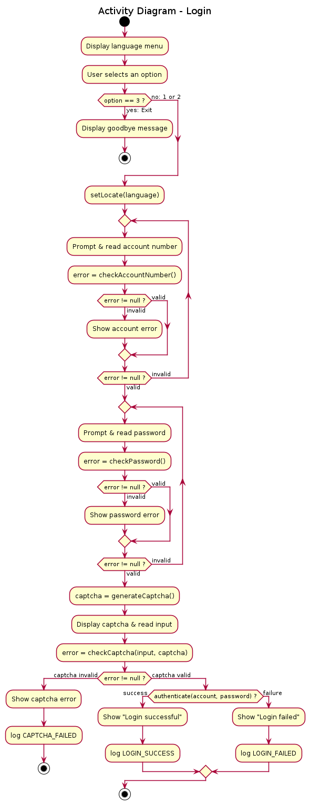
Figure 3. Activity Diagram – Login

III. Analysis Models

III.1 Interaction Diagrams
The communication and sequence diagrams below show the objects collaborating to realize the Login use case.
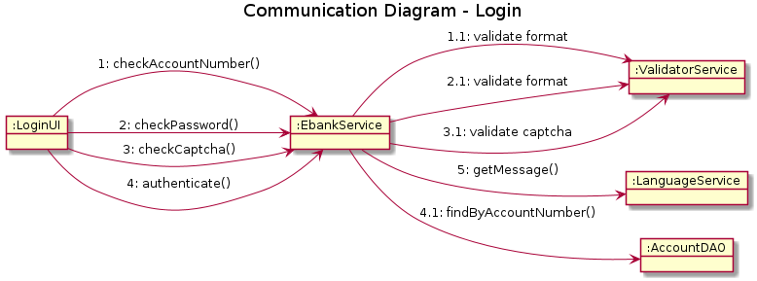
Figure 4. Communication Diagram – Login
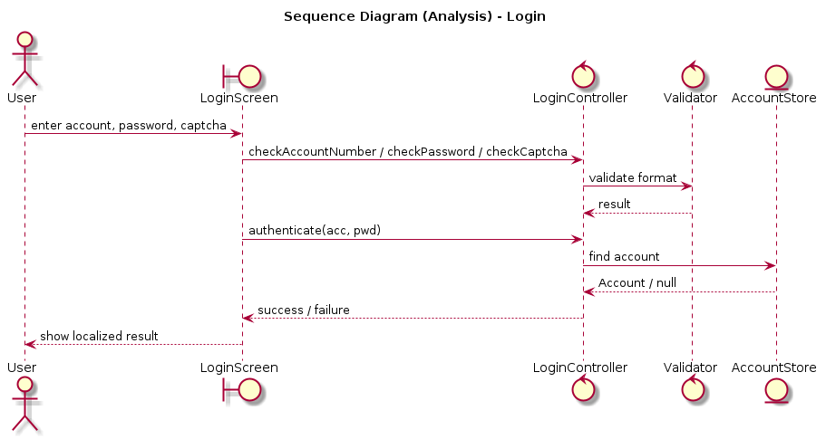
Figure 5. Sequence Diagram (Analysis) – Login

III.2 State Diagram
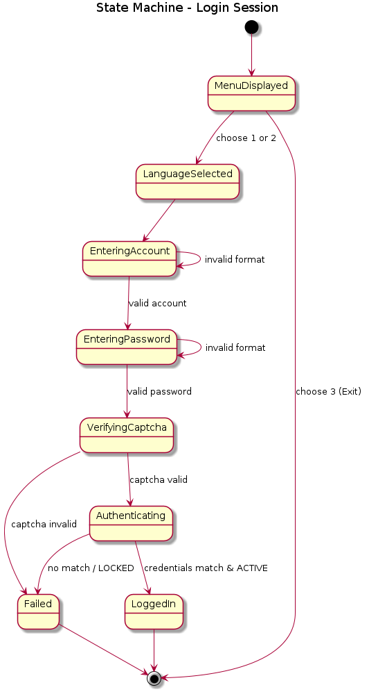
Figure 6. State Machine – Login Session

IV. Design Specification

IV.1 Integrated Communication Diagram
The detailed (design-level) sequence diagram integrates all layers for a complete login attempt.
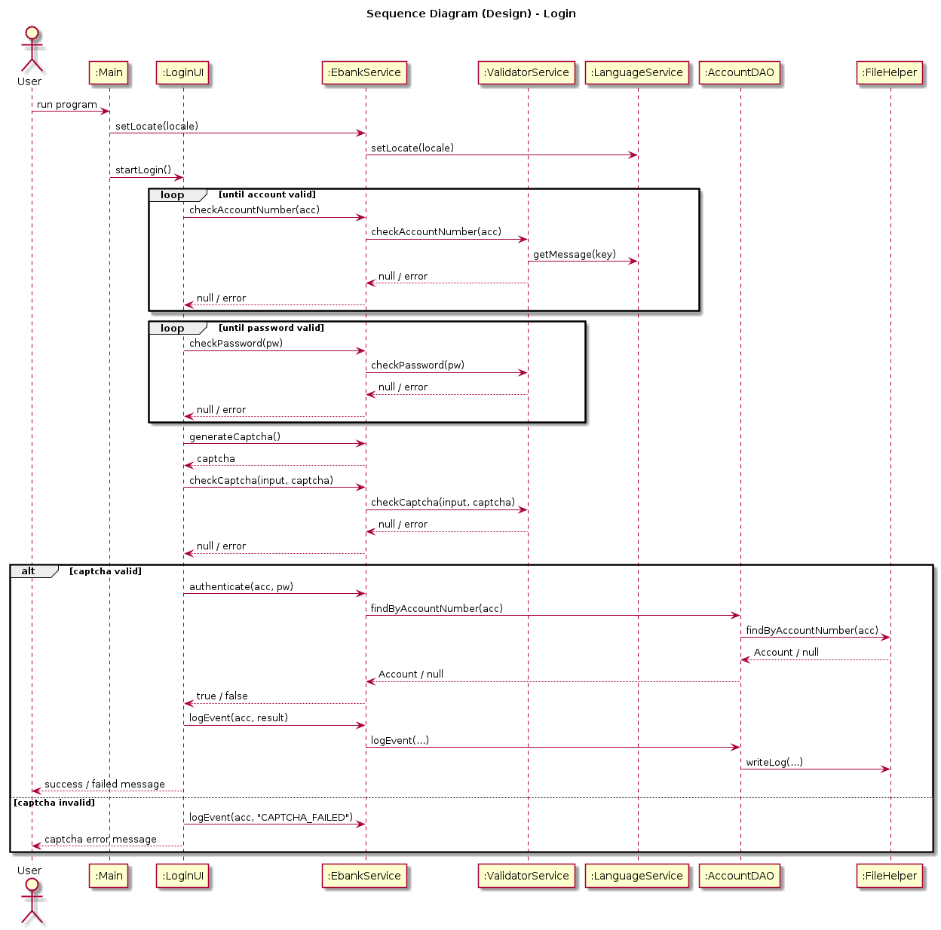
Figure 7. Sequence Diagram (Design) – Login

IV.2 System High-Level Design
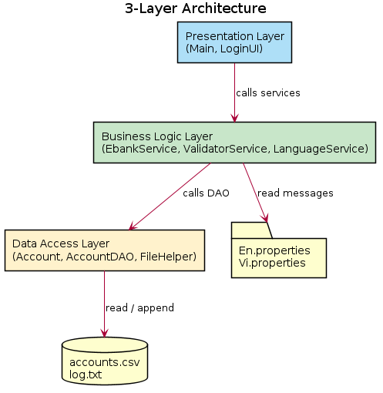
Figure 8. 3-Layer Architecture

IV.3 Component and Package Diagram

IV.3.1 Component Diagram
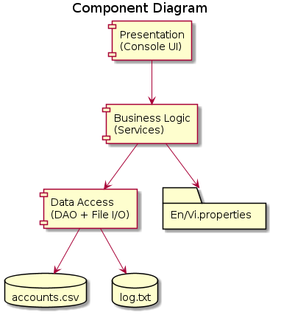
Figure 9. Component Diagram

IV.3.2 Package Diagram
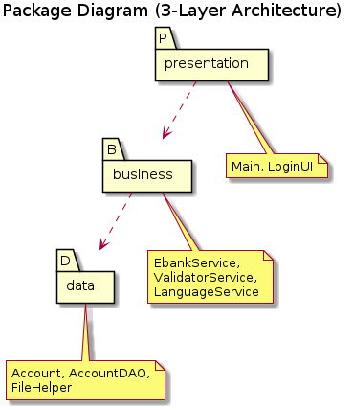
Figure 10. Package Diagram

IV.4 Class Diagram
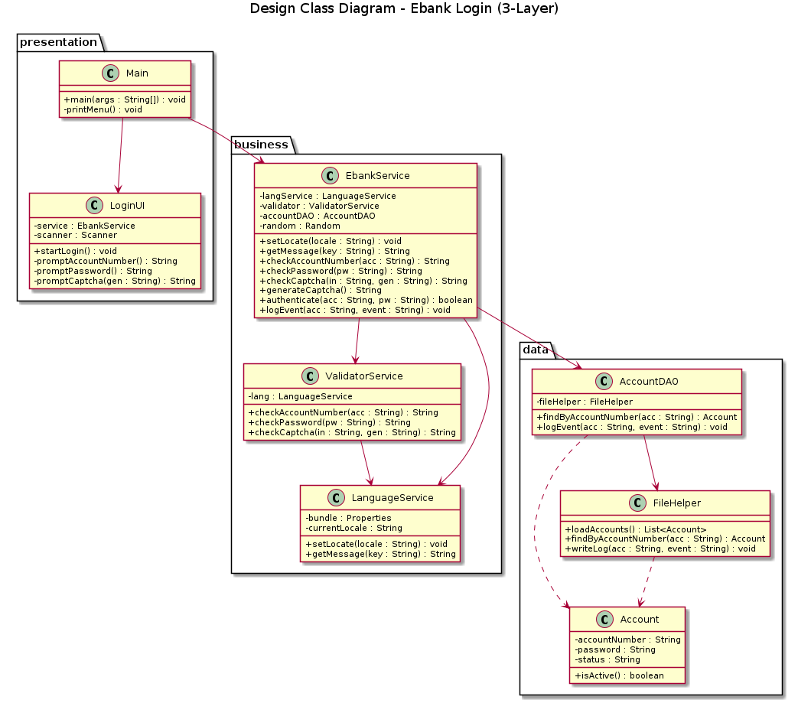
Figure 11. Design Class Diagram

IV.5 Database Design
Data is persisted in flat files. accounts.csv holds the account "table"; log.txt is an append-only event log.
Field | Type | Key | Description
accountNumber | String(10) | PK | Unique account number, 10 digits.
password | String |  | Account password (plain text in the sample).
status | String |  | ACTIVE or LOCKED.

V. Implementation

V.1 Map Architecture to the Project Structure
Each architectural layer maps to one source package; resources are kept separately.
ebank/
src/
presentation/ -> Presentation layer
Main.java (menu, routing, entry point)
LoginUI.java (login dialog)
business/ -> Business Logic layer
Ebank.java (orchestrator + captcha + auth)
ValidatorService.java (format validation)
LanguageService.java (localization)
data/ -> Data Access layer
Account.java (entity)
AccountDAO.java (data access object)
FileHelper.java (CSV / log file I/O)
resources/
accounts.csv, En.properties, Vi.properties, log.txt

V.2 Map Class & Interaction Diagrams to Code
Design Class | Source File | Layer
Main | src/presentation/Main.java | Presentation
LoginUI | src/presentation/LoginUI.java | Presentation
Ebank | src/business/Ebank.java | Business
ValidatorService | src/business/ValidatorService.java | Business
LanguageService | src/business/LanguageService.java | Business
Account | src/data/Account.java | Data
AccountDAO | src/data/AccountDAO.java | Data
FileHelper | src/data/FileHelper.java | Data
Example – the authenticate() message in the sequence diagram is realized by Ebank:
public boolean authenticate(String accountNumber, String password) {
Account acc = accountDAO.findByAccountNumber(accountNumber);
if (acc == null) return false;
if (!acc.isActive()) return false;
return acc.getPassword().equals(password);
}
Example – the validation rules (Check Account Number / Check Password) in ValidatorService:
private static final String ACCOUNT_REGEX = "^\\d{10}$";
private static final String PASSWORD_REGEX = "^(?=.*[a-zA-Z])(?=.*\\d).{6,}$";

VI. Applying Alternative Architecture Patterns

VI.1 Applying the Service-Oriented Architecture (SOA)
The current system is a single-process, layered console application. To support growth (web/mobile channels, many concurrent users, reuse by other bank systems) it can be re-architected as a Service-Oriented Architecture. The cohesive responsibilities already separated in the business and data layers become independent, network-accessible services behind an API Gateway:
- Authentication Service – orchestrates a login (the role of Ebank).
- Validation Service – format checks (ValidatorService).
- Localization Service – message bundles (LanguageService).
- Account Service – account data access (AccountDAO + store).
- Logging Service – centralized audit logging (FileHelper writeLog).
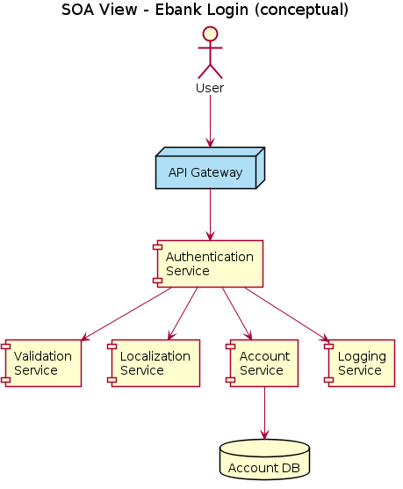
Figure 12. SOA View
Benefits: independent deployment and scaling, reuse across channels, and clear contracts. Trade-offs: added network latency, distributed-system complexity, and the need for infrastructure (gateway, monitoring, security between services).

VI.2 Applying the Service Discovery Pattern
In an SOA, each service may run as several instances whose network locations change as they scale or restart. Hard-coding addresses is brittle. The Service Discovery pattern introduces a Service Registry (for example Netflix Eureka or HashiCorp Consul): every service registers its address on startup, and clients (here, the API Gateway) look services up by logical name at runtime, then call a returned instance — enabling load balancing and resilience.
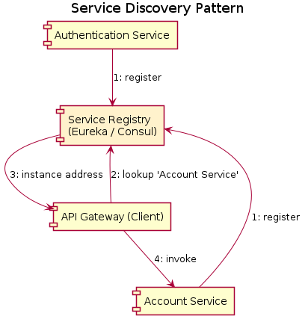
Figure 13. Service Discovery Pattern
- Registration – Authentication, Account and other services register with the registry.
- Lookup – the API Gateway asks the registry for "Account Service".
- Invocation – the registry returns a healthy instance address; the gateway invokes it.
This decouples callers from physical locations and lets the system add or remove service instances without configuration changes.

