SWD392 – SOFTWARE ARCHITECTURE AND DESIGN
PROJECT ASSIGNMENT / LAB

EBANK LOGIN SYSTEM
TienPhong Bank – Ebank Project

Software Requirement Specification
SRS – Ebank Login System

Student: <Full Name>
Roll Number: <RollNumber>
Class: <Class>
Lecturer: <Lecturer>

— Hanoi, June 2026 —

Table of Contents

I. Record of Changes
Date | A* / M, D | In charge | Change Description
21/06/2026 | A | <Student Name> | Initial version – SRS for the Ebank Login System.
*A - Added M - Modified D - Deleted

II. Software Requirement Specification

1. Overall Requirements

1.1 Context Diagram
The Ebank Login System is a console module extracted from the TienPhong Bank – Ebank project. It authenticates a bank customer before access to e-banking services. The context diagram shows the actor and the external data stores.
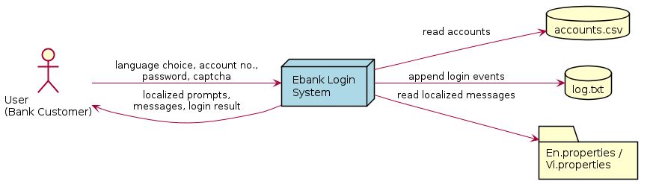
Figure 1. Context Diagram

1.2 Main Workflows

1.2.1 Login Workflow
The user selects a language, enters an account number and password (each re-prompted until the format is valid), then enters a generated captcha. If the captcha is correct the system authenticates the credentials against the account store and reports success or failure; every attempt is logged.

1.2.2 Language Selection Workflow
From the main menu the user chooses Vietnamese or English. The system loads the matching resource bundle so that all subsequent prompts and messages appear in the chosen language. Choosing Exit terminates the program.

1.3 User Requirements

1.3.1 Actors
# | Actor | Description
1 | User (Bank Customer) | The end user who selects a language and authenticates with account number, password and captcha.

1.3.2 Use Cases
The use case diagram below lists the use cases available to the User. Login includes four sub use cases that always execute as part of the login process.
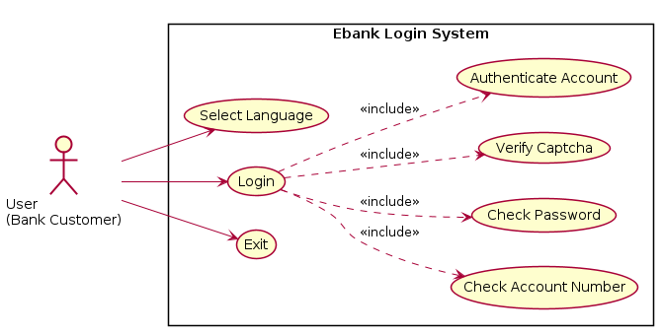
Figure 2. Use Case Diagram – User

1.4 System Functionalities

1.4.1 Screens Flow
Main Menu → (option 1/2) Login Inputs (account → password → captcha) → Result → back to Main Menu. Option 3 exits the program. Invalid format at any input step re-displays the same prompt.

1.4.2 Screen Authorization
Screen | Actor | Access
Main Menu | User | Full
Login Inputs | User | Full
Result | User | Full
The module has a single role (User); there is no administrative screen in this release.

1.4.3 Non-UI Functions
- Captcha generation – random 6-character string for each login attempt.
- Format validation – account number, password and captcha.
- Authentication – match credentials against accounts.csv and check ACTIVE status.
- Event logging – append each outcome to log.txt with a timestamp.
- Message localization – resolve all texts from the selected resource bundle.

1.5 Entity Relationship Diagram
The module persists a single entity, Account; there are no inter-entity relationships. Account records are stored in accounts.csv.
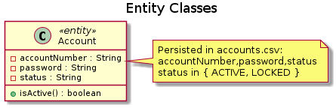
Figure 3. Data Model – Account

2. Use Case Specifications

2.1 User Authentication

2.1.1 Login
Primary Actors | User (Bank Customer) | Secondary Actors | None
Trigger | The User selects a language to start the login process.
Description | As a bank customer, I want to log into the Ebank system with a valid account number, password and captcha so that I can securely access my e-banking services.
Preconditions | The application is running; a language has been selected; account data exists in accounts.csv.
Postconditions | On success the User is authenticated and LOGIN_SUCCESS is logged; on failure an error is shown and LOGIN_FAILED / CAPTCHA_FAILED is logged.
Main Sequence | 1. The User selects a language (1 = Vietnamese, 2 = English).  2. The system prompts for and reads the account number.  3. The system validates the account number (10 digits). [A1]  4. The system prompts for and reads the password.  5. The system validates the password (>= 6 chars, letters and digits). [A2]  6. The system generates and displays a captcha and reads the input.  7. The system verifies the captcha. [A3]  8. The system authenticates account number and password against the store. [A4]  9. The system displays "Login successful" and logs LOGIN_SUCCESS.
Alternative Sequences | A1 – Invalid account: show error, repeat step 2.  A2 – Invalid password: show error, repeat step 4.  A3 – Invalid captcha: show error, log CAPTCHA_FAILED, return to menu.  A4 – Authentication failure (not found / wrong password / LOCKED): show "Login failed", log LOGIN_FAILED, return to menu.

2.1.2 Select Language
Primary Actors | User (Bank Customer) | Secondary Actors | None
Trigger | The application starts and the main menu is displayed.
Description | As a bank customer, I want to choose the interface language so that prompts and messages are shown in a language I understand.
Preconditions | The application is running and the main menu is displayed.
Postconditions | The chosen resource bundle (Vi.properties or En.properties) is loaded and used for all messages.
Main Sequence | 1. The system displays the main menu.  2. The User selects option 1 (Vietnamese) or 2 (English).  3. The system loads the corresponding properties file.  4. The system proceeds to the Login use case in the selected language.
Alternative Sequences | Step 2 – Option 3: the system shows a goodbye message and exits.  Step 2 – Invalid option: the system shows an error and redisplays the menu.

3. Functional Requirements
Each functional requirement is testable and traces back to a use case.
ID | Function | Description | UC
FR-01 | Language selection | Display a menu and let the user choose Vietnamese, English or Exit. | Select Language
FR-02 | Account validation | Accept only a 10-digit numeric account number; re-prompt on invalid input. | Login
FR-03 | Password validation | Require a password of at least 6 characters containing letters and digits. | Login
FR-04 | Captcha generation | Generate a random 6-character captcha for each login attempt. | Login
FR-05 | Captcha verification | Verify the entered captcha against the generated value. | Login
FR-06 | Authentication | Match account number and password against accounts.csv and require ACTIVE status. | Login
FR-07 | Event logging | Append each login outcome to log.txt with a timestamp. | Login
FR-08 | Localized messages | Show all prompts and messages in the selected language. | All

4. Non-Functional Requirements

4.1 External Interfaces
- User Interface: Text console; localized prompts (English / Vietnamese).
- Software Interfaces: Java SE 8+; local file system (accounts.csv, log.txt, *.properties).
- Communication Interfaces: None (standalone console application).

4.2 Quality Attributes

4.2.1 Usability
- Bilingual interface; clear, localized error messages; the program never crashes on bad input.

4.2.2 Performance
- Validation and authentication complete in well under one second for the sample data.

4.2.3 Security
- Format validation, per-attempt captcha, ACTIVE/LOCKED enforcement, and full audit logging.

4.2.4 Reliability
- Missing/unreadable resource files are handled with a warning and safe fallback.

5. Requirement Appendix

5.1 Business Rules
ID | Business Rule
BR-01 | An account number must be exactly 10 numeric digits.
BR-02 | A password must be at least 6 characters and contain both letters and digits.
BR-03 | A new random captcha is generated for every login attempt.
BR-04 | Only accounts with status ACTIVE may log in; LOCKED accounts are rejected.
BR-05 | Authentication requires an exact match of account number and password.
BR-06 | Every login attempt (success, failure, captcha failure) is logged with a timestamp.

5.2 System Messages
Key | English | Vietnamese
account.invalid | Account number must be exactly 10 digits. | So tai khoan phai co dung 10 chu so.
account.empty | Account number cannot be empty. | So tai khoan khong duoc de trong.
password.invalid | Password must be at least 6 characters and contain letters and digits. | Mat khau phai co it nhat 6 ky tu va chua ca chu va so.
captcha.invalid | Captcha is incorrect. Please try again. | Captcha khong dung. Vui long thu lai.
login.success | Login successful! Welcome to Ebank. | Dang nhap thanh cong! Chao mung den Ebank.
login.failed | Login failed. Invalid credentials. | Dang nhap that bai. Thong tin khong chinh xac.
menu.invalid | Invalid option. Please try again. | Lua chon khong hop le. Vui long thu lai.

5.3 Other Requirements
- A new language can be added by providing a new <Locale>.properties file without code changes.
- Passwords should be stored hashed in a production system (the sample uses plain text for demonstration).

