SWD392 – SOFTWARE ARCHITECTURE AND DESIGN
PROJECT ASSIGNMENT / LAB

EBANK LOGIN SYSTEM
TienPhong Bank – Ebank Project

Software Design Document
SDD – Ebank Login System

Student: <Full Name>
Roll Number: <RollNumber>
Class: <Class>
Lecturer: <Lecturer>

— Hanoi, June 2026 —

Table of Contents

I. Record of Changes
Date | A* / M, D | In charge | Change Description
21/06/2026 | A | <Student Name> | Initial version – SDD for the Ebank Login System.
06/07/2026 | M | <Student Name> | Aligned design with the implemented code: renamed EbankService to Ebank; setLocate now takes a Locate enum; menu localized via menu.* keys; UTF-8 resource bundles; validators return explicit validity messages.
*A - Added M - Modified D - Deleted

II. Software Design Document

1. System Design

1.1 System Architecture
The Ebank Login System is built on a 3-Layer (N-Layer) architecture. The Presentation layer handles all console I/O, the Business layer holds the application logic, and the Data Access layer encapsulates file storage. Dependencies flow strictly downward: Presentation → Business → Data; lower layers never reference upper layers (the Dependency Rule). The design applies three named patterns: Facade – the Ebank class is the single entry point that shields the presentation layer from the business subsystem; DAO – AccountDAO hides all file-storage details from the business layer; DTO – Account is a simple data object carried across layer boundaries. Dependencies are injected through constructors (LanguageService → Ebank → LoginUI), which keeps the wiring explicit and the business logic testable.
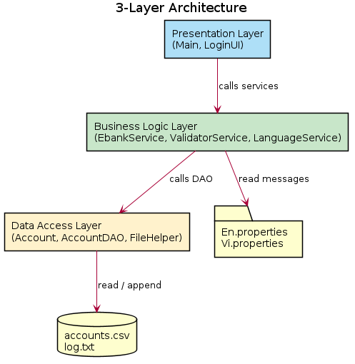
Figure 1. 3-Layer Architecture
Layer | Responsibility | Classes
Presentation | Display menus/screens, read keyboard input, show results. | Main, LoginUI
Business Logic | Validate input, generate captcha, authenticate, localize messages, log events. | Ebank, ValidatorService, LanguageService, Locate
Data Access | Read accounts, append logs, represent account data. | AccountDAO, FileHelper, Account

1.2 Package Diagram
The code is split into three packages that map one-to-one to the architectural layers.
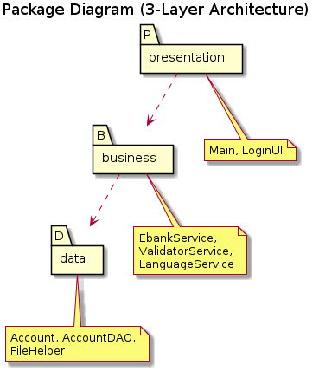
Figure 2. Package Diagram

2. Database Design
A relational database is not used; data is persisted in flat files. The account table is realized by accounts.csv and an append-only event log by log.txt.

2.1 accounts.csv
Field | Type | Key | Description
accountNumber | String(10) | PK | Unique account number, exactly 10 digits.
password | String |  | Account password (plain text in the sample data).
status | String |  | ACTIVE or LOCKED.

2.2 log.txt
One line per attempt: "yyyy-MM-dd HH:mm:ss | <accountNumber> | <EVENT>" where EVENT is LOGIN_SUCCESS, LOGIN_FAILED or CAPTCHA_FAILED.

III. Detailed Design

1. Login

1.1 Class Diagram
The design class diagram shows the full set of classes that implement the login feature, with attributes, operations and relationships.
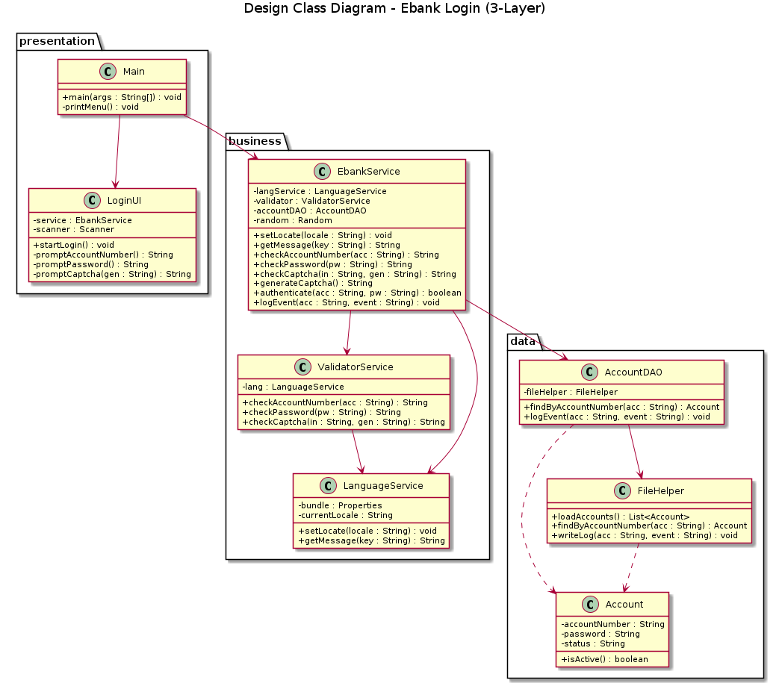
Figure 3. Design Class Diagram
Class | Layer | Key Responsibilities / Methods
Main | Presentation | main(); printMenu() – renders the menu from the localized menu.* keys; routes the option, calls setLocate(Locate), starts LoginUI.
LoginUI | Presentation | startLogin(); prompt loops for account/password/captcha; shows result.
Ebank | Business | setLocate(Locate); checkAccountNumber/Password/Captcha() – each returns a localized message describing the value (valid or the specific error); generateCaptcha(); authenticate(); logEvent().
ValidatorService | Business | checkAccountNumber/Password/Captcha() – regex and rule checks.
LanguageService | Business | setLocate(Locate); getMessage() – loads En/Vi.properties as UTF-8, keyed by the Locate enum.
AccountDAO | Data | findByAccountNumber(); logEvent() – delegates to FileHelper.
FileHelper | Data | loadAccounts(); findByAccountNumber(); writeLog() – CSV/log I/O.
Account | Data | Entity: accountNumber, password, status; isActive().

1.2 Sequence Diagram – Login
The sequence diagram details the message flow across all layers for a complete login attempt, including the validation loops, captcha check, authentication against the store, and logging.
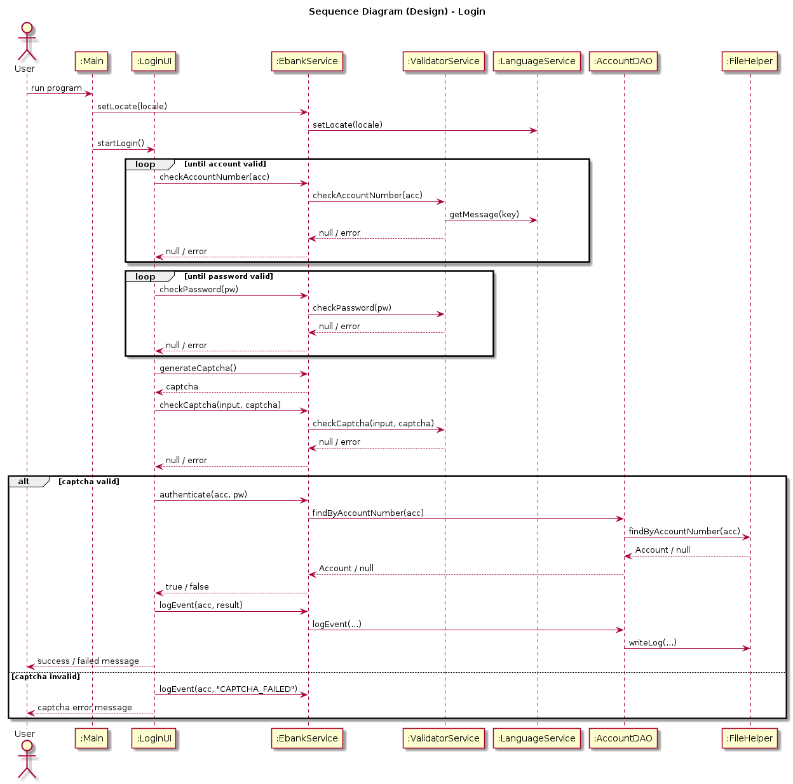
Figure 4. Sequence Diagram – Login

2. Select Language

2.1 Class Diagram
Select Language uses a subset of the classes in Figure 3: Main (presentation) → Ebank (business) → LanguageService (business), which loads the UTF-8 resource bundle identified by the Locate enum.

2.2 Sequence Diagram – Select Language
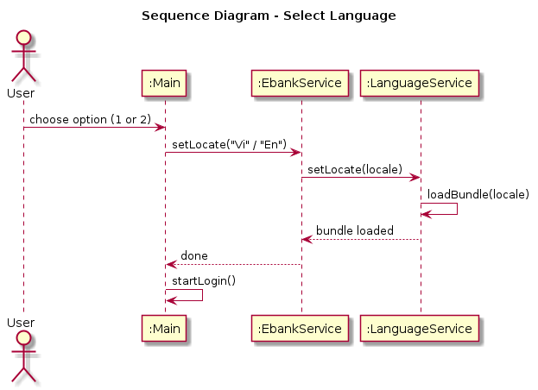
Figure 5. Sequence Diagram – Select Language

