Based on the observation on flows animation provided by nam, all flows do not get a fair share while using DropTail queue, but when using SFQ, they get a fair share. That was happened because DropTail works by dropping any packet if the queue has already full, so the node which is placed near the TCP sink has the greatest advantage of getting the share. To make it clearer, the line graph (a) shown by xgraph below indicates that the throughput of node 4 which is the closest node to the TCP sink has the most significant value and has great difference compared to the others. On the other hand, the line graph (b) shown by xgraph below also indicates that the throughput node 4 has the most significant value, but the difference is not that great especially compared to the second closest node to the TCP sink. The SFQ makes all flows get a fair share as it divides the traffic over a limited number of queues.

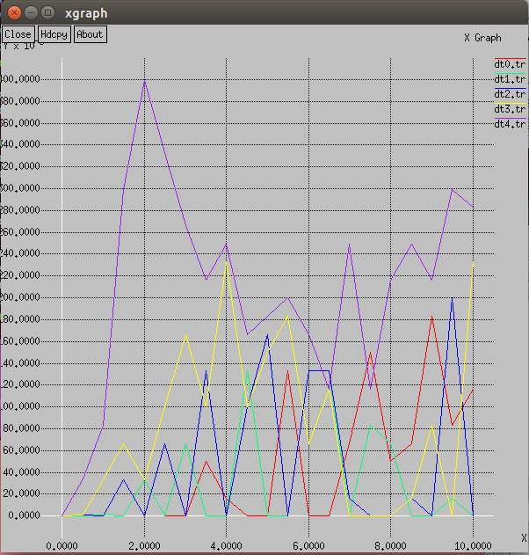 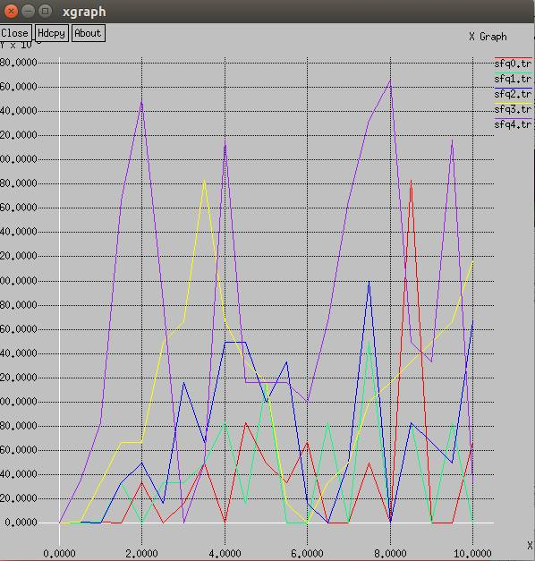

(b) SFQ

1. DropTail

The analysis above is strengthened by the calculation of the average throughput of each node per 0.5 second using awk script below. The gap of the value of each node’s throughput is bigger when using DropTail than SFQ. It shows that the SFQ provides fairer share than DropTail.

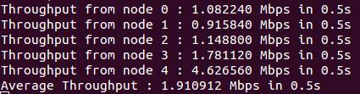 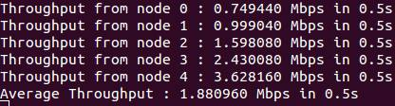

1. DropTail

(b) SFQ