High Impact Skills

Development Program

AI & Data Science

Hasnain Ali

Roll No # GIL-DSAI-267

GitHub: [github.com/tito-bot](https://github.com/tito-bot)

Data Mining Project.

**Customer Behavior Analysis in an Online Retail Environment**

**Introduction**

* **Objective:**  
  This project is dedicated to analyzing various facets of customer behavior within an online retail environment. The primary goals include deriving actionable insights through customer segmentation, analyzing order value distribution, understanding product affinity, and identifying monthly sales trends. By achieving these objectives, we aim to enhance customer targeting, optimize sales strategies, and improve overall business performance.
* **Tools & Techniques:**  
  The analysis was performed using SQL queries within a MySQL environment, leveraging the online_retail schema. This schema contains comprehensive data on customer transactions, allowing for detailed and meaningful analysis.

**Data Structure and Preparation**

* **Schema Overview:**  
  The online_retail table comprises several key fields:
* InvoiceNo: Unique identifier for each transaction.
* StockCode: Identifier for products.
* Quantity: Number of units purchased.
* UnitPrice: Price per unit.
* CustomerID: Unique identifier for customers.
* InvoiceDate: Date of the transaction.
* **Data Transformation:**  
  To ensure the accuracy of analysis:
* The InvoiceDate column was converted to a proper DATETIME format. This transformation facilitates effective time-based analysis, enabling insights into sales trends and seasonal variations.
* Calculations for order values and customer segmentation were verified for accuracy, ensuring the reliability of subsequent analyses.

**Key Analysis and Insights**

* **Customer Segmentation by Purchase Frequency:**  
  Customers were segmented based on their purchase frequency, categorized into high, medium, and low frequency groups. This segmentation was determined by counting the number of invoices associated with each customer.

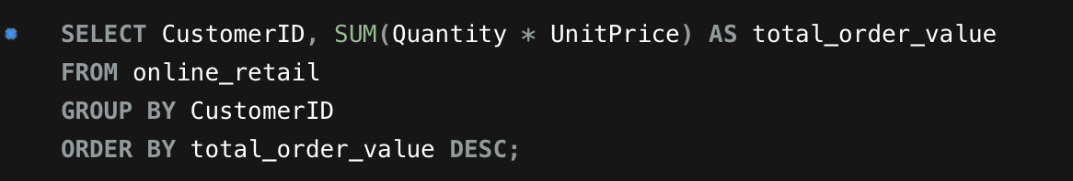

* **This segmentation helps in identifying:**
* High-Frequency Customers: These are typically loyal customers who frequently engage with the brand.
* Low-Frequency Customers: Individuals who may require targeted strategies to increase their purchase frequency.

**Order Value Distribution:**  
To understand the distribution of order values, we calculated the total order value for each customer by multiplying the quantity of items purchased by their unit price.

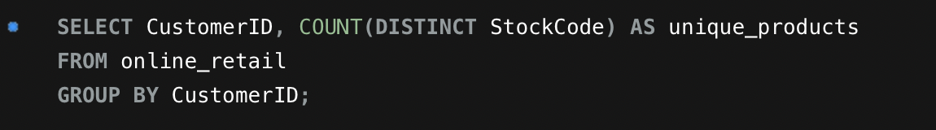

**This analysis helps in:**

* Identifying high-value customers who contribute significantly to overall revenue.
* Targeting these customers for loyalty programs or special offers.

**Product Affinity Analysis:**  
Product affinity was analyzed to identify products frequently purchased together. This provides insights into potential cross-selling and bundling opportunities.

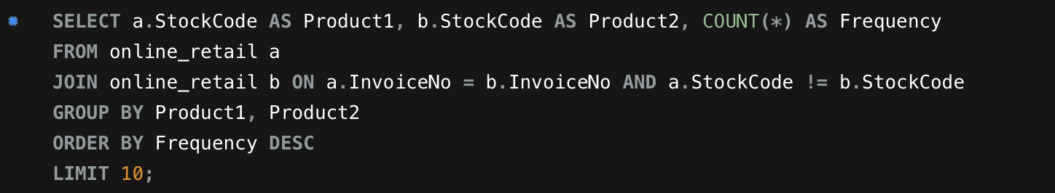

**This analysis reveals:**

* Common product pairs that could be bundled for promotions.
* Opportunities to enhance sales through targeted marketing efforts.

**Monthly Sales Analysis:**  
Total sales were computed on a monthly basis to identify trends and seasonal patterns.

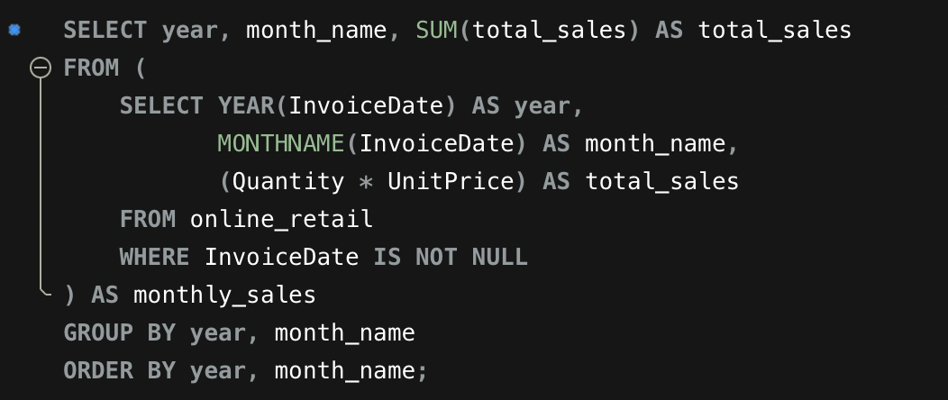

**This analysis provides insights into:**

* Seasonal trends that influence sales.
* Peak periods where marketing efforts and inventory management should be intensified.

**Conclusion and Future Recommendations**

**Key Insights:**

* High-Frequency Customers: They are the primary contributors to overall sales, indicating the importance of nurturing these relationships.
* Product Affinity: Certain products have a high propensity to be purchased together, suggesting opportunities for effective bundling and promotional strategies.
* Monthly Sales Trends: Understanding these trends assists in optimizing inventory levels and marketing strategies to align with peak sales periods.

**Future Recommendations:**

* Customer Churn Analysis: Conduct a detailed analysis of customer churn, focusing on those who have not made purchases in the last six months. This will help in understanding the reasons behind customer disengagement and formulating re-engagement strategies.
* Targeted Marketing Campaigns: Implement targeted marketing campaigns aimed at high-value customers. Personalizing offers and promotions for these individuals can drive further sales and enhance customer loyalty.

By following these recommendations, the online retail business can better cater to its customer base, improve sales performance, and develop more effective marketing and inventory strategies.