High Impact Skills

Development Program

AI & Data Science

Hasnain Ali

Roll No # GIL-DSAI-267

Tableau: [profile/ti.to/viz/ModuleSep5/Netflix](https://public.tableau.com/app/profile/ti.to/viz/ModuleSep5/Netflix)

Data Visualization Project.

Interactive Dashboard Development

Using Tableau for Exploratory Data Analysis (EDA)



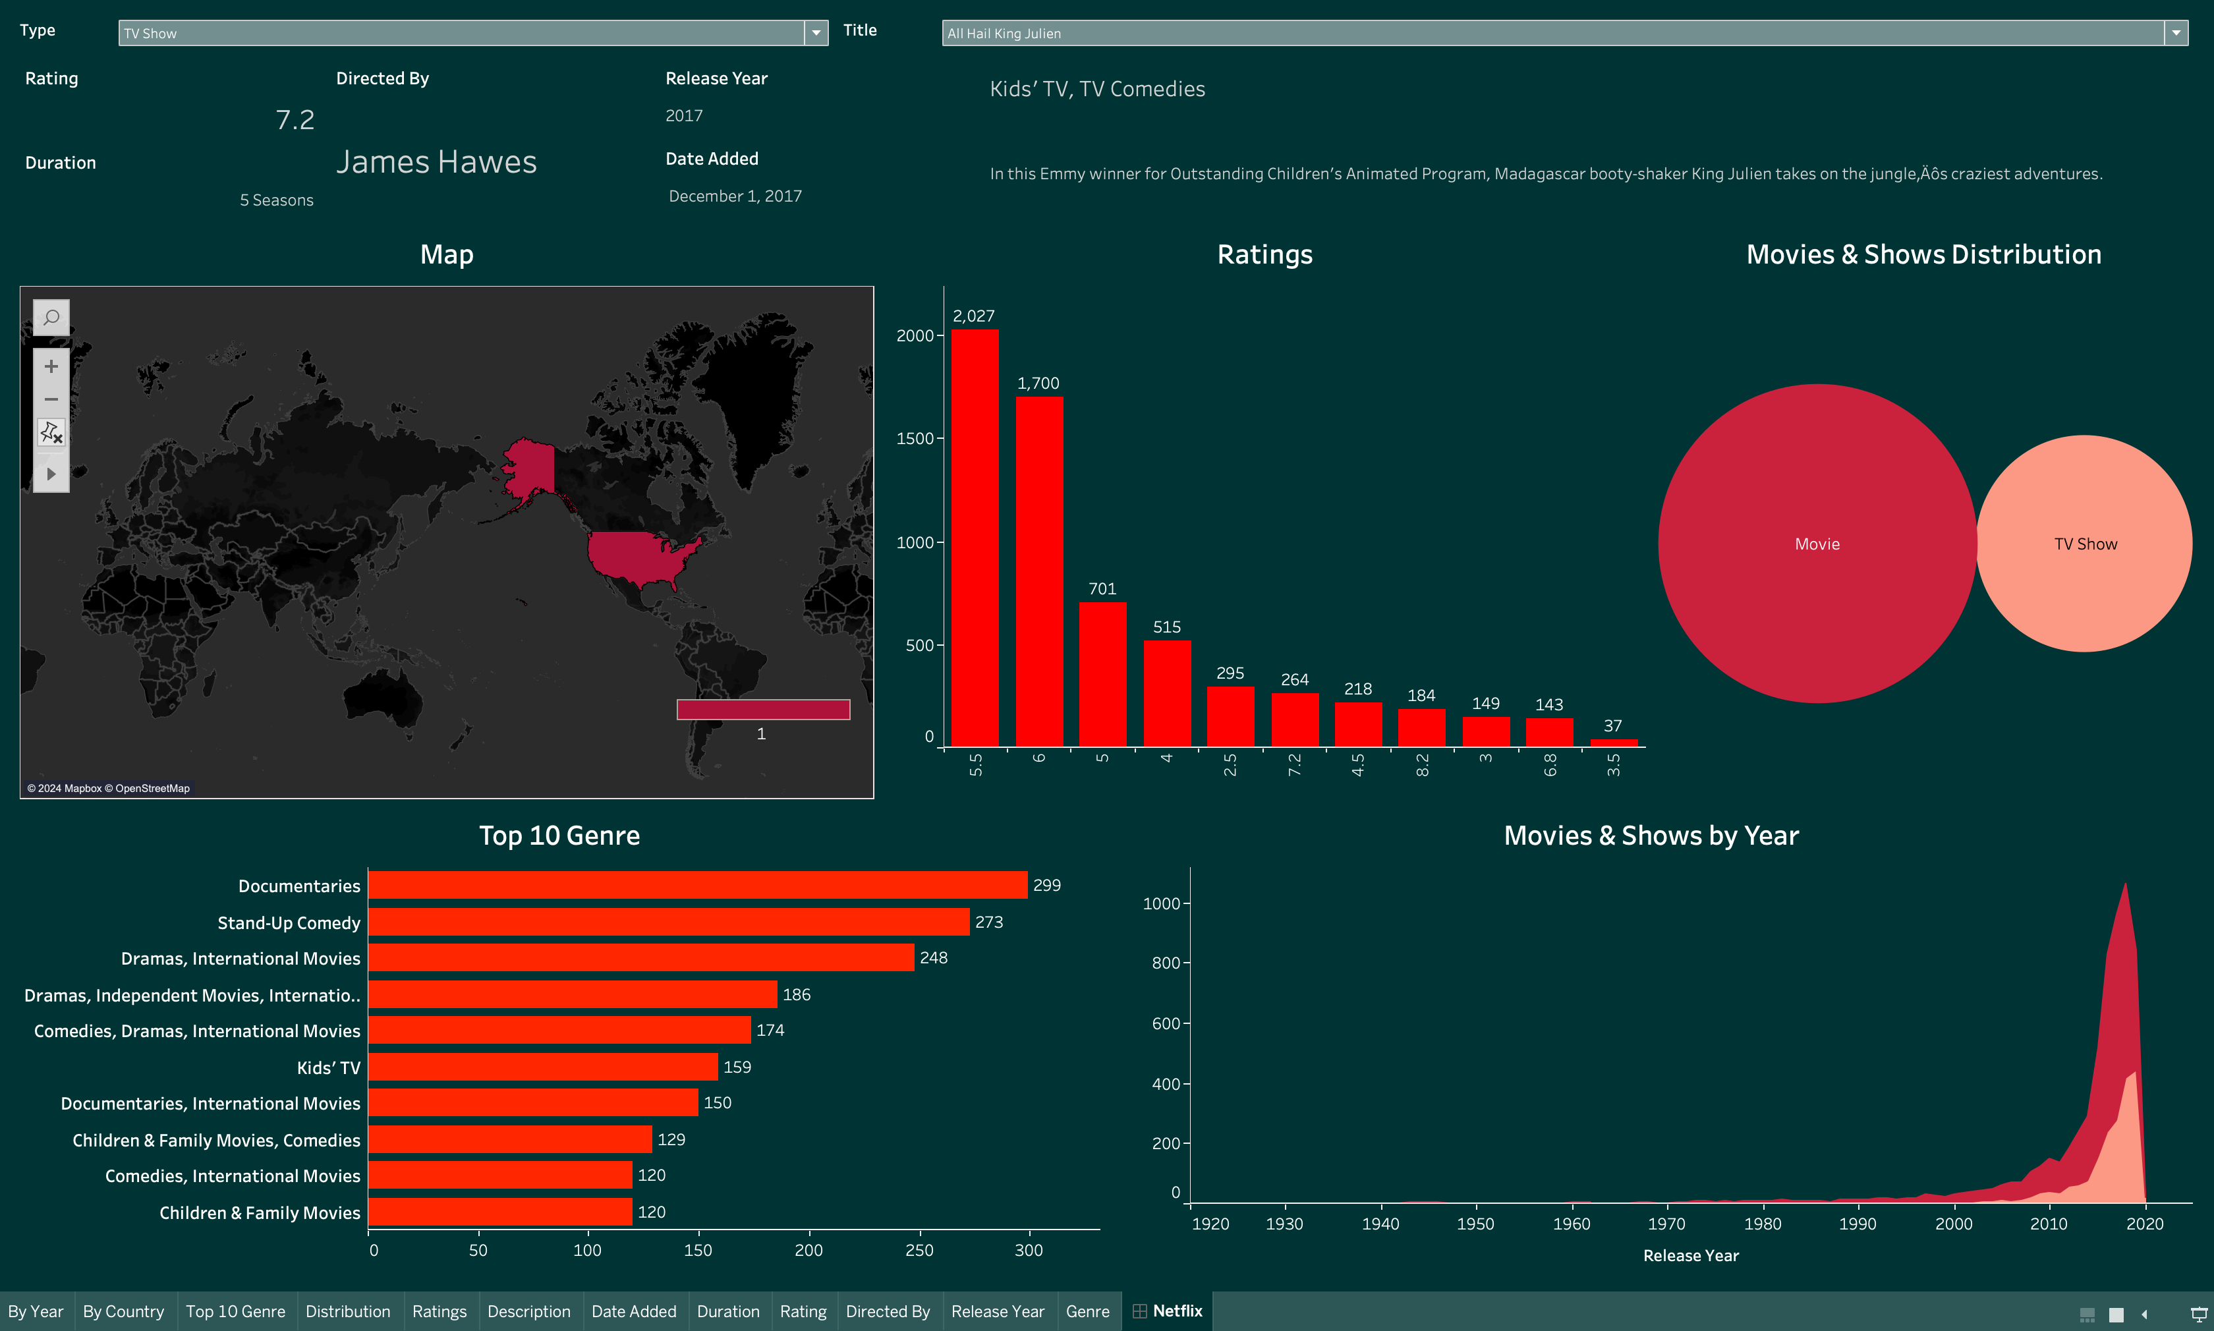



**Introduction**

The dataset contains information from Netflix, specifically about movies and TV shows. The main goals of the Exploratory Data Analysis (EDA) are to examine how content is distributed by country, genre, ratings, and release year. This analysis will offer valuable insights that can support future AI and machine learning projects, such as developing recommendation systems or segmenting audiences for targeted marketing. By identifying patterns, such as the popularity of certain genres or types of shows in various regions, these insights can guide the creation of predictive models and enhance user engagement strategies.

**Process**

I aimed to design the interface to resemble a website for user-friendliness. Referring to the labels on the screenshot above:

1. The “Type” section at position “1” allows users to filter by categories, with options to add or remove sections as needed.
2. The “Title” section at “2” lets users either select from a dropdown menu or enter a title manually.
3. At “3,” the interface displays the ratings for the title selected.
4. The “Length” field at “4” shows the duration of the movie or the number of seasons for a TV show.
5. The Director’s name is presented at “5.”
6. The genre information is provided at “6.”
7. The description appears at “7.”
8. A map at “8” indicates the film’s origin.
9. Position “9” features a bar chart illustrating ratings by year.
10. At “10,” a circular area fill chart displays the average release frequency of films globally.
11. The horizontal bar chart at “11” ranks the Top 10 Genres.
12. Finally, the area fill chart at “12” presents the number of film releases by year.

**Conclusion**

The EDA provided several key insights into Netflix's catalogue:

* Geographical Distribution: The dataset shows that Netflix content is highly concentrated in specific regions. These insights can help in regional content marketing or recommendations for local audiences.
* Popular Genres: Documentaries, Stand-Up Comedy, and Dramas are among the top genres, indicating the kind of content that performs well globally. This can inform the development of AI/ML models that recommend similar genres to users based on past behaviour.
* Content by Rating: A significant amount of content is rated TV-MA and R, which could influence content moderation, parental controls, or marketing for different audience demographics.
* Temporal Trends: The number of movies and TV shows released each year shows specific patterns, with a noticeable increase in TV show releases in recent years. This information can inform the development of predictive models to forecast future releases or content trends.