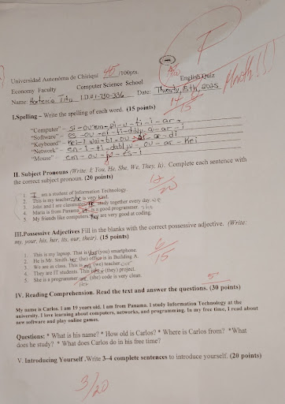

**Correction.**

**II. Subject Pronouns (Pronombres Sujeto)**

1. **I** am a student of Information Technology.
2. This is my teacher. **She** is very kind.
3. John and I are classmates. **We** study together every day.
4. Maria is from Panama. **She** is a good programmer.
5. My friends like computers. **They** are very good at coding.

**III. Possessive Adjectives (Adjetivos Posesivos)**

1. This is **my** laptop. That is **your** smartphone.
2. He is Mr. Smith. **His** office is in Building A.
3. We are in class. This is **our** teacher.
4. They are IT students. This is **their** project.
5. She is a programmer. **Her** code is very clean.

**IV. Reading Comprehension (Comprensión de Lectura)**

* **What is his name?** His name is Carlos.
* **How old is Carlos?** He is 19 years old.
* **Where is Carlos from?** He is from Panama.
* **What does he study?** He studies Information Technology at the university.
* **What does Carlos do in his free time?** He reads about new software and plays online games.

**V. Introducing Yourself (Presentarse)**

My name is Hortencio.

I am from Panama.

I am a student.

My favorite color is black.

I am 32 years old.

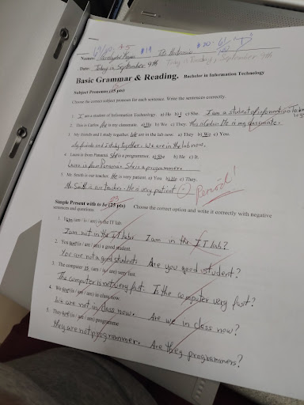

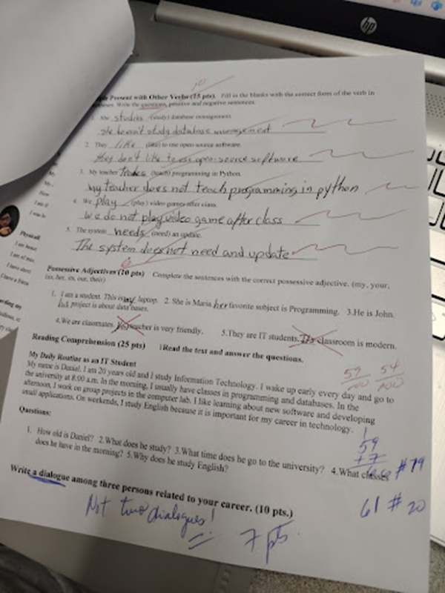

**Subject Pronouns**

* **I** am a student of Information Technology.
* This is Carlos. **He** is my classmate.
* My friends and I study together. **We** are in the lab now.
* Laura is from Panama. **She** is a programmer.
* Mr. Smith is our teacher. **He** is very patient.

**II. Simple Present with "to be"**

**Negative Sentences**

* I am not in the IT lab.
* You are not a good student.
* The computer is not very fast.
* We are not in class now.
* They are not programmers.

**Questions**

* **Am** I in the IT lab?
* **Are** you a good student?
* **Is** the computer very fast?
* **Are** we in class now?
* **Are** they programmers?

**I. Present with Other Verbs**

* 1. She **studies** (study) database management.
  2. They **like** (like) to use open source software.
  3. My teacher **teaches** (teach) programming in Python.
  4. We **play** (play) video games after class.
  5. The system **needs** (need) an update.

**II. Possessive Adjectives**

* 1. I am a student. This is **my** laptop.
  2. She is Maria. **Her** favorite subject is Programming.
  3. He is John. **His** project is about data bases.
  4. We are classmates. **Our** teacher is very friendly.
  5. They are IT students. **Their** classroom is modern.

**III. Reading Comprehension**

* **How old is Daniel?** He is 20 years old.
* **What does he study?** He studies Information Technology.
* **What time does he go to the university?** He goes to the university at 8:00 a.m.
* **What classes does he have in the morning?** He has classes in programming and databases.
* **Why does he study English?** He studies English because it is important for his career in technology.

**IV. Dialogue**

* **Ana:** "Hey, I'm thinking about a career in cybersecurity. What are you two planning to do?"
* **Ben:** "I'm focusing on cloud computing. I think it's where the future is heading."
* **Chris:** "I'm more interested in network administration. I like the challenge of building and maintaining a strong network infrastructure."

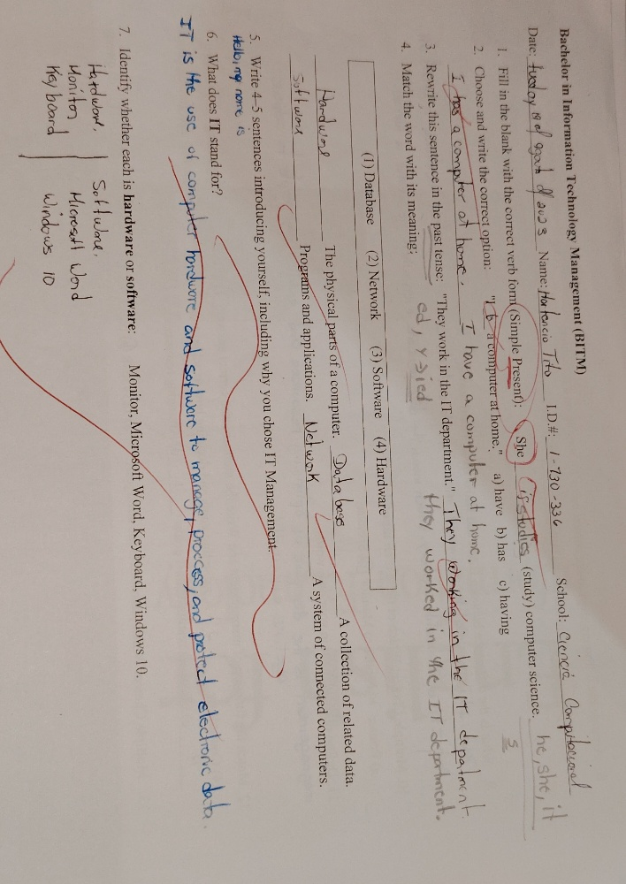

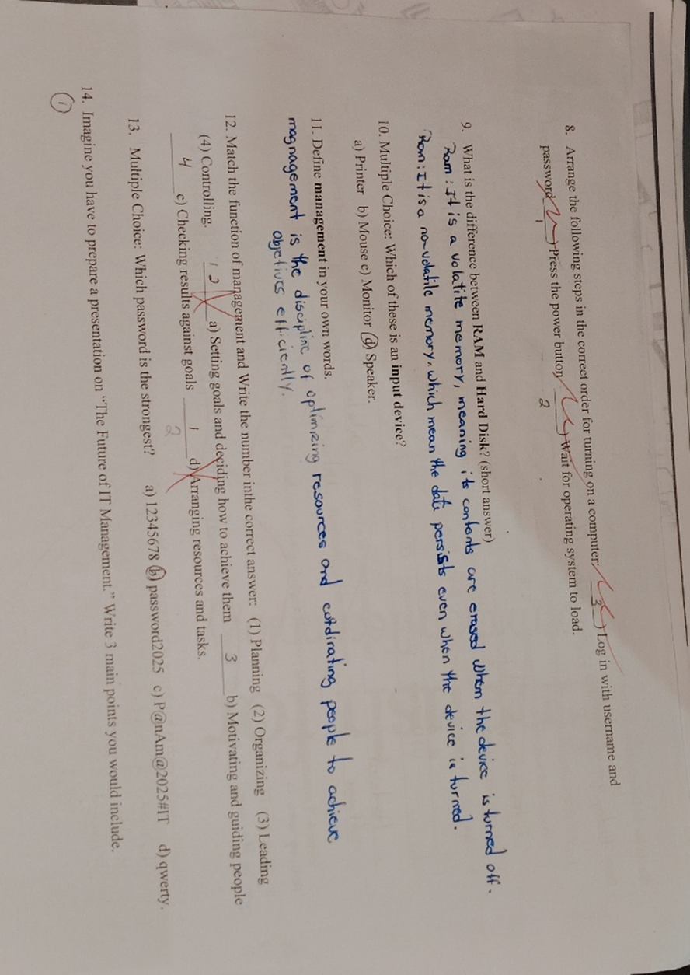

I. Fill in the blank with the correct verb form (Simple Present):

1. She studies computer science.

2. I have a computer at home.

3. They worked in the IT department.

1. Write 4-5 sentences introducing yourself, including why you chose IT Management.

*My name is Hortencio.*

*I am a student of IT Management.*

*I chose this field because it combines my passion for technology with my interest in leadership and strategy.*

1. What is IT?

IT is the use of computer hardware and software to manage, process, and protect electronic data.

1. Arrrage the following step in the correct order for turning on a computer:

1. Press the power button.

2. Wait for the operating system to load.

3. Log in with your username and password.

1. What is the difference between Ram and Hard Disk?

RAM: It is a volatile memory, meaning it contents are erased whem the divice ist turned oof.

ROM: It is a no -volatile memory,which mean the date persists even when the device in turned.

Which is an input device?

d) Mouse

1. Definición Managementin your own words.

Management is the discipline of organizing resources and coordinating people to achieve goals efficiently.

1. Match the function of management and write the number inthe correct aswer:
2. Planning
3. Leading
4. Controlling
5. Organizing
6. Imagine you have to prepare a presentation on “The Future of IT Management.” Write 3 main point you would include.
7. The Rise of Automation and AI.
8. Focus on Proactive Cybersecurity.
9. The Importance of Soft Skills.