Maternal International Work Migration and Adult Outcomes among Left-Behind Children in Indonesia
Anonymised working-paper draft — Riset 1 first-pass release

Abstract
This paper studies the association between verified mother-led international work migration after the first wave of the Indonesia Family Life Survey and adult outcomes among children who remained in the origin household. The analysis defines exposure narrowly: the linked mother must have a verified work-related move to a country outside Indonesia, the child must remain in the origin household at the event wave, and the baseline parent and household links must pass quality checks. The primary sample contains 3,847 W1 children aged 0–12 who are linked to W5 adult outcomes, including 25 treated and 3,822 controls. We estimate unweighted adjusted associations with W1 controls and origin-household clustered robust standard errors. The largest first-pass signals are lower college attainment and higher good self-rated health among treated observations; these are associations, not causal effects. Outcome support, the small treated cell, selective W5 follow-up, and unresolved survey design and source-release metadata limit inference. A combined multidimensional index is not constructed in this release.
Keywords: international migration; left-behind children; adult outcomes; Indonesia; longitudinal survey; social welfare

1. Introduction
International work migration can change the resources, care arrangements, and daily environments experienced by children who remain in the origin household. Those channels may matter long after the migration episode. The empirical challenge is that migration is not randomly assigned: households that send a mother abroad may differ from other households before the move, and a child’s continued residence or later survey observation may also be selective.
This paper asks a deliberately bounded question: within a quality-controlled longitudinal sample of Indonesian children, how are verified mother-led international work migration episodes after the first IFLS wave associated with separate adult education, labour, health, and social/behavioural outcomes observed in W5? The paper does not claim to identify a causal migration effect. It reports a transparent first-pass association that can be audited before a stronger identification strategy is attempted.
The release makes three choices that narrow the question. First, treatment is limited to the child’s linked mother and to a destination country that is verified as outside Indonesia under the wave-specific source rules. Second, children with ambiguous parent links, contaminated origin-household status, or incompatible whole-household movement are not silently assigned to the control group. Third, adult outcomes are kept as separate measures. The concept note proposed a multidimensional index, but the current files do not support a validated common index across the relevant outcome modules.

2. Data and study population
The Indonesia Family Life Survey (IFLS) is a longitudinal household survey covering multiple survey waves and a large Indonesian population. The official survey page documents the longitudinal design, geographic coverage, and wave history; the IFLS5 field report provides additional field documentation (RAND, 2016; RAND, n.d.). This first-pass analysis uses the local IFLS files and preserves the original source directory. The exact official source-release identifier is recorded as an open provenance item in the project manifest and must be completed before public replication.
The baseline cohort consists of W1 children aged 0–12. The primary frame requires both W1 parent links to be valid, a clean W1 origin household, and the necessary W5 linkage. The final common frame contains 3,847 observations: 25 treated observations and 3,822 controls. The number of observations and treated cases varies by adult outcome because the model uses outcome-specific listwise deletion.

Table 1. R1 sample flow and support
Stage | N
W1 child cohort aged 0–12 | 9,891
Both parents linked, clean origin, and W5 tracked | 6,046
Mother post-W1 migration evidence observed | 3,952
Verified treated | 25
Observed control | 3,884
R1 analysis frame before outcome-specific deletion | 3,847
Treated / control in common analysis frame | 25 / 3,822
The stage counts above are construction-flow counts. They should not be read as national prevalence estimates.

3. Exposure, outcomes, and empirical specification

3.1 Treatment definition
An observation is treated only when all of the following conditions hold:
- the child belongs to the W1 age 0–12 cohort;
- both baseline parent links and the W1 origin household pass the quality rules;
- the linked mother has an observed post-W1 migration episode or screen;
- the move has a verified work reason;
- the destination is verified as outside Indonesia under the relevant wave rule;
- the move occurs after the W1 baseline window;
- the child remains in the origin household at the event wave; and
- there is no incompatible whole-household or child-moved evidence.
Domestic migration, father-only migration, any-parent migration without a verified mother episode, unresolved country codes, commuting, death, and non-work moves are not part of the primary treatment. Unresolved exposure is kept as a separate status and is excluded from the primary frame rather than forced into control.

3.2 Adult outcomes
W5 adult outcomes are observed among persons aged 17–36. The primary release uses separate outcome families: college attainment, employment, log monthly salary, self-rated health score, good self-rated health, marital status, and trust-item scores. Binary coefficients are interpreted as percentage-point associations. Salary is ln(1 + salary) within W5; it is not deflated across waves. Profit is not interpreted for R1 because the model has only four treated observations and fails the predeclared support gate. The missing W5 b3b_vg module is not presented as a complete CES-D-10 measure.

3.3 Model
For each outcome (Y_{i}), the primary specification is:
[ Y_i = \alpha + \beta T_i + \gamma'X_i + \varepsilon_i, ]
where (T_i) is the locked migration indicator and (X_i) contains W1 child age, child sex, household size, and linked mother and father ages. Estimates are unweighted. Standard errors are robust and clustered at the W1 origin household. Each outcome has its own valid-code and missingness rule. The Benjamini–Hochberg adjustment is calculated within the predeclared paper by outcome-family group.
The coefficient β is an adjusted conditional association. It is not a causal effect because the design does not establish exchangeability, exogenous treatment timing, or a valid instrument.

4. Results

4.1 Headline estimates
Table 2 reports a pre-labelled set of outcome domains. It is not a table made by selecting only statistically significant results. The complete adjusted result file contains all estimable outcomes, including the social/behavioural items and the explicit below-support result status.
\newpage

Table 2. R1 adjusted associations in the common first-pass frame
Outcome | Estimate | 95% CI | p; BH q | N / treated
College attainment (pp) | -20.74 | [-30.15, -11.33] | <0.001; <0.001 | 3,638 / 22
Employment (pp) | 0.71 | [-12.92, 14.33] | 0.919; 0.919 | 3,655 / 22
Log monthly salary | -1.441 | [-4.002, 1.120] | 0.270; 0.540 | 1,795 / 13
Self-rated health score | 0.092 | [-0.059, 0.242] | 0.232; 0.309 | 3,644 / 23
Good self-rated health (pp) | 11.19 | [2.66, 19.72] | 0.010; 0.041 | 3,644 / 23
Married/cohabiting (pp) | 1.66 | [0.34, 2.97] | 0.014; 0.122 | 2,402 / 19
Trust item 3 score | 0.045 | [-0.191, 0.281] | 0.706; 0.795 | 3,479 / 22
The adjusted association with college attainment is -0.207, equivalent to about 20.7 percentage points in this binary outcome, with a BH q-value below 0.001. The adjusted association with good self-rated health is +0.112, or about 11.2 percentage points, with q = 0.041. These two signals should not be read as estimated causal impacts: they can reflect pre-existing household differences, selective exposure classification, or selective follow-up.
The other headline outcomes do not survive the predeclared q < 0.05 threshold within their outcome families. The salary estimate has wide uncertainty and a smaller outcome-specific treated count. The full table should be consulted before any interpretation of individual social/behavioural items.
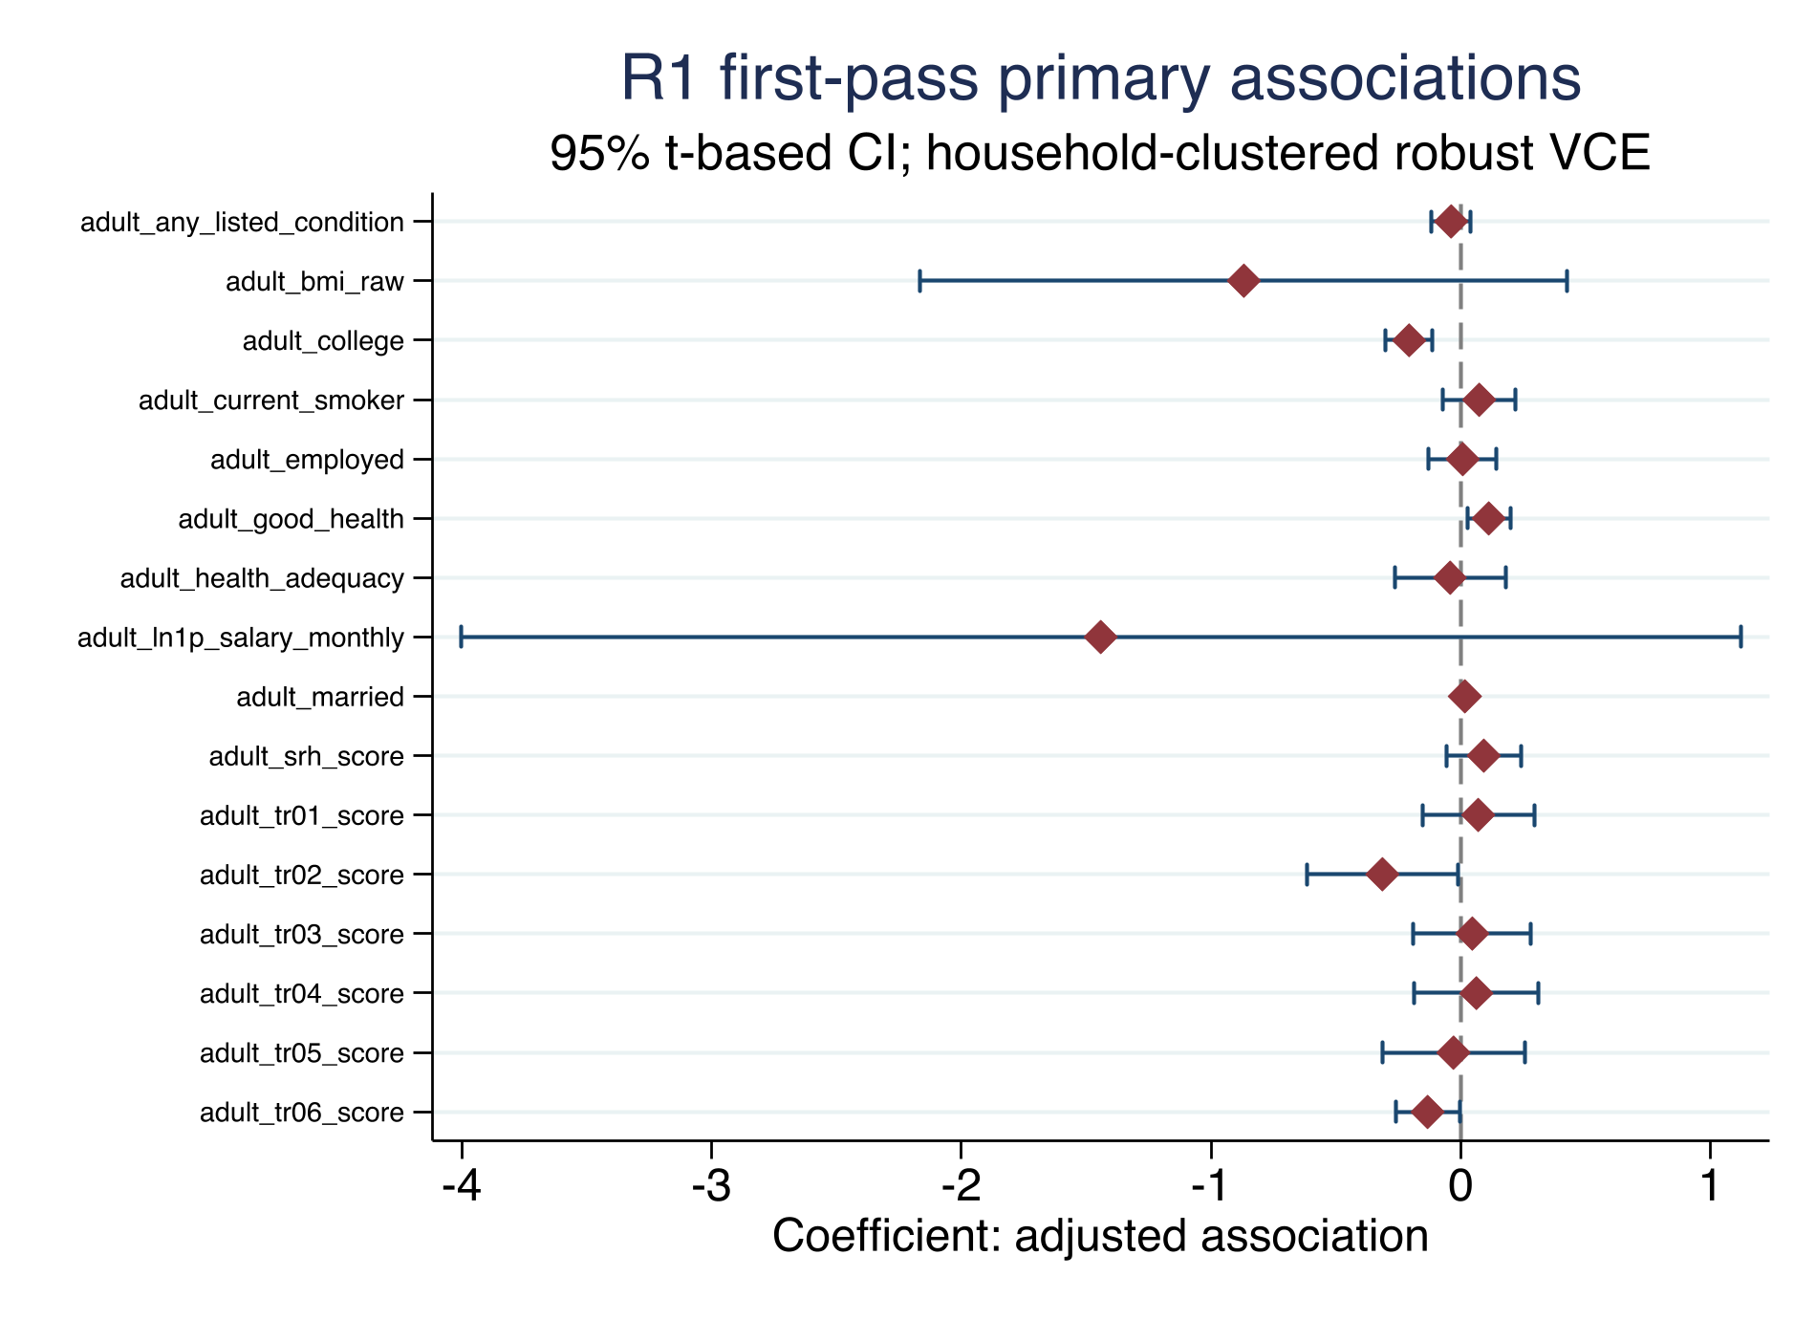

4.2 Descriptive baseline information
The package includes baseline means and standard deviations by treatment status in tables/baseline_descriptives.csv. They are descriptive within the locked frame, not balance tests that validate a causal design. The treated group is small, so baseline comparisons can be driven by a few households and should not be used to justify causal language.

5. Limitations and reviewer-facing boundaries
The first limitation is support. Only 25 observations are treated in the common frame, and outcome-specific treated counts range from 13 to 23 for the headline results. The R1 profit outcome has four treated observations and is withheld from interpretation. This makes the estimates sensitive to individual households and limits precision.
The second limitation is selection. The sample requires valid baseline parent links, a clean origin household, successful linkage to W5, and valid values for each outcome. This is necessary for transparent construction but may select a non-representative subset. No attrition correction is claimed in this release.
The third limitation is identification. W1 controls reduce measured baseline differences but do not remove unmeasured differences in migration preferences, resources, care arrangements, local labour markets, or child characteristics. No IV, matching, mediation, fixed-effects, or event-study result is part of the primary release.
The fourth limitation is measurement and provenance. Country coding is kept wave-specific rather than harmonised by assumption. Unresolved exposure and lineage statuses are excluded from the primary frame. The local file hashes are complete, but the exact official release identifier and authorized-data provenance remain open. Finally, the current release does not construct the proposed IMDI and does not report a national monetary loss or NPV.

6. Conclusion
In the locked IFLS first-pass sample, verified mother-led international work migration after W1 is associated with lower adult college attainment and higher good self-rated health after adjustment for measured W1 controls. The remaining headline outcomes do not show family-level q-values below 0.05. The result is a bounded descriptive-analytic starting point, not a causal estimate of the consequences of maternal migration. A stronger paper would require a closed source-release record, an attrition strategy, survey-design validation, and an identification design that can support causal language.

Declarations for author completion
Data availability. The project does not redistribute IFLS microdata. The code, aggregate tables, figures, diagnostics, and reproducibility instructions are local artifacts. Authors should obtain and cite the authorized IFLS files through the official RAND documentation and comply with the applicable access terms.
Funding, conflicts of interest, ethics, acknowledgements, and author contributions. To be completed by the authors. No author metadata or institutional statement is inferred from the supplied files.
AI use statement. AI-assisted drafting and organization were used during the 5 September 2026 preparation of this internal draft. All reported estimates were generated by the project's Stata do-files and checked against the saved aggregate CSV files and logs. AI did not modify the raw or derived IFLS data, and restricted microdata and credentials were not disclosed in the drafting process. The authors remain responsible for the final manuscript and for adapting this statement to the target journal's policy.

References
RAND Corporation. (2016). The Fifth Wave of the Indonesia Family Life Survey: Overview and Field Report. WR-1143/1-NIA/NICHD. https://www.rand.org/content/dam/rand/pubs/working_papers/WR1100/WR1143z1/RAND_WR1143z1.pdf
RAND Corporation. (n.d.). Indonesia Family Life Survey. https://www.rand.org/health/surveys/FLS/IFLS.html

