Child Labor and Adult Outcomes in Indonesia: A First-Pass Analysis of IFLS
Anonymised working-paper draft — Riset 3 first-pass release

Abstract
This paper examines the association between intensive market child labor at age 15 and adult outcomes in Indonesia. The exposure is defined from observed work screens and valid hours for up to two jobs in the second and third IFLS waves. The primary treatment is more than 43 hours of market work in the reference week. Younger age bands remain descriptive because their linked work-screen support is sparse or unresolved. The W2/W3 age-15 treatment file contains 1,131 eligible person-wave observations, including 71 treated and 1,060 controls before the W5-linked analysis frame. The common first-pass frame contains 753 observations, including 44 treated and 709 controls. We estimate unweighted adjusted associations with baseline controls, a wave indicator, and treatment-wave household-clustered robust standard errors. The largest signals are lower college attainment and higher marriage/cohabitation and trust-item-3 scores among treated observations. These are conditional associations, not causal effects. Attrition, small treated support, outcome missingness, and limited work-label documentation constrain interpretation.
Keywords: child labor; adult outcomes; education; health; Indonesia; longitudinal survey; social welfare

1. Introduction
Child labor may affect later education, employment, health, and social outcomes. A longitudinal design can connect an observed work episode during childhood to later outcomes, but it does not by itself solve selection into work. Children who work long hours may differ in household resources, school access, local labour demand, health, and expectations before the work episode.
This paper asks a bounded first-pass question: among IFLS children observed at age 15 in W2 or W3, how is intensive market work in the reference week associated with separate W5 adult outcomes? The paper focuses on transparent measurement and support rather than presenting a causal estimate. It uses a predeclared age-15 treatment because the age-10–14 data do not provide enough resolved, comparable work-hour support for primary inference.
The analysis also keeps the outcome families separate. Education, labour, health, and social/behavioural outcomes are not combined into a new index, and the earnings results are not converted into a national loss or present-value calculation. Those extensions require separate data and identification gates.

2. Data and study population
The IFLS is a longitudinal household survey. The official RAND survey page documents its wave history and coverage, while the IFLS5 field report provides fieldwork and documentation context (RAND, 2016; RAND, n.d.). This project uses local IFLS files and preserves the raw source folder. The exact official source-release identifier remains an open provenance item in the local manifest and must be closed before a public replication package is released.
The treatment unit is a person-wave observation from W2 (1997) or W3 (2000). The primary treatment population is restricted to persons aged exactly 15 at the treatment wave, with a valid person and household link, an observed work screen, and a W1 baseline linkage. W2 and W3 are pooled only with a wave indicator, and standard errors are clustered at the treatment-wave household.
The age-15 treatment construction has 1,891 person-wave observations across W2 and W3, of which 1,135 have an observed screen and 1,131 pass the primary eligibility rules. The construction file contains 71 treated and 1,060 controls. After the W1 and W5 common-frame restrictions, the analysis sample contains 753 observations: 44 treated and 709 controls.

Table 1. R3 sample flow and support
Stage | N
Age-15 person-wave observations in W2/W3 | 1,891
Observed work screen | 1,135
Primary-eligible age-15 observations | 1,131
Treated / control before common-frame restriction | 71 / 1,060
W1-plus-W5 common analysis frame | 753
Treated / control in common analysis frame | 44 / 709
These are construction and analysis-frame counts, not national child-labor prevalence estimates.

3. Exposure, outcomes, and empirical specification

3.1 Treatment definition
The market-work screen is positive when the relevant activity evidence meets the locked numeric rule. Job 1 hours are valid only when the job-1 status is observed and hours are between 0 and 168. Job 2 is either explicitly absent or has a valid status and hours in the same range. Total weekly hours are job 1 hours plus job 2 hours when a second job is present. The primary treatment is:
[ T_i = 1{\text{valid market-work screen and total hours} > 43}. ]
The screen uses the observed activity indicators documented in the treatment definition. A person is a control only when the screen and hours provide adequate evidence that the primary threshold is not met. Missing screens, unknown activity codes, invalid hours, and unresolved second-job status are kept as unresolved and are not forced into control.
The primary does not include chores, domestic work, hazardous work, or an occupation/industry hazard classification. The age-10–11 and age-12–14 thresholds are retained only for descriptive/feasibility outputs. In the working extraction, age-10–11 screen support is unresolved and age-12–14 treated counts are very small, so neither band is promoted to inferential primary status.

3.2 Adult outcomes
The W5 outcome universe contains persons aged 17–36. The headline outcomes are college attainment, employment, log monthly salary, self-rated health score, good self-rated health, married/cohabiting status, and trust-item-3 score. Binary coefficients are percentage-point associations. Salary is ln(1 + salary) within W5. An absolute-profit outcome is retained in the full output but is not a headline claim because its model has only 11 treated observations. No PCE deflation, NPV, or national aggregation is reported.

3.3 Model
For each valid W5 outcome (Y_i), the first-pass specification is:
[ Y_i = \alpha + \beta T_i + \gamma'X_i + \delta Wave_i + \varepsilon_i, ]
where (X_i) contains W1 age, child sex, household size, and linked parent ages. Wave distinguishes W2 from W3. The model is unweighted, uses treatment-wave household-clustered robust standard errors, and applies outcome-specific listwise deletion. Benjamini–Hochberg q-values are calculated within each predeclared paper-by-family group.
The coefficient β is an adjusted association. It does not identify the causal effect of child labor because the observed treatment is not randomly assigned and the current release has no valid instrument, fixed-effects design, or attrition correction.

4. Results

4.1 Headline estimates
Table 2 is a pre-labelled domain table. It includes the same selected domains for both papers and is not filtered after seeing the p-values. The complete adjusted results file contains all outcome-family rows.
\newpage

Table 2. R3 adjusted associations in the common first-pass frame
Outcome | Estimate | 95% CI | p; BH q | N / treated
College attainment (pp) | -16.95 | [-20.57, -13.32] | <0.001; <0.001 | 719 / 43
Employment (pp) | 1.77 | [-12.40, 15.95] | 0.806; 0.896 | 725 / 43
Log monthly salary | -0.051 | [-0.812, 0.711] | 0.896; 0.896 | 342 / 17
Self-rated health score | -0.141 | [-0.354, 0.073] | 0.197; 0.263 | 721 / 42
Good self-rated health (pp) | -3.74 | [-17.18, 9.71] | 0.586; 0.586 | 721 / 42
Married/cohabiting (pp) | 3.00 | [0.97, 5.03] | 0.004; 0.029 | 623 / 39
Trust item 3 score | 0.292 | [0.082, 0.502] | 0.006; 0.029 | 704 / 39
The adjusted association with college attainment is -0.169, or about 17.0 percentage points, with a BH q-value below 0.001. The adjusted associations with married/cohabiting status and trust-item-3 score are positive, with q = 0.029 for each. These patterns are conditional associations within the selected sample and should not be read as effects caused by child labor.
Employment, salary, self-rated health, and good self-rated health do not have headline q-values below 0.05. Salary is estimated on a much smaller sample than the binary and health outcomes. In the full output, the absolute-profit model has N = 168 and 11 treated observations; it is retained for auditability but is not used to claim a monetary consequence.
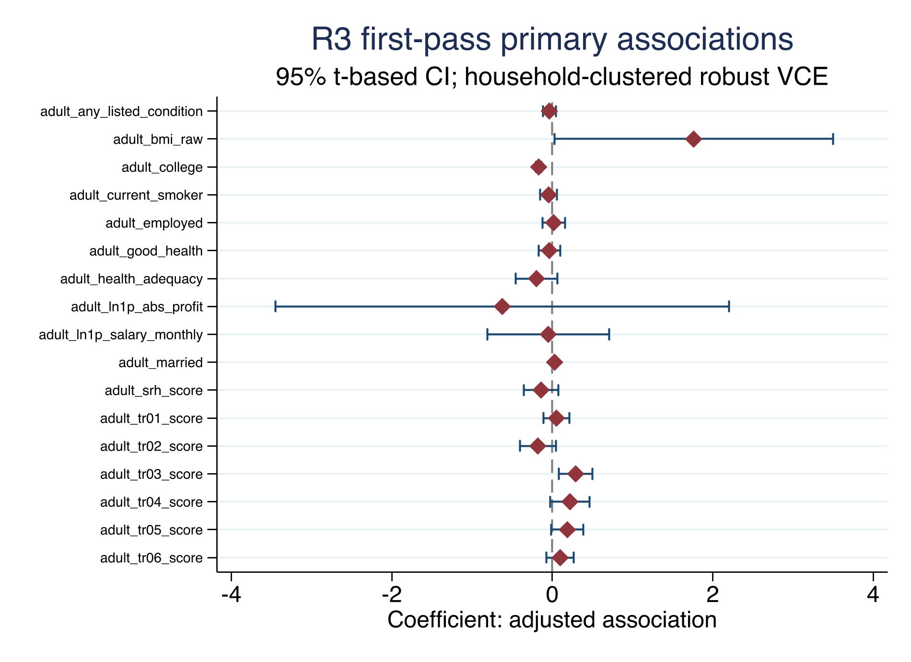

4.2 Wave and age-band support
The treatment prevalence diagnostic records 35 treated and 705 controls among age-15 W2 observations, and 36 treated and 355 controls among age-15 W3 observations before the common-frame restrictions. It also records unresolved work screens and hours. The younger age bands do not have comparable support: age-10–11 observations are unresolved in the working extraction, while age-12–14 treated observations are sparse. These counts motivate the locked age-15 primary rather than a broad age-band treatment.
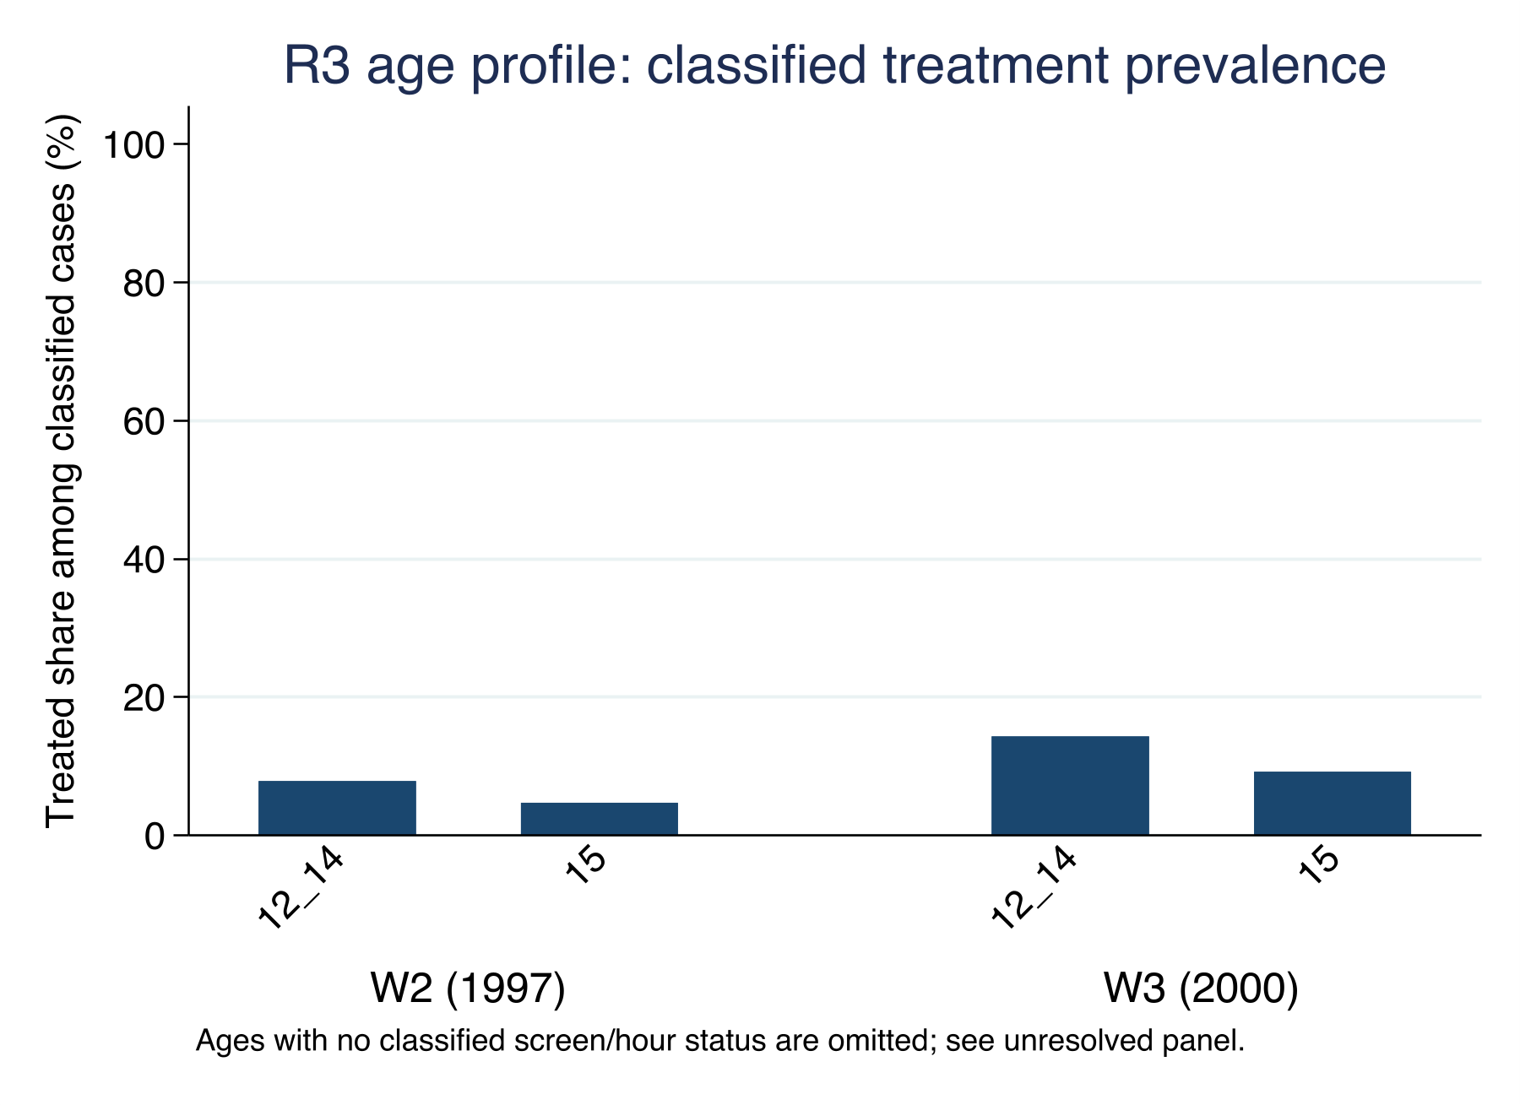

5. Limitations and reviewer-facing boundaries
The first limitation is selection into work. The age-15 treatment is based on work activity and hours in one reference week. It may proxy household poverty, school access, local labour demand, health, preferences, and other factors that also predict adult outcomes. W1 controls reduce measured differences but do not establish exchangeability.
The second limitation is support. There are 44 treated observations in the common frame, and outcome-specific treated counts range from 17 to 43 for the headline results. A few households can materially affect the estimates. The wave indicator and household clustering address a defined part of the data structure; they do not solve the small-cell or identification problem.
The third limitation is attrition and missingness. The common frame requires W1 linkage, W5 follow-up, and a valid value for each outcome. The outcome model therefore has its own sample. Attrition correction and inverse-probability sensitivity are parked, so the estimates should not be described as population-average adult effects.
The fourth limitation is measurement. The current primary screen measures market work and weekly hours. It does not establish hazardous work, chores, domestic labour, occupation-specific risk, or a complete measure of mental health. W3 value-label support is also limited for some work-screen variables; the numeric rule is retained as a documented constraint rather than treated as more informative than the source permits.
The fifth limitation is extrapolation. The current release does not have a closed PCE/price-index bridge or a declared earnings projection. Consequently it reports no NPV, national productivity loss, or policy-cost estimate.

6. Conclusion
In the locked first-pass IFLS frame, intensive market work at age 15 is associated with lower adult college attainment and higher adult marriage/cohabitation and trust-item-3 scores after adjustment for measured baseline controls and treatment wave. Other headline outcomes do not show family-level q-values below 0.05. The findings are bounded associations in a selected longitudinal sample, not causal effects. Before a stronger journal claim is made, the project needs an explicit attrition strategy, verified survey design, completed source-release provenance, and an identification design that can support causal interpretation.

Declarations for author completion
Data availability. The project does not redistribute IFLS microdata. The code, aggregate tables, figures, diagnostics, and reproducibility instructions are local artifacts. Authors should obtain and cite the authorized IFLS files through the official RAND documentation and comply with the applicable access terms.
Funding, conflicts of interest, ethics, acknowledgements, and author contributions. To be completed by the authors. No author metadata or institutional statement is inferred from the supplied files.
AI use statement. AI-assisted drafting and organization were used during the 5 September 2026 preparation of this internal draft. All reported estimates were generated by the project's Stata do-files and checked against the saved aggregate CSV files and logs. AI did not modify the raw or derived IFLS data, and restricted microdata and credentials were not disclosed in the drafting process. The authors remain responsible for the final manuscript and for adapting this statement to the target journal's policy.

References
RAND Corporation. (2016). The Fifth Wave of the Indonesia Family Life Survey: Overview and Field Report. WR-1143/1-NIA/NICHD. https://www.rand.org/content/dam/rand/pubs/working_papers/WR1100/WR1143z1/RAND_WR1143z1.pdf
RAND Corporation. (n.d.). Indonesia Family Life Survey. https://www.rand.org/health/surveys/FLS/IFLS.html

