**AN ANALYSIS REPORT ON SCHOOL SURVEYS IN KENYA**

**TITUS OLANG’**

Data Quality Issues:

1. **Data format**

By observing the data at a glance, I could tell the ‘subsidy_start_date’ had erroneous dates.

I formatted the ‘subsidy_start_date’ to a more likely date.

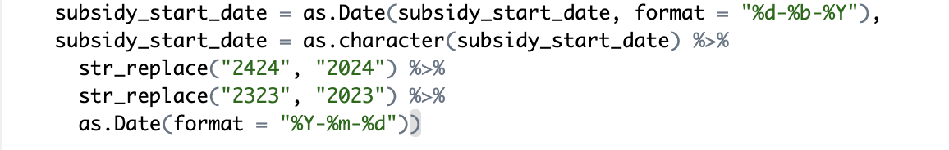

1. **Extra characters**

The ‘school_id’ in one of the student scores tables had extra characters.

I trimmed the extra to match the school sample id.



* This ensured that the id’s matched in both tables.

1. **ID Duplicates**

There were duplicates in ‘school_ids’, checked for duplicates by running:

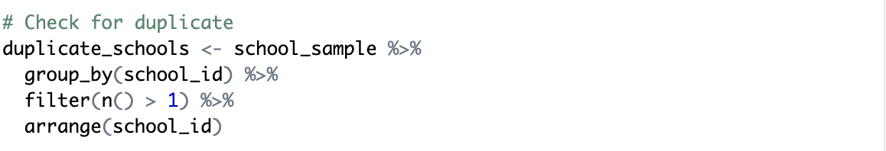

I combined it with the ‘school name’ to make a composite key for the join.



This is to ensure accurate mapping and that no data is lost as a result of duplication.

1. **After joining, I checked if there were any unmatched records.**

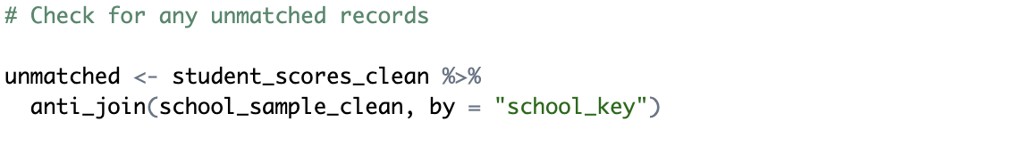

* There are other data validations, I just pinpointed some major ones.

Attraction Analysis and Sample Balance

1. **Age distribution**

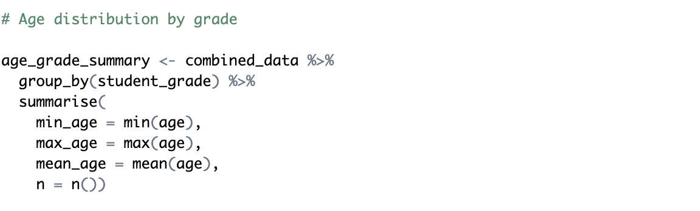

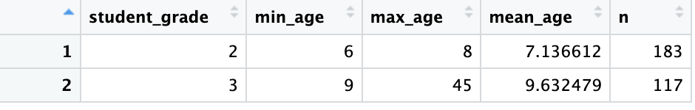

1. **Summary statistics for sample and control groups**

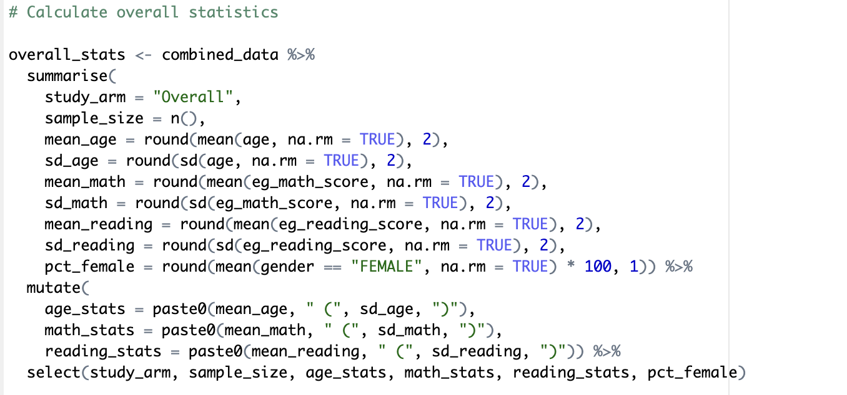

Results:

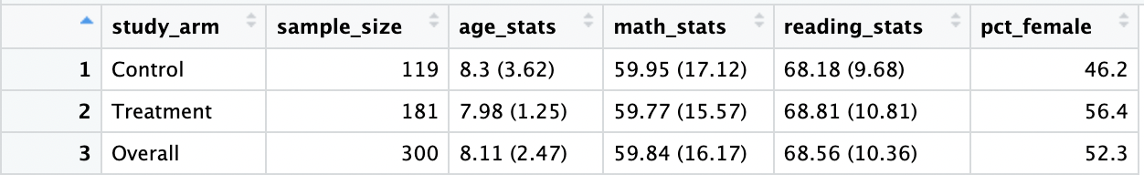

1. **Survey Duration and Outliers**

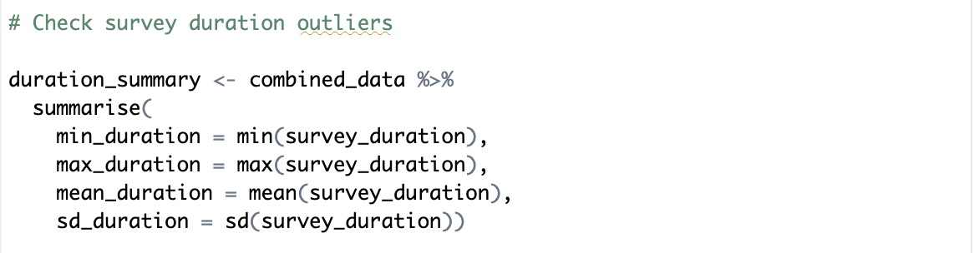

Results



1. **Comparison Table**

Includes means of age, sample size, test scores, and gender ratios

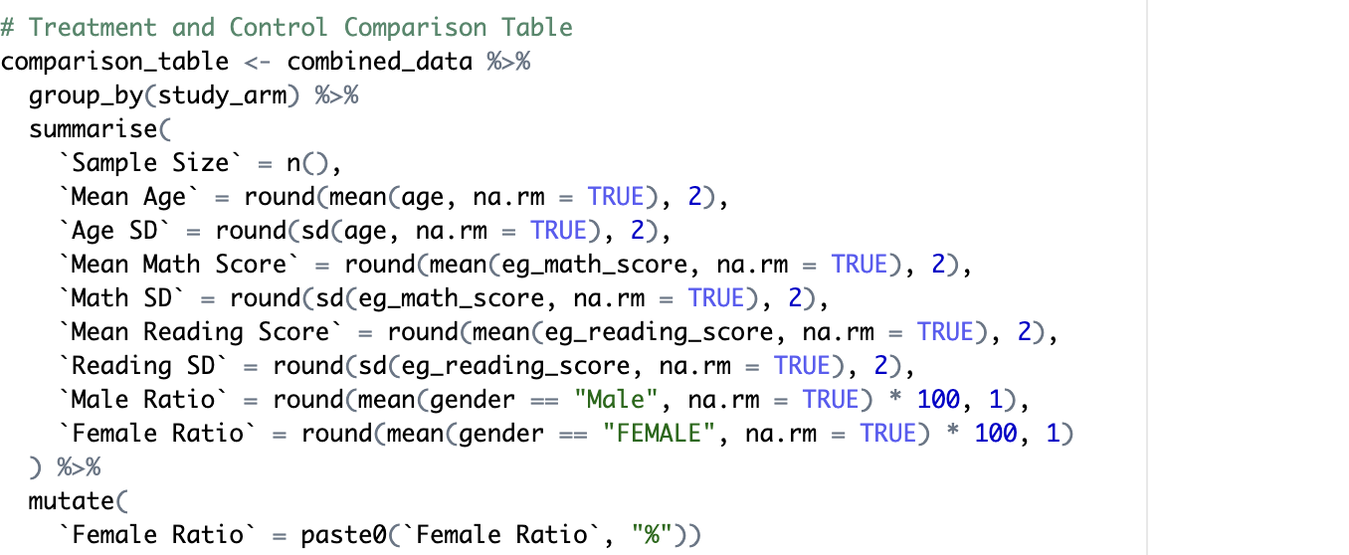

Results

