Presentation:
This application was initially designed to organize SAP GAP’s (developments) general information during an implementation project, but it became an excellent Python lab using SQLite3 to store data and TKINTER as graphic library. The interface resolution is set to 480x272 because it was designed to run using POCKETCHIP.
For more information, visit https://getchip.com/pages/pocketchip.

Installation guide for Mac, Linux and Windows will be covered in APPENDIX 1 at the end of this document.

This is the 1.0 version and all code is commented in English. It is free so you can use it the way you want by customizing the available fields and code according to your needs. If you want to improve the application itself, you are welcome!
If you really want to contribute to the project, just let me know.

All suggested data presented here are information that during my 15 years as an ABAP developer and 3 as Delivery Manager proved to be important for controlling the life cycle of a GAP. Those are helpful for the Project Management reports and follow the Customization area as well. Controlling info such as development status and the delivery date, for example.
The information shown here does not reflect any confidential information of any company I have worked for.

This development was a learning laboratory to me since until I started it, I’ve never had contact with the Python language before. With all learning steps during the development of this "Hello World", it took me approximately 30 days of work, about 3 hours a day. I am aware that the code can be improved and optimized. This is one of the objectives of this publication.

I hope that in addition to being useful, this development inspire you the same way that some examples by the web inspired me.

ENJOY!

Project’s Objectives:
This project aims to provide an interface easy to install and use in order to control management information from SAP developments. It has separate storage tables for added and deleted items (delta) and the effective base where we will use the information. You can insert, change, and remove items as well. You can export the information via CSV if you need to work data on another platform.
The development also provides a list for querying information from tables.

Data Base:
Refer APPENDIX 2 for complete field chart.

The application has 5 tables to work properly:
TBGAPS – Main information storage table.
This table will hold main data from the application.

TBDEL – Deleted items table.
This table holds deleted items information with its justify.

TBINS – Inserted items table.
Each item inserted at the system it´s recorded at this table the same way TBGAPS is. But in this case, data is locked and can’t be changed.

TBMOD – SAP Module information table.
Module list with its description can be found on this table.

TBSTS – Status values table.
Available status list can be found here.

On its first run, all tables will be created and data for TBMOD and TBSTS tables will be automatically loaded. Improvements are being made to this issue (refer APPENDIX 3).

Using the application:
The application has 3 Tabs: List, GAP Control and Tools:
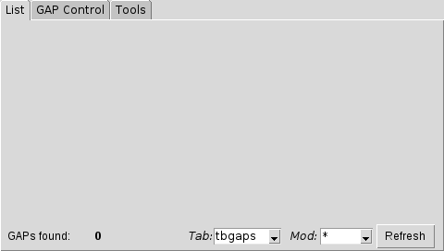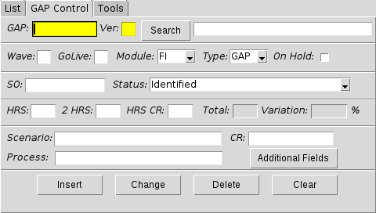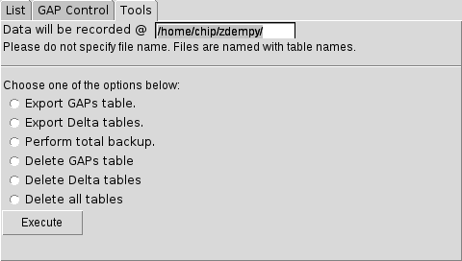

We will talk about each one individually starting with the tab number 2, GAP Control:

Tab 2 – GAP Control
This tab is the main application area. This is the place where we are going to check data details and also insert new data, change the info already filled up and delete items when needed.

The following fields are shown on this screen:
GAP: GAP ID
Ver: GAP Version
Search Button: Search button using GAP and Ver as parameters (yellow fields)
Description: GAP name/description
Wave: Delivery Wave
GoLive: Go Live information
Module: SAP Module
Type: GAP Type (GAP for general, INT for interfaces and MIG for data migrations)
On Hold: GAP on hold
SO: Service Order
Status: GAP Status
HRS: Development Metrics - hours
2 HRS: Second metrics evaluation - hours
HRS CR: Change request metrics - hours
Total: Total (metrics sum) – calc field
Variation: Variation in % (difference between HRS and 2 HRS) – calc field
Scenario: GAP corporative scenario
CR: Change Request number or code
Process: GAP corporative process
Additional Fields Button: Open additional field screen
Fields quantity (int): field quantity used at the interface
Delivery Date: Delivery date
GO / NoGO: GO / NOGO category – NOGO is an extremely necessary development.

Insert Button:
After fill up all fields with desired information, click this button to insert this GAP at the database. Tables TBGAPS and TBINS will be recorded. Success message is displayed.
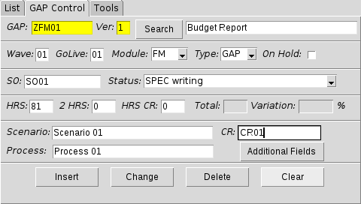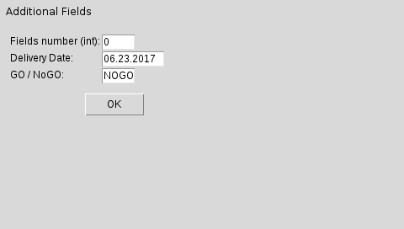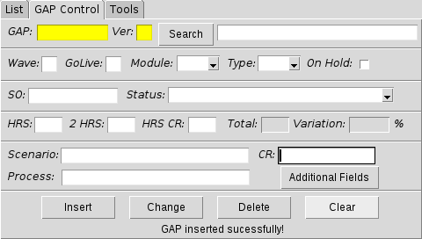

Delete Button:
After perform a search for the desired item, click this button to delete it from main data table. Item will be deleted from TBGAPS and a new line is recorded at the TBDEL table.
On this case, a pop-up screen will ask for justify GAP deletion. You have to fill up this field in order to complete the deletion.
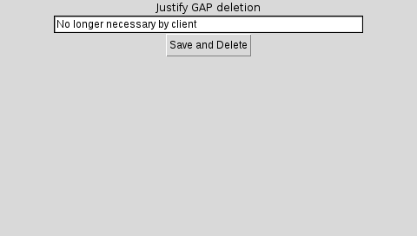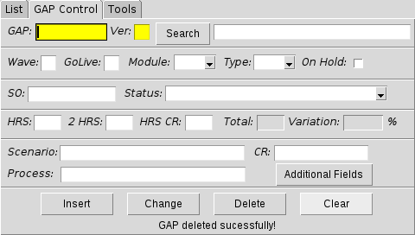
If you do not inform the reason of its deletion, the item is not deleted from the main table and a message is shown:
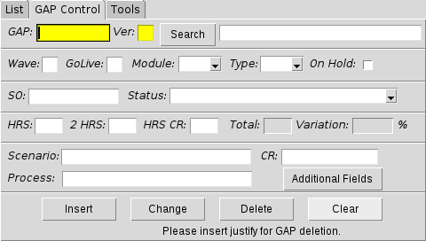

Change Button:
As soon you change the desired information, click this button to update data.
Table TBGAPS is updated. At the screens below an example updating the status field:
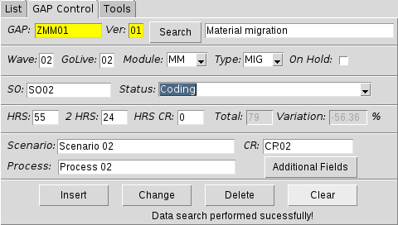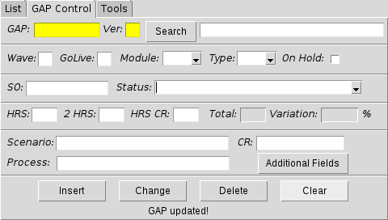

Clear Button:
This button erase all data filled up on screen. No table will be affected by this action.

Search Button:
The yellow fields, GAP and VERSION, are search parameters in case you desire to reach data faster. Click at the SEARCH button to perform to display info.
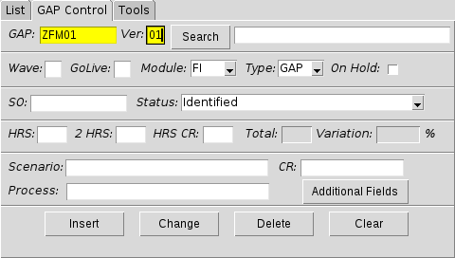

Message area:
At the footer on each tab we have an area that you can check all message displayed for actions. A counter is also displayed for tab 1.

Tab 1 – List:
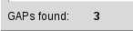

Tab 2 – GAP Control:
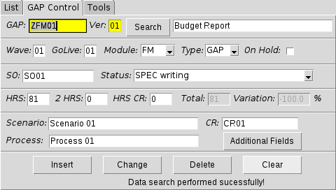

Tab 3 - Tools:
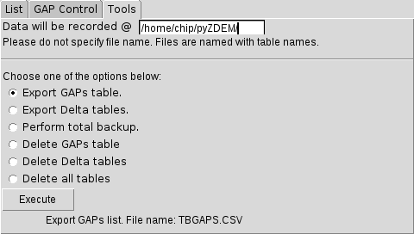

Tab 1 - List
This tab displays list reports for TBGAPS, TBINS e TBDEL tables
An item counter is shown at the left bottom corner.

Table filter:
Use the combo box to choose which table you want to check and then, click REFRESH:
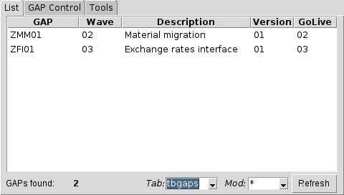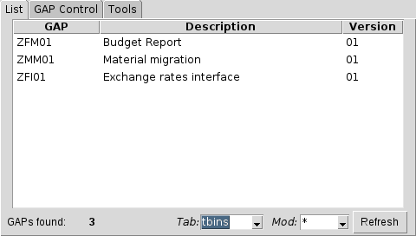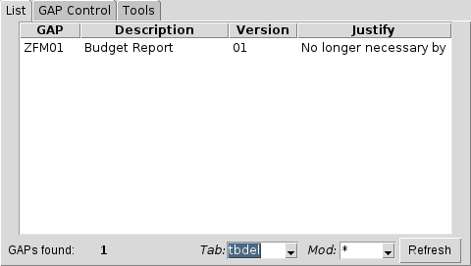

Module Filter:
Filter items by its module choosing the desired one at the combo box and then, click refresh.
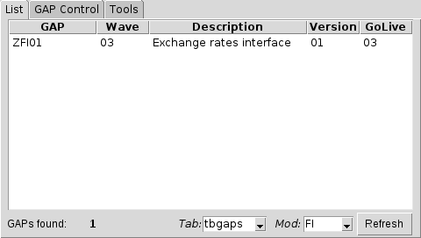

You can combine the combo boxes.

Additional function for TBGAPS list:
If you desire to perform a quick search about details for an item at the list for TBGAPS table, you can just click on it and then, go to tab 2, GAP Control. Data will be loaded automatically. (Attention: this feature is available only for the TBGAPS list – check your filter)
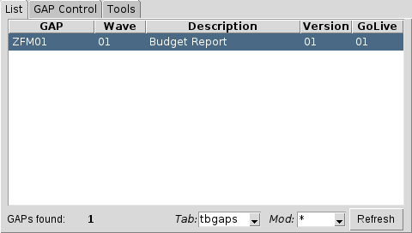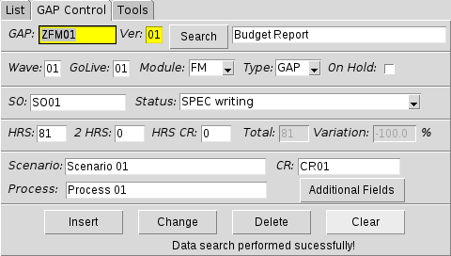

Tab 3 - Tools
To change the path to record files please edit the field right after the “DATA WILL BE RECORDED @” text. You do not net to specify a name for the csv files.
This tab has two kinds of control: Export/Backup and Data deletion. After you chose your command, click EXECUTE:
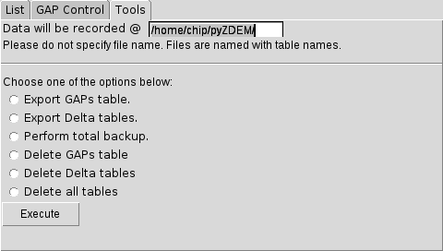

1 – EXPORT and BACKUP
On this case, you can download the data from the option you choose in CSV format. There are three options:
- Export GAPs table – Involved table: TBGAPS
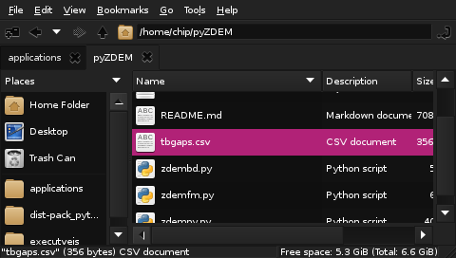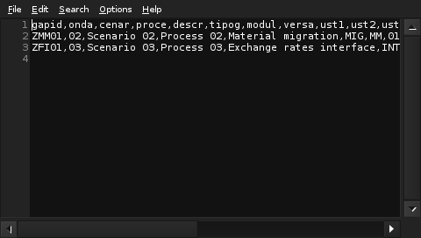

- Export delta tables – Involved tables: TBINS e TBDEL
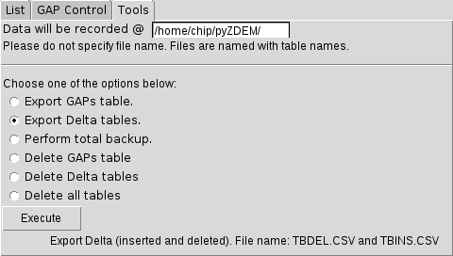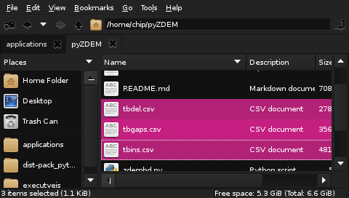

- Perform total backup – Involved tables: TBGAPS, TBINS, TBDEL, TBMOD, TBSTS.
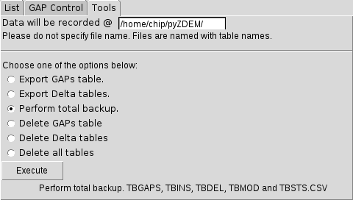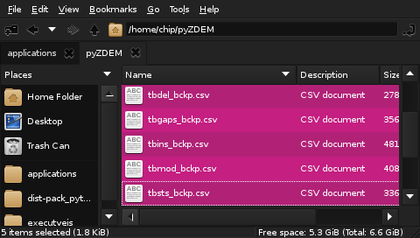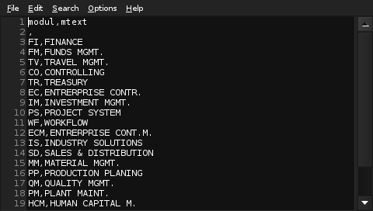

2 – DELETE
Here you can delete all tables. Once again, you have three options:
- Delete GAP main table – This action do not record item at the TBDEL table – involved table: TBGAPS
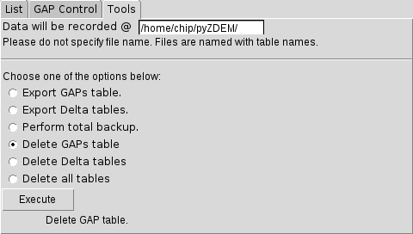
- Delete delta tables –– Involved tables: TBINS e TBDEL
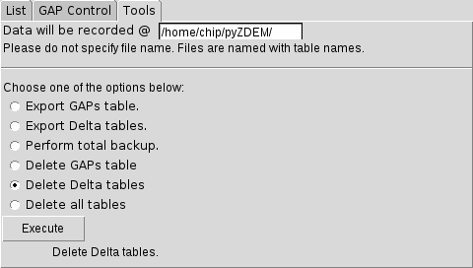
- Delete all tables – This option delete ALL TABLES – Involved tables: TBGAPS, TBINS, TBDEL, TBMOD e TBSTS
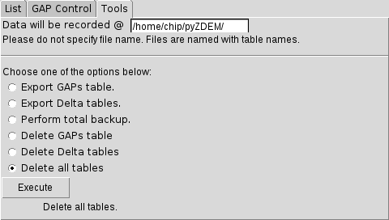

For the DELETE options, a pop-up screen will be displayed to confirm its deletion.
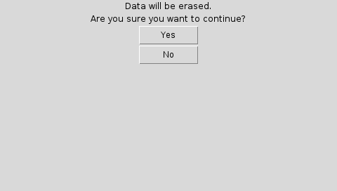

Like others tabs, there is a message area at the screen.
Example:
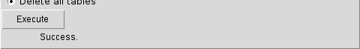

APPENDIX 1:
Follow the steps below to install all necessary components:

LINUX / MAC:
At the Terminal
1 – Install Python3 console:
sudo apt-get install python3
2 – Install TKINTER package:
sudo apt-get install python3-tk
3 – Install SQLITE3:
sudo apt-get install sqlite3
4 – Download this application by GitHub:
Git clone https://github.com/tiuksferve/pyZDEM.git
5 – Execute the app:
cd /pyZDEM/
python3 zdempy.py

Windows:
1 – Download this application:
https://github.com/tiuksferve/pyZDEM
2 – Install SQLite3:
https://www.sqlite.org/download.html
3 – Install Python3:
https://www.python.org/downloads/
4 – Install TKinter package:
This package is already installed with Python3 console. If you still need the files, here is the link to download:
http://www.tcl.tk/software/tcltk/download.html
5 – Run the app:
At command prompt:
- Check if your computer knows the py extension:
  - type: Assoc py
  - Result: .py=Python.File
- Check how windows execute python:
  - Type: ftype Python.File
  - Result: Python.file="C:\WINDOWS\py.exe" "%L" %*
- Now, run the app:
  - At the folder at the files were recorded:
    - type: "C:\WINDOWS\py.exe" “zdempy.py” foo
    - or: py zdempy.py

Keep in mind that the different fonts and types between those systems can cause fails at the fields positions at the screens.

APPENDIX 2:

For tables: TBGAPS, TBINS and TBDEL:
 |  |  |  | TABLES
 |  |  |  | Master | Delta
FIELDS  (as created) | DESCRIPTION | TYPE | SIZE  (recommended) | TBGAPS | TBINS | TBDEL
GAPID | GAP ID | Text | 20 | X | X | X
ONDA | Delivery Wave | Text | 3 | X | X | X
CENAR | Scenario | Text | 250 | X | X | X
PROCE | Process | Text | 250 | X | X | X
DESCR | GAP Description | Text | 250 | X | X | X
TIPOG | GAP Type | Text | 3 | X | X | X
MODUL | GAP Module | Text | 5 | X | X | X
VERSA | GAP Version | Text | 3 | X | X | X
UST1 | Metrics - 1st - (hours) | Text | 3 | X | X | X
UST2 | Metrics - 2nd - Revision (hours) | Text | 3 | X | X | X
USTR | Metrics - Change Request (hours) | Text | 3 | X | X | X
NRRDM | Change Request Reference | Text | 20 | X | X | X
STSFU | Functional Status (used) | Text | 250 | X | X | X
STSGP | Management Status (optional) | Text | 250 | X | X | X
PARAL | GAP On Hold | Text | 1 | X | X | X
GLIVE | Go Live | Text | 3 | X | X | X
NROSS | Service Order Number | Text | 12 | X | X | X
ARTFT | Custom field | Text | 250 | X | X | X
JUSTF | Deletion Justify | Text | 250 |  |  | X
QTDCP | Fields Quantity (interfaces) | Text | 5 | X | X | X
DATDV | GAP Delivery Date | Text | 10 | X | X | X
GONGO | GO or NOGO | Text | 4 | X | X | X

TBMOD table:
FIELDS  (as created) | DESCRIPTION | TYPE | SIZE  (recommended)
MODUL | Module Abbreviation | Text | 3
MTEXT | Module Description | Text | 250

TBSTS table:
FIELDS  (as created) | DESCRIPTION | TYPE | SIZE  (recommended)
STSFN | Functional Status (used) | Text | 3
STSGR | Module Description (optional) | Text | 250

APPENDIX 3:
Work in progress:

- TAB 4 development (Admin) to customize TBMOD and TBSTS tables
- Time stamp will be recorded at the ARTFT field
- Dynamic filters for tab 1

APPENDIX 4:
Suggestions for improvements and issues to observe:

- Username and password for DB connection
- Remote server for DB storage
- Username and password to use the application
- E-mail to the responsible when GAP status be changed
- Concatenate GAP ID at the messages for tab 2
- Include TBMOD values at the module filter combo box at the TAB 1.

