**陈中原：**

**hmac 加密算法**

**附件: Hmac.java**

**丁昌茂：**

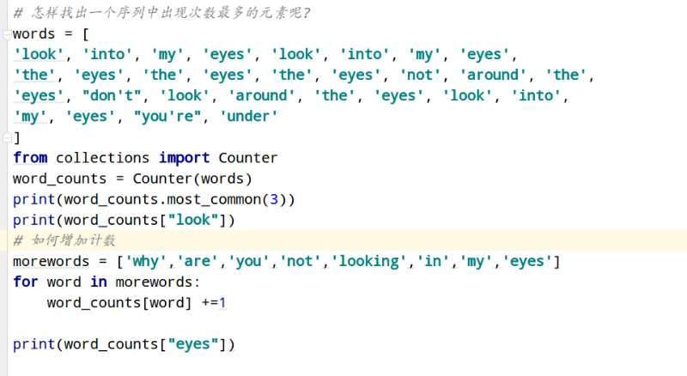

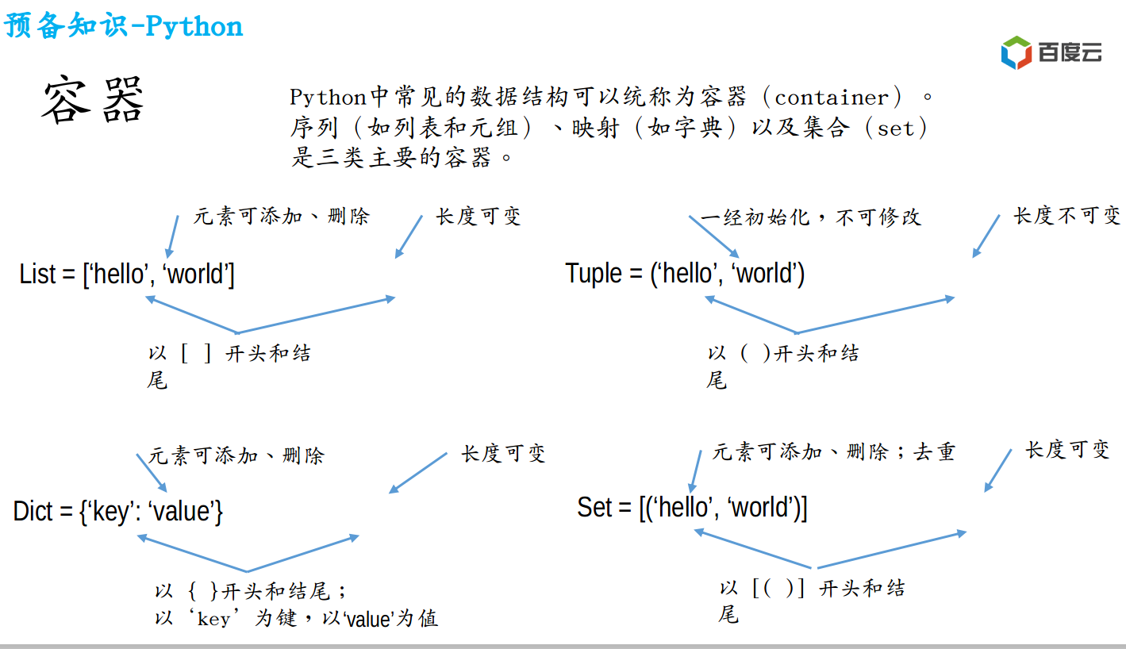

**苏建飞：**

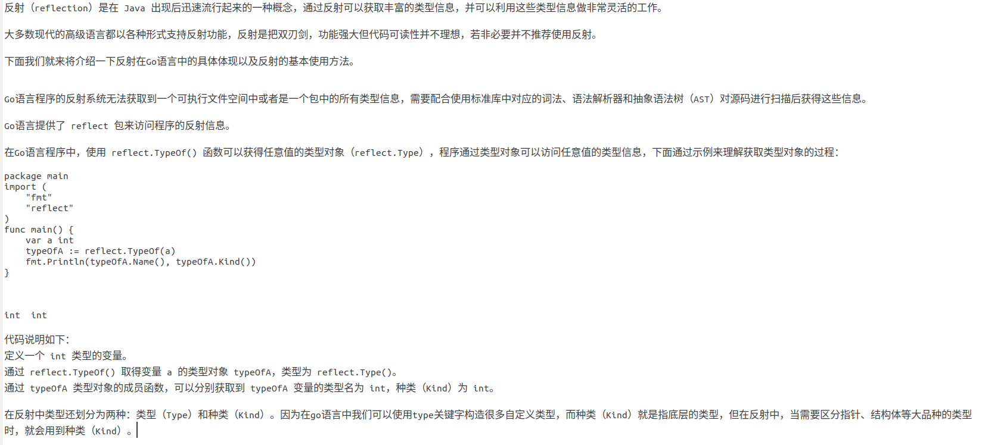

**王福成:**

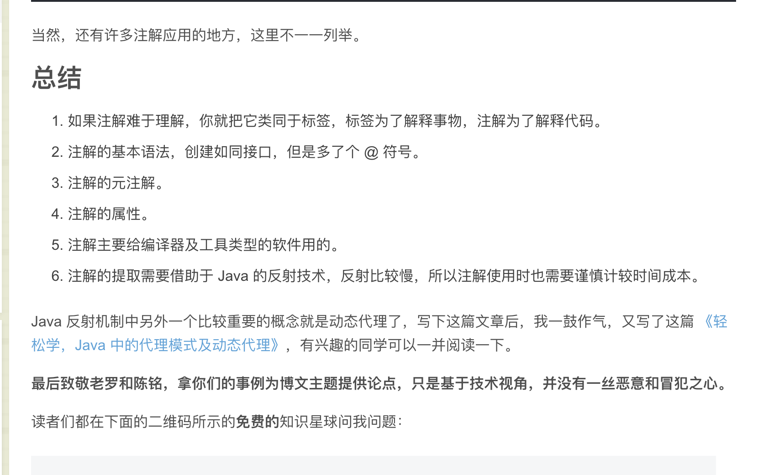

<https://blog.csdn.net/briblue/article/details/73824058>