1. Hiển thị trang HOME

<http://192.168.50.26:5353/home>

2 lấy thông tin của một GAME

<http://192.168.50.26:5353/home/rats>

Key : link_full

Value : <https://www.metacritic.com/game/playstation-5/curse-of-the-sea-rats>

3 <http://192.168.1.253:5353/home/all>

Dùng được cho cả : GAME , TV ,MOVIE, MUSIC

# trừ **MOVIEHOME** <https://www.metacritic.com/movie> (Phần này tìm khác)

Key : link_full

Value : <https://www.metacritic.com/browse/movies/release-date/theaters/date>

<https://www.metacritic.com/game>

<https://www.metacritic.com/tv>

<https://www.metacritic.com/music>

4 <http://192.168.1.253:5353/seach> tìm kiếm theo thể loại

Key : link_full

Value:

[https://www.metacritic.com/search/album/results?genres[alt-country]=1&search_type=advanced](https://www.metacritic.com/search/album/results?genres%5balt-country%5d=1&search_type=advanced)

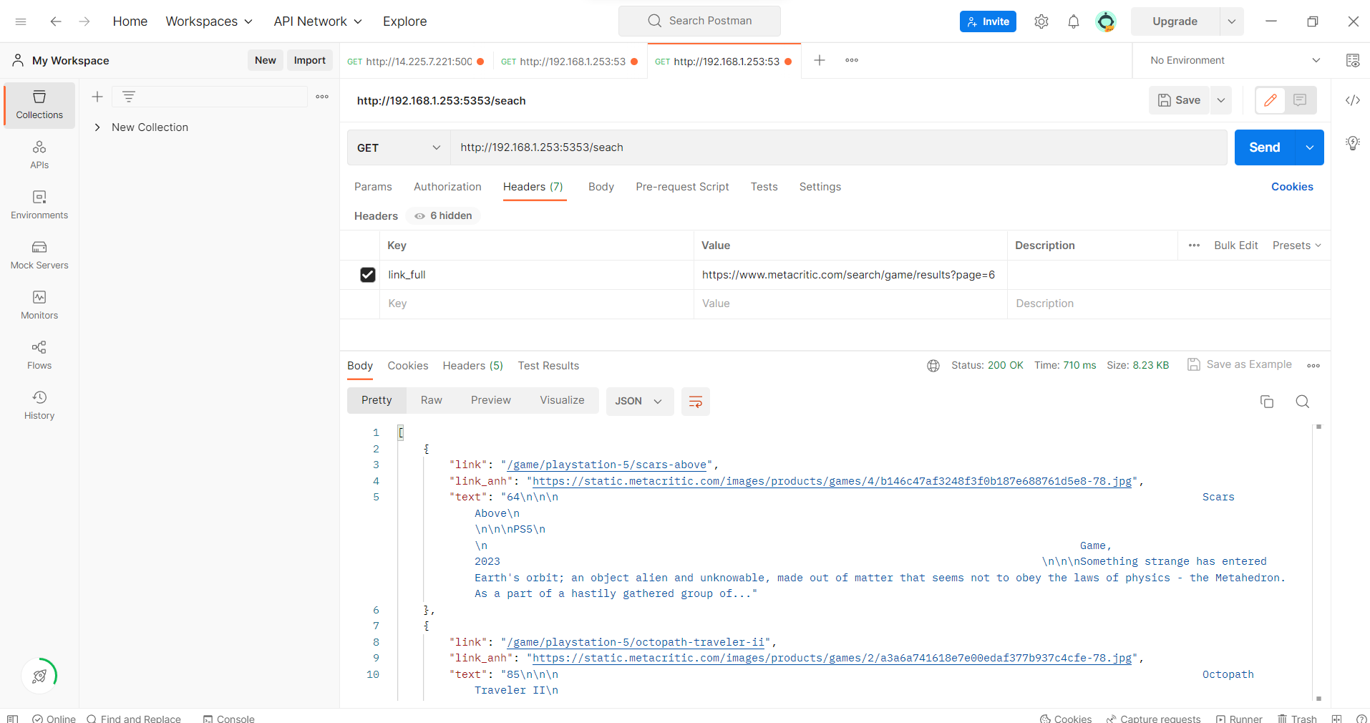

5 hiện thị list movie home

<http://192.168.1.253:5353/home/movie>

