HANOI UNIVERSITY OF SCIENCE AND TECHNOLOGY

School of Information and communications technology

Software Requirement Specification

Version 1.2

AIMS Project

Subject: ITSS Software Development

Nguyen Tieu Phuong 20210692

*Hanoi,* *March 2024*

Table of contents

Table of contents 1

1 Introduction 2

1.1 Objective 2

1.2 Scope 2

1.3 Glossary 2

1.4 References 3

2 Overall Description 4

2.1 Survey 4

2.2 Overall requirements 4

2.3 Business process 4

3 Detailed Requirements 5

3.1 Use case 1 6

3.2 Use case 2 7

4 Supplementary specification 8

4.1 Functionality 8

4.2 Usability 8

4.3 Reliability 8

4.4 Performance 8

4.5 Supportability 8

4.6 Other requirements 8

# Introduction

*<The following subsections of the Software Requirements Specifications (SRS) document should provide an overview of the entire SRS. The thing to keep in mind as you write this document is that you are telling what the system must do – so that designers can ultimately build it. Do not use this document for design!!!>*

## Objective

<*Identify the purpose of this SRS and its intended audience. In this subsection, describe the purpose of the particular SRS and specify the intended audience for the SRS*>

## Scope

<*In this subsection:*

1. *Identify the software product(s) to be produced by name*
2. *Explain what the software product(s) will, and, if necessary, will not do*
3. *Describe the application of the software being specified, including relevant benefits, objectives, and goals*
4. *Be consistent with similar statements in higher-level specifications if they exist*

*This should be an executive-level summary. Do not enumerate the whole requirements list here*>

## Glossary

| ***No*** | ***Term*** | ***Explanation*** | ***Example*** | ***Note*** |
| --- | --- | --- | --- | --- |
| 1 | token | A piece of data created by server, and contains the user's information, as well as a special token code that user can pass to the server with every method that supports authentication, instead of passing a username and password directly. | JSON Web Token (JWT) | Compact, URL-safe and usable especially in web browser single sign-on (SSO) context. |
| 2 | … |  |  |  |

## References

*<Listing the referenced material used in this documents, including the one related to the project>*

# Overall Description

## Survey

*<Software overall description. List of actors and descriptions>*

**List of actors**

* Customer
* Product manager
* Administrator
* VNPay

## Overall requirements

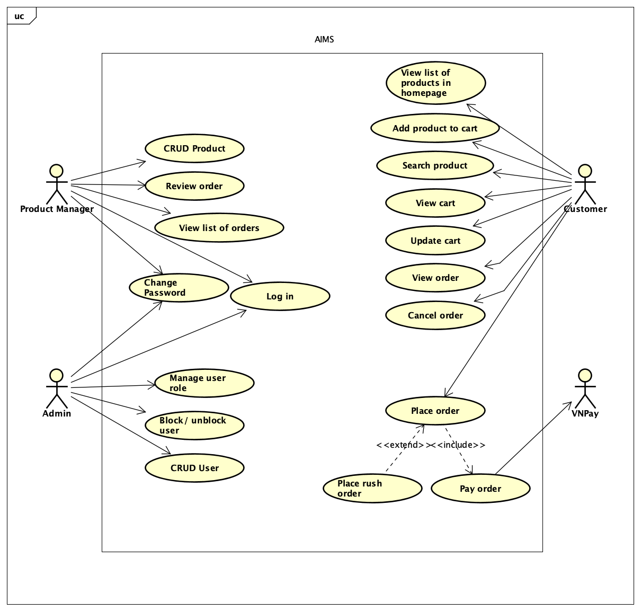

## Business process

*<*

# Detailed Requirements

## Use case “Place Order”

|  |  |  |  |  |  |  |  |  |  |  |  |  |  |  |  |  |  |  |  |  |  |  |  |  |  |  |  |  |  |  |  |  |  |  |  |  |  |  |  |  |  |  |  |  |  |  |  |  |  |  |  |  |  |  |  |  |  |  |  |  |  |  |  |  |  |  |  |  |  |  |  |  |  |  |  |  |  |  |  |  |  |  |  |  |  |  |  |  |  |  |  |  |  |  |  |  |  |  |  |  |  |  |  |  |  |  |  |  |  |  |  |  |  |  |  |  |  |  |  |  |  |  |  |  |  |  |  |  |  |  |  |  |  |  |  |  |  |  |  |  |  |  |  |  |  |  |  |  |  |  |  |  |  |  |  |  |  |  |  |  |  |  |  |  |  |  |  |  |  |  |  |  |  |  |  |  |  |  |  |  |
| --- | --- | --- | --- | --- | --- | --- | --- | --- | --- | --- | --- | --- | --- | --- | --- | --- | --- | --- | --- | --- | --- | --- | --- | --- | --- | --- | --- | --- | --- | --- | --- | --- | --- | --- | --- | --- | --- | --- | --- | --- | --- | --- | --- | --- | --- | --- | --- | --- | --- | --- | --- | --- | --- | --- | --- | --- | --- | --- | --- | --- | --- | --- | --- | --- | --- | --- | --- | --- | --- | --- | --- | --- | --- | --- | --- | --- | --- | --- | --- | --- | --- | --- | --- | --- | --- | --- | --- | --- | --- | --- | --- | --- | --- | --- | --- | --- | --- | --- | --- | --- | --- | --- | --- | --- | --- | --- | --- | --- | --- | --- | --- | --- | --- | --- | --- | --- | --- | --- | --- | --- | --- | --- | --- | --- | --- | --- | --- | --- | --- | --- | --- | --- | --- | --- | --- | --- | --- | --- | --- | --- | --- | --- | --- | --- | --- | --- | --- | --- | --- | --- | --- | --- | --- | --- | --- | --- | --- | --- | --- | --- | --- | --- | --- | --- | --- | --- | --- | --- | --- | --- | --- | --- | --- | --- | --- | --- | --- | --- | --- | --- |
| **Use Case “Place Order”**   1. **Use case code**   UC001   1. **Brief Description**   This use case describes the interaction between customer and AIMS when the customer wants to place an order.   1. **Actors**    1. **Customer** 2. **Preconditions** 3. **Basic Flow of Events**  |  |  |  | | --- | --- | --- | | **#** | **Doer** | **Actions** | | 1 | Customer | views the cart | | 2 | Customer | requests to place an order | | 3 | AIMS software | checks for inventory quantity | | 4 | AIMS software | displays the form of delivery information with order information | | 5 | Customer | provides delivery information | | 6 | AIMS software | calculates and displays order and shipping fees (See Table A) | | 7 | Customer | asks to pay order | | 8 | **AIMS software** | **calls UC “Pay Order”** | | 9 | AIMS software | creates a new order | | 10 | AIMS software | empties the cart | | 11 | AIMS software | sends invoice and payment transaction to the customer’s email | | 12 | AIMS software | displays general information of the order (see Table C) |  1. **Alternative flows**   Table N-Alternative flows of events for UC Place Order   |  |  |  |  |  | | --- | --- | --- | --- | --- | | **No** | **Location** | **Condition** | **Action** | **Resume location** | |  | At Step 3 | If the products are not available | * The AIMS software notifies that the the products in the cart are not available and stay at the use case “View cart” | Use case ends | |  | At Step 5 | If the delivery info is invalid | * AIMS software notifies that the delivery info is invalid (blank or wrong format) | At Step 3 | |  | At Step 5 | If the user chooses to place a rush order | * **AIMS software inserts use case “Place rush order”** | At Step 6 | |  | At Step 8 | If the order payment is not successul or goes back from payment | * AIMS notifies “unsuccessful payment” | At Step 5 |  1. **Input data**   Table A-Input data of delivery information   |  |  |  |  |  |  | | --- | --- | --- | --- | --- | --- | | **No** | **Data fields** | **Description** | **Mandatory** | **Valid condition** | **Example** | |  | Receiver Name |  | Yes |  | Nguyen Tieu Phuong | |  | Phone Number |  | Yes | 10 digits | 0987654321 | |  | Province | Choose from a list | Yes |  | Hanoi | |  | Address |  | Yes |  | 1st Dai Co Viet Street, Hai Ba Trung District | |  | Shipping message |  | No |  |  |  1. **Output data**   Table B-Output data of order information and shipping fee   |  |  |  |  |  | | --- | --- | --- | --- | --- | | **No** | **Data fields** | **Description** | **Display format** | **Example** | |  | Title | Title of a media product |  | DVD Peach, Pho, Piano | |  | Price | Price of the corresponding media | * Comma for thousands separator * Positive integer * Right alignment | 60,000 | |  | Quantity | Quantity of the corresponding media | * Positive integer * Right alignment | 3 | |  | Amount | Total money of the corresponding media | * Comma for thousands separator * Positive integer * Right alignment | 180,000 | |  | Subtotal | Total amount of all products in the order |  | 1,035,000 | |  | Shipping fee |  |  | 30,000 |   **Table C-Output data of** **general information of order and transaction info**   |  |  |  |  |  | | --- | --- | --- | --- | --- | | **No** | **Data fields** | **Description** | **Display format** | **Example** | |  | Customer name |  |  | Nguyen Tieu Phuong | |  | Phone number |  |  | 0987654321 | |  | Province |  |  | Hanoi | |  | Address |  |  | 1st Dai Co Viet Street, Hai Ba Trung District | |  | Total amount |  | * Right alignment * Vietnamese currency (VND) * Vietnamese locale | 1,035,000 | |  | Transaction ID |  |  |  | |  | Transaction content |  |  |  | |  | Transaction date time |  | DD/MM/YYYY HH:MM | 08/03/2024 21:04 |  1. **Postconditions** |

## Use case “Place Rush Order”

|  |  |  |  |  |  |  |  |  |  |  |  |  |  |  |  |  |  |  |  |  |  |  |  |  |  |  |  |  |  |  |  |  |  |  |  |  |  |  |  |  |  |  |  |  |  |  |  |  |  |  |  |  |  |  |  |  |  |  |  |  |  |
| --- | --- | --- | --- | --- | --- | --- | --- | --- | --- | --- | --- | --- | --- | --- | --- | --- | --- | --- | --- | --- | --- | --- | --- | --- | --- | --- | --- | --- | --- | --- | --- | --- | --- | --- | --- | --- | --- | --- | --- | --- | --- | --- | --- | --- | --- | --- | --- | --- | --- | --- | --- | --- | --- | --- | --- | --- | --- | --- | --- | --- | --- |
| **Use Case “Place Rush Order”**   1. **Use case code**   UC002   1. **Brief Description**   This use case describes the interaction between customer and the AIMS software when the customer wants to place a rush order.   1. **Actors**    1. **Customer** 2. **Preconditions** 3. **Basic Flow of Events**  |  |  |  | | --- | --- | --- | | **#** | **Doer** | **Actions** | | 1 | Customer | requests to place a rush order. | | 2 | AIMS software | checks whether the delivery address supports this service and if any products are eligible. | | 3 | AIMS software | displays the item list along with rush order eligibility status and fee | | 3 | AIMS software | requests additional rush order delivery information. | | 4 | Customer | provides the rush order delivery information. (see Table A) |  1. **Alternative flows**   Table N-Alternative flows of events for UC Place order   |  |  |  |  |  | | --- | --- | --- | --- | --- | | **No** | **Location** | **Condition** | **Action** | **Resume location** | |  | At Step 2 | If no products are eligible or the delivery address doesn't support rush order delivery | * The software prompts the customer to update the delivery information or delivery method. | End use case | |  | At Step 4 | If the customer wants to adjust the delivery method or the items they wish to purchase |  | Resumes at Step 5 |  1. **Input data**   Table A-Input data of rush delivery information   |  |  |  |  |  |  | | --- | --- | --- | --- | --- | --- | | **No** | **Data fields** | **Description** | **Mandatory** | **Valid condition** | **Example** | |  | Delivery time |  | Yes | HH:MM | 15:40 | |  | Delivery instruction |  | No |  |  |  1. **Output data**   Table B-Output data of …   |  |  |  |  |  | | --- | --- | --- | --- | --- | | **No** | **Data fields** | **Description** | **Display format** | **Example** | |  |  |  |  |  |  1. **Postconditions** |

## Use case “Pay Order”

|  |  |  |  |  |  |  |  |  |  |  |  |  |  |  |  |  |  |  |  |  |  |  |  |  |  |  |  |  |  |  |  |  |  |  |  |  |  |  |  |  |  |  |  |  |  |  |  |  |  |  |  |  |  |  |  |  |  |  |  |  |  |  |  |  |  |  |  |  |  |  |  |  |
| --- | --- | --- | --- | --- | --- | --- | --- | --- | --- | --- | --- | --- | --- | --- | --- | --- | --- | --- | --- | --- | --- | --- | --- | --- | --- | --- | --- | --- | --- | --- | --- | --- | --- | --- | --- | --- | --- | --- | --- | --- | --- | --- | --- | --- | --- | --- | --- | --- | --- | --- | --- | --- | --- | --- | --- | --- | --- | --- | --- | --- | --- | --- | --- | --- | --- | --- | --- | --- | --- | --- | --- | --- |
| **Use Case “Pay Order”**   1. **Use case code**   UC003   1. **Brief Description**   This use case describes the interaction between customer and the AIMS software when the customer wants to pay an order.   1. **Actors**    1. **Customer**    2. **VNPay** 2. **Preconditions** 3. **Basic Flow of Events**  |  |  |  | | --- | --- | --- | | **#** | **Doer** | **Actions** | | 1 | Customer | chooses the payment method. | | 2 | AIMS software | connects to VNPay for further payment by credit cards. | | 3 | AIMS software | redirects to VNPay with payment information | | 4 | VNPay | notifies the transaction result | | 5 | AIMS software | saves the payment transaction. |  1. **Alternative flows**   Table N-Alternative flows of events for UC Pay Order   |  |  |  |  |  | | --- | --- | --- | --- | --- | | **No** | **Location** | **Condition** | **Action** | **Resume location** | |  | At Step 4 | If customer does not complete mandatory field(s) | * VNPay requires customer to provide the information before proceeding | Resumes at Step 3 | |  | At Step 5 | If the payment is not successful | * VNPay notifies the customer about the failed payment | Resumes at Step 3 | |  | At Step 5 | If the customer cancels the payment transaction |  | Resumes at Step 1 |  1. **Input data**   Table A-Input data of payment information   |  |  |  |  |  |  | | --- | --- | --- | --- | --- | --- | | **No** | **Data fields** | **Description** | **Mandatory** | **Valid condition** | **Example** | |  | Card number |  | Yes | * 16-digit number * Valid credit card number | 9704 5356 4413 6232 | |  | Expiration date |  | Yes | MM/YY | 08/27 | |  | Security code (CVV code) |  | Yes | 3-digit number | 123 |  1. **Output data**   Table B-Output data of …   |  |  |  |  |  | | --- | --- | --- | --- | --- | | **No** | **Data fields** | **Description** | **Display format** | **Example** | |  |  |  |  |  |  1. **Postconditions** |

# Supplementary specification

## Functionality

*<Functional requirements that are general to many use cases>*

## Usability

AIMS Project is a desktop e-commerce software that operates 24/7, allowing new users to easily familiarize themselves.

## Reliability

This software can serve up to 1,000 customers simultaneously without significantly reducing performance and can operate continuously for 300 hours without failure. Additionally, the software can resume normal operation within a maximum of 1 hour after an incident.

## Performance

The maximum response time of the software is 2 seconds under normal conditions or 5 seconds during peak hours.

## Supportability

*<Any requirements that will enhance the supportability or maintainability of the system being built>*

## Other requirements

*<Descriptions of other requirements are located here>*