Lab 1 Report

Scanner

*Compiler Construction Lab - 147826*

Nguyễn Tiểu Phương 20210692

# Results

The results are the same as the expected results given.

### Example 1

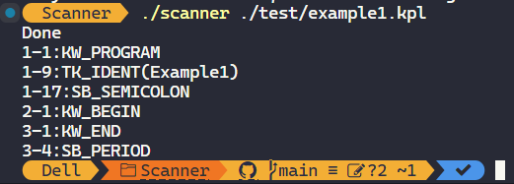

### Example 2

### Example 3

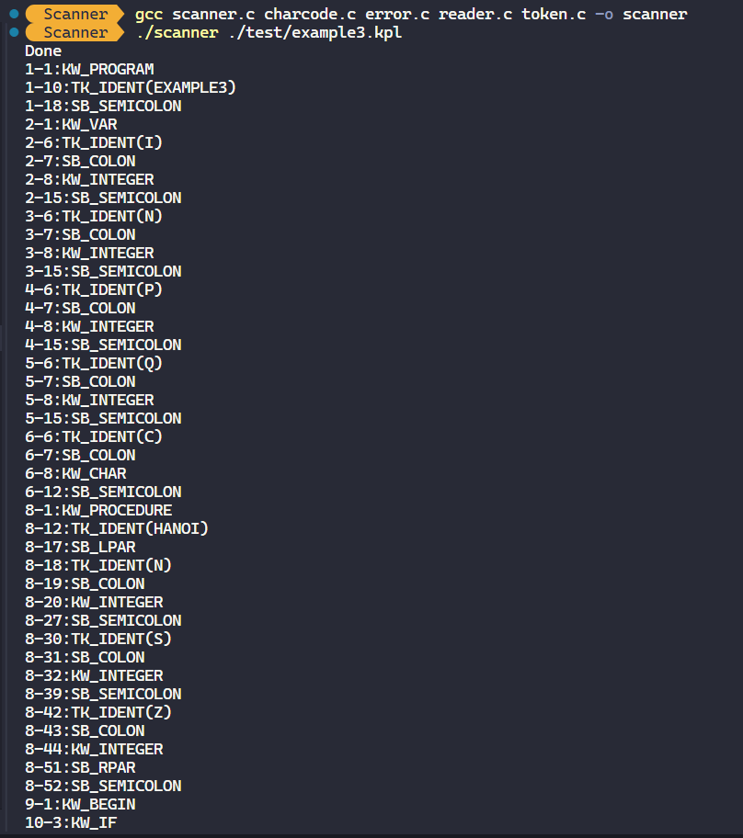

# Errors

The goal is to evaluate whether the scanner can detect and announce all the errors encountered.

### Example 1

For this example, since the KPL program is too simple (having nothing inside between begin and end) we only invoke the following error:

#### Error: Comment is not closed correctly

ERM_ENDOFCOMMENT

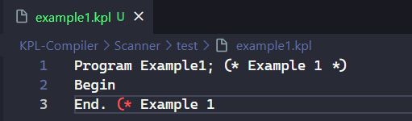

We invoke this error by deleting the closing bracket of a comment in Line 3 here.

The scanner throws the error message.

### Example 2

#### Error: Identification too long

This error can be raised by trying to create a variable with a very long name.

The scanner announces the message and continues.

#### Error: Number outside of range (too long)

Again, we can try to create a very big number to raise the error.

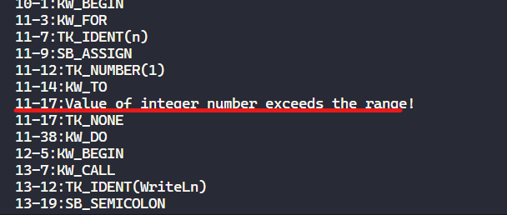

The corresponding error message.

#### Error: Comment not closed

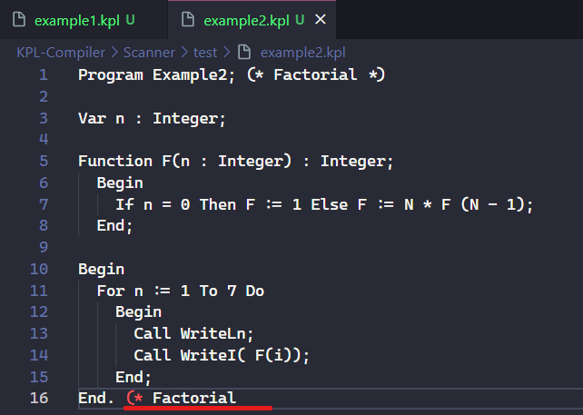

Similar to Example 1. We try to delete some comment brackets.

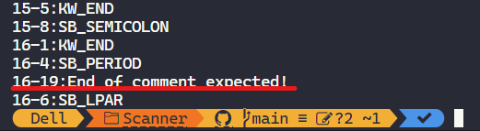

The scanner detects the error.

#### Error: Invalid symbol

One way to invoke this error is using non-printable character (state = 43). We can find those easily by Google search and copy the character from there.

I use the following site to copy a ***Zero-width space character (ZWSP)***:

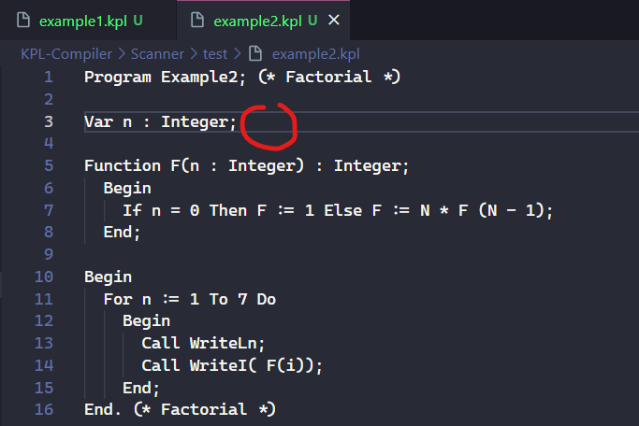

I’ve pasted the character here, but since it is not printable, it does not show up in the editor.

The scanner recognizes the non-printables and outputs the errors.

#### Error: Invalid char constant

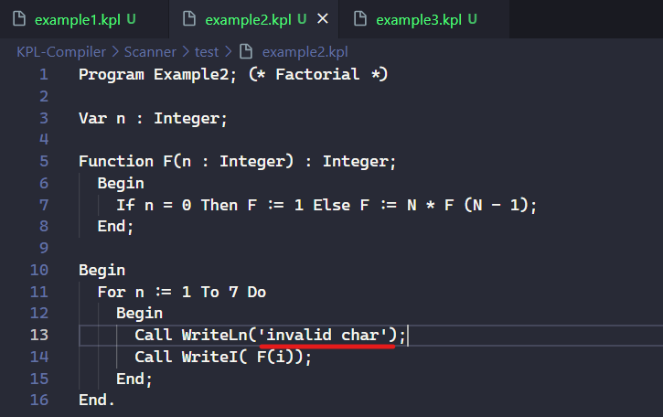

In KPL, the string is not a valid char constant, so we can raise the error as above.

The scanner successfully detects the invalid char constant.

### Example 3

Similar to previous examples, we can create the errors by the same method.

#### Error: Comment not closed

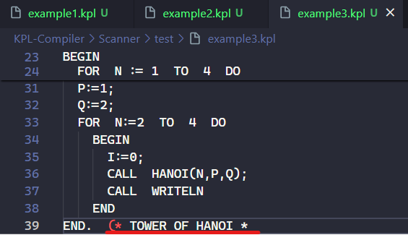

#### Error: Identifier too long

#### Error: Number too long

*Error: Invalid char constant*

#### Error: Invalid symbol

THE END